SAMPLE School Dental Program Permission and Medical History Form

Child’s Name: _________________ ___________________ Date of Birth: _ _/_ _ /_ _ _ _  Male  Female
(First) (Last)

Social Security Number __ __ __ -__ __- __ __ __ __ School _________________________________________

Grade ____________ Room ____________ Teacher ________________________________________________

YES, I give permission for my child to participate in the ___________________________program.
Please complete and return this form.

NO, I do NOT give permission for my child to participate in the _____________________________program.

General Information:

1. What language does your child speak best? ____________ What language does parent speak at home? _______________

2. What is your child’s race?
 American Indian/Alaskan Native  Asian  Black/African American  Hispanic/Latino  White  Other

Health Information:
1. Does your child see a doctor for regular checkups?  YES  NO

2. Does your child see a dentist for regular checkups?  YES  NO
If yes, name of the dentist____________________________________________________________

3. In general, how would you describe the health of your child’s teeth and mouth?
 Excellent  Very Good  Good  Fair  Poor

4. Is your child taking any medication now?  YES  NO
If yes, please list medications. _________________________________________________________
5. Has a dentist or physician ever told you that your child needs to take antibiotics (penicillin) before
having dental treatment?  YES  NO

6. Please check any illnesses or conditions your child has EVER had:
 ADD/ADHD  Diabetes  Hepatitis  Rheumatic Fever  Convulsions
 Anemia  Epilepsy  Heart Murmur  Seizures  Allergies to Medicine
 Asthma  Heart Conditions  Kidney/Liver  Tuberculosis  HIV/AIDS

7. Does your child have any other health conditions?  YES  NO
If yes, please list.___________________________________________________________________

8. Does your child have any allergies? If yes, please check all that apply:  YES  NO
 Penicillin  Antibiotics  Colophonium  Aspirin  Foods  Latex  Resins  Other: _______________________

9. Does your child have DENTAL INSURANCE?  YES  NO
If no, would you like help getting health or dental insurance for your child?  YES  NO

If your child has dental insurance, please check which one and complete below:
 Blue Cross/Shield  Delta Dental  Children’s Medical (CMSP)  Mass Health/Medicaid  Other________________
Delta Dental, CMSP, or Other Dental Insurance

Company_____________________________________
Address______________________________________
Subscriber____________________________________
Subscriber ID #________________________________
Subscriber’s Date of Birth _____ /______/_________
Subscriber’s Social Security Number_ _ _/_ _/_ _ _ _
Group/Policy #________________________________
Employer Name_______________________________

MassHealth
MassHealth RID Number
_______________________________

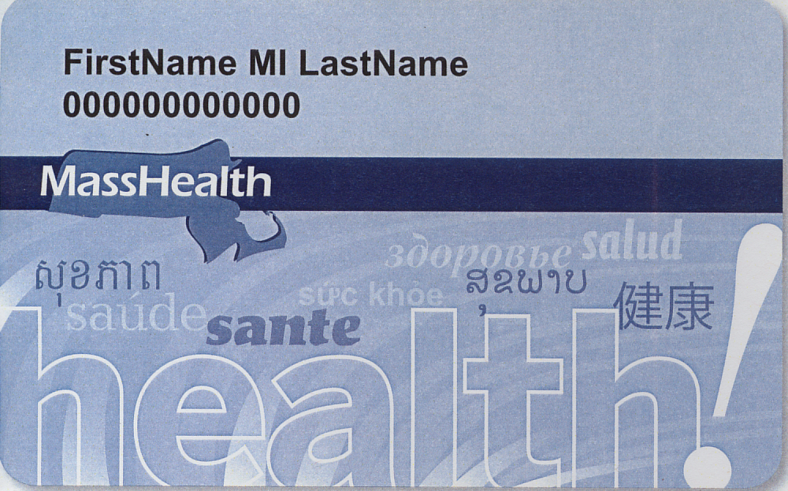

I understand that ________________________ may use my child’s health information for treatment, payment and health care operations. I have been given a copy of their Notice of Privacy Practices. I have read and understand the dental program and services that may be provided to my child. I consent to have my child participate in the program. I authorize the dental program to provide a written summary of the examination-services to an official designated by my child’s school. I understand that these services do not substitute for an examination by a dentist and that my child should obtain an examination by a dentist within 90 days, if they have not had one. If needed, this program will provide a list of dentists in my area. I understand that my child may continue to receive dental care from any other provider. If I have dental insurance, I acknowledge that this treatment may affect my future rights and insurance benefits, and I authorize my insurance carrier to be billed for any services provided.

X________________________________________________ Date: ___/___/___ Relationship to Child: ________________________

Parent/Guardian Signature
______________________________ _____________________ __________________ ________________________________
Print Name Daytime Phone Number Cell Phone Number Email Address

Parent/Guardian Email Address: _________________________________________________________

