Bid Request
Long Term Culvert Replacement Training Project
Spencer, MA & Ashfield, MA

TO: Category 1 vendors

FROM: Tim Chorey, DFG Division of Ecological Restoration

RE: EcOLOGICAL RESTORATION technical service master agreement/RFR ID # DER 2015-04

DATE: April 7, 2016

Consistent with the performance criteria and specifications contained within RFR ID # DER 2015-04, “EcOLOGICAL RESTORATION technical service master agreement,” the Massachusetts Department of Fish and Game’s Division of Ecological Restoration (DER) is requesting bids for technical services as described below under section III, Project Specifications for the Long Term Culvert Replacement Training Project in Spencer, MA and Ashfield, MA.

This Bid Request presents a general proposed sequence of work with an expectation that responding firms will express their own project approaches. Bidders will be evaluated based upon their demonstrated experience with scientific river assessments and data collection and engineering culvert replacements that meet the MA River and Stream Crossing Standards, project examples, technical and management approach to this project, timeline for completed work, and cost effectiveness.

DER anticipates execution of a contract in April of 2016 for services through June 30, 2016.

- PROJECT LOCATION
The projects consist of two separate culvert locations:
Site # | Location | Type of site | GPS Coordinate | Desired technical service
1 | Tributary to Stiles Reservoir, Clark Road, Spencer, MA | Road-stream crossing, 18” Round Concrete Pipe | Lat: 42°12'28.76"N, Long: 71°57'16.14"W | Site Reconnaissance and assessment for replacement
2 | Tributary to Bear River, Baptist Corner Road, Ashfield, MA | Road-stream crossing, 5’ Round CMP | Lat: 42°32'51.51"N, Long: 72°46'4.66"W | Site Reconnaissance and assessment for replacement

Site #1 (Clark Rd) is located in south central Massachusetts in the town of Spencer. The Project Site (culvert) is located in the French River watershed in the southeast corner of town on an unnamed tributary west of the Stiles Reservoir. The Project Site is approximately 350 feet east of the intersection of Chickering Road and Clark Road. Clark Road is a busy rural collector road residents use to travel to the Mass Pike. Please see the locus map and photo below.
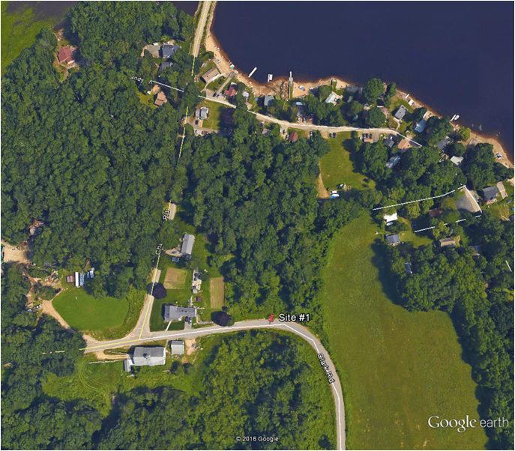
Locus Map 1- Site #1 on Clark Road east of Chickering Road.

Site # 1

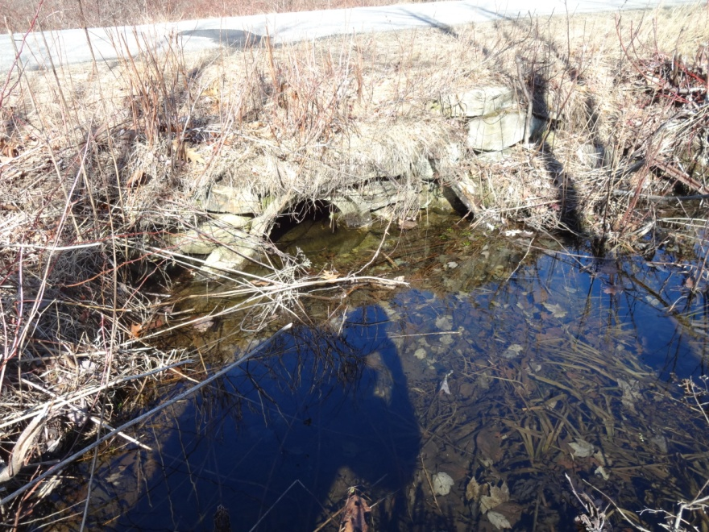
Photo 1- Site #1 Culvert looking north at the inlet.

Site #2 (Baptist Corner Road) is located in the northwest corner of Massachusetts in the town of Ashfield, just south of Route 2 and Shelburne Falls. The Project Site (culvert) is located in the Deerfield River watershed in the northeast corner of town on an unnamed tributary to Bear River. The Project Site is approximately 0.25 miles southwest of Phillips Road on Baptist Corner Road. Baptist Corner Road is quite busy for its rural setting because it connects Ashfield to Shelburne Falls. Please see the locus map and photo below.
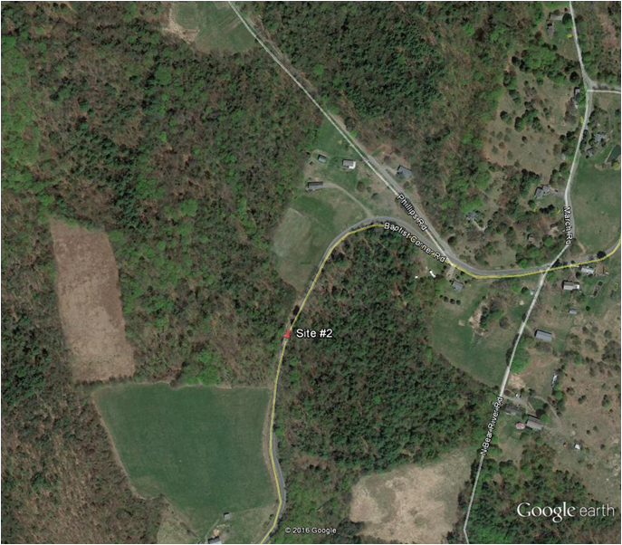
Locus Map 2- Site #2 on Baptist Corner Road southwest of Phillips Road.

Site # 2

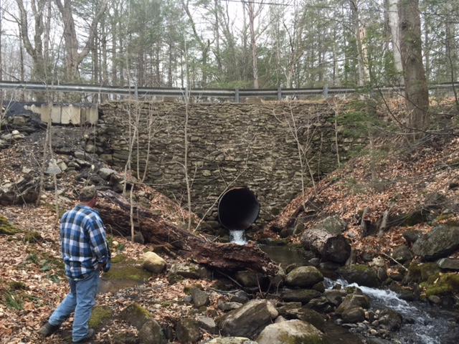
Photo 2- Site #2 Culvert looking west at the outlet.

- PROJECT PURPOSE AND BACKGROUND

The goal of this project is to assess and understand existing conditions at two road-stream crossing (culvert) locations; Clark Road and Baptist Corner Road and use the collected information from the Project Sites to conduct onsite training. The work will serve as the initial site assessment and first phase of what will ultimately be the replacement of each of these culverts. Essentially, DER is looking to obtain the necessary data needed to start the design of two new road-stream crossing that meet the MA River and Stream Crossing Standards (one crossing for each site).

DER will use reports and material developed from this Project to develop training material and project examples that will help municipalities more easily begin the culvert replacement process. Each crossing location will be used as a long term training site for Spencer, Ashfield, and surrounding municipalities to learn and understand how to replace road-stream crossings that allow for natural river process and are resilient to the increasing frequency and intensity of northeastern rainstorms. The information gathered from site assessments will be used to hold one DER led training at each crossing location (two total trainings). The intent of the training is to educate municipalities about the practice and methods and reasons and rationale behind completing a site assessment. The trainings will be conducted sometime in mid to late June, after the data have been collected. The engineer shall be present during both (2) full day training sessions to answer technical questions about the project. The selected bidder is not expected to develop a presentation or handouts for the presentation.

In addition to gathering site information for design, DER’s intent is to work with and educate the towns on the ideal and proper way to perform a culvert replacement that meets the Massachusetts Stream Crossing Standards. Each site will have its own project team consisting of a variety of town officials. DER will manage meeting coordination between the project teams, but the engineer shall be present during meetings and available throughout the project process. There shall be frequent communication between DER, the Town, and Engineer through the duration of this contract. Information generated for the technical reports and gathered from the field shall be made available to DER as soon as possible, because DER will be planning the training sessions for municipalities while the selected bidder is conducting the site assessment. Training sessions are targeted for mid-June. The first draft of each site's technical report shall be available for DER and Town review no later than May 27, 2016, this deadline may be extended if Project information is communicated regularly to DER prior to May 27th. DER expects the Notice To Proceed for this Project by April 22, 2016.

PROJECT SPECIFICATIONS

Scope of Services
DER is presenting a general outline of tasks thought to be required at this time to support the above referenced goal. DER welcomes variations on this approach from prospective Bidders. DER reserves the right to not execute certain task. Bidders are encouraged to submit succinct proposals; DER will be an active technical partner with the selected Bidder. The Bidders shall expect full access to the site and adjacent properties necessary to perform the below tasks. Using the Scope of Work template (Attachment 1), deliverables should be clearly identified under each task by Bidders. The proposed scope must, at minimum, include the following tasks for each site:

Task 1: Geotechnical Evaluation

- Perform a subsurface investigation and soils analysis, including at least 2 borings per culvert replacement (4 total).

Task 2: Site reconnaissance and resource delineation
This task shall occur in consultation and coordination from DER staff (T. Chorey).

- Perform a wetland resource area delineation of the project area within the vicinity of the culverts (USCAE Determination forms and associated materials required).
- Perform a riverbed substrate analysis, i.e. pebble-count, to understand the existing riverbed substrate and provide data to calculate the design stream bed material.
- Identify the type and integrity of stream grade controls on an accurate (but not to scale) field sketch so locations are able to be survey located.
- Identify and flag at least six (6) bankfull width measurement locations and representative cross-sections to be surveyed (3 upstream and 3 downstream of culvert).
- Determine appropriate reference reaches with similar slope to the road-stream crossing location.

Task 3: Survey the two road-stream crossings.
This task shall occur in consultation and coordination from DER staff (T. Chorey).

- Perform a radial topographic survey and include other relevant features; including, but not limited to resource areas, adjacent areas for the potential use of stormwater features, headwall/wingwall locations and elevations, centerline elevation of the road at each culvert, and geotechnical boring locations.
- Survey longitudinal profiles of the river for each site; including, but not limited to longitudinal profile features (steps, pools, riffles, glides), grade control locations and elevations, culvert invert elevations, top of culvert, locations of bankfull width measurements, representative cross-sections above and below each culvert, and mean annual high water.
- Review and survey key site features that may act as constraints to replacing the crossing, including infrastructure upstream and downstream. Describe and photograph significant features.
- Identify adjacent property lines and roadway right-of-way.
- Prepare an existing conditions topographic plan and plot the streambed longitudinal profile and cross sections for each crossing.

Task 4: Hydrologic / Hydraulic Studies: Determine existing hydrology of each site as necessary to inform design.

- Conduct a hydrologic study of the project sites, using appropriate methods. Identify typical low flows, the bankfull discharge, 5-year, 10-year, and 100-year discharges, or other flows essential to the engineering and design process.
- Conduct a hydraulic analysis to predict water depths, velocities, and water surface profiles for existing conditions. Identify any existing erosion concerns adjacent to the existing culvert.

Task 5: Traffic analysis at both Project Sites

- The Bidder shall use their expertise to develop a plan to analyze the traffic over the project culvert. Necessary information shall include, but not be limited to: volume, peak volume, type of vehicle traffic. Type of vehicle is important to know in determining a detour route in the event of a washout or during construction. The information gathered will be used to determine road use, aid in roadway design, and used to support possible grant applications, such as a Benefit Cost Analysis for a Hazard Mitigation Grant.
- After review and input from the Project Teams execute the plan to analyze traffic over each culvert; Clark Road and Baptist Corner Road.

Task 6: Recommend a structure type and cost estimate

- The Bidder shall use their expertise to develop a plan to best evaluate the most appropriate structure for each site. The plan shall consider design and construction costs, constructability; including duration and water control, and metrics to demonstrate the pros and cons of the recommended structure as compared to other structure types.
- In determining the recommended structure the Bidder shall use their professional judgment and available site data to estimate scour, footing depth, hydraulic capacity, and other unknown factors not easily identifiable. No modeling is expected for determining a recommended structure.
- After review and input from the Project Teams execute the plan to determine a recommended structure for each site; Clark Road and Baptist Corner Road.
Task 7: Technical Report for each Project Site

- Prepare separate draft technical report for each stream crossing site; Clark Road and Baptist Corner Road. Each technical report shall include information from Tasks 1-6 and the following information:
  - Site description, including features of the existing crossing and stream, bankfull width, stream gradient, habitat features, natural resource areas, and etc.
  - Description of the critical infrastructure at each site and potential constraints to replacing the crossing.
  - Geotechnical analysis with adequate information to complete design and construction recommendations for all foundation types and earthwork aspects of the two culvert replacements as outlined by the MassDOT LRFD Bridge Manual.
  - A description of river longitudinal profile, including type and integrity of grade controls, cross-sections, and riverbed substrate.
  - Synthesis of hydrologic and hydraulic analysis with sufficient information necessary to inform design.
  - Traffic analysis.
  - Recommended structure type and cost analysis.
  - A listing of the required additional engineering studies that will be needed to complete the engineering design.
- After review and input from the Project Teams prepare the separate final technical report.

Task 8: Project Management

- Participate in an onsite kickoff meeting for each Site; Clark Road and Baptist Corner Road.
- Participate in a conference call for each site to review Task 2 Site reconnaissance and resource delineation information prior to executing Task 3: Survey the two road-stream crossings.
- Participate in a conference call to review the traffic analysis plan prior to execution.
- Participate in a conference call to review the crossing structure evaluation plan prior to execution.
- Anticipate at least one additional in-person meeting at a location TBD based on the nature of the meeting.
- Be available for project inquires through the duration of the contract by phone or email.
- Participate in two (2) day-long training sessions. The selected bidder is not expected to develop a presentation or handouts for the training sessions, but is expected to be present to answer technical questions.

III. DELIVERABLES

Deliverables shall include, at minimum:
- Field work and site visits as necessary to collect the information described above;
- Photo copies of field notes and field sketches;
- A technical report (draft and final) including information described above for each stream crossing in MS Office format and 3 color paper copies with full size site plans;
- Survey data and 24"x36" existing conditions plan in CAD files and mapped in pdf format for each crossing;
- All data in native formats;
- Four borings logs and notes; and
- 2 full days of participation in the training sessions.

IV. BID

Please provide a bid including a Scope of Services to meet the project purpose, description and requirements as outlined above and in keeping with the terms as specified in RFR ID # DER 2015-04, “EcOLOGICAL RESTORATION technical service master agreement.” Associated project costs and personnel assignments must be consistent with the fee schedule, terms and qualifications packet accepted with your Standard Contract Form for the EcOLOGICAL RESTORATION technical service master agreement. Please contact Megan Sampson at 617-626-1547, if you have any questions about this.

The bid should be formatted to the accompanying bid template (Attachment 1), use the budget template (Attachment 2) as a guide, and must include the following:

- Project scope including deliverables for each task (please use attached bid template)
- Specific budget, broken down by task, personnel, etc. (please use attached budget template as a guide)
- Project schedule by task and week
- List of personnel and their rate category who will specifically be working on this project
- Project examples of experience with culvert replace projects that meet MA River and Stream Crossing Standards.
- Description of Bidder’s commitment to Supplier Diversity Plan goals and use of SOMWBA certified sub-contractors commensurate with the terms of your Standard Contract for the EcOLOGICAL RESTORATION technical service master agreement.

Note that DER reserves the right to reject any and all bids, including specific tasks and solicit additional proposals from other vendors to ensure the best value is obtained for the services requested. The decision to request additional proposals will be made after evaluating the submitted proposals for overall value, including:

- Demonstrated understanding of, and proper approach to, the scope of work;
- Demonstrated experience with scientific river assessments and data collection;
- Demonstrated experience engineering culvert replacements that meet the MA River and Stream Crossing Standards;
- Appropriate allocation of qualified staff and level of effort to scope tasks;
- Timeline for completed work and;
- Competitive total cost to complete the scope of work.

Duration of Contract:

We anticipate contract beginning in April 2016. Initial contracting is expected to be directly with DER, with associated work completed by June 30, 2016 DER reserves the right to re-negotiate the Scope of Work related to any tasks under any subsequent contract.

Q/A
All questions related to the bid must be submitted in writing by 5 PM, April 12, 2016 to timothy.chorey@state.ma.us

DER will email responses to questions to all bidders by 5 PM, April 13, 2016

Submissions:
Deadline: April 18, 2016, 10:00PM

Responses must be sent via email to timothy.chorey@state.ma.us as well us uploaded to COMMBUYS via the “Create Quote” functionality contained in COMMBUYS. Please enter the following information in response to this bid; no other fields should need to be adjusted:
- General Tab – Enter the contact information for the project manager for this quote
- Items Tab - please enter the overall project price in the unit cost
- Term & Conditions Tab - This tab refers to the terms and conditions that apply to this bid, per RFR# DER 2015-04 Ecological Restoration Technical Service Master Agreement and any additional terms located in this bid. The terms and conditions must be accepted before your quote can be submitted.
- Attachments tab - Upload scope of work and budget attachment(s)
From the summary tab, submit the quote and an email from COMMBUYS should be received if submission was successful. For additional instructions concerning how to respond to a bid, please see Attachment 3.

Department of Fish and Game (DFG)
Division of Ecological Restoration (DER)

