Dear Parent or Guardian:

On _____________, your child, __________________________participated in an Oral Health Prevention Program.

SCREENING RESULTS:

___ No obvious decay; x-rays were not taken.
___ Areas of possible decay exist. Please have your child checked by a dentist in the near future.
___ Large areas of possible decay exist. Please have your child checked by a dentist as soon as possible.
___ There is an immediate need for dental treatment due to pain and/or infection.
___ Sealants are present and were not needed at this visit
______________________________________________________________________________________________________________________________________________________________________________________________________________________________________________________________________________

ORAL HYGIENE RESULTS:

___ Clean teeth and healthy gums were found. Keep up the good work!
___ Food/Plaque was found on teeth. Please encourage better brushing and flossing!

PREVENTIVE SERVICES PROVIDED:

___ Dental Screening
___ Tooth Brushing Instruction
___ Fluoride Varnish (D1206) was applied: $ ________

___ Dental Sealants (D1351) were placed on the teeth noted below $ ________

___ _______________________________________________ $ ________
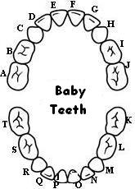
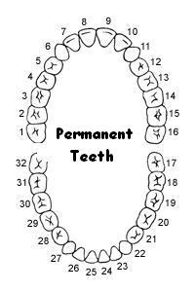
COMMENTS:
___________________________________________________________________________________________________________________________________________________________________________

TODAY’S PREVENTIVE DENTAL SERVICES WERE PROVIDED BY:

(Dental Provider’s Printed Name and Signature)


A copy of this report was given to your child’s school nurse. If follow-up dental treatment is needed, a letter will be sent to the dentist that was named on your child’s signed consent form. If you did not provide us the name of a dentist, we will help you find one in your area. If you have any questions concerning the preventive dental services provided today or need assistance in locating a dentist, please contact ___________________________ at XXX-XXX-XXXX or (email address).

