Sanctions

**Purpose:** Procedures for EI Division staff to address programs that have identified noncompliance or may be at risk in meeting compliance with state or federal compliance indicators, educational outcomes, and fiscal requirements.

Sanctions will be determined by the EI Division through ongoing monitoring of EIS and SSP programs for compliance. Compliance will be monitored by established general supervision methods such as:

* Database reports
* Record reviews
* Self-assessments
* Data quality reports
* Fiscal monitoring
* Local determinations
* Cyclical monitoring

**Scope:** The intended audience is the EI Division staff for internal monitoring activities, contracted early intervention service programs, contracted specialty service programs and other key representatives.

**Prerequisites:** The EI Division uses data sources through established general supervision methods listed above to determine necessary sanctions.

**Procedure:**

1. Clinical Oversight and Support Specialist (COSS) of assigned program identifies the need for assistance or intervention during established general supervision activities. Once it is identified that there is a need for assistance or intervention, the COSS:
2. Identifies which level of sanction is necessary to support the EIS program based on the data results and history of past sanctions
3. Notifies the Clinical Quality Manager (CQM)
4. Notifies the EIS program or SSP program of the identified level of sanction and determine the next steps in technical assistance to improve or come into compliance

**Levels of Sanction:**

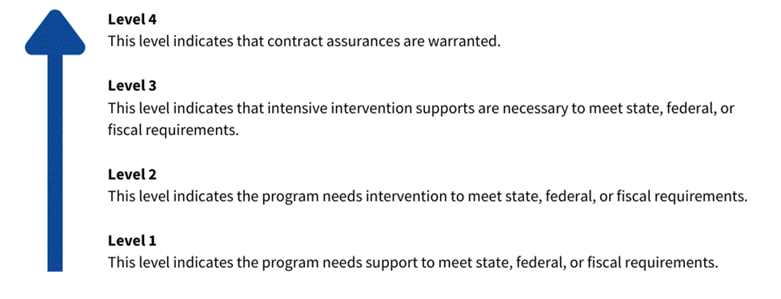

**Level 1:**

It is determined through established general supervision methods that the EIS or SSP program needs assistance and support meeting a state, federal, or fiscal requirement.

The Early Intervention (EI) Division determines a contracted program **needs assistance for two consecutive years on their local determinations**:

* Progress monitoring or review of data
* TA/Training and supervision from COSS
* Correction of child-specific noncompliance
* Submit documentation that correction occurred
* Quality Improvement Plan

**Level 2:**

It is determined through established general supervision methods that the EI program needs intervention to meet state, federal, or fiscal requirements. **Level 2 includes programs that have a determination of Needs Intervention for three consecutive years on their local determinations or have not corrected identified noncompliance within the 1-year timeframe**.

Early Intervention (EI) Division determines that a program needs intervention, the lead agency shall take one or more of the following actions:

* Formal written Corrective Action Plan (CAP)
* Correction of child-specific non-compliance
* Documentation that child-specific non-compliance correction occurred

A CAP will be developed that records the actions to be taken by the program, including root cause analysis, strategies for improvement, who is responsible, monitoring, progress, target completion date, and actual completion date, as well as any assistance to be provided by the EI Division. The program and the EI Division will follow the agreed-upon action steps and monitor progress.

**Level 3:**

It is determined through established general supervision methods that the EI program needs substantial intervention to meet state, federal, or fiscal requirements. **A Determination by the EI Division of needs substantial intervention on local determinations**, has long standing noncompliance (not corrected within 2 years) or that there is a substantial failure to comply with any requirement under part C of the Act; The EI Division takes one or more of the following actions:

* Withhold, in whole or in part, any further payments to the program under part C of the Act
* Withhold referrals to the program
* Seek to recover funds due to failure to meet the contract requirements
* Initiate the process to cancel or not renew the contract
* Schedule a focused monitoring visit
* Impose additional contract requirements
* Amend, shorten, or terminate the term of the contract

**Level 4:**

The EI Division reserves the right to use any appropriate enforcement actions to correct persistent deficiencies related to compliance with the IDEA or 17a-248 C.G.S., et seq. Persistent deficiencies are defined as substantial noncompliance issues that the EI Division identifies through established general supervision methods, cyclical monitoring, or other corrective action activities. These deficiencies have been identified and noticed in writing to the EIS or SSP program for at least one year without significant improvement, as determined by the EI Division.

Enforcement actions by the EI Division under this section may include:

* Denying or recouping payment for services for which noncompliance is documented
* Halting all new referrals until the program substantially remediates the deficiency
* Amending the contract to reduce its length by revising the ending date
* Termination or non-renewal of the contract in accordance with Part I of this contract

After written notification by the EI Division of impending enforcement action, the EIS or SSP program will have the opportunity to meet with the EI Division staff to review the available data, explain what will be necessary to achieve compliance, and check the evidence of change that will be necessary to demonstrate sufficient improvement to reverse the enforcement action, if appropriate.