INDOOR AIR QUALITY ASSESSMENT

Sandisfield Town Offices
66 Sandisfield Road
Sandisfield, MA

Prepared by:
Massachusetts Department of Public Health
Bureau of Environmental Health
Indoor Air Quality Program
January 2018

Background
Building: | Sandisfield Town Offices (STO)
Address: | 66 Sandisfield Road
Reason for Request: | Occupants reported sulfur odor and metallic taste
Date of Assessment: | January 12, 2018
Massachusetts Department of Public Health/Bureau of Environmental Health (MDPH/BEH) Staff Conducting Assessment: | Michael Feeney, Director, Indoor Air Quality (IAQ) Program
Building Description: | Originally constructed as a one-story school with a finished basement. The building currently serves both the STO and Senior Center.
Building Population: | Approximately 5 employees
Year of Construction: | 1949
Windows: | Openable

Methods
Please refer to the IAQ Manual for methods, sampling procedures, and interpretation of results (MDPH, 2015).

IAQ Testing Results
The following is a summary of indoor air testing results (Table 1).
- Carbon dioxide levels were below 800 parts per million (ppm) in all occupied areas assessed, indicating adequate fresh air in the space.
- Temperature was within or below the recommended range of 70°F to 78°F in occupied areas assessed and slightly above in the furnace room.
- Relative humidity was near or within the recommended range of 40% to 60% in all occupied areas assessed.
- Carbon monoxide levels were non-detectable in all occupied areas assessed. Up to 2 ppm was detected in the furnace room.
- Fine particulate matter (PM2.5) concentrations measured were below the National Ambient Air Quality Standard (NAAQS) level of 35 μg/m³ in all occupied areas assessed. Levels in the furnace room ranged above that level.

Ventilation
A heating, ventilating, and air conditioning (HVAC) system has several functions. First it provides heating and, if equipped, cooling. Second, it is a source of fresh air. Finally, an HVAC system will dilute and remove normally-occurring indoor environmental pollutants by not only introducing fresh air, but by filtering the airstream and ejecting stale air to the outdoors via exhaust ventilation. Even if an HVAC system is operating as designed, point sources of respiratory irritation may exist and cause symptoms in sensitive individuals. The following analysis examines and identifies components of the HVAC system and likely sources of respiratory irritant/allergen exposure due to water damage, aerosolized dust, and/or chemicals found in the indoor environment.
The assessment results indicate that the ventilation system is providing adequate fresh air for the occupancy in the building. Note that many areas had low occupancy, which can reduce the creation of carbon dioxide. To maximize air exchange, the BEH recommends that mechanical ventilation systems operate continuously during periods of occupancy. Without the system operating as designed, normally occurring pollutants cannot be diluted or removed, allowing them to build up and lead to IAQ/comfort complaints.
The HVAC system has no mechanical means to provide fresh air. Rooms are equipped with a fan coil unit (FCU) (Picture 1) that provides heat only. It appears that the original ventilation system in the building was removed when the building became town offices. Fresh air intake vents on the outside wall of the building were found sealed (Picture 2). Exhaust vents were also sealed. The sole mean to provide fresh air or to exhaust air is by opening windows.

Assessment of Odors

STO staff reported symptoms that they attribute to exposure to a sulfur odor; they also reported a metallic taste sensation. The STO has had no renovation activity before or during the timeframe of these reported odors/symptoms. IAQ staff assessed the furnace room, Senior Center and the Treasurer’s Office in which people reported these odors and symptoms. The following conditions were noted which can provide a pathway for furnace products of combustion to impact the Treasurer’s Office.
- The heating pipes supplying the Treasurer’s Office FCU have a space which opens into the floor space between the Senior Center and the Treasurer’s Office (Picture 3).
- The same heating pipes have a space that is open between the Senior Center above the kitchen cabinets to the furnace room (Picture 4).
- The flue connecting the furnace to the chimney has a hole (Picture 5).
- The air intake for the furnace power vent was clogged with debris, including leaves, which would prevent combustion air from getting to the furnace (Picture 6).
- A barometric pressure vent exists on the duct supplying the furnace power vent (Picture 7). If the combustion air intake is blocked, this vent would allow for combustion air to be drawn from the furnace room. This is an unusual configuration because without the barometric pressure vent on the flue between the furnace and the chimney this particular vent can allow for backdrafting of products of combustion into the building.
This furnace combusts oil as a fuel. The process of combustion produces airborne liquids, solids and gases, including carbon monoxide (CO) and carbon dioxide (NFPA, 1997). Of these materials, CO and smoke can produce immediate, acute health effects upon exposure. CO is a by-product of incomplete combustion of organic matter (e.g., gasoline, wood and tobacco).
IAQ staff examined the furnace and conducted air sampling for PM2.5, carbon monoxide and carbon dioxide in the furnace room. The air sampling results for the furnace room, as shown in Table 1:
- CO measurement of 2 ppm
- Carbon dioxide measurement of 1572 ppm
- A PM 2.5 range of 10 to 337 µg/m³
These measurements indicate that when the furnace is activated, products of combustion are venting into the furnace room/basement, rather than out of the building via the chimney. Due to the holes around the heating pipes it is possible that products of combustion from the furnace are drawn into the treasurer’s office from the ceiling of the Senior Center via the holes for the heating pipes that were noted in Pictures 3 and 4.
In addition to CO and carbon dioxide, various other pollutants can be produced from fuel oil which include hydrogen sulfide, residual metals, water vapor and particulate (e.g., smoke). These products of combustion can be irritating to the eyes, nose throat and respiratory system. In addition the sulfur odor as well as metallic taste can be attributed to exposure to these products of combustion from the furnace.
It is important to note that while CO levels were below the level of concern during this assessment, the elevated carbon dioxide levels in the furnace room when compared to occupies space indicate the furnace room is not well-ventilated.

Conclusions/Recommendations
Based on the observations made during this assessment, the BEH makes the following recommendations:
- Consult with the Fire Safety Office of the Sandisfield Fire Department.
- Ensure that an adequate supply of combustion air exists for the boiler and other fuel-fired equipment.
- Ensure that the chimney is not blocked.
- Seal the hole in the furnace flue.
- Consult with a furnace company to identify the reason why the combustion air vent is equipped with the barometric pressure vent. If not required, remove the barometric pressure vent.
- Ensure that the power vent fresh air intake is not blocked the debris. If possible, reconfigure the combustion air intake to prevent blockage by leaves and other debris.
- Examine and repair the furnace casing to prevent furnace exhaust leakage.
- Seal the spaces between heat vent pipes in Pictures 3 and 4 with a fire rated sealant. Seal both sides of these and any other pipe penetration in floors, ceilings and walls throughout STO.
- Obtain a digital readout carbon monoxide detector for the hallway immediately outside the furnace room and also for the first floor of the building.
- Use openable windows during temperate weather to allow fresh air into the building. Ensure windows are closed tightly at the end of the day.
- Refer to resource manual and other related IAQ documents located on the MDPH’s website for further building-wide evaluations and advice on maintaining public buildings. These documents are available at: http://mass.gov/dph/iaq.

References
MDPH. 2015. Massachusetts Department of Public Health. Indoor Air Quality Manual: Chapters I-III. Available at: http://www.mass.gov/eohhs/gov/departments/dph/programs/environmental-health/exposure-topics/iaq/iaq-manual/.
NFPA. 1997. Fire Protection Handbook. 18th ed. Cote, A.E., ed. National Fire Protection Association, Quincy, MA.
Picture 1
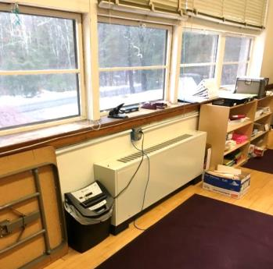
Fan Coil Unit (FCU)
Picture 2
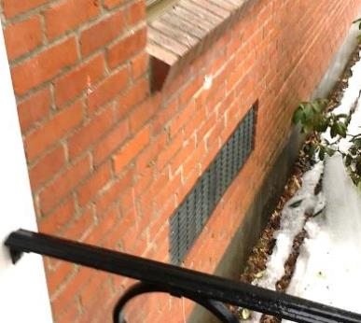
Sealed former fresh air intake
Picture 3
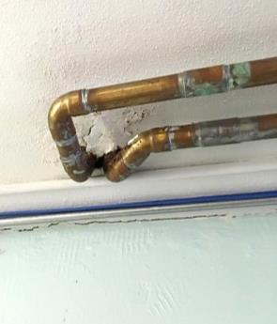
Heating pipes supplying the Treasurer’s Office FCU; note space between pipes
Picture 4
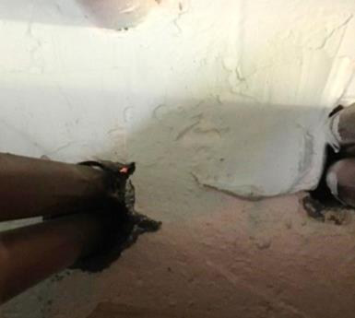
Gaps between heating pipes penetrating wall between the senior center and the furnace room

Picture 5

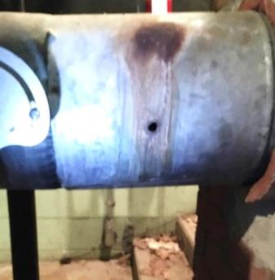

Hole in furnace flue

Picture 6

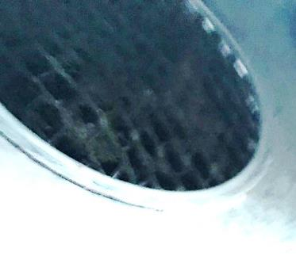

Furnace power vent air intake clogged with debris

Picture 7

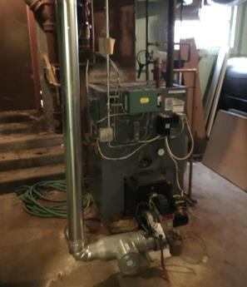

Barometric pressure vent on power vent duct
Location | Carbon  Dioxide  (ppm) | Carbon Monoxide  (ppm) | Temp  (°F) | Relative  Humidity  (%) | PM2.5  (µg/m³) | Occupants  in Room | Windows  Openable | Ventilation |  | Remarks
 |  |  |  |  |  |  |  | Supply | Exhaust
Background (outdoors) | 368 | ND | 59 | 67 | ND
Town Selectman | 511 | ND | 64 | 50 | ND | 1 | Y | N | N
Treasurer | 573 | ND | 66 | 41 | ND | 1 | Y | N | N
Mainframe | 538 | ND | 68 | 43 | ND | 0 | Y | N | N
Office | 563 | ND | 71 | 43 | ND | 1 | Y | N | N
Men’s restroom | 549 | ND | 70 | 41 | 1 | 0 | Y | N | N
Women’s restroom | 552 | ND | 72 | 39 | ND | 0 | Y | N | N
Senior center | 508 | ND | 68 | 38 | 1 | 0 | Y | N | N
Furnace room | 1572 | 2 | 80 | 26 | 10-337 | 0 | N | N | N

