INDOOR AIR QUALITY ASSESSMENT

Sandwich Middle High School
365 Quaker Meeting House Road
East Sandwich, MA

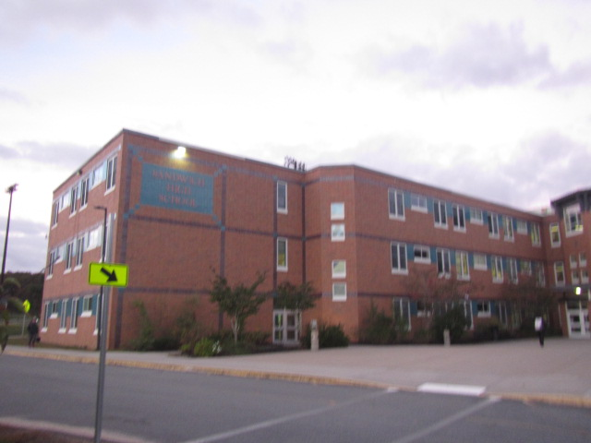

Prepared by:
Massachusetts Department of Public Health
Bureau of Climate and Environmental Health
Indoor Air Quality Program
November 2023

BACKGROUND
Building: | Sandwich Middle High School (SMHS)
Address: | 365 Quaker Meeting House Road, East Sandwich, MA
Assessment Requested by: | Chris George, Facilities Director, Sandwich Public Schools (SPS)
Reason for Request: | Collaborative effort to perform general indoor air quality (IAQ) assessments throughout the SPS District. A previous report that focused on room D-266 was issued on November 13, 2023.
Date of Assessment: | October 24, 2023
Massachusetts Department of Public Health/Bureau of Environmental Health (MDPH/BCEH) Staff Conducting Assessment: | Cory Holmes, Assistant Director, IAQ Program
Date of Building Construction: | Originally constructed in 1976 with an addition completed in 2001 to include the middle school.
Building Description: | The SMHS is three-story brick building housing grades 7-12. Building materials consist of carpeting (both wall-to-wall and carpet squares), floor tile, with gypsum wallboard walls, and suspended ceiling tiles throughout most of the school.
Windows: | Windows are openable throughout the building.

METHODS
Please refer to the IAQ Manual and appendices for methods, sampling procedures, and interpretation of results (MDPH, 2015).

RESULTS and DISCUSSION
The following is a summary of indoor air testing results (Table 1).
- Carbon dioxide levels were above the MDPH recommended level of 800 parts per million (ppm) in 8 of 122 areas surveyed, indicating some areas could use an increase in air exchange at the time of assessment. It is also important to note that several classrooms with carbon dioxide levels below 800 ppm were unoccupied or sparsely populated, which can greatly reduce carbon dioxide levels.
- Temperature was within the MDPH recommended range of 70°F to 78°F in occupied areas. However, chronic heat/temperature control complaints were expressed in several areas, notably the Nurses’ suite (B-119).
- Relative humidity was within the MDPH recommended range of 40 to 60% in all areas tested the day of assessment.
- Carbon monoxide levels were non-detectable (ND) in all areas tested.
- Particulate matter (PM2.5) concentrations measured were below the National Ambient Air Quality (NAAQS) level of 35 μg/m³ in all areas tested.

Ventilation
A heating, ventilating, and air conditioning (HVAC) system has several functions. First it provides heating and, if equipped, cooling. Second, it is a source of fresh air. Finally, an HVAC system will dilute and remove normally occurring indoor environmental pollutants by not only introducing fresh air, but by filtering the airstream and ejecting stale air to the outdoors via exhaust ventilation. Even if an HVAC system is operating as designed, point sources of respiratory irritation may exist and cause symptoms in sensitive individuals.
Fresh air is supplied by 11 rooftop air handling units (AHUs, Picture 1). The building uses ducted supply vents (Picture 2) where air is directed back to the AHUs via ceiling-mounted return vents (Picture 3). Some areas are equipped with supplemental exhaust vents installed in the suspended ceiling with additional filtration (Picture 4). It should be noted that the MDPH recommends pleated filters with a Minimum Efficiency Reporting Value (MERV) of 8 or higher, which are adequate in filtering out pollen and mold spores (ASHRAE, 2012). Filters should also be changed two to four times a year, or per the manufacturer’s recommendations. The additional filters, which are MERV 7 (ETF, 2004), work in conjunction with the rooftop filters (Picture 5) that are MERV 14 (Camfil, 2023), far exceeding the MERV 8 recommendation.
To maximize air exchange, the IAQ program recommends that both supply and exhaust ventilation operate continuously during periods of occupancy. In order to have proper ventilation with a mechanical ventilation system, the systems must be balanced after installation to provide an adequate amount of fresh air to the interior of a room while removing stale air from the room. It is recommended that HVAC systems be re-balanced every five years to ensure adequate air systems function (SMACNA, 1994).
Also noted in many classrooms were fan coil units (FCUs) that facilitate airflow and temperature control (Picture 6). FCUs do not provide fresh air to rooms; rather, FCUs re-circulate air and provide auxiliary heating and cooling. Conditioned air is filtered and provided to the classroom by a diffuser atop the unit. Air is then drawn into a return vent at the base of the unit.
It is also important to note that the majority of HVAC system components are original to the building’s construction, which are over 22-48 years old at the date of this report. According to the American Society of Heating, Refrigeration, and Air-Conditioning Engineering (ASHRAE), the service life of this type of unit is 15-20 years, assuming routine maintenance of the equipment (ASHRAE, 1991). However, it was reported by Mr. George that 3 of the 11 AHUs were on a capital repair list for replacement, which will also include an automated management system.
Chemistry/science rooms are equipped with laboratory hoods to conduct experiments and art rooms contain kilns that have local exhausts. This specialty equipment is important to remove airborne pollutants generated by their specific activities. Preventative maintenance programs should be in place to conduct regular checks to ensure proper function.

Microbial/Moisture Concerns
Water-damaged ceiling tiles were observed in a number of areas of the building (Table 1) which indicate current and/or historic leaks from the building envelope or plumbing system. Ceiling tiles are considered a porous material which, if exposed to chronic moisture, may become a source for mold growth. These tiles should be discarded and replaced. Some tiles exhibited dark stains, which are likely mold growth (Table 1, Pictures 7 and 8), these tiles should be replaced first.
Plants were present in some classrooms and other areas (Table 1). Plants should be well maintained, not overwatered, and not placed on porous materials or in the airstream of ventilation equipment. A few aquariums and terrariums were observed in classrooms (Table 1). These items should also be kept in good condition to prevent mold, scale, and associated odors.

Other Conditions
Other conditions that can affect IAQ were observed during the assessment. In some areas, supply diffusers (and surrounding ceiling tiles), exhaust vents, and personal fans accumulated dust/debris (Table 1, Pictures 2 and 3). This dust can be reaerosolized under certain conditions and can also be a medium for mold growth.
The woodshop contains equipment such as table saws and drills. The majority of this equipment appeared to be connected to a centralized wood dust collection system which removes dust from the source and contains it for later disposal. Dust collection systems need to be operated every time cutting/drilling occurs, and the collection vessel needs to be emptied regularly. Wood dust can be irritating to the skin, eyes, and respiratory tract, and collected wood dust or shavings can become mold colonized if moistened, or pest food/harborage if left unattended for long periods of time.
Several areas had carpeting (Table 1). Carpeting should be vacuumed regularly with a high efficiency particulate arrestance (HEPA) filter equipped vacuum cleaner to avoid particulates from causing further irritation or serving as a reservoir for microbial colonization. Also, carpeting and rugs should be cleaned at least once per year according to IICRC recommendations (IICRC, 2012). However, it should be noted that the usable life of carpeting in schools is approximately 10-11 years (IICRC, 2002). Aging carpet can produce fibers that can be irritating to the respiratory system. Area carpets too worn to be effectively cleaned should be replaced. Area rugs should be rolled up and stored in a clean, dry place when rooms are not occupied during the summer months to prevent moistening due to condensation.
In several classrooms, large numbers of items were on floors, windowsills, tabletops, counters, bookcases, and desks, which provide a source for dusts to accumulate. These items (e.g., papers, folders, boxes) make it difficult for custodial staff to clean. Items should be relocated and/or be cleaned periodically to avoid excessive dust build up. In addition, dust and debris can accumulate on flat surfaces (e.g., desktops, shelving, and carpets) in occupied areas and subsequently be re-aerosolized causing further irritation.
Exposure to low levels of total volatile organic compounds (TVOCs) may produce eye, nose, throat, and/or respiratory irritation in some sensitive individuals. BCEH/IAQ staff examined rooms for products containing VOCs. BCEH/IAQ staff noted hand sanitizers, plug-in air fresheners (Picture 9), and dry erase materials in use within the building. All of these products have the potential to be irritants to the eyes, nose, throat, and respiratory system of sensitive individuals.
Several kinds of equipment that may produce odors and other pollutants were observed including laminators and photocopiers in teacher workrooms, and 3-D printers in a few areas (Table 1). This equipment can be a source of odors, particulates, and VOCs, particularly if older or heavily used. They should be used away from occupants and with good ventilation, preferably a direct exhaust vent.
Many classrooms contained high efficiency particulate arrestance (HEPA)-filtered air purifiers (Picture 10). HEPA units remove up to 99% of airborne contaminants as small as 0.1 microns. According to the manufacture, the specific units in use at SMHS utilize a 4-stage filtration system that removes viruses, bacteria, dust, dander, mold spores, pollen, and other allergens. An activated carbon filter removes chemicals, gases, and odors (Austin, 2022). It is important to note that filters should be cleaned/changed, and these units be maintained in accordance with the manufacturers’ recommendations, these units should also be free of obstructions to operate as designed.
In a few classrooms, tennis balls were found sliced open and placed on chair legs to reduce noise (Table 1). Tennis balls are made of materials that may be a source of respiratory irritants. Constant wearing of tennis balls can produce fibers and off-gas VOCs. Tennis balls are made with a natural rubber latex bladder, which becomes abraded when used as a chair leg pad. Use of tennis balls in this manner may introduce latex dust into the school environment. Some individuals are highly allergic to latex (e.g., spina bifida patients) (SBAA, 2001). It is recommended that the use of materials containing latex be limited to reduce the potential for symptoms in sensitive individuals (NIOSH, 1997). Latex-free glides should be used for this purpose.
Note that the Environmental Protection Agency (EPA) conducted a National School Radon Survey in which it discovered nearly one in five schools had “…at least one frequently occupied ground contact room with short-term radon levels above 4 [picocuries per liter] pCi/L” (US EPA, 1993). The BCEH/IAQ Program therefore recommends that every school be tested for radon, and that this testing be conducted during the heating season while school is in session in a manner consistent with USEPA radon testing guidelines. Radon measurement specialists and other information can be found at www.nrsb.org and http://aarst-nrpp.com/wp, with additional information at: http://www.mass.gov/eohhs/gov/departments/dph/programs/environmental-health/exposure-topics/iaq/radon.

CONCLUSIONS/RECOMMENDATIONS
In view of the findings at the time of the visit, the following recommendations are made:

Ventilation Recommendations
- Make necessary adjustments to HVAC controls/air intakes to allow an increase in fresh air to rooms with elevated carbon dioxide levels (Table 1).
- Operate all supply and exhaust ventilation equipment continuously during occupied hours.
- Ensure all univents, supply and exhaust/return vents are free of obstructions to facilitate airflow.
- Periodically check exhaust vents in classrooms and restrooms for draw and repair any non-operating motors/vents.
- Develop a preventative maintenance program for laboratory hoods, kiln exhaust hoods, and the woodshop dust removal machines.
- Close hallway doors during occupancy to allow for more effective air exchange within classrooms.
- Temperature/comfort complaints (e.g., chronic heat in nurse’s suite) should be made through proper channels and followed up by facilities staff using an electronic reporting system.
- Use openable windows to supplement fresh air during temperate weather. Ensure all windows are tightly closed at the end of the day or during periods of elevated relative humidity to avoid condensation/mold issues, or extreme cold and freezing of pipes.
- Continue to change filters for HVAC equipment 2-4 times a year, or as per the manufactures recommendations, using MERV 8 or the highest MERV rating the ventilation system can accommodate to improve air filtration as much as possible without significantly reducing airflow.
- Clean the interior of AHUs and FCUs during regular filter changes using a HEPA-filtered vacuum cleaner with brush attachment or compressed air.

Water Damage Recommendations
- Continue to ensure any roof and plumbing leaks are repaired promptly and replace any remaining water-damaged suspended ceiling tiles or other porous building materials.
- Ensure plants are well-maintained and not overwatered. Avoid placing plants on or in the airstream of univents.
- Clean and maintain aquariums and terrariums to prevent mold/algal growth and associated odors.
- Roll up area rugs and store in a clean, dry place when rooms are unoccupied during summer months to prevent moistening due to condensation.
- Consider using the methods described in the document “Preventing Mold Growth in Massachusetts Schools During Hot, Humid Weather” to help reduce impact of conditions during hot, humid weather. This guideline can be found online at: https://www.mass.gov/service-details/preventing-mold-growth-in-massachusetts-schools-during-hot-humid-weather

Other Recommendations
- Avoid bringing in scented products (e.g., air fresheners, candles). Use only school-provided cleaning materials to avoid potential product interactions.
- Use photocopiers and laminators away from occupants and in areas with exhaust ventilation and/or an open window.
- Use local/direct exhaust ventilation and dust collection systems for workshop equipment, ensure the dust collection system is regularly emptied, and good dust control cleaning methods are used.
- Use local exhaust vents for kilns whenever the equipment is in use and for a cooldown period afterwards, check periodically for proper function.
- Keep 3-D printers away from occupants when in use and use exhaust ventilation wherever possible to prevent exposure to VOCs and particulates.
- Avoid using latex-containing tennis balls as chair or table glides. Replace with latex-free glides or other materials.
- Change filters and maintain portable air purifiers/HEPA units in accordance with manufacturers’ recommendations.
- Ensure air purifiers are located away from walls and free of obstructions to operate as designed.
- Regularly clean supply/return/exhaust vents and fans to avoid aerosolizing accumulated particulate matter. To clean ceiling vents/grills, remove and wash, refinish/replace if necessary.
- If ceiling tiles around dusty vents cannot be cleaned, replace.
- Consider reducing the number of items stored in rooms to make cleaning easier. Periodically move items to clean flat surfaces. Store porous items on shelving and away from walls.
- For buildings in New England, periods of low relative humidity during the winter are often unavoidable. Therefore, scrupulous cleaning practices should be adopted to minimize common indoor air contaminants whose irritant effects can be enhanced when the relative humidity is low. To control dusts, a high efficiency particulate arrestance (HEPA) filter equipped vacuum cleaner in conjunction with wet wiping of all surfaces is recommended. Avoid the use of feather dusters. Drinking water during the day can help ease some symptoms associated with a dry environment (throat and sinus irritations).
- Clean carpeting annually or semi-annually in soiled high traffic areas as per the recommendations of the Institute of Inspection, Cleaning and Restoration Certification (IICRC, 2012).
- The school should be tested for radon by a certified radon measurement specialist during the heating season when school is in session. Radon measurement specialists and other information can be found at: www.nrsb.org, and http://aarst-nrpp.com/wp.
- To learn more about radon, review the MDPH’s Radon in Schools and Child Care Programs factsheet, with additional information at: http://www.mass.gov/eohhs/gov/departments/dph/programs/environmental-health/exposure-topics/iaq/radon.
- Consider including an IAQ component in the school’s Wellness Advisory Committee program. An IAQ plan should have an IAQ liaison/teacher representative, a member of maintenance/facilities and administration that conduct regular walk-throughs to identify on-going and/or potential environmental issues.
- Utilize the US EPA’s (2000), “Tools for Schools”, as an instrument for maintaining a good IAQ environment in the building available at: https://www.epa.gov/iaq-schools.
- For guidance on maintaining an asthma-friendly healthy school environment, please consult the MDPH Asthma Prevention and Control Program’s Clearing the Air: An Asthma Toolkit for Healthy Schools.
- Refer to resource manual and other related IAQ documents located on the MDPH’s website for further building-wide evaluations and advice on maintaining public buildings. These documents are available at: http://mass.gov/dph/iaq.

Long Term Recommendations
- Replace HVAC components past their service life (AHUs, FCUs, exhaust vents, and controls). As previously discussed, the age (> 22-48 years old), software limitations, availability of parts for mechanical ventilation system components, and controls should be fully evaluated by an HVAC engineering firm to determine the operational lifespan of existing equipment and the feasibility of repair vs. replacement.
- Install sensor technology in classrooms to measure the following indoor air parameters. Sensors should be re-calibrated quarterly or according to manufacturer’s specifications and building management software updated as per manufactures instructions, industrial standards, and/or change in operating systems.
  - Carbon dioxide
  - Temperature
  - Relative Humidity
  - Carbon monoxide, and
  - Particulate matter (PM2.5).
- Replace carpeting that is beyond its service life (i.e., > 11 yrs.).

REFERENCES
ASHRAE. 1991. ASHRAE Applications Handbook, Chapter 33 “Owning and Operating Costs”. American Society of Heating, Refrigeration and Air Conditioning Engineers, Atlanta, GA.
ASHRAE. 2012. American Society of Heating, Refrigeration and Air Conditioning Engineers (ASHRAE) Standard 52.2-2012 -- Method of Testing General Ventilation Air-Cleaning Devices for Removal Efficiency by Particle Size (ANSI Approved).
Austin. 2022. Austin Air HealthMate®. Copyright© 2022. AustinAir. HealthMate - Welcome to Austin Air Systems. Clinically Proven Air Purifiers.
Camfil. 2023. Durafil® ES³. High Efficiency, High Capacity, Energy Saving, Mini-Pleated V-Bank Air Filter https://www.camfil.com/product/documents/dam/53357/Product-Documentation-Durafil-ES.pdf
ETF. 2004. Environmental Technology Verification Test Report of Control of Bioaerosols in HVAC Systems, Airflow Products AFP30. https://cfpub.epa.gov/si/si_public_file_download.cfm?p_download_id=504180
IICRC. 2002. Institute of Inspection, Cleaning and Restoration Certification. A Life-Cycle Cost Analysis for Floor Coverings in School Facilities.
IICRC. 2012. Institute of Inspection Cleaning and Restoration Certification. Institute of Inspection, Cleaning and Restoration Certification. Carpet Cleaning: FAQ.
MDPH. 2015. Massachusetts Department of Public Health. Indoor Air Quality Manual: Chapters I-III. Available at: Indoor air quality – manual and appendices | Mass.gov
NIOSH. 1997. NIOSH Alert Preventing Allergic Reactions to Natural Rubber latex in the Workplace. National Institute for Occupational Safety and Health, Atlanta, GA.
NIOSH. 2023. Approaches to safe 3D printing: a guide for makerspace users, schools, libraries, and small businesses. DHHS (NIOSH) PUBLICATION NUMBER 2024-103 (NOVEMBER 2023). https://www.cdc.gov/niosh/docs/2024-103/default.html
SBAA. 2001. Latex In the Home And Community Updated Spring 2001. Spina Bifida Association of America, Washington, DC.
SMACNA. 1994. HVAC Systems Commissioning Manual. 1st ed. Sheet Metal and Air Conditioning Contractors’ National Association, Inc., Chantilly, VA.
US EPA. 1993. Radon Measurement in Schools, Revised Edition. Office of Air and Radiation, Office of Radiation and Indoor Air, Indoor Environments Division (6609J). EPA 402-R-92-014.
US EPA. 2000. Tools for Schools. Office of Air and Radiation, Office of Radiation and Indoor Air, Indoor Environments Division (6609J). EPA 402-K-95-001, Second Edition. https://www.epa.gov/iaq-schools.
Picture 1
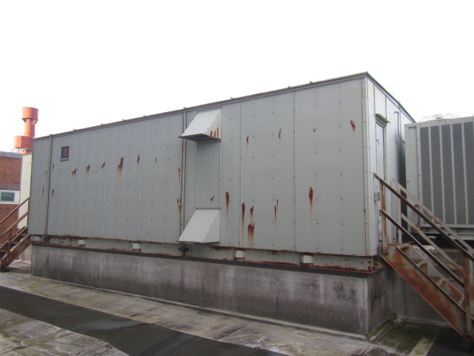
Rooftop air handling unit

Picture 2
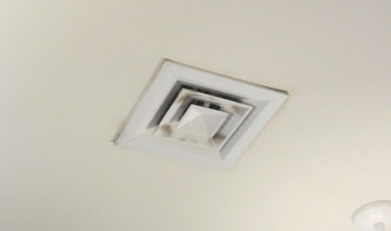
Supply vent, note dust/debris accumulation on louvers

Picture 3
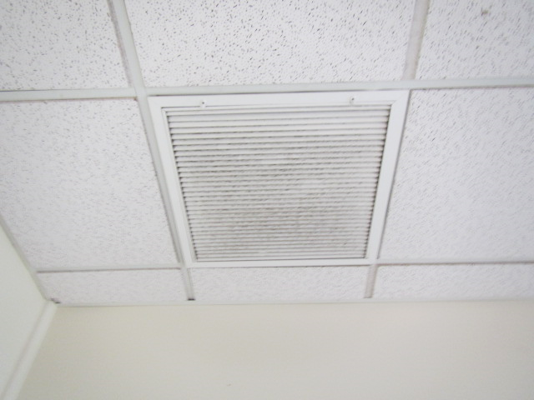
Ceiling-mounted return, vent note dust/debris accumulation

Picture 4
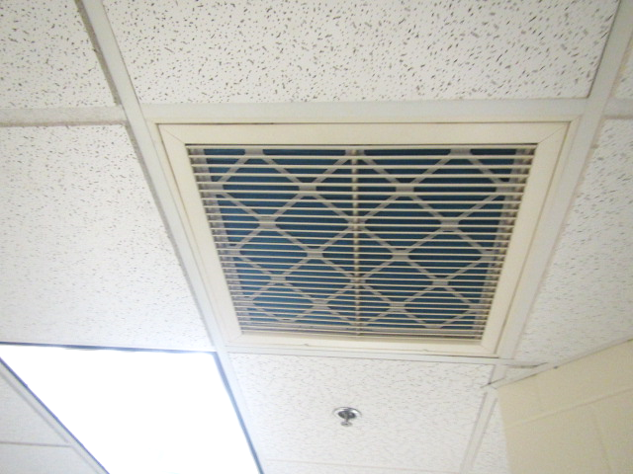
Supplemental exhaust vents with filters installed
Picture 5
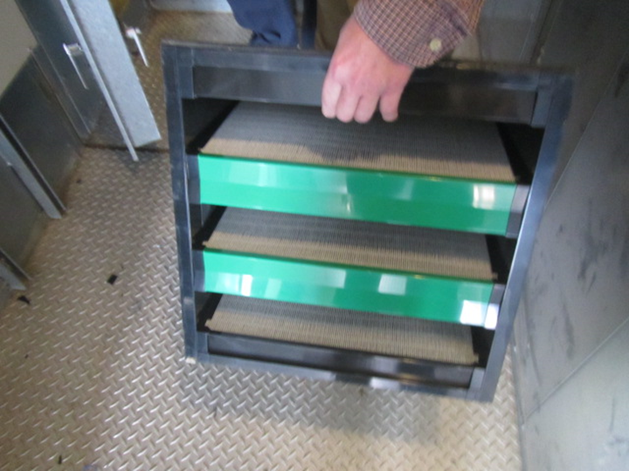
MERV 14 box filters installed in rooftop AHU

Picture 6
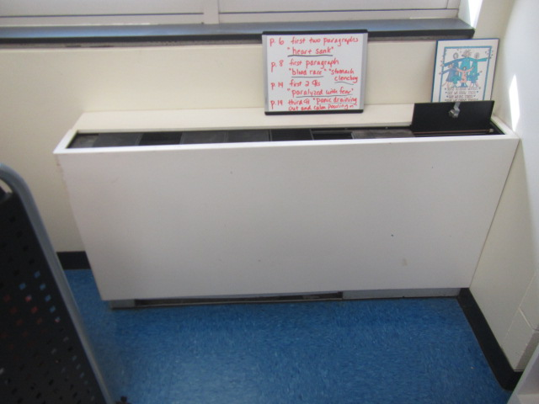
Fan coil unit in classroom
Picture 7
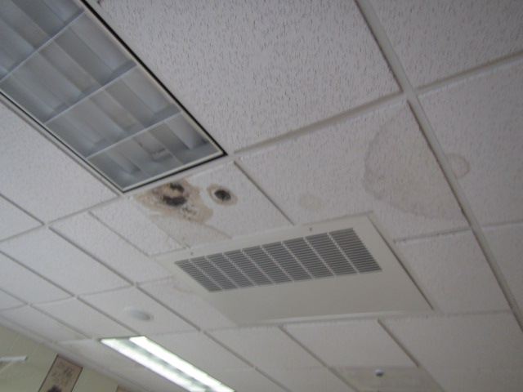
Dark staining on ceiling tiles likely indicating mold growth

Picture 8
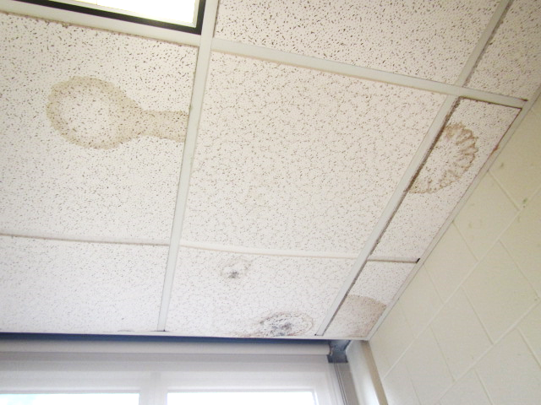
Dark staining on ceiling tiles likely indicating mold growth (arrows)
Picture 9
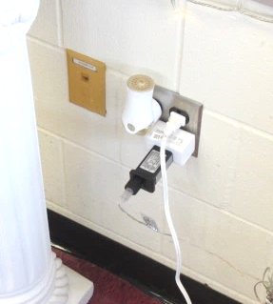
Plug-in air freshener in classroom

Picture 10
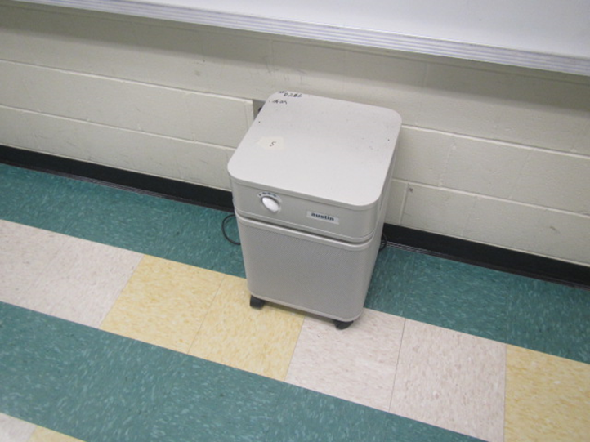
Air purifier in classroom

Location | Carbon  Dioxide  (ppm) | Carbon Monoxide  (ppm) | Temp  (°F) | Relative  Humidity  (%) | PM2.5  (µg/m³) | Occupants  in Room | Windows  Openable | Ventilation |  |  | Remarks
 |  |  |  |  |  |  |  | Intake | Exhaust
Background | 476 | ND | 74 | 54 | 10 |  |  |  |  |  | Cool and cloudy  TVOCs = ND
Main Office | 636 | ND | 75 | 49 | 1 | 1 | N | Y |  | Y | Dust/debris on vents
Admin | 577 | ND | 76 | 48 | 1 | 0 | N | Y |  | Y | Wall to wall carpet
A 102 | 673 | ND | 75 | 51 | 1 | 26 | Y  Open | Y |  | Y
A 103 | 623 | ND | 76 | 48 | 1 | 19 | Y  Open | Y |  | Y | Kiln – vented
A 104 | 841 | ND | 77 | 50 | 1 | 14 | Y | Y |  | Y
A 105 | 494 | ND | 75 | 48 | 1 | 4 | Y  Open | Y |  | Y | WD CT, wall to wall carpet
A 106 | 501 | ND | 75 | 49 | 1 | 0 | Y  Open | Y |  | Y | Wall to wall carpet
A 107 | 616 | ND | 75 | 49 | 1 | 1 | Y | Y |  | Y | Copier, wall to wall carpet
A 108 | 567 | ND | 74 | 50 | 1 | 6 | Y  Open | Y |  | Y
A 110 | 1103 | ND | 76 | 53 | 1 | 20 | Y  Open | Y |  | Y
A 112 | 697 | ND | 75 | 49 | 1 | 0 | Y | Y |  | Y | DO
A 114 | 505 | ND | 75 | 48 | 1 | 0 | N | Y |  | Y | Dust/debris on vents, wall to wall carpet
A 114 Nurse | 576 | ND | 77 | 47 | 1 | 0 | Y | Y |  | Y
A 202 | 748 | ND | 76 | 49 | 1 | 19 | Y  Open | Y |  | Y | TB, PF
A 203 | 779 | ND | 77 | 48 | 1 | 15 | Y | Y |  | Y | Plants
A 204 | 545 | ND | 74 | 50 | 1 | 1 | Y  Open | Y |  | y
A 205 | 780 | ND | 75 | 52 | 1 | 19 | Y  Open | Y |  | Y | DO
A 206 | 790 | ND | 75 | 51 | 1 | 21 | Y  Open | Y |  | Y | DO, plug in AF
A 207 | 620 | ND | 74 | 50 | 1 | 1 | Y  Open | Y |  | Y
A 208 | 690 | ND | 74 | 51 | 1 | 16 | Y  Open | Y |  | Y | TB
A 210 | 604 | ND | 74 | 50 | 1 | 1 | Y  Open | Y |  | Y | Occupants gone ! 20 mins
A 211 | 601 | ND | 73 | 52 | 1 | 7 | Y  Open | Y |  | Y | TB, plant
A 212 | 511 | ND | 73 | 51 | 1 | 0 | Y | Y |  | Y
A 213 | 511 | ND | 75 | 49 | 1 | 1 | N | Y |  | Y | PF, AP, DO, wall to wall carpet
A 215 | 594 | ND | 74 | 51 | 1 | 0 | N | Y |  | Y | Copier, wall to wall carpet
A 261 | 841 | ND | 75 | 51 | 1 | 19 | Y | Y |  | Y | Aquarium, 1 ajar CT, dust/debris on vents and surrounding CTs, 4 WD CTs
A 300 | 488 | ND | 74 | 48 | 1 | 0 | N | Y |  | Y | Dust/debris on vents, 11 WD CTs, book storage
A 301 | 523 | ND | 72 | 50 | 1 | 1 | Y | Y |  | Y | TB, DO, WD CT
A 302 | 508 | ND | 71 | 51 | 1 | 1 | Y | Y |  | Y | TB
A 303 | 512 | ND | 73 | 50 | 1 | 1 | Y | Y |  | Y | FCU blocked, 15 occupants gone ~ 40 mins, cleaning products
A 304 | 533 | ND | 73 | 49 | 1 | 1 | N | Y |  | Y
A 305 | 560 | ND | 74 | 49 | 1 | 1 | Y | Y |  | Y | Items in front of FCU, class gone ~ 40 mins, AP, TB
A 306 | 532 | ND | 74 | 49 | 1 | 1 | Y  2 Open | Y |  | Y
A 307 | 765 | ND | 74 | 50 | 1 | 21 | Y | Y |  | Y | DO, TB
A 308 | 806 | ND | 74 | 51 | 1 | 19 | Y  Open | Y |  | Y | 8 WD CTs-leak reported repaired
A 309 | 530 | ND | 74 | 49 | 1 | 0 | Y | Y |  | Y | Wall to wall carpet
A 310 | 558 | ND | 74 | 50 | 1 | 5 | Y  Open | Y |  | Y | Dust/debris CTs, DO
A 311 | 505 | ND | 74 | 49 | 1 | 1 | Y | Y |  | Y | Dust/debris CTs, DO
A 312 | 546 | ND | 74 | 50 | 1 | 2 | Y | Y |  | Y | DO, WD CT
A 313 | 765 | ND | 71 | 51 | 1 | 5 | N | Y |  | Y | Wall to wall carpet
A 315 | 560 | ND | 74 | 49 | 1 | 1 | N | Y |  | Y | Wall to wall carpet, copier
B 119 Nurse | 662 | ND | 76 | 48 | 1 | 3 | N | Y |  | Y | Chronic heat issues reported
B 120 | 561 | ND | 76 | 47 | 1 | 0 | N | Y |  | Y | Wall to wall carpet
Guidance | 594 | ND | 72 | 46 | 1 | 0 | N | Y |  | Y | Wall to wall carpet, AP
B 133 | 579 | ND | 77 | 46 | 1 | 0 | N | Y |  | Y | DO, wall to wall carpet
B 136 | 614 | ND | 76 | 46 | 1 | 0 | N | Y |  | Y | AP, wall to wall carpet, WD CT
B 139 | 539 | ND | 77 | 46 | 1 | 0 | N | Y |  | Y | 7 WD CTs
Little Cafeteria | 528 | ND | 76 | 48 | 1 | 0 | Y | Y |  | Y
Big Cafeteria | 487 | ND | 77 | 46 | 1 | 0 | Y | Y |  | Y | 2 WD CTs
Faculty Lunchroom | 484 | ND | 76 | 48 | 1 | 0 | Y | Y |  | Y
B 220 | 590 | ND | 72 | 46 | 1 | 0 | N | Y |  | Y | DO, 6 WD CTs
B 222 | 617 | ND | 78 | 46 | 1 | 4 | N | Y |  | Y | DO, 6 WD CTs
B 223 | 610 | ND | 77 | 46 | 2 | 2 | N | Y |  | Y | Dust/debris on vents, AP, wall to wall carpet
B 223 TV Studio | 667 | ND | 78 | 45 | 1 | 2 | N | Y |  | Y | 6 WD CTs, DO, AP
C 224 | 632 | ND | 77 | 46 | 1 | 0 | N | Y |  | Y | 5 WD CTs, AP
Library | 571 | ND | 75 | 47 | 1 | 8 | Y | Y |  | Y | 2 WD CTs, wall to wall carpet, 3-D printers
Copy Room | 619 | ND | 75 | 48 | 1 | 0 | N | Y |  | Y | Laminator, 2 copiers, dust/debris on vents, 3 WD CTs
C 226 | 723 | ND | 76 | 46 | 1 | 21 | Y | Y |  | Y | 5 WD CT, PF, DO
C 227 | 640 | ND | 77 | 46 | 1 | 1 | Y | Y |  | Y | DO, 16 occupants just left, AP, 3 WD CTs
C 228 | 566 | ND | 73 | 49 | 1 | 12 | Y | Y |  | Y | Plug in AF (4) some not plugged in
C 229 | 652 | ND | 75 | 48 | 1 | 10 | Y | Y |  | Y | DO, PF
C 230 | 909 | ND | 75 | 50 | 1 | 9 | Y | Y |  | Y | DO, 5 WD CTs, dust/debris on vents
C 231 | 975 | ND | 75 | 51 | 1 | 14 | Y | Y |  | Y | DO
C 232 | 798 | ND | 75 | 48 | 1 | 14 | Y | Y |  | Y | Plants, 7 WD CTs (visible mold)
C 233 | 798 | ND | 75 | 48 | 1 | 14 | Y | Y |  | Y | 4 WD CTs
C 234 | 691 | ND | 73 | 50 | 1 | 5 | Y | Y |  | Y | 2 WD CTs, plug in AF
C 235 | 777 | ND | 74 | 50 | 1 | 12 | Y | Y |  | Y | DO, 10 WD CT (visible mold)
C 236 | 1060 | ND | 73 | 54 | 1 | 8 | Y | Y |  | Y | 6 WD CTs, DO
C 237 | 640 | ND | 72 | 50 | 1 | 0 | Y | Y |  | Y | 2 WD CT, dust/debris on vents and surrounding CTs
C 238 | 641 | ND | 77 | 47 | 1 | 27 | Y | Y |  | Y | Plug in AF, DO, WD CT
C 239 Work Room | 732 | ND | 74 | 50 | 1 | 0 | N | Y |  | Y | Dust/debris on vents, copier
C 240 | 740 | ND | 74 | 50 | 1 | 0 | N | Y |  | Y | Wall to wall carpet, area rug
C 243 | 560 | ND | 76 | 46 | 1 | 1 | Y | Y |  | Y | AP, PF, 3 WD CT, 12-14 occupants gone ~ 12 mins
C 320 | 637 | ND | 76 | 48 | 1 | 3 | N | Y |  | Y | Dust/debris CTs, AP
C 321 | 672 | ND | 76 | 48 | 1 | 14 | N | Y |  | Y | 2 WD CTs, dust/debris vents and surrounding CTs, DO
C 322 | 733 | ND | 75 | 49 | 1 | 17 | N | Y |  | Y
C 323 | 719 | ND | 78 | 44 | 1 | 15 | N | Y |  | Y | 2 WD CT, AP, dust/debris on vents and CTs
C 324 | 755 | ND | 78 | 47 | 1 | 21 | Y | Y |  | Y | 2 WD CTs, plants
C 325 | 735 | ND | 75 | 50 | 1 | 12 | Y | Y |  | Y | Dust/debris on vents and CTs
C 327 | 782 | ND | 74 | 52 | 1 | 25 | Y | Y |  | Y | DO
C 328 | 682 | ND | 74 | 50 | 1 | 19 | Y | Y |  | Y | DO, plants, AP (2)
C 329 | 490 | ND | 74 | 48 | 1 | 0 | Y | Y |  | Y | 14 WD CTs
C 330 | 572 | ND | 77 | 46 | 1 | 2 | Y | Y |  | Y | Dust/debris on vents, DO
C 331 | 600 | ND | 77 | 48 | 1 | 0 | N | Y |  | Y
C 332 | 662 | ND | 74 | 51 | 1 | 0 | N | Y |  | Y | Dust/debris on vents, copier
C 334 | 749 | ND | 75 | 50 | 1 | 22 | Y | Y |  | Y | 7 WD CTs
C 336 | 579 | ND | 75 | 49 | 1 | 9 | Y | Y |  | Y | WD CT, AP
Prep Room | 597 | ND | 74 | 50 | 1 | 0 | Y | Y |  | Y | WD CTs, PF
C 337 | 632 | ND | 78 | 46 | 1 | 1 | Y | Y |  | Y | Lab hood rusted exterior
D 140 | 603 | ND | 75 | 49 | 1 | 7 | Y | Y |  | Y
D 141 | 764 | ND | 74 | 53 | 1 | 14 | N | Y |  | Y | DO, 2 kilns - vented
D 142 | 760 | ND | 73 | 54 | 1 | 15 | N | Y |  | Y | DO, WD CT, AP
D 144 | 662 | ND | 77 | 50 | 1 | 16 | N | Y |  | Y
D 146 | 618 | ND | 77 | 47 | 1 | 4 | N | Y |  | Y | AP
D 148 | 740 | ND | 75 | 50 | 1 | 2 | N | Y |  | Y
D 149 Band | 828 | ND | 74 | 52 | 1 | 16 | N | Y |  | Y
Band Storage | 797 | ND | 74 | 52 | 1 | 0 | N | Y |  | Y | 12 + WD CTs
D 151 | 651 | ND | 74 | 51 | 1 | 25 | N | Y |  | Y | AP, WD CT
D 152 | 510 | ND | 73 | 50 | 1 | 0 | N | Y |  | Y | AP
D 154 | 548 | ND | 75 | 49 | 1 | 6 | N | Y |  | Y | DO, AP
D 155 | 556 | ND | 75 | 49 | 1 | 5 | N | Y |  | Y | AP
D 247 | 570 | ND | 74 | 49 | 1 | 1 | Y | Y |  | Y | AF, hand sanitizer, 26 WD CTs
D 248 | 615 | ND | 74 | 49 | 1 | 0 | N | Y |  | Y | 3 WD CTs
D 249 | 634 | ND | 73 | 51 | 1 | 1 | Y | Y |  | Y | AP, plug in AF
D 250 | 733 | ND | 73 | 51 | 1 | 0 | Y | Y |  | Y | 2 WD CTs
D 251 | 605 | ND | 73 | 49 | 1 | 4 | Y | Y |  | Y | Occupants at lunch
D 252 | 656 | ND | 74 | 50 | 1 | 1 | Y | Y |  | Y | DO, occupants at lunch, 4 WD CTs
D 253 | 623 | ND | 74 | 50 | 1 | 1 | Y | Y |  | Y | 7 WD CTs, occupants at lunch
D 254 | 533 | ND | 74 | 48 | 1 | 0 | Y | Y |  | Y | Many WD CTs, former roof leak
D 255 | 632 | ND | 76 | 48 | 1 | 1 | Y | Y |  | Y | 15 + WD CTs
D 256 | 704 | ND | 76 | 48 | 1 | 11 | Y | Y |  | Y | WD CT
D 257 | 650 | ND | 74 | 50 | 1 | 9 | Y | Y |  | Y | DO
D 258 | 532 | ND | 74 | 49 | 1 | 1 | Y | Y |  | Y | WD CT, dust/debris on vents
D 259 | 789 | ND | 74 | 51 | 1 | 13 | Y | Y |  | Y | DO, plug in AF
D 260 | 671 | ND | 74 | 49 | 1 | 0 | Y | Y |  | Y | Copier
D 261 | 665 | ND | 74 | 51 | 1 | 11 | Y | Y |  | Y | WD CT, plants
D 264 | 554 | ND | 73 | 50 | 1 | 1 | N | Y |  | Y | 14 WD CTs, dust/debris on vents, carpet squares, 3-D printer
D 265 | 559 | ND | 73 | 50 | 1 | 2 | Y | Y |  | Y | 10 WD CTs, DO, dust/debris on vents
D 266 | 549 | ND | 71 | 50 | 1 | 0 | N | Y |  | Y | TVOCs = ND, room temporarily vacant, WD CT, dust/debris on vents/ceiling grid, AP, no WD above CTs, moisture testing walls and CTs – dry (normal)
Auditorium | 492 | ND | 74 | 49 | 1 | 1 | N | Y |  | Y
Gym | 504 | ND | 75 | 48 | 1 | 0 | N | Y |  | Y
Wood Shop | 664 | ND | 76 | 49 | 10 | 1 | Y | Y |  | Y | Wood dust collector, local exhaust, class just left

The service life is the median time during which a particular system or component of … [an HVAC] … system remains in its original service application and then is replaced. Replacement may occur for any reason, including, but not limited to, failure, general obsolescence, reduced reliability, excessive maintenance cost, and changed system requirements due to such influences as building characteristics or energy prices (ASHRAE, 1991).

