BACKGROUND

INDOOR AIR QUALITYASSESSMENT

Sandwich Middle High School
Room D-266
365 Quaker Meeting House Road
East Sandwich, MA

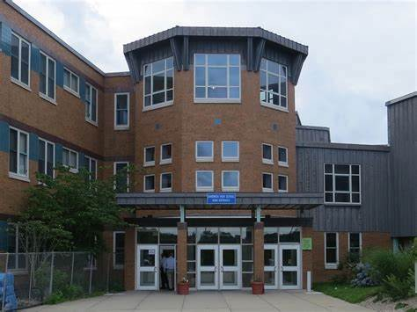

Prepared by:
Massachusetts Department of Public Health
Bureau of Climate and Environmental Health
Indoor Air Quality Program
November 2023
Building: | Sandwich Middle High School (SMHS)
Address: | 365 Quaker Meeting House Road, East Sandwich, MA
Assessment Requested by: | Chris George, Facilities Director, Sandwich Public Schools (SPS)
Date of Assessment: | October 24, 2023
Reason for Request: | Collaborative effort to perform general indoor air quality (IAQ) assessments throughout the SPS District. This report focuses on conditions in room D-266, a full report for the entire building will be forthcoming.
Massachusetts Department of Public Health/Bureau of Climate and Environmental Health (MDPH/BCEH) Staff Conducting Assessment: | Cory Holmes, Assistant Director, IAQ Program

BUILDING/VENTILATION
Room D-266 is an interior classroom with no windows that has a suspended ceiling tile system, gypsum wallboard walls, and vinyl tile floor that formerly served as a computer classroom. Since D-266 served as a computer classroom, it is equipped with supplemental ventilation components, in addition to the general heating, ventilation and air conditioning (HVAC) system vents, to facilitate air exchange and heat-generated by computer equipment.
Fresh air is supplied by rooftop air handling units (AHUs, Picture 1). The building uses ducted supply vents and return system (Pictures 2 and 3). Supplemental exhaust vents are also installed in the suspended ceiling, some equipped with additional filtration (Picture 4). It should be noted that the MDPH recommends pleated filters with a Minimum Efficiency Reporting Value (MERV) of 8 or higher, which are adequate in filtering out pollen and mold spores (ASHRAE, 2012). Filters should also be changed two to four times a year, or per the manufacturer’s recommendations. The additional filters, which are MERV 7 (ETF, 2004), work in conjunction with the rooftop filters (Picture 5) that are MERV 14 (Camfil, 2023), far exceeding the MERV 8 recommendation.

METHODS
Please refer to the IAQ Manual for methods, sampling procedures, and interpretation of results (MDPH, 2015). The following is a summary of indoor air testing results. BCEH/IAQ staff also conducted moisture testing of building materials (ceiling tiles and gypsum walls), performed visual inspection for water damage and/or microbial growth, and examined the space for the presence of odors or other environmental concerns within the classroom and above the ceiling tile system.

Air Testing Results
Media sampled |  | MDPH Guideline/  Comparison Value |  | Measured Range |  |  | Comments
 |  |  |  | Outdoors/  Background |  | Indoors
Carbon Dioxide (CO₂) |  | < 800 parts per million (ppm) is preferred |  | 476 |  | 549 | Room unoccupied
Total Volatile Organic Compounds (TVOCs) |  | Equal to or below background level measured |  | ND |  | ND | No odors detected
Carbon Monoxide (CO) |  | Non-detectable (ND) or equal to or below background level measured |  | ND |  | ND
Particulate Matter 2.5 (PM2.5) |  | US EPA National Ambient Air Quality Standards (NAAQS) 35 μg/m³ or less |  | 10 |  | 1
Temperature |  | 70 to 78ºF |  | 74 |  | 71 | Within MDPH comfort guidelines
Relative Humidity (RH) |  | 40% to 60% |  | 54 |  | 50 | Within MDPH comfort guidelines
Moisture Testing |  | Normal = dry |  |  |  | All building materials found dry at time of assessment | Ceiling tiles (one stained)  Gypsum wallboard
ppm = parts per million | µg/m³ = microgram per cubic meter |  | ND = non-detectable

DISCUSSION/VISUAL OBSERVATIONS
At the time of assessment, some dust and debris were observed on vents and the ceiling tile grid (Pictures 6 and 7). The MDPH IAQ Program recommends cleaning vents (and surrounding areas) periodically (i.e., during regular filter changes). Also noted in the room was a high-efficiency particulate arrestance (HEPA) air purifier (Picture 8). HEPA units remove up to 99% of airborne contaminants as small as 0.1 microns. According to the manufacture, the specific units in use at SMHS utilize a 4-stage filtration system that removes viruses, bacteria, dust, dander, mold spores, pollen, and other allergens. An activated carbon filter removes chemicals, gases, and odors (Austin, 2022).
No water-damaged or moist materials were observed, with the exception of one ceiling tile that was dry at the time of assessment and appeared to be painted over (Picture 7). The area above the ceiling tile system was observed in all four quadrants and center of the room and found to be dry (Pictures 9 through 12), with no visible mold or odors.

RECOMMENDATIONS
In view of the findings at the time of assessment, the following recommendations are made:
- Continue to operate the HVAC system in continuous mode to provide air exchange and filtration.
- Continue to change filters for HVAC equipment 2-4 times a year or as per the manufacture’s recommendations, using Minimum Efficiency Reporting Value (MERV) 8-rated filters or the highest rating the building’s ventilation system can accommodate to improve air filtration as much as possible without significantly reducing airflow.
- Change the water-damaged ceiling tile and monitor to ensure no further leaks occur.
- Prior to reoccupancy, conduct a thorough cleaning of ceiling vents and tile grid, as well as wet wiping of all surfaces.
- Continue to operate the HEPA air purifier during occupancy. Ensure filters are cleaned/changed as per the manufacturers recommendations or more frequently if needed.

REFRENCES
ASHRAE. 2012. American Society of Heating, Refrigeration and Air Conditioning Engineers (ASHRAE) Standard 52.2-2012 -- Method of Testing General Ventilation Air-Cleaning Devices for Removal Efficiency by Particle Size (ANSI Approved).
Austin. 2022. Austin Air HealthMate®. Copyright© 2022 AustinAir. HealthMate - Welcome to Austin Air Systems. Clinically Proven Air Purifiers.
Camfil. 2023. Durafil® ES³. High Efficiency, High Capacity, Energy Saving, Mini-Pleated V-Bank Air Filter https://www.camfil.com/product/documents/dam/53357/Product-Documentation-Durafil-ES.pdf
ETF. 2004. Environmental Technology Verification Test Report of Control of Bioaerosols in HVAC Systems, Airflow Products AFP30. https://cfpub.epa.gov/si/si_public_file_download.cfm?p_download_id=504180
MDPH. 2015. Massachusetts Department of Public Health. “Indoor Air Quality Manual: Chapters I-III”. Available at: Indoor air quality – manual and appendices | Mass.gov
Picture 1
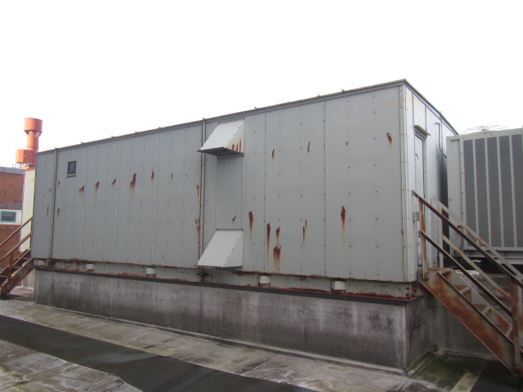
Rooftop air handling unit (AHU)
Picture 2
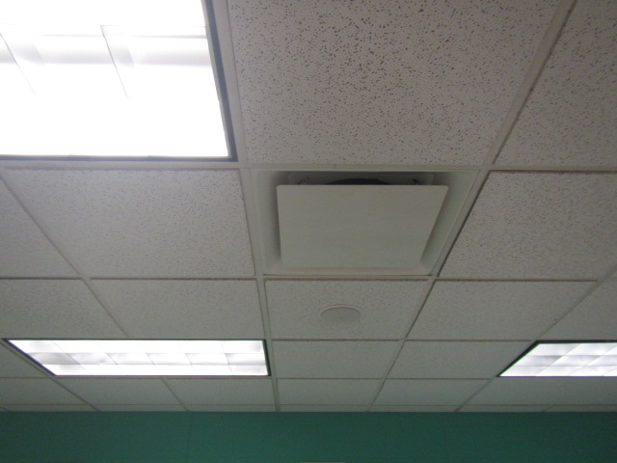
Ceiling-mounted supply vent
Picture 3
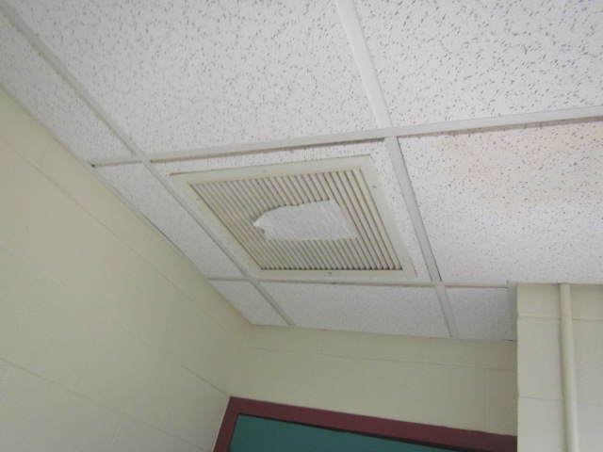
Ceiling-mounted return vent, paper is shown to indicate draw of air into vent
Picture 4
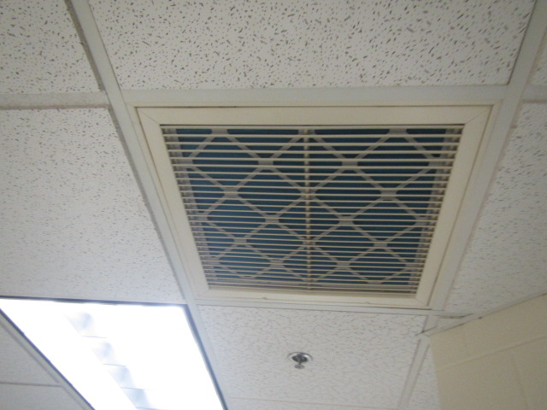
Supplemental exhaust vents with filters installed
Picture 5
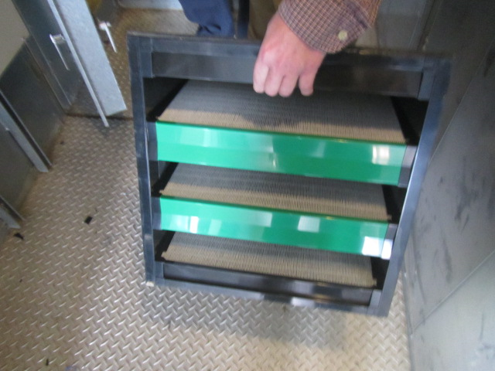
MERV 14 box filters installed in rooftop AHU
Picture 6
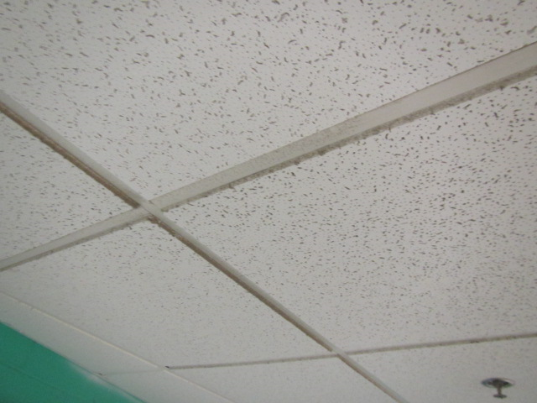
Dust/debris accumulation on ceiling tile grid
Picture 7
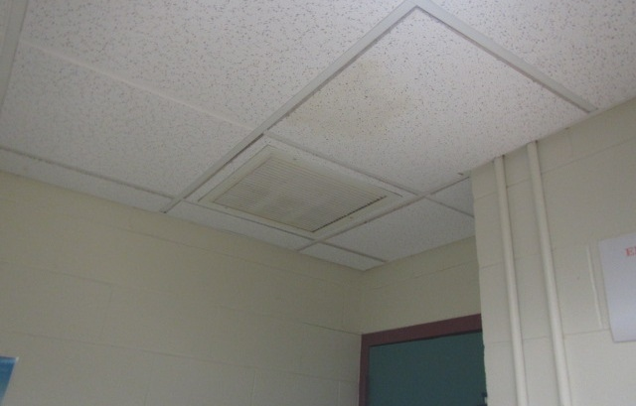
Dust/debris accumulation on return vent and water-damaged ceiling tile
Picture 8
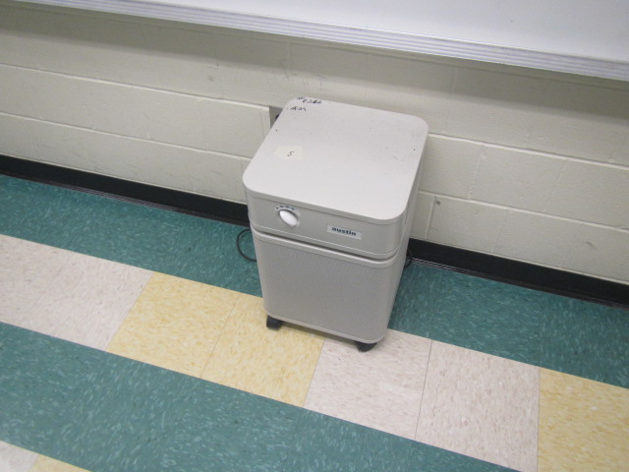
Air purifier
Picture 9
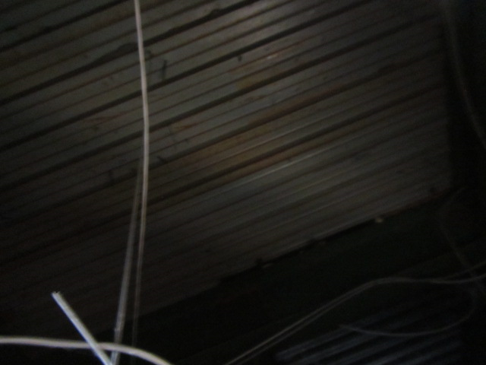
Ceiling plenum above ceiling tiles
Picture 10
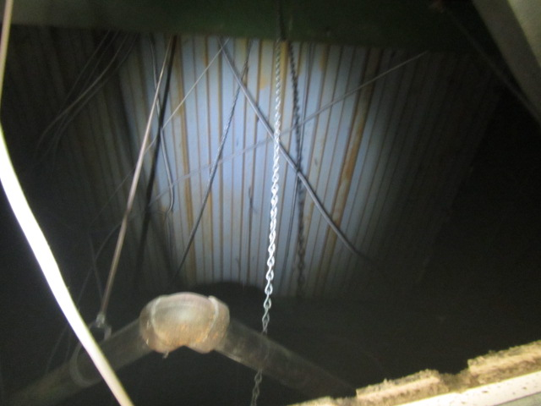
Ceiling plenum above ceiling tiles
Picture 11
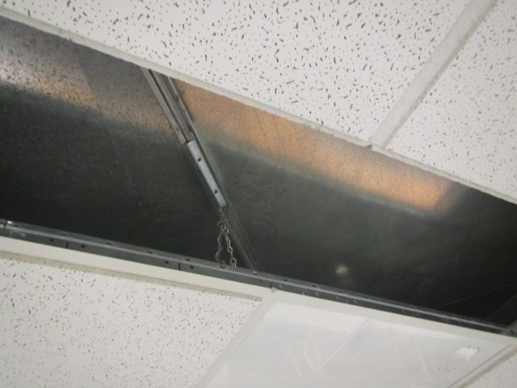
Ceiling plenum above ceiling tiles
Picture 12
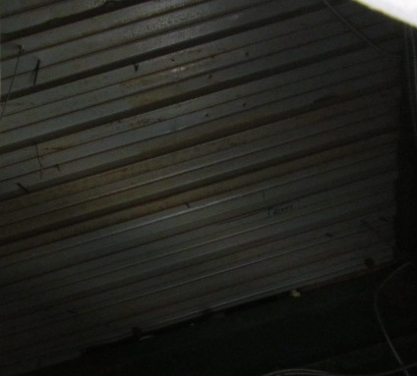
Ceiling plenum above ceiling tiles

