Are YOU looking to make a difference?
Become a MA SANE Nurse!

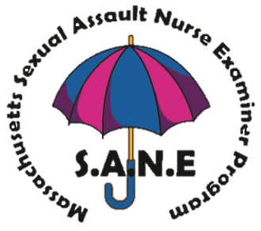

The mission of the MA Sexual Assault Nurse Examiner (SANE) Program is to provide compassionate, coordinated, expert forensic nursing care to sexual assault patients. The program welcomes Massachusetts Registered Nurses, Nurse Practitioners, and Certified Nurse Midwives to apply to become a MA SANE and provide on-call SANE services in 1 of 6 MA SANE regions. This intensive, innovative training model will consist of lectures, independent reading, and hands-on instruction. Join our team of talented SANEs working all across the Commonwealth!
Application Requirements
- Must be a Registered Nurse or Advanced Practice Nurse
- Minimum of THREE YEARS nursing experience (emergency/women’s health nursing preferred)

DATES
Monday, September 16, 2019
Thursday, September 19, 2019
Monday, September 23, 2019 Clinical Day 1* — OR —
Thursday, September 26,, 2019 Clinical Day 2*
Tuesday, October 1, 2019
Friday, October 4, 2019
Tuesday, October 8, 2019
Tuesday, October 22,, 2019 - exam day
*Clinical Dates, only one required
All days are 8am – 4pm

All

*Clinical Dates, only one required.

To Apply:
https://www.mass.gov/ma-sexual-assault-nurse-examiner-sane-program
Or request an application by emailing Latoya.Brown2@state.ma.us

ADDITIONAL INFORMATION
Location: UMass Medical School
Albert Sherman Building iCELS
55 Lake Avenue North
Worcester, MA 01655

Course Fee: $400 (includes 40 contact hours and clinical lab fee)

DAILY LUNCH IS PROVIDED

