SECTION VIII

SEXUALLY TRANSMITTED INFECTIONS (STIS)
A primary concern for most patients who have experienced a sexual assault is contracting Sexually Transmitted Infections (STIs). SANEs should provide anticipatory guidance and education about testing and treatment for STIs as recommended by the MA Department of Public Health (MDPH) and Center for Disease (CDC) STI 2021 guidelines.
Patient Education

- Educate the patient about the possibility and risks of disease transmission as indicated by the specific details of the assault described by the patient.
- STI testing within 5 days of a sexual assault may be testing for exposure to an STI that occurred before the incident of the assault.
- STI testing is offered to all patients presenting post-sexual assault.
- If a patient has signs and symptoms of STI infection, additional site-specific testing should be discussed with and conducted by the ED Medical Provider.

STI Testing - Also see Appendix VI – STI Testing Algorithm

All Patients with Mucosal Exposure to Blood/Hazardous Bodily Fluids:
- STI prophylaxis is recommended
- Decisions to perform STI testing should be made on an individual basis
- Verbal patient consent should be obtained

Patient with Signs and Symptoms of Genital Infection:
Management to be discussed with ED medical provider; recommend STI diagnostic testing be done, based on presenting signs and symptoms.

Lab Testing Recommended:
- Urine NAAT (First catch)
  - Gonorrhea
  - Chlamydia
  - Trichomoniasis*
- Serology
  - HIV -1/2 antigen/antibody combination immunoassay (4th generation) testing preferred. Antibody only if antigen/antibody not available.
  - Syphilis serology (as per individual hospital protocol)
  - Hepatitis C antibody
  - Hepatitis B surface antigen and antibody, and core antibody
*Testing not recommended for patients with a penis.

Additional Lab Testing if nPEP is Administered:
- Obtain:
  - Serum creatinine
  - ALT/AST

Site-Specific Testing (Oral, Anal, Vaginal):
In an effort to eliminate additional trauma to the patient, the MA DPH SANE Program recommends urine testing only. If STI symptoms are present, site-specific testing should be considered and determined by the ED medical provider.

Medication Recommendations for STI Prophylaxis

SANES should recommend STI prophylactic medications and vaccinations for gonorrhea, chlamydia, hepatitis B, HIV and human papilloma virus (HPV) for all patients after sexual assault with mucosal exposure or unknown exposure to bodily fluids. Additionally, SANEs should recommend prophylactic medication for trichomoniasis for patients with a vagina.
- If the patient declines STI prophylaxis, the patient should be advised to obtain STI testing 2 – 6 weeks after the ED visit at a public community testing center or with their Primary Care Physician (refer patient to MSAECK Form 7).
The SANE should ensure that the patient has been educated about STIs and prophylaxis, assessed for any allergies and has been advised of the signs and symptoms of medication side effects. The SANE should collaborate with the ED medical provider and make recommendations for STI testing and STI prophylaxis based on the patient’s assault and the associated risk factors of the assault. The SANE should communicate their recommendations to the provider. The ED medical provider is responsible for ordering medication(s) and the patient’s primary nurse is responsible for obtaining and administering the medication(s) in a timely manner. The ED staff is responsible for providing follow-up medical referrals.

This document is intended to serve as a recommendation and is not intended to be a comprehensive list of all effective treatment regimens. These medications may not be appropriate for all patients and the choice of medications may differ depending on the patient’s needs and the most updated CDC guidelines. This information does not replace, and is not intended to replace, the full description of these medications. Consult with the Emergency Department medical provider about indications and contraindications of these medications.
MDPH SANE Protocol for Gonorrhea, Chlamydia, and Trichomonas Prophylaxis*

- Ceftriaxone 500 mg IM x 1 dose (1 gm for patients ≥ 150kg)
- Doxycycline 100 mg orally twice a day for 7 days
- Metronidazole 500 mg orally twice a day for 7 days**
(Consider using lidocaine as a diluent for ceftriaxone for patient comfort. Consider administration of anti-emetic 30 minutes before administration of STI prophylaxis medications. See below for additional medication information)

Depending on the patient circumstances, prophylaxis may also include:
- Hepatitis B vaccine
- Human papilloma virus (HPV) vaccine
- HIV prophylaxis

*These regimens are standard choices but do not take into considerations allergies, pregnancy status or ages other than adolescents/adults.
**Recommended for patients with a vagina only.

Antiemetic Medication
The combined administration of multiple STI medications may cause patients to become nauseous. The SANE and the Primary Nurse should consider the need for an antiemetic, to be provided 30 minutes prior to 1st medication administration, to minimize nausea and the risk of vomiting.

Additional Medication Prophylaxis Information

Gonorrhea Prophylaxis

Medication: Dosage:
Indicated for Rx of: Safe for: Contraindications: Notes:
Ceftriaxone
500 mg IM, single dose (1 gm for patients ≥ 150kg)
Uncomplicated gonococcal infections at all sites (genital, anal, and pharyngeal) Adults, pregnant persons, and adolescents
Allergy to cephalosporins
Consider using lidocaine as a diluent for ceftriaxone for patient comfort.

Chlamydia Prophylaxis
Medication: Doxycycline
Dosage: 100 mg orally twice a day for 7 days Indicated for Rx of: Chlamydial infection at all sites
Safe for: Adults and adolescents
Contraindications: Allergy to tetracyclines; pregnancy, chest/breastfeeding
Notes: Azithromycin, single dose 1 gm orally should be used in pregnant patients and may be considered in patients in whom nonadherence to doxycycline regimen is a substantial concern. Azithromycin is significantly less effective in patients with possible oral or rectal infection. Chlamydia is detected at the anorectal site among 33%–83% of women who had urogenital chlamydia infection, and its detection was not associated with report of receptive anorectal sexual activity.

Trichomoniasis Prophylaxis (Recommended for patients with a vagina only.) Medication: Metronidazole
Dosage: 500 mg orally twice a day for 7 days Indicated for Rx of: Trichomoniasis
Safe for: Adults, pregnant persons, and adolescents
Contraindications: Allergy to metronidazole
Notes: Per 2021 CDC guidelines refraining from alcohol use while taking metronidazole is unnecessary.

Hepatitis B Prophylaxis (for dosage recommendations for all ages, click here: https://rb.gy/iujpsp)
Medication: Hepatitis B Vaccine (or HBIG if indicated)
Indicated for Rx of: Hepatitis B prophylaxis after potential exposure d/t sexual assault Safe for: Adults, pregnant persons, and adolescents
Contraindications: Allergy to yeast (very rare)
Notes: Administer if hepatitis status of assailant is unknown and patient has NOT been previously vaccinated; patients should be informed of the need for follow-up for completion of the vaccination series for Hepatitis B immunization

Human Papillomavirus (HPV) Prophylaxis (for patients aged 9-45 years)
Medication: HPV vaccine
Dosage (ages 9-14): Single dose 0.5ml IM in ER; 2 dose series, subsequent dosing per follow-up provider
Dosage (ages 15-45): Single dose 0.5ml IM in ER; 3 dose series, subsequent dosing per follow-up provider
Indicated for Rx of: HPV prophylaxis after potential exposure d/t sexual assault
Safe for: Adults and adolescents
Contraindications: Hypersensitivity to vaccine, pregnancy
Notes: Administer if patient has NOT been vaccinated or is incompletely vaccinated

For full treatment guidelines please see link: https://www.cdc.gov/std/treatment-guidelines/STI-Guidelines-2021.pdf

HUMAN IMMUNODEFICIENCY VIRUS (HIV)

Sexual assault patients often have concern about their risk of contracting HIV from the assault. SANEs/clinicians should provide patients with information to help them make informed choices regarding HIV prophylaxis and testing. All patients presenting within 5 days following a sexual assault should be offered prompt HIV/STI testing and prophylaxis.

Patient Education

- In collaboration with ED medical provider, inform patient about estimated risk for acquiring HIV from an infected source (See Table 1 below).
- Provide patient with information so that they may make an informed choice about HIV testing and prophylaxis in the ED.
- Explain that the seroconversion period (the time it takes a person to develop HIV antibodies that may show up on an HIV test after exposure to HIV) varies from person to person:
  - Some people seroconvert as early as one to three weeks after exposure, with greater than 80% of the infected individuals testing positive for HIV antibodies by six weeks.
  - It could take as long as six months for seroconversion to occur in some people. Therefore, patients should be informed that the results of HIV testing in the ED indicate the baseline status of HIV infection, not the HIV status resulting from the sexual assault.

Risk of Seroconversion

Table 1. Estimated per-act risk for acquiring human immunodeficiency virus (HIV) from an infected source, by exposure act*
Exposure type | Rate for HIV acquisition per 10,000 exposures
Parenteral
Blood transfusion | 9,250
Needle sharing during injection drug use | 63
Percutaneous (needle stick) | 23
Sexual
Receptive anal intercourse | 138
Receptive penile-vaginal intercourse | 8
Insertive anal intercourse | 11
Insertive penile-vaginal intercourse | 4
Receptive oral intercourse | Low
Insertive oral intercourse | Low
Other**
Biting | Negligible

Spitting | Negligible
Throwing body fluids (including semen or saliva) | Negligible
Sharing sex toys | Negligible
* Factors that may increase the risk of HIV transmission include sexually transmitted diseases, acute and late-stage HIV infection, and high viral load. Factors that may decrease the risk include condom use, male circumcision, antiretroviral treatment, and pre-exposure prophylaxis. None of these factors are accounted for in the estimates presented in the table.

** HIV transmission through these exposure routes is technically possible but unlikely and not well documented.

Source: https://www.cdc.gov/hiv/pdf/programresources/cdc-hiv-npep-guidelines.pdf

Limits of Confidentiality

The limits of confidentiality of the HIV antibody test must also be discussed before the patient chooses to be tested in the ED setting. Patients should be informed the results of HIV testing in the ED indicate the present status of HIV infection, not the HIV status resulting from the sexual assault. Although conducted in a “confidential manner” according to hospital procedures, the results of the HIV test become a part of the medical record and may be subpoenaed in court proceedings.

The MDPH strongly recommends that patients receive pre-test and post-test education and counseling.

Additional Information Regarding ED-based HIV Testing
- For all patients tested for HIV in a hospital: the hospital is responsible for compliance with Mass. General Laws c. 111, §70F and related policies in obtaining informed patient consent for HIV testing and for providing mechanisms for appropriate counseling, follow-up, and maintenance of HIV-related information contained in their records.
- HIV testing is offered to all patients at the time of the sexual assault examination in the ED. If HIV post- exposure prophylaxis is started, baseline testing for HIV should be performed soon after the sexual assault examination. Patients who choose not to be tested but continue to have questions about their baseline HIV status may be referred to their primary care provider or to the AIDS Action Committee at 617-437-6200 (Mon-Fri) 9 AM-5PM to obtain HIV testing any time after the ED evaluation.

HIV Testing - Table 2 (based on CDC 2016 nPEP guidelines)
Test | Source | Exposed Persons
 | Baseline | Baseline | 4-6 weeks after exposure | 3 months  after exposure | 6 months  after exposure
 |  | For all persons considered for or prescribed nPEP for any exposure
HIV Ag/Ab testing^{i}  (or antibody testing if Ag/Ab test unavailable) | ✓ | ✓ | ✓ | ✓ | - ii
Hepatitis B serology, including: hepatitis B surface antigen  hepatitis B surface antibody hepatitis B core antibody |  |  | — | — | - iii
Hepatitis C antibody test |  |  | — | — | - iv
 | For all persons considered for or prescribed nPEP for sexual exposure
Syphilis serology^{v} |  |  |  | —
Gonorrhea^{vi} |  |  | - vii | — | —
Chlamydia^{viii} |  |  | - ix | — | —

Pregnancy^{x} | — |  |  | — | —
For persons prescribed
tenofovir DF + emtricitabine + raltegravir or
tenofovir DF + emtricitabine + dolutegravir
Serum creatinine  (for calculating estimated creatinine clearance) |  |  |  | — | —
Alanine transaminase, aspartate aminotranferase |  |  |  | — | —
 | For all persons with HIV infection confirmed at any visit
HIV viral load |  | - xi
HIV genotypic resistance |  | - xii

HIV Non-Occupational Post-Exposure Prophylaxis (nPEP)

MA SANE Program Protocol recommends HIV nPEP administration for up to 72 hours following a sexual assault for all sexual assaults with a high risk of exposure to HIV. Sexual assaults with higher risk of exposure to HIV include situations with:
- Multiple assailants
- Known HIV-infected assailant(s)
- Known ejaculate or blood exposure
- Vaginal and/or anal assault
- Any disruption in skin integrity of the vaginal, anal, or oral mucosa

The SANE should notify the ED Attending Provider of the patient’s risk factors to ensure timely administration of HIV nPEP. Current data analysis indicates that HIV nPEP is less likely to be effective if initiated more than 72 hours after an exposure. When a patient presents within 72 hours of an exposure, the use of HIV nPEP should be initiated promptly for the best chance of success. The sooner HIV nPEP is initiated after an exposure, the more likely transmission will be interrupted, and viral replication suppressed.

  - Baseline serum lab tests are recommended. Refer to Table 2 above for details on testing to be completed.
  - If a patient declines serology, decisions regarding nPEP administration should be made by the medical provider, in consultation with the patient, based on the patient’s medical history and assault- related risk factors.

2021 CDC Guidelines: Recommended HIV nPEP Medication Regime
Table 5. Preferred and alternative antiretroviral medication 28-day regimens for nPEPxiii xiv
Age group | Preferred/ Alternative | Medication
Adults and adolescents aged ≥ 13 years including pregnant women with normal renal function (creatinine clearance ≥ 60mL/min) | Preferred | A 3-drug regimen consisting of:  tenofovir DF 300mg and fixed dose combination emtricitabine 200mg (Truvadaxv) once daily  with  raltegravir 400mg twice daily  or  dolutegravir 50mg once daily

 | Alternative | A 3-drug regimen consisting of:  tenofovir DF 300mg and fixed dose combination emtricitabine 200mg (Truvada) once daily  with  darunavir 800mg (as two, 400mg tablets) once daily  and  ritonavirxvi 100mg once daily
Adults and adolescents aged ≥ 13 years with renal dysfunction (creatinine clearance ≤ 59mL/min) | Preferred | A 3-drug regimen consisting of:  zidovudine and lamivudine with both doses adjusted to degree or renal function  with  raltegravir 400mg twice daily  or  dolutegravir 50mg once daily
 | Alternative | A 3-drug regimen consisting of:  zidovudine and lamivudine with both doses adjusted to degree or renal function  with  darunavir 800mg (as 2, 400mg tablets) once daily  and  ritonavir 100mg once daily
Children aged 2-12 years | Preferred | A 3-drug regimen consisting of:  tenofovir DF, emtricitabine, and raltegravir with each drug dosed to age and weight
 | Alternative | A 3-drug regimen consisting of: zidovudine and lamivudine with  raltegravir  and  lopinavir/ritonavir with raltegravir and lopinavir/ritonavir dosed to age and weight
 | Alternative | A 3-drug regimen consisting of: tenofovir DF and emtricitabine and lopinavir/ritonavir  with each drug dosed to age and weight
Children aged 3-12 years | Alternative | A 3-drug regimen consisting of:  tenofovir DF and emtricitabine and darunavirxvii  /ritonavir  with each drug dosed to age and weight

Follow-up Care

Concern about possible HIV infection as a result of sexual assault is common. Ideally, follow-up care—including HIV counseling and additional testing—is best done in the supportive, on-going relationship of the primary care provider. However, reluctance to disclose a sexual assault to the primary care provider may prevent this continuity of care. Therefore, options for confidential or anonymous HIV testing should be offered. The SANE/ED Clinician should be aware of confidential or anonymous HIV testing resources for survivors of sexual assault, available within the community and through the hospital. The following options for HIV testing can be provided as needed to the patient prior to discharge:
- HIV and STI testing is provided at most private physician’s offices, community health centers, family planning agencies, and hospitals.
- Local Sexual Assault Prevention and Survivor Services Programs generally can provide free sexual assault crisis counseling and referral to local HIV testing, counseling, and treatment services.
- The MDPH Office of HIV/AIDS funds numerous HIV Counseling, Testing, and Referral (CTR) sites throughout the state.
- The MDPH and AIDS Action sponsor a website, http://www.aac.org/ which gives HIV/STISTI test site information and other resources in Massachusetts.
- The hospital system may have other available services for HIV counseling as well as referral sources to meet the needs of the sexual assault patient.
- Additional resources for nPEP for MA patients can be found at https://crine.org/npep

Also, aftercare forms containing the names of ED providers, primary care or clinic networks, AIDS Action Hotline number, local Sexual Assault Prevention and Survivor Service Programs and Family Planning Clinic numbers will be provided.

MA DPH educational brochures about HIV Counselling and Testing can be found at: http://files.hria.org/files/HA1656.pdf

Recommended Follow-up per 2021 CDC Guidelines
At the initial examination and, if indicated, at follow-up examinations, patients should be counseled regarding symptoms of STIs and the need for immediate examination if symptoms occur. Further, they should be instructed to abstain from sexual intercourse until STI prophylactic treatment is completed.

After the initial post-assault examination, follow-up examinations provide an opportunity to detect new infections acquired during or after the assault, complete hepatitis B and HPV vaccinations if indicated, complete counseling and treatment for other STIs, and monitor side effects and adherence to PEP if prescribed. If initial testing was performed, follow-up evaluation should be conducted in <1 week to ensure that results of positive tests can be discussed promptly with the patient, treatment is provided if not administered at the initial visit, and any follow-up for infections can be arranged. If initial tests are negative and treatment was not provided, examination for STIs can be repeated 1–2 weeks after the assault; repeat testing detects infectious organisms that might not have reached sufficient concentrations to produce positive test results at the time of initial examination.

If initial testing was positive for gonorrhea, please see 2023 Clinical Alert on Non Susceptible Gonorrhea, dated January 19, 2023; https://www.mass.gov/lists/std-treatment-guidelines-and-clinical-advisories

For patients who are treated during their initial visit, regardless of whether testing was performed, post-treatment testing for all STIs, excluding gonorrhea should be conducted only if the person reports having symptoms. If initial test results were negative and infection in the assailant cannot be ruled out, serologic tests for syphilis can be repeated at 4-6 weeks and 3 months; HIV testing can be repeated at 6 weeks and 3 months by using methods to identify acute HIV infection.

MA SANE Program © 2021 updated 2023

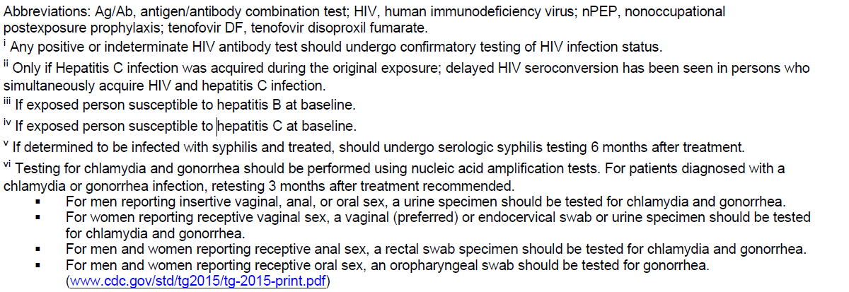
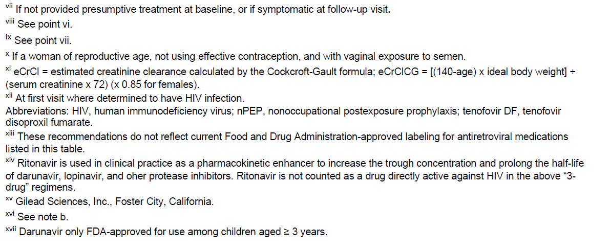

MA SANE Program © 2021 updated 2023

