SECTION X

VICTIM COMPENSATION

Financial compensation from the Victim Compensation and Assistance Division (VCAD) of the Attorney General's Office is available to victims of crime, including sexual assault. Experienced staff within this Division assist victims in understanding their rights as a crime victim, determining what expenses may be eligible for compensation, and assessing what other resources are available to them.

The MA Attorney General’s Office (AGO), Executive Office of Health and Human Services (EOHHS), Executive Office of Safety and Security (EOPSS), and MA Health and Hospital Association (MHA) have worked together to ensure that post-assault sexual assault care including forensic examinations are provided to victims at “no cost” as required by Violence Against Women Act (VAWA) Reauthorization Act of 2013 (see www.congress.gov/bill/113th-congress/senate-bill/47 for more information).

Patient Rights
As of March 2016, MA hospitals are allowed to directly bill the VCAD for all Emergency Department (ED) expenses incurred as the result of a sexual assault that involve a patient whose assault occurs in Massachusetts, and who has a MA Sexual Assault Evidence Collection Kit (MSAECK) completed at a Massachusetts hospital. This includes all expenses incurred from the time the patient enters the ED until they are discharged from the ED. While a patient’s primary health care can be used if the patient affirmatively opts in, direct billing to VCAD should be implemented for patients who have privacy/confidentiality or other concerns about their primary health insurance being billed. Hospitals may not bill patients for any co-payments or other patient-incurred costs from their primary health insurance. Those should be submitted to the VCAD for payment.

To Facilitate the Direct Billing Process

- The SANE should complete only Section 1 “Victim Information” on Attachment B (located in the envelope on the back of the MSAECK).

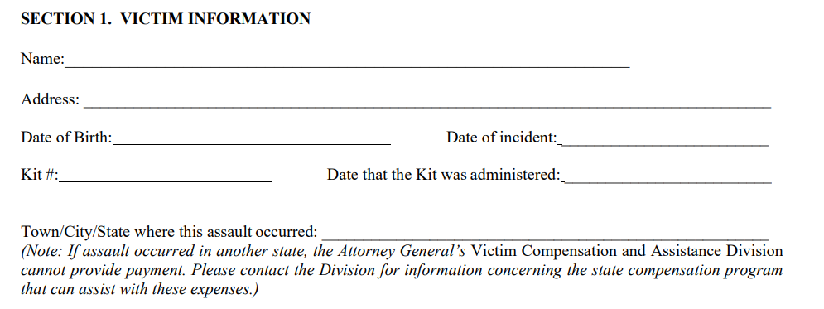

- The SANE should provide the Attachment B to hospital staff who will follow their hospital process regarding direct billing.
- Faxing the patient’s MSAECK form 2A (PSCR) to EOPSS helps to ensure that the patient’s sexual assault is considered “reported” and acts as a safeguard if there is a problem with the direct billing process
- Ensure that the patient’s MSAECK # is included on the Form 7 Discharge Form for the patient’s future reference (e.g. for Additional Compensation eligibility).

Sexual Assaults Occurring Outside of Massachusetts
If the patient’s assault occurred out of state, patients are not eligible for compensation from the MA VCAD but may be eligible for compensation from the state where the assault occurred. Patients should be directed to the MA VCAD for guidance and assistance with this process. The SANE should provide the VCAD brochure (located in the MSAECK Patient Information Packet) as a reference.

Patient Declines MSAECK or Patient Ineligible for MSAECK
Patients who decline a forensic exam or whose assault occurred > 5 days may be eligible for Victim Compensation but are required to report their assault to the police within 5 days of the assault. In these circumstances, patients must submit a copy of their police report with their Victim Compensation Application. Patients can receive further guidance in this regard by contacting VCAD.

To be eligible for additional Victim Compensation (outside of emergency department related expenses) patients must complete and submit the Victim’s Compensation Application (located in the Patient Information Envelop) within the MSAECK within three years of their assault. The application can also be found at the following site https://www.mass.gov/massachusetts-victims-of-violent-crime-compensation.

