INDOOR AIR QUALITY ASSESSMENT

Saugus High School
1 Pearce Memorial Drive
Saugus, MA 01906



Prepared by:
Massachusetts Department of Public Health
Center for Environmental Health
Emergency Response/Indoor Air Quality Program
March 2007

Background/Introduction
At the request of parents, the Massachusetts Department of Public Health (MDPH), Center for Environmental Health (CEH) provided assistance and consultation regarding indoor air quality at each of Saugus’s public schools. These assessments were jointly coordinated through Sharon McCabe, Director of the Saugus Health Department, and Ralph Materissi, Building Maintenance Director of the Town of Saugus.
On November 15, 2006, a visit to conduct an assessment at the Saugus High School (SHS) was made by Cory Holmes and Sharon Lee, Environmental Analysts in CEH’s Emergency Response/Indoor Air Quality (ER/IAQ) Program. Mr. Holmes returned on November 16, 2006 to complete the assessment.
The SHS is a two-story brick building constructed in 1955. Two classroom wings were added in 1972. The roof was reportedly replaced approximately nine years ago. No other major interior renovations have occurred in the building, with the exception of the boiler plant, which was reportedly replaced approximately three years ago. The majority of building materials are original (ceiling systems, mechanical ventilation equipment, etc.). The building contains general classrooms, science rooms, administrative offices, a gymnasium, locker rooms, a multi-purpose room, cafeteria, wood shop, art room, library and the boiler/custodian rooms.

Methods
Air tests for carbon dioxide, carbon monoxide, temperature and relative humidity were conducted with the TSI, Q-TRAK™ IAQ Monitor, Model 8551. CEH staff also performed a visual inspection of building materials for water damage and/or microbial growth. Moisture content of porous building materials was measured with Delmhorst, BD-2000 Model, Moisture Detector with a Delmhorst Standard Probe.

Results
The school houses approximately 850 students in grades 9 through 12 and has approximately 80 staff members. Tests were taken during normal operations at the school and results appear in Tables 1 and 2.

Discussion
Ventilation
On November 15, 2006, carbon dioxide levels were above 800 parts per million (ppm) in seventeen of forty-six areas surveyed. Carbon dioxide levels were above 800 ppm parts of air in four of twenty-three areas surveyed on November 16, 2006. Areas with carbon dioxide levels greater than 800 ppm are considered to have poor or less than optimal air exchange. Please note that on both days of the assessment, several areas had open windows and/or were sparsely populated, which can greatly reduce carbon dioxide levels.
Fresh air in classrooms is supplied by unit ventilator (univent) systems (Picture 1). A univent draws air from the outdoors through a fresh air intake located on the exterior wall of the building (Picture 2) and returns air through an air intake located at the base of the unit. Fresh and return air are mixed, filtered, heated and provided to classrooms through an air diffuser located in the top of the unit. Adjustable louvers control the ratio of outside to recirculated air (Figure 1). Univents are reportedly original equipment (i.e. over 50 years old in the main building, over 20 years old in the 1972 wings). Univents of this age are difficult to maintain because replacement parts are often unavailable. Univents were found deactivated on not functioning in a number of areas (Tables 1 and 2). Poor airflow complaints were expressed by occupants in the A-wing, which was evidenced by elevated carbon dioxide levels (1,423-2,507 ppm). Obstructions to airflow, such as items stored on or in front of univents were observed in some areas. In order for univents to provide fresh air as designed, units must be activated while rooms are occupied and air diffusers should remain free of obstructions.
Exhaust ventilation in the 1955 building consists of floor level, ungrated “cubby” holes connected to rooftop exhaust fans (Picture 3). The mechanical exhaust ventilation system for classrooms in the 1972 wings consists of ducted, grated wall vents connected to rooftop motors (Picture 4). As with the univents, a number of exhaust vents were either deactivated or drawing weakly (Tables 1 and 2). Tables, chairs, boxes and other items obstructed a number of exhaust vents, preventing draw of air (Picture 4). Some exhaust vents are equipped with pull chains that control a flue that adjusts airflow via the ventilation shaft. At the time of the assessment, a number of these control mechanisms (i.e., pull chains and flues) were closed or in disrepair. Without removal by the exhaust ventilation, normally occurring environmental pollutants can build up, leading to indoor air complaints.
Fresh air in the gymnasium, multi-purpose room, locker rooms and the auditorium is provided by ceiling-mounted air handling units (AHUs). No air flow could be detected from any of the locker room AHUs during the assessment.
To maximize air exchange, the MDPH recommends that both supply and exhaust ventilation operate continuously during periods of school occupancy. In order to have proper ventilation with a mechanical supply and exhaust system, the systems must be balanced to provide an adequate amount of fresh air to the interior of a room while removing stale air from the room. It is recommended that HVAC systems be re-balanced every five years to ensure adequate air systems function (SMACNA, 1994). The date of the last balancing of these systems was not available at the time of the assessment. The Massachusetts Building Code requires a minimum ventilation rate of 15 cubic feet per minute (cfm) per occupant of fresh outside air or have openable windows in each room (SBBRS, 1997; BOCA, 1993). The ventilation must be on at all times that the room is occupied. Providing adequate fresh air ventilation with open windows and maintaining the temperature in the comfort range during the cold weather season is impractical. Mechanical ventilation is usually required to provide adequate fresh air ventilation.
Carbon dioxide is not a problem in and of itself. It is used as an indicator of the adequacy of the fresh air ventilation. As carbon dioxide levels rise, it indicates that the ventilating system is malfunctioning or the design occupancy of the room is being exceeded. When this happens, a buildup of common indoor air pollutants can occur, leading to discomfort or health complaints. The Occupational Safety and Health Administration (OSHA) standard for carbon dioxide is 5,000 parts per million parts of air (ppm). Workers may be exposed to this level for 40 hours/week, based on a time-weighted average (OSHA, 1997).
The MDPH uses a guideline of 800 ppm for publicly occupied buildings. A guideline of 600 ppm or less is preferred in schools due to the fact that the majority of occupants are young and considered to be a more sensitive population in the evaluation of environmental health status. Inadequate ventilation and/or elevated temperatures are major causes of complaints such as respiratory, eye, nose and throat irritation, lethargy and headaches. For more information concerning carbon dioxide, consult Appendix A.
Temperature measurements ranged from 67º F to 78º F on November 15, 2006 and from 65º F to 78º F on November 16, 2006. Temperature measurements in some areas were below the MDPH recommended comfort range on the days of the assessment. The MDPH recommends that indoor air temperatures be maintained in a range of 70º F to 78º F in order to provide for the comfort of building occupants. Staff located in the Saugus Cooperative Bank, which is sectioned off from the cafeteria, had complaints of excessive heat. In many cases concerning indoor air quality, fluctuations of temperature in occupied spaces are typically experienced, even in a building with an adequate fresh air supply.
The relative humidity measured in the building ranged from 46 to 73 percent on November 15, 2006 and 52 to 68 percent on November 16, 2006. Relative humidity levels were above the MDPH recommended comfort range in a number of areas on both days of assessment. It is important to note that the assessment occurred over a two-day period of moderate to heavy rainfall, with outdoor relative humidity ranging from 85 to 100 percent. The MDPH recommends a comfort range of 40 to 60 percent for indoor air relative humidity. Moisture removal is important since the sensation of heat conditions increases as relative humidity increases (the relationship between temperature and relative humidity is called the heat index). As indoor temperatures rise, an increase in relative humidity will make occupants feel warmer. If moisture is removed, the comfort of the individuals is increased.
While temperature is mainly a comfort issue, relative humidity in excess of 70 percent for extended periods of time can create an environment conducive to mold and fungal growth (ASHRAE, 1989). During periods of high relative humidity (late spring/summer months), windows and exterior doors should be closed when the HVAC system is operating in air-conditioning mode. During the heating season, relative humidity levels would be expected to drop below the recommended comfort range. The sensation of dryness and irritation is common in a low relative humidity environment.

Microbial/Moisture Concerns
The building has had a history of water infiltrating through the roof and window systems, as evidenced by water stained ceilings/tiles and damaged ceilings (Pictures 5 and 6). Porous water-damaged building materials can serve as mold growth media, and should be replaced after a water leak is discovered. As mentioned previously, the roof was replaced nine years ago; however, windows reportedly leak on occasion. A mold-colonized box was found in the storage closet in classroom A 02 (Picture 7). As with other porous materials, cardboard should be discarded once it has become water-damaged and colonized with mold.
Water-damaged wooden walls were observed in the gymnasium (Picture 8). In order for building materials to support mold growth, a source of moisture is necessary. Identification and elimination of water moistening building materials is necessary to control mold growth. In this case, moisture stemmed from a plumbing failure. Building materials with increased moisture content over normal concentrations may indicate the possible presence of mold growth. Identification of the location of materials with increased moisture levels can also provide clues concerning the source of water supporting mold growth.
In an effort to ascertain moisture content of the water-damaged wall in the gymnasium, moisture content was measured with a Delmhorst Moisture Detector equipped with a Delmhorst Standard Probe. The Delmhorst probe is equipped with three lights that function as visual aids that indicate moisture level. Readings that activate the green light indicate a sufficiently dry or low moisture level, those that activate the yellow light indicate borderline conditions and those that activate the red light indicate elevated moisture content. No elevated moisture readings were measured during the assessment (Table 1).
Window-mounted air conditioners (ACs) were observed in several areas. These units are normally equipped with filters, which should be cleaned or changed as per manufacturer’s instructions to avoid the build-up and re-aerosolization of dirt, dust and particulate matter. Several of the units were missing filters and the cooling fins were occluded with dust and debris (Picture 9), which can provide a mold growth media when moistened.
A number of classrooms had plants. Moistened plant soil and drip pans can be a source of mold growth. Plants should be equipped with drip pans; the lack of drip pans can lead to water pooling and mold growth on windowsills. Plants are also a source of pollen. Plants should be located away from the air stream of ventilation sources to prevent the aerosolization of mold, pollen or particulate matter throughout the classroom (Picture 10). Plants were also observed on and in close proximity to fresh air intakes, which can draw in pollen, moisture and particulates (Pictures 11 and 12).
CEH staff examined the exterior of the building to identify breaches in the building envelope that could provide sources for water penetration. A number of sources of moisture intrusion were identified:
- Spaces, missing/damaged mortar around masonry was observed (Picture 13);
- Debris accumulated in gutters (Picture 14);
- Downspouts emptying water against the building (Picture 15);
- Rotted wooden window frames and spaces around exterior doors and wall panels (Pictures 16 and 17); and
- Clogged drains at the rear of the building, resulting in water accumulation (Picture 18).
These conditions can undermine the integrity of the building envelope and provide a means of water entry by capillary action into the building through exterior walls, foundation concrete and masonry (Lstiburek & Brennan, 2001).

Other IAQ Evaluations
Several other conditions that can also affect indoor air quality were noted during the assessment. In some classrooms and in the shop areas, items were observed on windowsills, tabletops, counters, bookcases and desks. The large number of items stored in classrooms provides a source for dusts to accumulate. These items (e.g., papers, folders, boxes) make it difficult for custodial staff to clean. Items should be relocated and/or be cleaned periodically to avoid excessive dust build up. In addition, these materials can accumulate on flat surfaces (e.g., desktops, shelving and carpets) in occupied areas and subsequently be re-aerosolized causing further irritation.
Wood shop odors were detected outside the shop area and throughout the technical arts wing hallway. Although this area is equipped with a mechanical wood dust collection system, accumulated wood dust was observed around machinery on the floor and on a number of flat surfaces. In addition, the general ventilation system that provides air exchange for this room was not operating at the time of the assessment.
A large hole was observed in the plaster ceiling above the shower/changing area of the girl’s locker room, presumably from previous water damage/leaks. Several other areas had classrooms had missing/dislodged ceiling tiles. The movement or damage to ceilings/tiles can release accumulated dirt, dust and particulates that accumulate in the ceiling plenum into occupied areas.
A number of univents, exhaust vents and personal fans had accumulated dust. If return vents are not functioning, backdrafting can occur, which can re-aerosolize dust particles. Fans can aerosolize dust and particulates when activated. Accumulated chalk dust was noted in some classrooms (Table 1). Chalk dust is a fine particulate, which can be easily aerosolized and is an eye and respiratory irritant.
Several classrooms contained dry erase boards and dry erase board markers. Materials such as dry erase markers and dry erase board cleaners may contain VOCs, such as methyl isobutyl ketone, n-butyl acetate and butyl-cellusolve (Sanford, 1999), which can be irritating to the eyes, nose and throat.
A few areas had plug-in air fresheners (Picture 19). These products contain chemicals that can be irritating to the eyes, nose and throat of sensitive individuals. Furthermore, air fresheners do not remove materials causing odors, but rather mask odors that may be present in the area.
Finally, a damaged vent was observed on the exterior of the building (Picture 20). The damaged vent can serve as a pathway for pests/rodents into the building.

Conclusions/Recommendations
In view of the findings at the time of the assessment, the CEH makes the following recommendations:
- Operate all ventilation systems that are operable throughout the building (e.g., gym, cafeteria, classrooms) continuously during periods of school occupancy. Make repairs as needed. Consult the school’s heating, ventilation and air conditioning (HVAC) engineer concerning an increase in the introduction of outside air.
- Ensure pull chain for classroom exhaust louvers in the 1955 portion of the building are in the “open” position to allow air exchange.
- Remove obstructions from univents and exhaust vents.
- Consider having the ventilation system balanced by an HVAC engineer every five years (SMACNA, 1994).
- Supplement airflow by using openable windows to control for comfort (with the exception of during the cooling season when AC is activated). Care should be taken to ensure windows are properly closed at night and on weekends to avoid freezing of pipes and potential flooding.
- For buildings in New England, periods of low relative humidity during the winter are often unavoidable. Therefore, scrupulous cleaning practices should be adopted to minimize common indoor air contaminants whose irritant effects can be enhanced when the relative humidity is low. To control for dusts, a high efficiency particulate arrestance (HEPA) filter equipped vacuum cleaner in conjunction with wet wiping of all surfaces is recommended. Avoid the use of feather dusters. Drinking water during the day can help ease some symptoms associated with a dry environment (throat and sinus irritations).
- Remove/replace water-damaged ceiling tiles. Examine the area above and around these areas for mold growth. Disinfect areas of water leaks with an appropriate antimicrobial or mild detergent.
- Discard mold-contaminated box in classroom A 02. Disinfect area with an appropriate antimicrobial or mild detergent.
- Repair water-damaged wood/walls \near gymnasium bleachers.
- Repair breaches in the building envelope:
- Seal loose/leaking window panes.
- Repair rotted wooden window frames/sills exterior doors and wall panels.
- Repoint missing/damaged mortar around exterior brickwork.
- Unclog exterior drain at rear of building and inspect regularly for proper drainage.
- Inspect and clear debris from gutter system on a regular basis.
- Extend downspouts to drain away from the building.
- Ensure all plants are equipped with drip pans. Examine drip pans periodically for mold growth and disinfect with an appropriate antimicrobial where necessary.
- Remove plants from the air stream of univents and along exterior walls near fresh air intakes.
- Install filter media in portable air conditioners and clean cooling fins prior to use. Disinfect with an appropriate antimicrobial if necessary. If filtration media cannot be acquired consider replacing AC units.
- Clean/change filters for ACs and univents and AHUs as per the manufacture’s instructions or more frequently if needed.
- Make repairs to girl’s locker room ceiling and replace missing ceiling tiles, to prevent the egress of dirt, dust and particulate matter into occupied areas.
- Relocate or consider reducing the amount of materials stored in classrooms to allow for more thorough cleaning of classrooms. Clean items regularly with a wet cloth or sponge to prevent excessive dust build-up.
- Clean personal fans, exhaust and return vents periodically of accumulated dust.
- Clean/change filters for portable air purifiers as per the manufacturer’s instructions or more frequently if needed.
- Increase cleaning/dust control measures in wood shop. Reactivate general ventilation system and keep doors shut to prevent odor migration into adjacent areas.
- Ensure boiler room doors are closed to prevent the migration of boiler/fuel odors into adjacent areas.
- Clean chalk dust trays periodically to prevent dust aerosolization.
- Refrain from using strongly scented materials (e.g., air fresheners).
- Repair damaged vent shown in Picture 20 to eliminate a pathway for pests/rodents into the building.
- Consider adopting the US EPA (2000) document, “Tools for Schools”, as an instrument for maintaining a good indoor air quality environment in the building. This document is available at: http://www.epa.gov/iaq/schools/index.html.
- Consult “Mold Remediation in Schools and Commercial Buildings” published by the US EPA (US EPA, 2001) for further information on mold and/or mold clean up. Copies of this document are available from the US EPA at: http://www.epa.gov/iaq/molds/mold_remediation.html.
- Refer to resource manual and other related indoor air quality documents located on the MDPH’s website for further building-wide evaluations and advice on maintaining public buildings. These documents are available at: http://mass.gov/dph/indoor_air.

References
ACGIH. 1989. Guidelines for the Assessment of Bioaerosols in the Indoor Environment. American Conference of Governmental Industrial Hygienists, Cincinnati, OH.
ASHRAE. 1989. Ventilation for Acceptable Indoor Air Quality. American Society of Heating, Refrigeration and Air Conditioning Engineers. ANSI/ASHRAE 62-1989
BOCA. 1993. The BOCA National Mechanical Code-1993. 8th ed. Building Officials & Code Administrators International, Inc., Country Club Hills, IL.
Lstiburek, J. & Brennan, T. 2001. Read This Before You Design, Build or Renovate. Building Science Corporation, Westford, MA. U.S. Department of Housing and Urban Development, Region I, Boston, MA
OSHA. 1997. Limits for Air Contaminants. Occupational Safety and Health Administration. Code of Federal Regulations. 29 C.F.R 1910.1000 Table Z-1-A.
Sanford. 1999. Material Safety Data Sheet (MSDS No: 198-17). Expo® Dry Erase Markers Bullet, Chisel and Ultra Fine Tip. Sanford Corporation. Bellwood, IL.
SBBRS. 1997. Mechanical Ventilation. State Board of Building Regulations and Standards. Code of Massachusetts Regulations. 780 CMR 1209.0
SMACNA. 1994. HVAC Systems Commissioning Manual. 1st ed. Sheet Metal and Air Conditioning Contractors’ National Association, Inc., Chantilly, VA.
US EPA. 2000. Tools for Schools. Office of Air and Radiation, Office of Radiation and Indoor Air, Indoor Environments Division (6609J). EPA 402-K-95-001, Second Edition. http://www.epa.gov/iaq/schools/tools4s2.html
US EPA. 2001. “Mold Remediation in Schools and Commercial Buildings”. Office of Air and Radiation, Indoor Environments Division, Washington, DC. EPA 402-K-01-001. March 2001. Available at: http://www.epa.gov/iaq/molds/mold_remediation.html
Picture 1

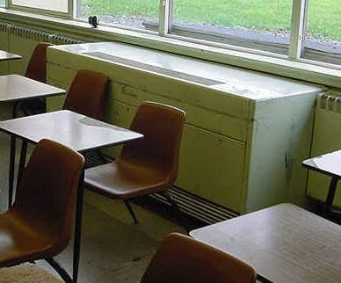

Classroom Univent 1955 Vintage

Picture 2

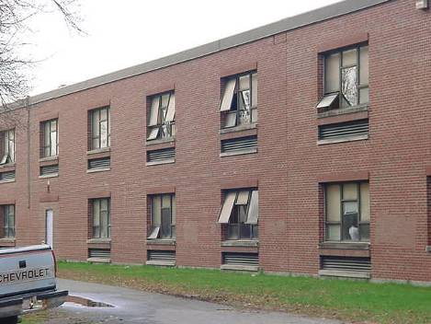

Univent Fresh Air Intakes (below Windows)

Picture 3

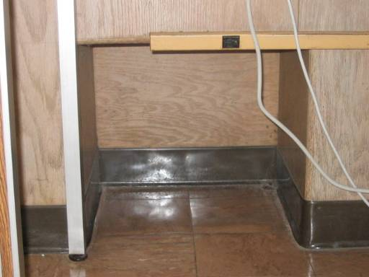

Cubby Hole Exhaust in 1955 Wing Classroom

Picture 4

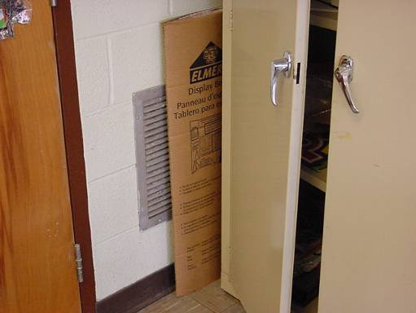

Obstructed Wall-Mounted Exhaust Vent in 1972 Wing Classroom
Picture 5

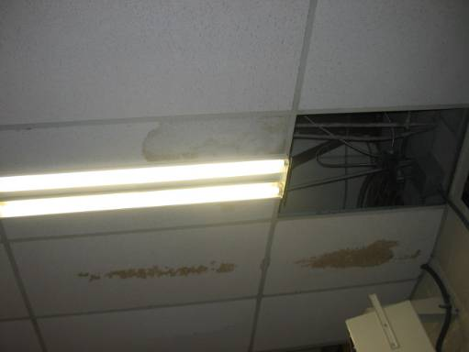

Missing/Water-Stained Ceiling Tiles

Picture 6

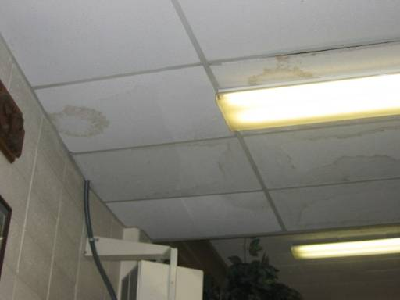

Water-Stained Ceiling Tiles
Picture 7

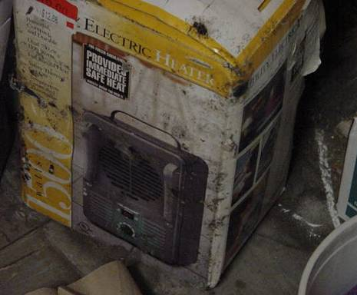

Water Damaged/Mold Colonized with Mold in Storage Closet in Room A 02

Picture 8

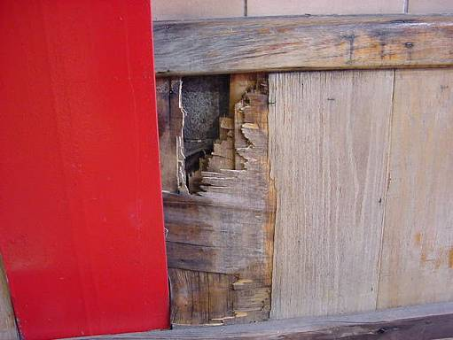

Water Damaged Wood (Wall near Bleachers) in Gymnasium
Picture 9

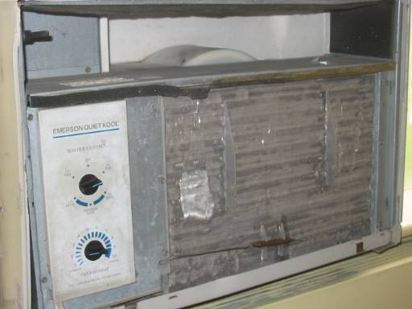

Window-Mounted Air Conditioner, Note Filter Missing and Cooling Coils
With Accumulated Dust and Debris
Picture 10

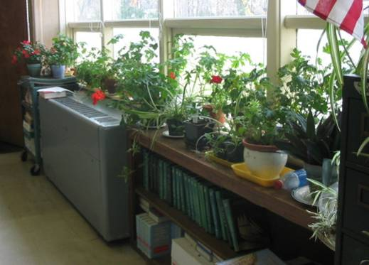

Plants in Classroom and in Close Proximity to Univent Air Diffuser
Picture 11

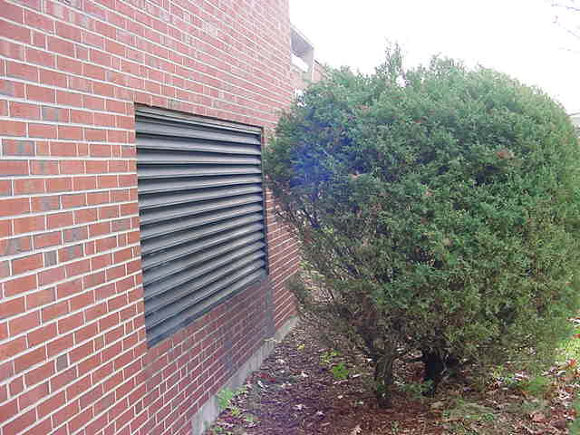

Shrubbery in Close Proximity to Air Intake

Picture 12

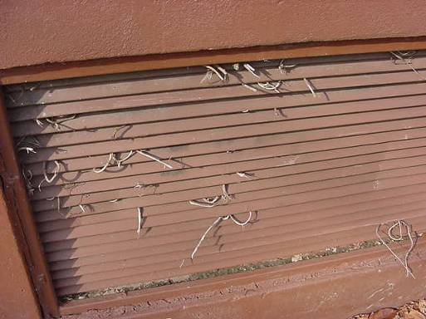

Plant Growth in Univent Air Intakes
Picture 13

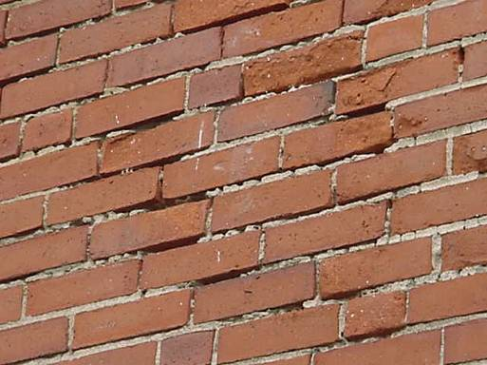

Missing/Damaged Mortar around Exterior Brick

Picture 14

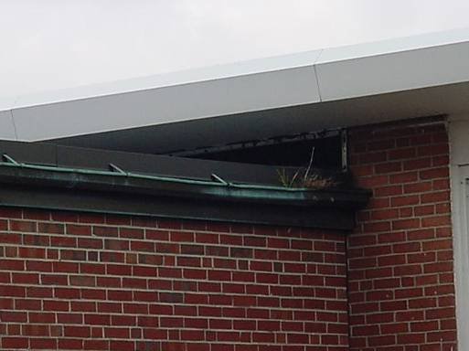

Debris Clogging Gutter
Picture 15

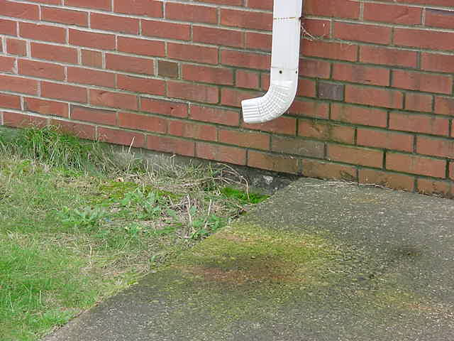

Downspout Emptying Water against the Building

Picture 16

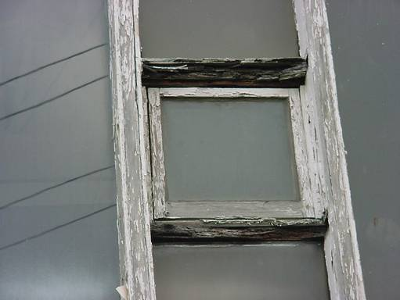

Rotted Wooden Window Frames
Picture 17

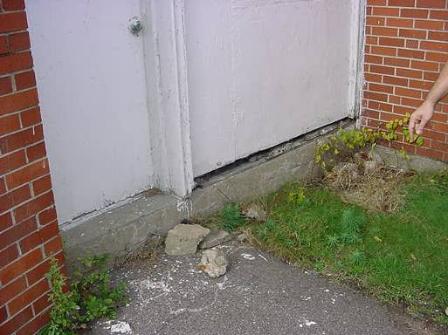

Spaces around Wooden Wall Panels/Door, Note Missing Sealing Compound

Picture 18

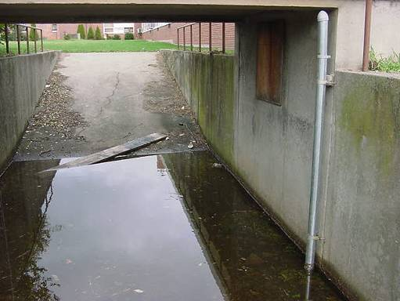

Accumulated Water Pooling at Rear of Building
Picture 19

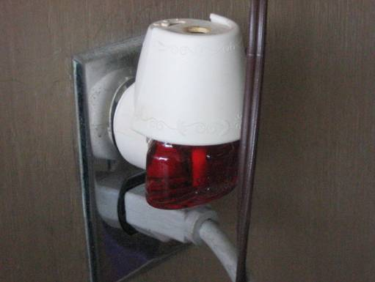

Plug-in Air Freshener in Classroom

Picture 20

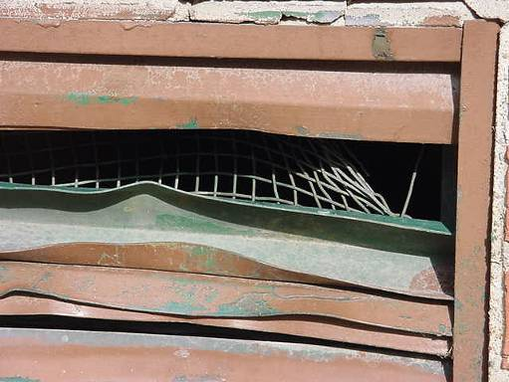

Damaged Vent Exterior/Rear of Building
Location | Carbon  Dioxide  (*ppm) | Temp  (°F) | Relative  Humidity  (%) | Occupants  in Room | Windows  Openable | Ventilation |  | Remarks
 |  |  |  |  |  | Supply | Exhaust | Remarks
Background | 375 | 64 | 83
Gym | 620 | 67 | 69 | 0 | N | Y | Y | Water damaged wood-wall, low (i.e., normal) moisture – dry, flaking/damaged ceiling-fiberglass
A 02 | 2507 | 74 | 73 | 30 | Y | Y | Y | UV-off, exhaust-off/blocked, moldy box/paper items in bottom of closet
A 04 | 1642 | 72 | 61 | 19 | Y | Y | Y | DEM, UV-off, exhaust partially blocked
A 03 | 1423 | 72 | 62 | 19 | Y | Y | Y | Chalk dust
A 01 | 1637 | 73 | 62 | 20 | Y | Y | Y | UV-off, exhaust-off, PF
Auditorium | 521 | 69 | 56 | 0 | N | Y | Y
Boiler Room |  |  |  |  | N | Y | Y | Doors open
Band Room | 673 | 73 | 46 | 7 | N | Y | Y | Water damaged plaster-ceiling
WD 20 | 1815 | 75 | 72 | 24 | Y | Y | Y | UV-off, exhaust-weak/partially blocked, PF, items hanging from CTs
WD 21 | 948 | 75 | 64 | 19 | Y | Y | Y | Windows open, UV-off, exhaust-weak/off, DO, chalk dust, DEM, AC-filter dirty
WD 22 | 1129 | 78 | 56 | 6 | Y | Y | Y | UV-off, exhaust-weak/off, chalk dust, 20 computers, 1 CT, AC-filter dirty, DO
WD 23 | 674 | 74 | 53 | 0 | Y | Y | Y | Windows open, UV-off, exhaust-weak/off, DO, chalk dust
WD 24 | 770 | 72 | 57 | 1 | Y | Y | Y | Window open, UV-off/blocked, exhaust-off, DO, 6 CTs
WD 25 | 548 | 71 | 56 | 0 | Y | Y | Y | Windows open, DO, DEM
WD 27 | 735 | 74 | 57 | 23 | Y | Y | Y | UV-off, exhaust-off, DO
WD 15 | 659 | 69 | 45 | 12 | Y | Y | Y | Window open, UV-off, exhaust-off, chalk dust, DO, 4 CTs
WD 13 | 591 | 70 | 62 | 2 | Y | Y | Y | UV-off, chalk dust, DO
WD 12 | 557 | 70 | 61 | 1 | Y | Y | Y | Dusty exhaust vent, DO, windows open
WD 11 | 555 | 71 | 60 | 29 | Y | Y | Y | Plant, cleaning products, DO, window open
E 02 | 971 | 73 | 67 | 16 | Y | Y | Y | Chalk dust, 3 CTs, 1 MT, DO, exhaust-off (in rear storage room), UV-weak
E 06 | 395 | 70 | 57 | 0 | Y | Y | Y | UV-weak, exhaust-off, DO, chalk dust
E 05 | 573 | 73 | 57 | 16 | Y | Y | Y | Window open, exhaust-off, AC-filter dirty
E 07 | 545 | 74 | 54 | 0 | Y | Y | Y
E 08 | 446 | 71 | 53 | 0 | Y | Y | Y | Window open, UV-off, exhaust-off, chalk dust, 2 MTs
E 09 | 513 | 72 | 57 | 16 | Y | Y | Y | UV-blocked, DO, 2 CTs, 19 computers
E 11 | 735 | 74 | 58 | 0 | Y | Y | Y | Plug-in air freshener, DEM, 2-dislodged CTs
E 12 | 896 | 74 | 58 | 20 | Y | Y | Y | UV-weak, exhaust-blocked, DEM, DO
E 14 | 638 | 72 | 56 | 14 | Y | Y | Y | UV-weak, plants, chalk dust
E 16 | 876 | 72 | 60 | 23 | Y | Y | Y | DEM, chalk dust, DO
E 15 | 1050 | 72 | 60 | 20 | Y | Y | Y | UV-weak, exhaust-blocked, chalk dust, 2 CTs, 1 MT
A 09 | 917 | 71 | 61 | 10 | Y | Y | N | UV-off, 1 MT
A 08 | 1295 | 72 | 65 | 12 | Y | Y | Y | UV-off, exhaust-weak, 3 CTs
A 06 | 1015 | 73 | 61 | 21 | Y | Y | Y | Window open, UV-off, exhaust-weak/off, DO, 15 CT, chalk dust
W 12 | 527 | 71 | 56 | 0 | Y | Y | Y | Windows open, exhaust-weak/off, DO
W 11 | 564 | 72 | 57 | 0 | Y | Y | Y | Window open, UV-weak, exhaust-weak/off, chalk dust, PF
W 07 | 896 | 73 | 56 | 18 | Y | Y | Y | UV-off, exhaust-off, plants, chalk dust
W 06 | 721 | 73 | 56 | 18 | Y | Y | Y | Window open, exhaust-off, plants, PF
W 05 | 1001 | 74 | 58 | 25 | Y | Y | Y | Window open, exhaust-off, chalk dust, many plants, DO
W 04 | 820 | 73 | 55 | 19 | Y | Y | Y | Window open, exhaust-off, PF, chalk dust, DO
W 08 | 638 | 73 | 55 | 27 | Y | Y | Y | Windows open, UV-weak, exhaust-off, chalk dust
W 09 | 690 | 73 | 55 | 20 | Y | Y | Y | Window open, exhaust-off, chalk dust
W 03 | 532 | 72 | 55 | 21 | Y | Y | Y | UV-weak, exhaust-off, DO, chalk dust
W 01 | 567 | 72 | 56 | 1 | Y | Y | Y | Exhaust-off, plants, chalk dust, PF
W 01A | 589 | 72 | 56 | 2 | N | N | N | Plants, PF
W 01A Office | 578 | 73 | 56 | 2 | Y | N | N | AC, plants
Library | 399 | 68 | 55 | 15 | Y | Y |  | Windows open, UV-off, PF, CT, MT, photocopiers, leak-buckets

Location | Carbon  Dioxide  (*ppm) | Temp  (°F) | Relative  Humidity  (%) | Occupants  in Room | Windows  Openable | Ventilation |  | Remarks
 |  |  |  |  |  | Supply | Exhaust | Remarks
Background | 350 | 64 | 100 |  |  |  |  | Moderate to heavy rainfall
C 09 | 845 | 71 | 68 | 22 | N | Y | Y | Accumulated items, exhaust vent partially obstructed
C 07 | 1427 | 73 | 66 | 23 | Y | Y | Y
C 05 | 770 | 73 | 59 | 0 | Y | Y | Y | UV-off/not operating, exhaust-louvers shut
C 03 | 706 | 71 | 57 | 11 | Y | Y | Y | DO
C 02 | 515 | 78 | 58 | 0 | Y | Y | Y
C 01 | 941 | 75 | 54 | 23 | Y | Y | Y | UV-off, exhaust-louvers shut, MTs, plant
Athletic Director’s Office | 442 | 75 | 53 | 0 | Y | Y | Y | Window open
Nurse’s Office | 690 | 74 | 55 | 4 | Y | N | N | Plant
School Adjustment Councilor | 825 | 74 | 56 | 2 | y | N | N
C 00 | 593 | 72 | 52 | 0 | N | N | N | AC-dusty
Girls Locker Room | 464 | 74 | 54 | 0 | Y | Y | Y | Ventilation-off, MTs-bathroom
Girls Track Locker Room |  |  |  | 0 | N | Y | Y | CTs around sky lights
Multi-Purpose Room | 600 | 70 | 55 | 1 | Y | Y | Y | 27 occupants gone 2 mins., window open, dusty vents
Storage room |  |  |  |  |  |  |  | Musty odors, crawl space hatch, sink-dry trap, utility hole behind abandoned radiator-drafts
Boys Locker Room | 600 | 65 | 61 | 0 | N | Y | Y | Ventilation-off
Girls Locker Room (Main) | 600 | 68 | 66 | 0 | N | Y | Y | Ventilation-off, large hole in ceiling plaster
Cafeteria | 600 | 72 | 64 | 2 | Y | Y | Y | CT, exterior DO
Bank | 676 | 77 | 64 | 3 | N | Y | Y | Ceiling fan, passive vents, heat complaints
Wood Shop | 401 | 69 | 61 | 12 | Y | Y | Y | Wood dust accumulation on floor, ventilation-off, wood shop odors in tech wing hallway
ACT | 405 | 71 | 62 | 0 | Y | Y | Y | CTs
C 24 | 443 | 71 | 60 | 0 | Y | Y | Y | Chalk dust, exhaust-off
C 25 | 431 | 69 | 61 | 4 | Y | Y | Y | window open, UV-off, exhaust-off
Art | 630 | 72 | 62 | 12 | Y | Y | Y | CTs, exhaust louvers shut, kiln vented to outside
C 15 | 727 | 74 | 61 | 8 | Y | Y | Y | Unvented dryer, UV-off
C 14 | 413 | 72 | 57 | 2 | Y | Y | Y | Exhaust-off, window open

