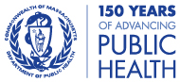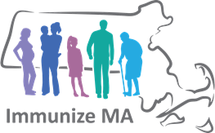

In-Person Sessions

8:00am – 12:00pm *(registration starts at 7:30 am)*

Tuesday, April 23 State Public Health Laboratory, Jamaica Plain

Please note: Cafeteria is closed; attendees are welcome to bring their own food and drink.

Wednesday, May 1 UMass Medical School, Worcester

Tuesday, May 7 Bristol Community College, Fall River

Wednesday, May 8* Holyoke Community College, Holyoke

Wednesday, May 15 Cape Cod Community College, West Barnstable

Friday, May 17**\*** Berkshire Medical Center (Hillcrest), Pittsfield

Thursday, May 23 Northern Essex Community College, Haverhill

Webinar Sessions

Begins at 12:00pm on specified date

Tuesday, June 4 Massachusetts Immunization Information System MIIS) Update

Thursday, June 6 VFC Compliance/Vaccine Storage and Handling

Tuesday, June 11 Immunization Nurse Webinar

Thursday, June 13 Epidemiology of Vaccine-Preventable Diseases

**\***There will be a Vaccine Confidence Project meeting following the event from 1:00 – 2:00 pm. All welcome, more details to follow.

# The Massachusetts Department of Public Health’s Immunization Division is pleased to announce the

# **2019**

# **Immunization Updates**

Topics will include:

* MIIS updates, including ways to improve data quality and bi-directionality
* VFC compliance/vaccine storage and handling (meets the annual VFC training requirement)
* Updates to the 2019 childhood and adult immunization schedules
* School immunization data
* Current trends in the epidemiology of vaccine-preventable diseases

**Registration opens early April!**