Medicaid 101: Introduction
Executive Office of Health and Human Services
March 2021

Distributed March 2021
This training was distributed in March 2021 and was accurate at the time of distribution. As always, Local Education Agencies are responsible for reviewing information on the School-Based Medicaid Program website (www.mass.gov/masshealth/schools) to determine whether subsequent guidance has superseded the content shared here. MassHealth plans to update these trainings periodically as needed.

Introduction to Medicaid 101 Training Series
The Medicaid 101 training series is designed to provide the essentials to understanding the School-Based Medicaid Program (SBMP). Some modules are designed for a broad, general audience. Other modules are targeted to the learning needs of a specific audience within each Local Education Agency (LEA).
Training Module | Intended Audience
Module 1: Introduction* (this module) | Everyone
Module 2: SBMP for LEA Administrators | LEA Administrators, such as superintendents, business managers, health services and special education directors
Module 3: SBMP for LEA Random Moment Time Study (RMTS) Coordinators | Designated LEA RMTS Coordinators, including those who support an RMTS coordinator with required information
Module 4: SBMP for Clinical Leadership | LEA clinical leadership staff, such as health directors and nursing directors
Module 5: SBMP for Financial Leadership | LEA financial leadership, such as business managers, accounting managers

Introduction to Medicaid 101 Training Series
The Medicaid 101 Training Series, continued:
Training Module | Intended Audience
Module 6: SBMP for Legal/Regulatory Leadership | LEA Administrators, such as superintendents, compliance staff, finance directors, legal and contracts staff
Module 7: SBMP for Technology Leadership | LEA technology directors/managers
Module 8: SBMP for Direct Service Practitioners | LEA staff who participate in the Direct Medical Services reimbursement portion of the SBMP
Module 9: SBMP for LEA RMTS Participants performing Medicaid Administrative Activities | LEA staff who participate in the RMTS

Training Agenda
  - Training Objectives
  - Overview
  - Terminology
  - How federal claiming works
  - “Relationship Map” of organizations, agencies and other entities involved in the School-Based Medicaid Program
    - What is the School-Based Medicaid Program (SBMP)?
    - What is the Random Moment Time Study (RMTS)?
    - What is Administrative Activities Claiming (AAC)?
    - What is Direct Service Claiming (DSC)?
  - Understanding Cost-Based Reimbursement
  - Next Training Steps
  - Contact Information & Resources

Training Objectives
By the conclusion of this training, you will:
  - Have a high-level understanding of the School-Based Medicaid Program (SBMP) and the federal and state agencies involved in managing the program and providing oversight
  - Gain a conceptual understanding of how the SBMP works, including a basic idea about the connections between various components of the program, including RMTS, Administrative Claiming, and Direct Services reimbursement
  - Have a basic understanding of the types of costs incurred by Local Education Agencies (LEAs) that are eligible for partial reimbursement through the SBMP
  - Have a framework from which to consider your role at your LEA to help you identify the points of interaction that you personally have with the SBMP and what additional training needs you may have
  - Know where to go for additional information and training that is pertinent to your role with the SBMP

Overview
  - Medicaid is a joint state-federal program that offers partial reimbursement for costs that are incurred by Local Education Agencies (LEAs) to provide certain covered health care services to students and for the costs related to performing certain administrative activities that support the Medicaid program
  - The Executive Office of Health and Human Services (EOHHS) is the single state agency responsible for the operation of the Medicaid program known in Massachusetts as MassHealth
  - The University of Massachusetts Medical School (UMMS) administers the School-Based Medicaid Program on behalf of and in conjunction with MassHealth
  - Local Education Agencies must take an active role in the administration of the School-Based Medicaid Program. LEAs are the entities in this program that certify the accuracy of their allowable state and local expenditures to the federal government and are requesting federal matching funds to help offset those costs.

Terminology
The Medicaid program uses some terminology which may be unfamiliar to individuals working in an educational environment. In this training series, we have tried hard to minimize jargon and the use of terminology that may not be commonly understood.
We will define terms as they come up throughout the modules. These are some very high-frequency terms that are going to be used throughout this training series:
- SBMP = School-Based Medicaid Program
- MassHealth = Medicaid and the Children’s Health Insurance Program in Massachusetts
- LEA = Local Education Agency
    - This term is inclusive of all public K-12 school entities eligible for School-Based Medicaid Program (SBMP) reimbursement, including municipal (city or town) school districts, regional school districts, regional vocational/technical schools, and public charter schools
- RMTS = Random Moment Time Study
    - The RMTS is the tool used to measure how much time LEA staff spend doing work activities that are eligible for Medicaid reimbursement

Terminology
  - Medicaid Penetration Factor = the portion of each LEA’s students who are enrolled in MassHealth.
  - Direct Services = services directly provided by an LEA staff member to a student.
  - Covered Services = The direct services provided by school staff that are identified in state and federal laws and regulations that govern the Medicaid program as services that MassHealth can provide partial reimbursement for, when provided to a MassHealth-enrolled member.
    - The full list of covered services will be explored in other training modules in this series, but to provide context, these are health-care services such as physical therapy, speech therapy, psychological counseling and skilled nursing care, to name a few.
  - Reimbursable Services = SBMP-covered direct services that meet all program requirements for reimbursement.
  - Direct Service Claiming (DSC) = The part of the SBMP reimbursement program that provides partial reimbursement to LEAs for the cost of providing reimbursable direct services to MassHealth-enrolled students.

Terminology
  - Interim Billing/Claiming = The file that is submitted to MassHealth that identifies every time a reimbursable service is provided to a MassHealth enrolled student.
  - Provider = In the School-Based Medicaid Program (SBMP), the Medicaid-enrolled provider is the LEA that is seeking reimbursement.
  - Medicaid-Qualified Practitioner = In the SBMP this is an LEA staff member who meets the licensure and supervision requirements required by the clinical licensing body specified in the Covered Services and Qualified Practitioners (CSQP) document on the SBMP Resource Center.
  - Cost-Based Reimbursement = Final reimbursement for School-Based Medicaid direct services and administration is based on Medicaid-allowable actual incurred costs that each LEA files in the form of cost reports. This means the SBMP is not a fee-for-service program.
  - Administrative Activities Claiming (AAC) = The process through which an LEA requests payment based on Medicaid-allowable actual incurred costs related to Administrative Activities.
  - Administrative Activities = Activities performed by an LEA that are necessary for the proper and efficient administration of the Medicaid State Plan, which assist students with access to health care services.

How Federal Claiming Works
- The Centers for Medicare and Medicaid Services (CMS) allows states to claim reimbursement for Medicaid-covered services and associated administrative expenses as long as certain conditions are met
  - If conditions are not met, states cannot claim
  - SBMP is no exception to this rule – SBMP claims must meet CMS-wide and MassHealth-wide standards
- In order for Massachusetts to claim federal reimbursement, there must be an associated public (state or local funds) expenditure
  - For both Administrative Activity Claiming (AAC) and Direct Service Claiming (DSC), LEAs certify their public expenditures and that the expenditures meet the requirements for reimbursement. The certification is completed quarterly for AAC and annually with the Cost Report for DSC.
  - DSC reimbursement rate: State statute mandates that LEAs receive the Federal Medical Assistance Percentage (FMAP) of the certified public expenditure for direct medical services (typically 50%, but 25% for residential tuition costs).
  - AAC reimbursement rate: For Medicaid administrative services, LEAs receive the Federal Financial Participation (FFP) percentage, which is generally 50% of the certified public expenditure.

Relationship Map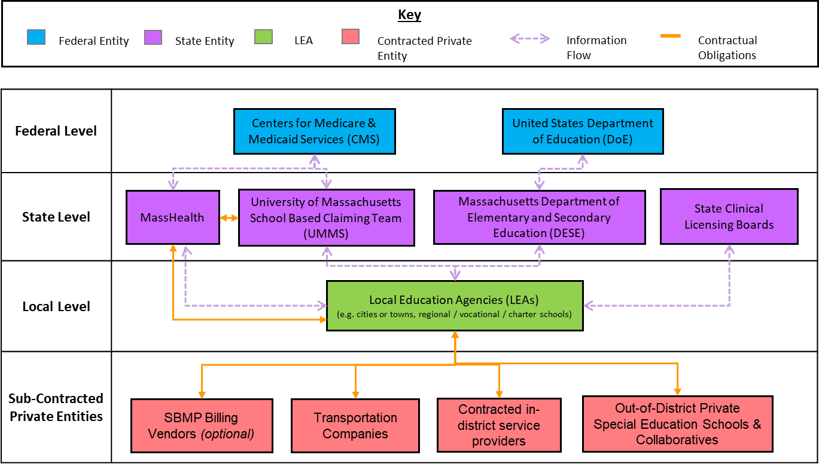

What is SBMP?
  - The School-Based Medicaid Program (SBMP) offers Local Education Agencies (LEAs) an opportunity to receive federal dollars to offset costs for providing certain Medicaid-covered direct services in a school setting. This is referred to as the Direct Services Claiming (DSC) portion of the program.
  - The school setting provides a unique opportunity for local communities to partner with MassHealth (the Massachusetts Medicaid and Children’s Health Insurance Programs) to enroll eligible children in MassHealth, and to assist children who are already enrolled to access the benefits available to them. This is referred to as the Administrative Activity Claiming (AAC) portion of the program.
The SBMP exists at the intersection between Educational Achievement and Healthy Students by providing financial support to help offset the costs of providing the health care services that students need to succeed in school, as well as the costs of administering programs and services that help ensure access to health care for students. 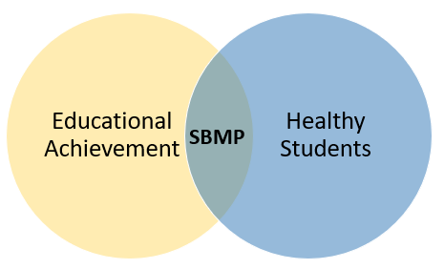

SBMP Reimbursement Streams

Random Moment Time Study’s (RMTS) Role in SBMP Reimbursement
- MassHealth uses a method called the Random Moment Time Study (RMTS) to quantify the proportion of time that staff spend performing reimbursable work activities for the purpose of allocating costs
- The RMTS samples LEA staff at random moments throughout the school year to gather information about the work activity that was occurring at these randomly assigned “snapshots” (called moments) of the staff member’s workday
- Respondents from all LEAs statewide are grouped into “pools” based on the type of work that they perform, as determined by their LEA
- A specified number of moments are assigned randomly across each statewide pool of participants each quarter
RMTS Participant Pools
1. Mental/Behavioral Health Services
2. Therapy Services
3. Medical Services
4. Administrative Services Only

Random Moment Time Study’s (RMTS) Role in SBMP Reimbursement (Cont.)
- Participation in the RMTS is required under the Provider Contract as a condition for reimbursement
- All employed and contracted staff for whom the LEA seeks Direct Service and/or Administrative Activity reimbursement must be included in the RMTS
- LEAs can receive Direct Service reimbursement for staff costs related to the provision of direct health care services to students when the qualified practitioners participate in 1 of the 3 direct service RMTS pools and meet all other requirements for direct service reimbursement.
- LEAs receive Administrative Activity reimbursement for ALL staff in the RMTS (regardless of RMTS pool)
- The results of the RMTS are combined with allowable LEA costs, which are submitted in an annual cost report and in administrative activity claims, to determine the reimbursable portion of each LEA’s costs

Random Sampling
- Using the power of statistically valid random sampling, LEA staff do not need to document how they spend their workday, all day, every day.
- Instead, by asking what they are doing during a relatively small number of randomly assigned working moments (minutes), we can predict within a 95% confidence level how LEA staff time is spent all day, every day.

Cost-Based Reimbursement - AAC and DSC
The SBMP uses the distribution of LEA staff working time quantified by the RMTS to allocate costs – i.e. to determine what portion of the cost of employed or contracted staff can be attributed to doing work activities that are eligible for Medicaid AAC and DSC reimbursement.

LEA RMTS Requirements
LEAs must:
- Designate an LEA-employed RMTS Coordinator for the LEA to maintain the list of RMTS participants and monitor staff participation in the RMTS to ensure all randomly assigned moments are answered.
- Update the LEA’s list of RMTS participants quarterly per program guidelines
- Ensure staff are included in the appropriate RMTS cost pool. This determination should be made based on individual job function rather than job title (e.g. counselors may be in different pools, or may not be included at all, based on how they spend their time) and in accordance with program guidelines
- Provide training to staff who will be participating in the RMTS and oversee staff training compliance
- Ensure that at least 85% of all moments randomly assigned to the LEA’s staff are answered within the required timeframe

What is Administrative Activities Claiming (AAC)?
- The Administrative Activities Claiming (AAC) program reimburses government agencies for some of the costs of their allowable Medicaid administrative functions when those activities support provision of services as outlined in the Medicaid State Plan
- Final reimbursement for the AAC component of School-Based Medicaid services is based on Medicaid-allowable actual incurred costs related to performance of Medicaid administrative activities as quantified by the Random Moment Time Study (RMTS)
- To seek reimbursement, LEAs file quarterly AAC cost reports.
- Unlike direct service (DSC) reimbursement, there are no interim claims for AAC
- The Administrative Only RMTS pool is designed to identify additional staff for whom the LEA is not claiming, or cannot claim, Direct Service reimbursement, but who perform reimbursable Medicaid administrative activities.

Reimbursable Administrative Activities
There are seven types of reimbursable administrative activities:
  - Medicaid Outreach—informing eligible or potentially eligible individuals and families about MassHealth and accessing MassHealth benefits.
  - Application Assistance—assisting individuals or families to apply or renew eligibility for MassHealth.
  - Provider Networking/Program Planning/Interagency Coordination—participating in activities to develop strategies to improve the delivery of covered services, including collaborative activities with other agencies regarding covered services.
  - Individual Care Planning, Monitoring, Coordination, and Referral for Covered Services— making referrals to covered services, coordinating, or monitoring the delivery of covered services.
  - Arranging MassHealth-covered transportation.
  - Arranging or providing translation or interpretation services when required to access covered services.
  - Training—participating in and coordinating (including providing) training related to Medicaid topics.

What is Direct Service Claiming (DSC)?
- The Direct Service Claiming (DSC) program is the mechanism through which LEAs seek federal reimbursement for the provision of covered direct services
- This is separate and distinct from the administrative costs captured in Administrative Activity Claiming (AAC))
- Throughout the year, LEAs submit interim claims for reimbursable services provided to eligible MassHealth-enrolled members through MassHealth’s Medicaid Management Information System (MMIS). Interim claims must be submitted within 90 days of the date a reimbursable service was provided to a student.
- After the conclusion of the fiscal year, LEAs submit a Cost Report to determine the total Medicaid-allowable costs the LEA incurred that year
- Submitted and paid interim claims are required to demonstrate that reimbursable services were provided to an eligible member and are the basis for which costs can be included in the Annual Cost Report
- All of the School-Based Medicaid Provider’s interim claims are reconciled to the allowable costs as determined by the certified Cost Report. Interim claims paid throughout the year are deducted from the total reimbursable amount, and the remaining amount is paid to the LEA during cost settlement.

Reimbursable Direct Services
The SBMP covers health services provided in the school setting, including:

Reimbursable Direct Services
- Covered Service vs. Reimbursable Service: All costs claimed under the School-Based Medicaid Program must be consistent with state and federal laws and regulations. When an SBMP-covered service is provided and meets all program requirements for reimbursement, that service is referred to as a reimbursable service.
- Resources and important additional information about the direct service claiming program are available on the “Resource Center” page of the SBMP website:
https://www.mass.gov/info-details/sbmp-resource-center
- The list of SBMP-covered services and practitioner qualification for provision of those services is outlined in “Local Education Agencies Covered Services and Qualified Practitioners” document
- The corresponding list of procedure codes, modifiers, and maximum interim billing fees can be found in the “SBMP Billable Procedure Codes and Maximum Fees” document
- Full instructions for all program requirements for reimbursement of direct services are provided in the “SBMP Direct Service Claiming (DSC) Guide”

Understanding Cost-Based Reimbursement
- For most of us, our personal experience with health insurance reimbursement involves our health care provider submitting a claim to our health insurance company to request reimbursement for the procedure or service that they provided. We call that reimbursement methodology “fee for service” reimbursement, where the provider agrees to accept a certain fee for the service provided.
- Fee for service reimbursement involves negotiation of fee schedules, complex medical procedure coding rules, and often other administrative requirements such as provider network requirements, prior authorization requirements and so forth.
- Cost-based reimbursement is an alternative methodology that instead reimburses each LEA based on the LEA’s actual, incurred costs to provide services.

Understanding Cost-Based Reimbursement
DSC & AAC Calculation:
Component | Source | Example
Allowable Costs: What costs did my LEA incur (for staff and other categories of costs) related to either Direct Services Claiming (DSC) or Administrative Activities Claiming (AAC)? | Payroll records; other accounting system records of expenditures | $500,000
RMTS Results: What portion of LEA staff working hours are spent performing duties that are reimbursable by Medicaid? | Statewide RMTS Percentages | X 35%
Medicaid Penetration Factor: What portion of the students that my LEA serves are enrolled in MassHealth? | Medicaid Penetration Factor calculated from Medicaid eligibility matching statistics | X 45%
Gross Medicaid allowable expenditures total: |  | = $78,750

Next Training Steps
We suggest that you select the module to move on to next from the list below, based on your role with your LEA and your specific training needs.
Training Module | Intended Audience
Module 2: SBMP for LEA Administrators | LEA Administrators, such as superintendents, business managers, health services and special education directors
Module 3: SBMP for LEA Random Moment Time Study (RMTS) Coordinators | Designated LEA RMTS Coordinators, including those who support an RMTS coordinator with required information
Module 4: SBMP for Clinical Leadership | LEA clinical leadership staff, such as health directors and nursing directors
Module 5: SBMP for Financial Leadership | LEA financial leadership, such as business managers, accounting managers
Module 6: SBMP for Legal/Regulatory Leadership | LEA administrators, such as superintendents, compliance staff, finance directors, legal and contracts staff
Module 7: SBMP for Technology Leadership | LEA technology directors/managers
Module 8: SBMP for Direct Service Practitioners | LEA staff who participate in the Direct Medical Services reimbursement portion of the SBMP
Module 9: For LEA RMTS Participants performing Medicaid Administrative Activities | LEA staff who participate in the RMTS

Contact Information & Resources
MassHealth School-Based Medicaid Program information:
www.mass.gov/masshealth/schools
UMMS School-Based Help Desk:
SchoolBasedClaiming@umassmed.edu
1-800-535-6741
M-F 7:30 a.m. – 7:30 p.m.

