Medicaid 101: For LEA Administrators
Executive Office of Health and Human Services
April 2021

Distributed April 2021
This training was distributed in April 2021 and was accurate at the time of distribution. As always, Local Education Agencies are responsible for reviewing information on the School-Based Medicaid Program website (www.mass.gov/masshealth/schools) to determine whether subsequent guidance has superseded the content shared here. MassHealth plans to update these trainings periodically as needed.

Introduction to Medicaid 101 Training Series
The Medicaid 101 training series is designed to provide the essentials to understanding the School-Based Medicaid Program (SBMP). Some modules are designed for a broad, general audience. Other modules are targeted to the learning needs of a specific audience within each Local Education Agency (LEA).
The Medicaid 101 Training Series:
Training Module | Intended Audience
Module 1: Introduction | Everyone
Module 2: SBMP for LEA Administrators (this module) | LEA Administrators, such as superintendents, business managers, health services and special education directors
Module 3: SBMP for LEA Random Moment Time Study (RMTS) Coordinators | Designated LEA RMTS Coordinators, including those who support an RMTS coordinator with required information
Module 4: SBMP for Clinical Leadership | LEA clinical leadership staff, such as health directors and nursing directors
Module 5: SBMP for Financial Leadership | LEA financial leadership, such as business managers, accounting managers

Introduction to Medicaid 101 Training Series
The Medicaid 101 Training Series, continued:
Training Module | Intended Audience
Module 6: SBMP for Legal/Regulatory Leadership | LEA Administrators, such as superintendents, compliance staff, finance directors, legal and contracts staff
Module 7: SBMP for Technology Leadership | LEA technology directors/managers
Module 8: SBMP for Direct Service Practitioners | LEA staff who participate in the Direct Medical Services reimbursement portion of the SBMP
Module 9: SBMP for LEA RMTS Participants performing Medicaid Administrative Activities | LEA staff who participate in the RMTS

Training Agenda
Training Objectives
- Building Your LEA’s Medicaid Team
- Random Moment Time Study (RMTS) Coordinator Role
- Clinical Leadership Role
- Financial Leadership Role
- Legal / Regulatory Leadership Role
- Technology Leadership Role
- Bring It All Together
- Overcome Common Roadblocks
- Next Training Steps
- Contact Information & Resources

Training Objectives
By the conclusion of this training, you will:
- Learn some key things to consider to structure your LEA’s participation in the program for success, such as
  - What types of information is needed?
  - What types of knowledge and expertise is needed?
  - What school departments and staff are involved?
- Create an action plan to build your LEA’s Medicaid team
- Return to your LEA with information, ideas and perspective on how to overcome common roadblocks and ensure that your LEA receives the maximum allowable reimbursement.

Identifying Your LEA’s Medicaid Team Members
Successful participation in the School-Based Medicaid Program (SBMP) requires coordination and collaboration among people responsible for managing each of the key pieces of the Medicaid program.
Senior LEA leadership support and empowerment of staff in each of these key roles will ensure that your SBMP reimbursement program operates smoothly and effectively.
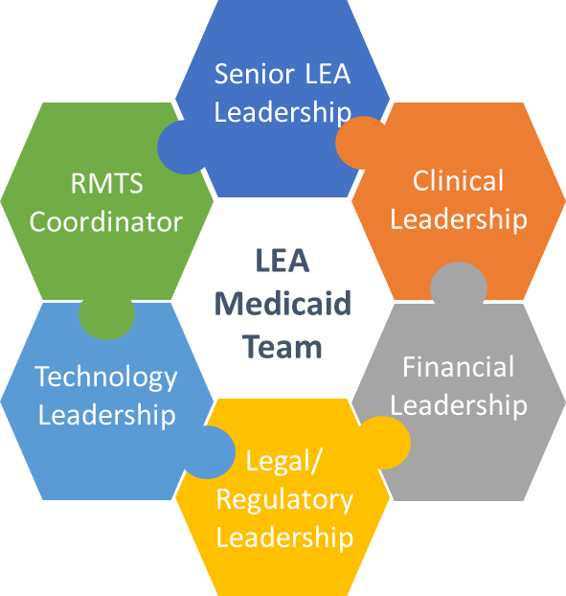

RMTS Coordinator Role
- LEAs are required to designate an individual from the LEA as the primary contact for RMTS operations (RMTS Coordinator).
- LEAs may also designate another LEA employee or contracted billing agent to assist with RMTS operations. However, as with all LEA contractual obligations, the LEA is ultimately responsible for ensuring compliance with all program requirements and deadlines as outlined in the LEA RMTS Coordinator Guide for Random Moment Time Study (RMTS).
- Due to the key nature of RMTS in determining all SBMP reimbursement, it is strongly recommended that an appropriate staff member is designated who
  - has the authority to oversee the RMTS for the LEA
  - has time designated for RMTS coordinator duties
  - has been properly trained in RMTS coordinator duties
  - has the support and cooperation of other staff/departments to fulfill the responsibilities
- Management of your LEA’s participation in RMTS directly impacts your reimbursement and reimbursement to all LEAs statewide!

High-Level Cost-Based Reimbursement Methodology
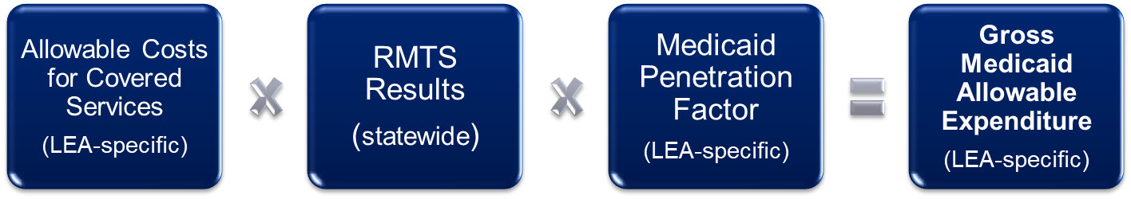
In the cost-based reimbursement methodology used in the SBMP, LEA-specific costs based on each LEA’s actual, incurred costs to provide services, are multiplied by the statewide RMTS percentages (portion of those costs that can be attributed to performing reimbursable work activities) then the LEA’s specific Medicaid Penetration Factor (portion of students who are enrolled in MassHealth) is applied to calculate the total Medicaid allowable expenditures.
This is why we say that “we’re all in this together” in terms of the RMTS, because the results are applied statewide to all LEA reimbursement calculations. Therefore, the quality of each participant’s responses, and the degree to which each LEA is compliant with RMTS requirements impacts every participating LEA in the state.

RMTS Coordinator Role
The LEA RMTS Coordinator responsibilities require coordination with other staff and support areas. Below are some of the potential support areas and related information.
Support Area | Information Needed
Human Resources | Staffing changes: hires, promotions, leave of absence status
Building, Department or Team-level Support | Staff scheduled workdays and hours
Payroll/Business Office | Staff funding sources, ensuring that staff whose costs are included in the indirect cost rate are excluded from RMTS
Building, Department or Team-level Support | Determine appropriate staff for Direct Service pool participation vs. Administrative Only participation; provide staff training; follow up when moments aren’t answered; provide feedback to RMTS coordinator on staff absences and schedule changes
HR or Clinical Supervisors | Tracking staff clinical license status, as applicable

Clinical Leadership Role
For LEAs who participate in the Direct Medical Services reimbursement portion of the program, identifying clinical leader(s) will be key to ensuring that all requirements for reimbursement are met and that opportunities for reimbursement are recognized and pursued.
- Monitor licensure status and ensure supervision where required
- Clinical training for LEA procedures around documentation of plans of care and service delivery to be consistent with clinical standards of practice
- Clinical input and perspective in the design of interfaces/processes that support Medicaid billing

Financial Leadership Role
A financial leader plays a key role in ensuring accurate expenditure reporting and should be empowered to institute procedures that will efficiently and effectively identify allowable expenditures and ensure reimbursement and compliance.
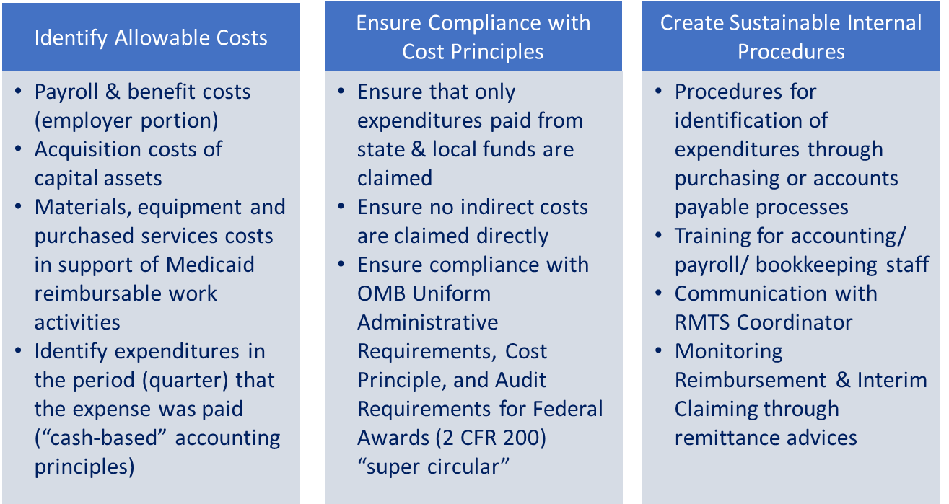

Legal/ Regulatory Leadership Role
LEAs are responsible for compliance with the terms of the LEA Provider Contract and state and federal regulations and guidance. Since there are so many moving pieces to monitor, LEAs should designate someone to be responsible for monitoring LEA compliance, addressing contract issues and providing audit responses.
- A model SBMP provider contract is published on the SBMP Resource Center for easy reference: https://www.mass.gov/doc/school-based-medicaid-program-amended-contract-and-appendix-a-for-fy20/download
- In addition to FERPA privacy regulations, participation in the Medicaid program also requires compliance with any relevant provisions of the Health Insurance Portability and Accountability Act of 1996 (HIPAA)
- The SBMP mandatory School District Contact Information form requires LEAs to identify a primary point of contact for audits, PERM reviews, program compliance, record requests, etc. Be sure to keep this important contact information up to date by updating the form as needed. The form can be downloaded from the SBMP Resource Center: https://www.mass.gov/doc/school-district-contact-information-forrm/download

Applicable Laws, Regulations, and Published Guidance
Any LEA or subcontractor participating in the SBMP must comply with applicable federal and state laws, regulations, published guidance, and the terms of the provider contract. These include, but are not limited to:
- Section 1902(a) of the Social Security Act
- Code of Federal Regulation (CFR) Titles 42, 45
- OMB Uniform Administrative Requirements, Cost Principle, and Audit Requirements for Federal Awards (2 CFR 200): www.federalregister.gov/documents/2013/12/26/2013-30465/uniform-administrative-requirements-cost-principles-and-audit-requirements-for- federal-awards
- OMB Circular A-133 Audits of States, Local Governments and Non-Profit Organizations
- MassHealth School-Based Medicaid Program Bulletins
- MassHealth School-Based Medicaid Program Instruction Guides
- Massachusetts School-Based Medicaid Program Provider Contract

Technology Leadership Role
Key areas for a technology leader to be involved with the Medicaid program are:
- Design of queries or reports from the Student Information Management system to provide required student enrollment demographic data for quarterly Medicaid eligibility matching process
- Interfacing of data between IEP data, student records, student health data, and Medicaid billing software or vendor
- Coordination with RMTS Coordinator relative to internet connectivity, currency of internet browsers, and staff ability to receive RMTS notification emails and complete their online moment responses, including the use of cell phones or tablets to respond to moments
- Technical assistance/support for processes and solutions to track required data in financial/accounting systems, payroll/HR systems and Student Information Management systems
- Ensure compliance of technology with provisions of the Health Insurance Portability and Accountability Act of 1996 (HIPAA)
- Ensure system(s) compliance with 6-year record retention requirement per the terms of the Medicaid provider contract

Bring it All Together
Manage your LEA’s Medicaid reimbursement program:
- Identify key staff to form the team
- Support team members to fulfill their role by allowing sufficient work time and standing behind the importance of their work
- Take responsibility for oversight of all program activities, claiming, and compliance

Overcome Common Roadblocks
The following can be roadblocks or signposts for smooth travel through the SBMP:
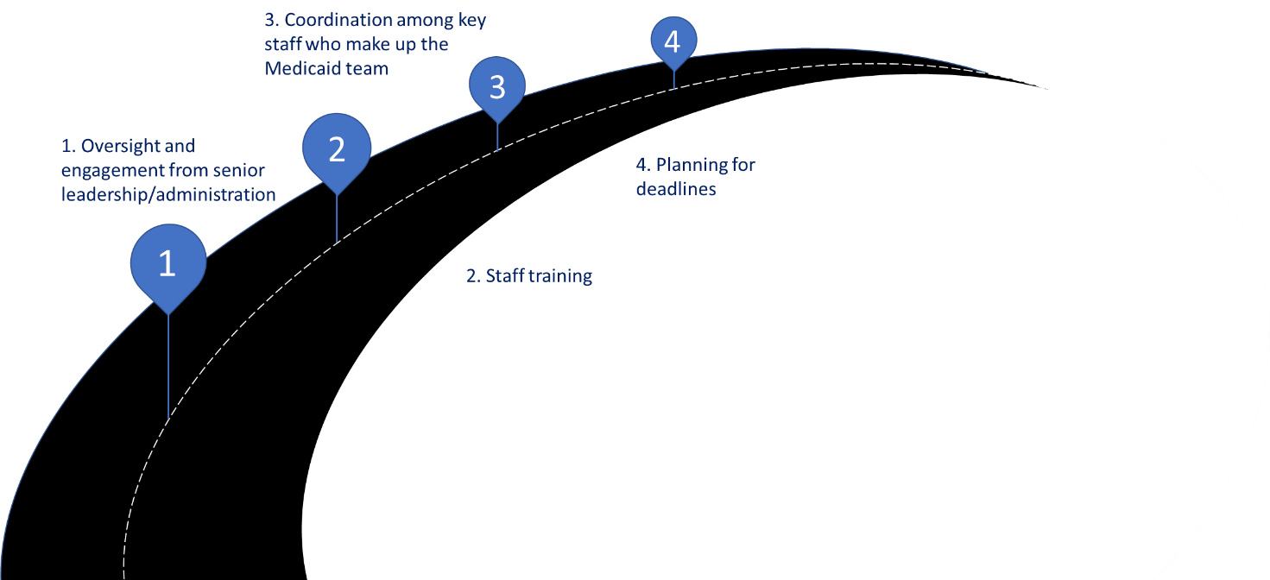

1. Oversight from Senior Leadership / Administration
Someone in a senior leadership position at every LEA signs the Certification of Public Expenditure (CPE) letters with every quarterly Administrative Activity Claim and annual Direct Services Cost Report.
Has your LEA’s senior leadership provided appropriate oversight to confidently certify the following statements included in the certification?
- The expenditures and other information reported are true and correct statements prepared from the books and records of the LEA in accordance with applicable instructions
- The expenditures included are based on the actual allowable cost of allowable expenditure categories
- The required amount of public funds were used to pay for the total allowable expenditures and such public funds are not federal funds and are not funds authorized by federal law to be used to match other federal funds
- No expenditures claimed are duplicative of any costs included in the claim or report through the application of the Indirect Cost Rate
- The signor has made a good faith effort to assure that all information reported is true and accurate
- The signor understands that falsification or concealment of a material fact may result in prosecution under federal or state civil or criminal law

2. Staff Training
Training for members of your LEA’s Medicaid team, and for all staff involved in the Medicaid program at any level, requires a plan. The risks of inadequate training include: failure to maximize your LEA’s Medicaid reimbursement; and non-compliance and audit/recoupment risk.
Identifying staff who need training, and planning timely trainings, is an ongoing process as new staff are hired, job responsibilities change, and time goes on indicating that refresher training may be appropriate. LEAs are organizations made up of people, and people will naturally seek information to fill in any knowledge gaps from wherever they can.
Where/How are your staff filling in any knowledge gaps?
- Instructions that have been handed down from a predecessor or co-worker without comparing with official MassHealth guidance?
- Casual “water cooler” conversations?
- Organized and planned process for timely dissemination of training information?

2. Staff Training
A comprehensive training plan for your LEA will likely include information from several sources:
Training Information Needed | Sources
SBMP policies and guidelines | MassHealth SBMP website: www.mass.gov/masshealth/schools
SBMP procedures for using UMMS-hosted SBMP applications | UMMS Help Desk: SchoolBasedClaiming@umassmed.edu
FERPA and other educational policies and guidelines | Dept. of Elementary and Secondary Education (DESE)
Guidelines for clinical practice standards | State clinical licensing boards: https://www.mass.gov/topics/division-of-professional-licensure-boards-of-registration  Professional practice organizations: AOTA, MAOT, APTA, APTA of MA, ASHA, MSHA, ANA, MNA, MSNO, MAMHCA, ABHMass, NASWMA, APA, NEAFAST, and others
Procedures for using billing vendor software/systems for Medicaid billing | Your LEA’s Medicaid billing vendor or software company

3. Coordination of Effort Among the Medicaid Team
If you reflect on your LEA’s internal operations that support the Medicaid program, are your team’s efforts well coordinated?
- Does your RMTS Coordinator have the information and support needed to accurately identify all of the correct staff to include in the RMTS, and only the correct staff who are eligible to be included (and their schedules)?
- Do department heads/team leaders/clinical supervisors participate in the identification of staff members for Medicaid program participation? Are they ensuring that staff have received appropriate training?
- What does your expenditure data collection process look like? Are all the people involved in identifying expenditures for the Administrative Activity claims and Direct Services Cost Reports properly trained? Do they collaborate to ensure accuracy and compliance?
- Can your LEA improve overall coordination and collaboration among the Medicaid team and support areas? Is everyone “on the same page” or do staff work in isolation?
THE BOTTOM LINE: Do you have a well-functioning Medicaid TEAM? If not, what steps will you take to change this?

3. Coordination with External Partners in your LEA’s Medicaid Team
Many LEAs rely on external partners for assistance with participation in the SBMP. Administrative oversight of your LEA’s relationship with these partners and coordination of the work that each performs is a key to successful participation in the program. Similar to your team’s review of internal coordination of efforts, you may want to make sure coordination with external partners is as it should be in terms of defining roles and responsibilities, ensuring good communication and information flow, ensuring sharing of training information, and program compliance.
- Examples of key, external partners include:
- Billing vendors
- Private special education schools
- Special education collaboratives
- Contracted staffing agencies or individuals
- Contracted transportation companies

4. Plan to Meet all Deadlines
Most deadlines in the Medicaid program have been in place for over 10 years. All deadlines are published in corresponding instruction guides and also published in an annually updated, easy to reference, one-page overview on the SBMP Resource Center (https://www.mass.gov/info-details/sbmp-resource-center).
Last minute scrambles and missed deadlines can lead to inaccurate data, potential compliance issues, audit risk and potential lost reimbursement. Therefore, it’s best to have internal processes in place to gather all required information, review information for accuracy and compliance, and comfortably meet deadlines for:
- RMTS participant lists and work schedules
- Quarterly Administrative Activity Claims
- Ongoing Interim direct service claims
- Annual Cost Report
If you utilize a third-party billing vendor to assist with any processes, be sure to get required information to them in sufficient time for it to be compiled and submitted to the Medicaid program
Billing vendors are a great resource and partner for LEAs in the program, however the LEA is ultimately responsible for the accuracy of all data and for meeting all deadlines, so collaborate with your vendor on how best to ensure program integrity

Next Training Steps
There may be other modules in the Medicaid 101 training series that apply to your specific training needs
Training Module | Intended Audience
Module 3: SBMP for LEA Random Moment Time Study (RMTS) Coordinators | Designated LEA RMTS Coordinators, including those who support an RMTS coordinator with required information
Module 4: SBMP for Clinical Leadership | LEA clinical leadership staff, such as health directors and nursing directors
Module 5: SBMP for Financial Leadership | LEA financial leadership, such as business managers, accounting managers
Module 6: SBMP for Legal/Regulatory Leadership | LEA administrators, such as superintendents, compliance staff, finance directors, legal and contracts staff
Module 7: SBMP for Technology Leadership | LEA technology directors/managers
Module 8: SBMP for Direct Service Practitioners | LEA staff who participate in the Direct Medical Services reimbursement portion of the SBMP
Module 9: For LEA RMTS Participants performing Medicaid Administrative Activities | LEA staff who participate in the RMTS

Contact Information & Resources
MassHealth School-Based Medicaid Program information:
www.mass.gov/masshealth/schools
UMMS School-Based Help Desk:
SchoolBasedClaiming@umassmed.edu
1-800-535-6741
M-F 7:30 a.m. – 7:30 p.m.

