Medicaid 101: For Local Education Agency (LEA) Random Moment Time Study (RMTS) Coordinators
Executive Office of Health and Human Services
April 2021

Distributed April 2021
This training was distributed in April 2021 and was accurate at the time of distribution. As always, Local Education Agencies are responsible for reviewing information on the School-Based Medicaid Program website (www.mass.gov/masshealth/schools) to determine whether subsequent guidance has superseded the content shared here. MassHealth plans to update these trainings periodically as needed.

Introduction to Medicaid 101 Training Series
The Medicaid 101 training series is designed to provide the essentials to understanding the School-Based Medicaid Program (SBMP). Some modules are designed for a broad, general audience. Other modules are targeted to the learning needs of a specific audience within each Local Education Agency (LEA).
The Medicaid 101 Training Series:
Training Module | Intended Audience
Module 1: Introduction | Everyone
Module 2: SBMP for LEA Administrators | LEA Administrators, such as superintendents, business managers, health services and special education directors
Module 3: SBMP for LEA Random Moment Time Study (RMTS) Coordinators (this module) | Designated LEA RMTS Coordinators, including those who support an RMTS coordinator with required information
Module 4: SBMP for Clinical Leadership | LEA clinical leadership staff, such as health directors and nursing directors
Module 5: SBMP for Financial Leadership | LEA financial leadership, such as business managers, accounting managers

Introduction to Medicaid 101 Training Series
The Medicaid 101 Training Series, continued:
Training Module | Intended Audience
Module 6: SBMP for Legal/Regulatory Leadership | LEA Administrators, such as superintendents, compliance staff, finance directors, legal and contracts staff
Module 7: SBMP for Technology Leadership | LEA technology directors/managers
Module 8: SBMP for Direct Service Practitioners | LEA staff who participate in the Direct Medical Services reimbursement portion of the SBMP
Module 9: SBMP for LEA RMTS Participants performing Medicaid Administrative Activities | LEA staff who participate in the RMTS

Training Agenda
- Training Objectives
- RMTS Coordinator Role and Responsibilities
- Which LEA staff should participate in RMTS?
- RMTS Work Schedules
- Monitoring RMTS Participation
- Tracking Clinical Staff license information
- RMTS Participant Training
- Review RMTS deadlines
- Provide additional training resources

Training Objectives
By the conclusion of this training, you will:
- Have a general understanding of the role of a school district RMTS coordinator and the key responsibilities
- Have ideas about what other internal district resources you will need to complete the responsibilities
- Develop an understanding of which staff should be included in RMTS
- Develop an understanding of RMTS work schedules
- Understand the RMTS participation requirements
- Understand RMTS participant training requirements and have ideas and resources for participant training
NOTE: This training is at the introductory “101” level. Participants will get an overall description of concepts and processes to build foundational knowledge, but this training will not provide all the necessary details that an RMTS Coordinator needs to know. Please plan to review the additional resources and training opportunities that will be introduced in this training.

RMTS Coordinator Role
- LEAs must designate an individual from the LEA as an RMTS Coordinator.
- This person is the primary contact for all matters related to the operations of the RMTS.
- LEAs may also designate another LEA employee or contracted billing agent to assist with RMTS operations.
- Regardless of designation to an outside entity, like all LEA contractual obligations, the LEA is ultimately responsible for ensuring compliance with RMTS and other program requirements and deadlines.
- To update this information, complete and return the “School-Based Medicaid Program: District Contact Designee Information” sheet found on the SBMP Resource Center (https://www.mass.gov/info-details/sbmp-resource-center).
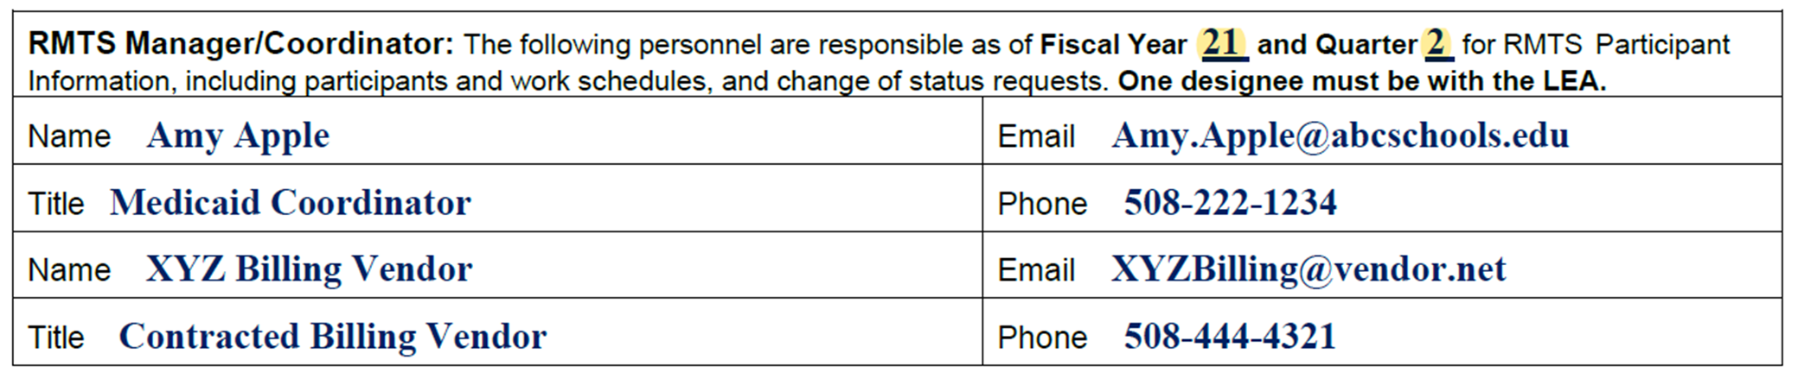

Resources for RMTS Coordinators
Resources available on the SBMP Resource Center (https://www.mass.gov/info-details/sbmp-resource-center):
- LEA RMTS Coordinator Guide for Random Moment Time Study (RMTS)
- Local Education Agencies Covered Services and Qualified Practitioners
- SBMP Program Guide for Local Education Agencies
- SBMP Direct Service (DSC) Claiming Guide
- School-Based Medicaid Program Provider Contract
- School District Contact and Authorized Designee Forms
- Dates & Deadlines for SFY 20XX
Resources available from the UMMS SBMP Help Desk:
- Step by Step Instruction Guide for Managing RMTS Participants
- Step by Step Instruction Guide for Managing RMTS Work Schedules

RMTS Coordinator Responsibilities
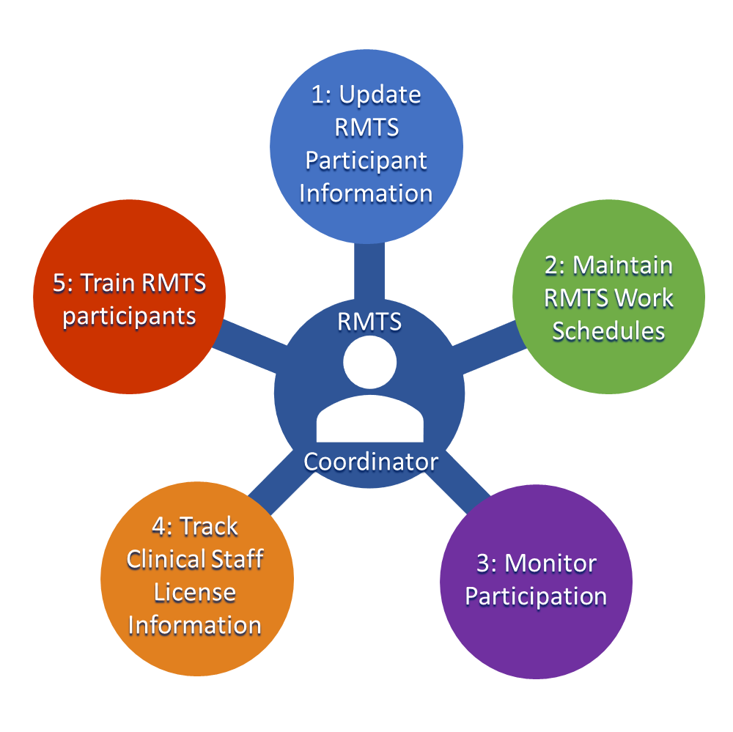

1 Update RMTS Participant Information
A key to your school district’s Medicaid reimbursement program is including ALL of the “right” staff (employees and contractors) in the RMTS, but ONLY the right staff.
How do you know who the “right” staff are?
- It’s all about identifying the staff members at your school district who perform work activities that are reimbursable in either the Medicaid Administrative program or the Medicaid Direct Service reimbursement program.
- And, on an ongoing basis, maintaining that data to add new hires and remove staff who have terminated, retired or changed job duties, among other things.
To successfully manage this task, RMTS Coordinators may need to work with other district staff to gather required information.

RMTS Information: Who? When? How?
Most RMTS Coordinators need support and assistance to accurately maintain RMTS participant information.
Information Needed | Who will provide the information? | How much time do they need to prepare? | What’s the correct data source? | How will information be communicated?
New hires | HR? Payroll? | 1 week? | Payroll system? | Reports? Email?
Job position/duty changes | HR? Payroll? Building Admin? Supervisors? | 10 days? | Payroll system? | Reports? Email?
Staff funding source & FTE | Finance? | 1 week? | General Ledger? | Reports? Email?
Work Schedules | Building Admin? | 2 weeks? | Timekeeping system? | Reports? Email?
Leaves; Retirements; Terminations | HR? Payroll? | 1 week? | HR system? | Reports? Email?

Which LEA staff should participate in RMTS?
Eligible staff who meet pool requirements should be included in the appropriate RMTS pool.
The 4 RMTS pools are:
- Mental/Behavioral Health (Direct Services & Admin)
- Therapy Services (Direct Services & Admin)
- Medical Services (Direct Services & Admin)
- Administrative Only (Administrative Reimbursement Only)

Participant/Staff Pools – Direct Services
Who should be included in one of the Direct Services Pools?
- Only staff who will meet ALL requirements for reimbursement under the Direct Service claiming program should be included in a Direct Service RMTS Pool. Requirements include:
- Have an active license for their service specialty and receive clinical supervision (as required)
- See “LEA Covered Services and Qualified Practitioners” document (available on the Resource Center): https://www.mass.gov/files/documents/2019/02/27/sbmp-lea-csqp-0219%20%28rev%29.pdf
- Provide Services that meet Medicaid reimbursement requirements
- The LEA submits interim claims to MMIS
Resources for details regarding requirements for reimbursement of direct services are detailed in the “SBMP Direct Service Claiming (DSC) Guide” available on the Resource Center (https://www.mass.gov/info-details/sbmp-resource-center) and in Module 8 of this training series.

Participant/Staff Pools – Direct Services
Each staff member should be considered individually – not included based on job title
Mental/Behavioral Health | Therapy Services | Medical Services
Autism Specialist (incl. Assistant  Applied Behavior Analyst)  Licensed Applied Behavior Analyst  Licensed Clinical Social Worker  Licensed Independent Clinical Social Worker  Licensed Marriage and Family Therapist  Licensed Mental Health Counselor  Licensed Psychiatrist  Licensed Psychologist  Licensed Educational Psychologist  DESE Licensed School Psychologist | Licensed Audiologist  Licensed Hearing Instrument Specialist  Licensed Occupational Therapist  Licensed Occupational Therapy Assistant  Licensed Physical Therapist  Licensed Physical Therapy Assistant  Licensed Speech-Language Pathologist  Licensed Speech-Language Pathology Assistant | Dental Hygienist  Licensed Nutritionist/Dietitian  Licensed Physician  Optometrist  Personal Care Service Provider  Licensed Practical Nurse (LPN)  Registered Nurse (RN)

Participant/Staff Pools – Administrative
Who should be included in the Administrative Only Pool?
- Employed or contracted staff members who are reasonably expected to perform Medicaid reimbursable Administrative Activities.
- Remember: staff included in any Direct Service pool are eligible for reimbursement for both Direct Medical Services and Administrative Services, so they’re already taken care of. For the Administrative Only Pool, you’re identifying any additional staff who perform Medicaid Administrative activities, but who don’t qualify for a Direct Service pool.

Participant/Staff Pools – Administrative
Reimbursable Administrative Activities include:
- Outreach* – Informing eligible or potentially eligible individuals/families about MassHealth and how to access it.
- Application assistance* – Assisting individuals/families to apply for MassHealth
- Participating in activities to develop strategies to improve the delivery of Covered Services, including when performing collaborative activities with other agencies regarding health-related services
- Making referrals to health services, coordinating, or monitoring the delivery of Covered Services
- Assisting an individual to obtain MassHealth-covered transportation
- Translation and interpretation services, when required to access health-related services
- Providing or receiving school staff training related to Medicaid topics
*Medicaid Penetration Rate does not apply

Participant/Staff Pools – Administrative
Administrative Only Pool “job descriptions”
- The actual job titles for staff participating in the Administrative Only pool can vary
- For RMTS purposes, identify the primary Medicaid Administrative duty that each staff member is expected to perform which qualifies them for participation
Admin Only Pool
- Medicaid Outreach Worker
- Health Services Director/Manager/Administrator
- Health Services Referral Specialist
- Specialized Transportation Coordinator
- Health Care Case Manager/Coordinator
- Interpreter/Translator

2 Maintain RMTS Work Schedules
The RMTS methodology depends on sampling all and only paid time for LEA staff. This is accomplished by assigning staff to accurate RMTS work schedules.
- All scheduled working time must be available to be sampled
  - Include days or hours when students are not in school, such as
    - Administrators scheduled to work on vacation weeks
    - Professional development days/teacher work days
    - Early release days for students when staff work a full day
  - Include time working at all work locations/buildings
  - Include travel time between buildings
- Contractor work schedules should reflect only the scheduled work time for your LEA
- Remember: Many Medicaid-reimbursable work activities are performed by your staff during time when they are NOT working directly with students!

Work Schedules
Group staff who share common working days and hours into a single ‘Work Schedule’
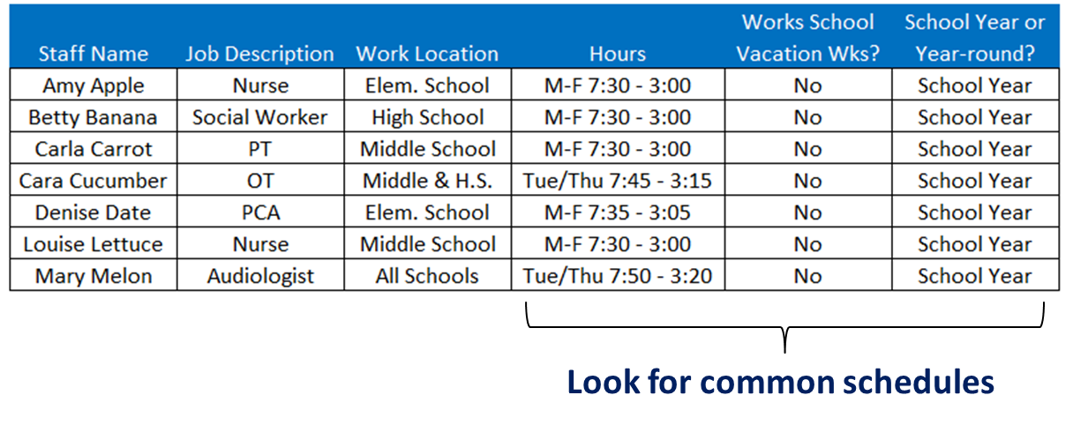
- Create a schedule, and maybe name the schedule “M-F 730-300” and assign Amy, Betty, Carla, Denise & Louise to that schedule
- Then perhaps a second schedule, named “TueThu 745-315” would be created and assigned to Cara & Mary

3 Monitor Participation
RMTS Coordinators have many tools to help you monitor your school district’s participation in the time study.
- Identify up to 3 “supervisors” per RMTS participant to be cc’d on “late” reminders when moments go unanswered, so they can follow up and help ensure all moments are answered
- The RMTS system includes live reports that can be run quickly and easily on a regular basis to track that all moments assigned to your staff have been answered
  - Follow-up with staff using these reports is as easy as a “copy” and “paste” of email addresses into an email of your own

RMTS Participation Requirements
- Participation is crucial to the accuracy of the RMTS results
- For EACH pool, 85% of moments must be answered
- If a pool does not meet the 85% requirement statewide
  - The 15+% of unanswered moments will be coded as non-reimbursable, which reduces statewide RMTS %
  - If LEAs that contributed to the <85% response rate have been below 85% response in that pool in any quarter in the past 2 years, then they will not be able to claim ANY revenue for that quarter (direct or admin)
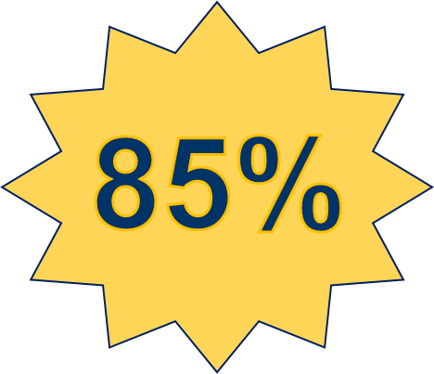

RMTS Supporting Documentation
- Pursuant to section 4.2 of the Provider Contract, LEAs must retain records to support activities recorded in response to the RMTS for at least 6 years after the date of submission of the Administrative Claim or Cost Report, which is supported by such documentation.
- RMTS Coordinators are expected to identify and implement internal processes/procedures (if not already established) and oversee compliance to ensure that RMTS participants provide supporting documentation for the activities recorded in any assigned RMTS moments. These records should be maintained by the LEA in an organized and retrievable fashion to be available upon audit.

4 Track Clinical Staff License Information
- The LEA RMTS Coordinator should NOT automatically include all staff who meet the licensure qualifications into one of the Direct Medical Services pools.
- The determination to include a staff member in the RMTS should be made based on individual job function rather than job title.
- For RMTS participants with licensure requirements, include the active license information for each staff member, including
  - state clinical license number, license type and license expiration date
- Staff found to have an inactive or expired license or whose license information is invalid or cannot be verified are ineligible for a direct service pool
- Ineligible staff must be removed, and their associated costs are not claimable

5 Train RMTS Participants
LEA RMTS Coordinators are required to provide training to all (new and returning) RMTS participants at least annually.
- Time study participant trainings should have two components:
  - The SBMP-provided, federally-required online training video
  - LEA-specific supplemental training
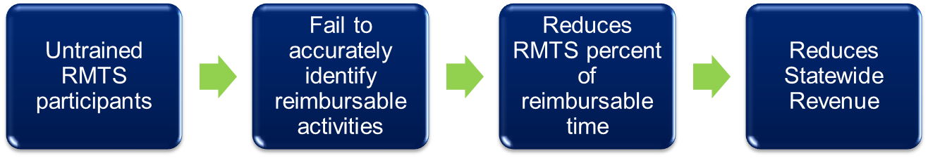

SBMP Provided Participant Training
- The federally-required online training video is available for RMTS Coordinators at www.chcf.net/chcfweb/ and for RMTS participants within the RMTS Moments application (https://cbe-rmts.chcf-umms.org/).
- The training offers an overview of the RMTS and walks participants through the mechanics of responding to moments.
- The RMTS System tracks each participant’s training status. Participants out of compliance with the training requirement will be prompted to complete the training upon login.
- RMTS Coordinators should monitor the Online Training Management reports and follow up with participants to ensure that they are properly trained.

LEA-supplemental Participant Training
- Explain why staff participation is important, including fiscal impact to the LEA and why each particular staff member is included in the time study
- Explain the LEA’s expectations, including LEA oversight and staff compliance expectations and consequences
- Inform staff who are new to the time study about their required participation in the RMTS
- Inform staff about the required online training module and the need to complete the training prior to answering any random moments, and annually thereafter
- Provide staff with appropriate LEA resources for troubleshooting any problems or answering questions about the Medicaid program;
- Instruct participants what to do if they return to work after being out for several days and discover that they have missed a random moment;
- Discuss whether participants can access school email from their personal cell phone (so they can take advantage of the option to respond from their mobile device);

LEA-supplemental Participant Training
- Indicate how participants without a dedicated computer at the school will be notified and respond to moments. This includes addressing questions like:
  - What is the school’s expectation for how frequently I should check my email?
  - Where should I go to check my email and/or respond to RMTS moments?
- Specify where participants must save or submit RMTS moment supporting documentation
- Identify the staff in participants’ building that they can go to if they have questions or need assistance related to the RMTS
- Describe LEA policy around CC’ing “supervisors” on RMTS moments
- Address any other topics participants need to understand about how to be fully compliant, including responding to moments timely and accurately

RMTS Management Deadlines
- RMTS is conducted over three quarters each fiscal year
  - There is no RMTS conducted in quarter one (7/1 – 9/30). LEAs may still seek reimbursement for quarter one costs.
- RMTS Coordinators must accurately complete all pre-quarter participant management tasks by the published deadlines
  - Update list of staff participating (add, remove, update)
  - Update RMTS work schedules
Time Study Quarter | RMTS Admin Task Deadline
Q2: October 1 – December 31 | First Friday of September
Q3: January 1 – March 31 | First Friday of December
Q4: April 1 – June 30 | First Friday of March
- Refer to the “Dates & Deadlines” document on the SBMP Resource Center for quick reference (https://www.mass.gov/info-details/sbmp-resource-center).

Next Training Steps
Training Module | Intended Audience
Module 2: SBMP for LEA Administrators | LEA Administrators, such as superintendents, business managers, health services and special education directors
Module 4: SBMP for Clinical Leadership | LEA clinical leadership staff, such as health directors and nursing directors
Module 5: SBMP for Financial Leadership | LEA financial leadership, such as business managers, accounting managers
Module 6: SBMP for Legal/Regulatory Leadership | LEA administrators, such as superintendents, compliance staff, finance directors, legal and contracts staff
Module 7: SBMP for Technology Leadership | LEA technology directors/managers
Module 8: SBMP for Direct Service Practitioners | LEA staff who participate in the Direct Medical Services reimbursement portion of the SBMP
Module 9: For LEA RMTS Participants performing Medicaid Administrative Activities | LEA staff who participate in the RMTS
There may be other modules in the Medicaid 101 training series that apply to your specific training needs.

Next Training Steps
Additionally, all designated RMTS Coordinators have access to two online training videos once logged in with your User ID and password to the School Based Claiming system. Login to:
www.chcf.net/chcfweb/
From the “Online Training” menu, you can view detailed instructions, including a demonstration of working in the system to perform each task, in these training modules:
- “MA RMTS Participant Management:” Instruction for RMTS Coordinators on identifying the correct staff for RMTS participation and managing your LEAs RMTS participant list
- “MA RMTS Work Schedules:” Instructions for RMTS Coordinators on creating and maintaining Work Schedules

Contact Information & Resources
MassHealth School-Based Medicaid Program information:
www.mass.gov/masshealth/schools
UMMS School-Based Help Desk:
SchoolBasedClaiming@umassmed.edu
1-800-535-6741
M-F 7:30 a.m. – 7:30 p.m.

