Medicaid 101: For LEA Clinical Leadership
Executive Office of Health and Human Services
April 2021

Distributed April 2021
This training was distributed in April 2021 and was accurate at the time of distribution. As always, Local Education Agencies are responsible for reviewing information on the School-Based Medicaid Program website (www.mass.gov/masshealth/schools) to determine whether subsequent guidance has superseded the content shared here. MassHealth plans to update these trainings periodically as needed.

Introduction to Medicaid 101 Training Series
The Medicaid 101 training series is designed to provide the essentials to understanding the School-Based Medicaid Program (SBMP). Some modules are designed for a broad, general audience. Other modules are targeted to the learning needs of a specific audience within each Local Education Agency (LEA).
The Medicaid 101 Training Series:
Training Module | Intended Audience
Module 1: Introduction | Everyone
Module 2: SBMP for LEA Administrators | LEA Administrators, such as superintendents, business managers, health services and special education directors
Module 3: SBMP for LEA Random Moment Time Study (RMTS) Coordinators | Designated LEA RMTS Coordinators, including those who support an RMTS coordinator with required information
Module 4: SBMP for Clinical Leadership *(this module) | LEA clinical leadership staff, such as health directors and nursing directors
Module 5: SBMP for Financial Leadership | LEA financial leadership, such as business managers, accounting managers

Introduction to Medicaid 101 Training Series
The Medicaid 101 Training Series, continued:
Training Module | Intended Audience
Module 6: SBMP for Legal/Regulatory Leadership | LEA Administrators, such as superintendents, compliance staff, finance directors, legal and contracts staff
Module 7: SBMP for Technology Leadership | LEA technology directors/managers
Module 8: SBMP for Direct Service Practitioners | LEA staff who participate in the Direct Medical Services reimbursement portion of the SBMP
Module 9: SBMP for LEA RMTS Participants performing Medicaid Administrative Activities | LEA staff who participate in the RMTS

Training Agenda
- Training Objectives
- Your Contribution to your LEA’s Medicaid Team
- Clinical Leadership Role
- Overview of Direct Services Claiming Requirements
- Clinical Leadership for Medicaid Compliance
- Clinical Leadership for Medicaid Billing Process
- Clinical Leadership for Staff Training
- Next Training Steps
- Contact Information & Resources

Training Objectives
By the conclusion of this training, you will:
- Understand the components of the Direct Services reimbursement program
- Understand why involvement from clinical leadership is important to the success of the program
- Take away ideas about focus areas for clinical leaders to review current practices and processes and to evaluate opportunities for improvements
NOTE: This training is at the introductory “101” level. Participants will get an overall description of concepts and processes to build foundational knowledge, but this training will not provide all the necessary details that clinical staff and leadership need to know about Direct Service program requirements. Please plan to review the additional resources and training opportunities that will be introduced in this training

Your Contribution to your LEA’s Medicaid Team
Successful participation in the School-Based Medicaid Program (SBMP) requires coordination and collaboration among people responsible for managing each of the key pieces of the Medicaid program.
Your role as a clinical leader is key to the success of your Medicaid team, particularly relative to the Direct Services reimbursement portion of the SBMP.
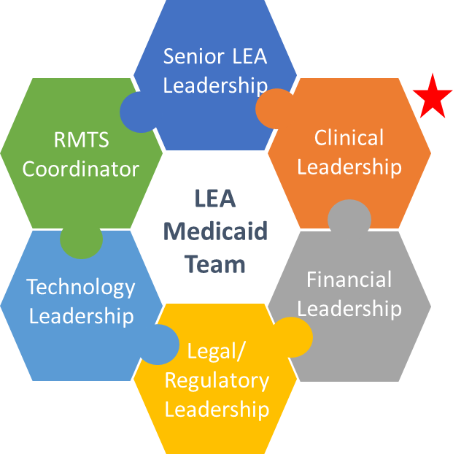

Clinical Leadership Role
For LEAs who participate in the Direct Medical Services reimbursement portion of the program, identifying clinical leader(s) will be a key to success to ensure that all requirements for reimbursement are met and that opportunities for reimbursement are recognized and pursued.
Clinical Leadership will be a key to successful participation in the Medicaid program particularly in the following areas:
- Compliance with Medicaid program requirements
- Clinical perspective and support for the Medicaid billing process
- Staff training
- Integrate clinical perspectives and best practices within educational landscape and competing priorities

SBMP Reimbursement Streams
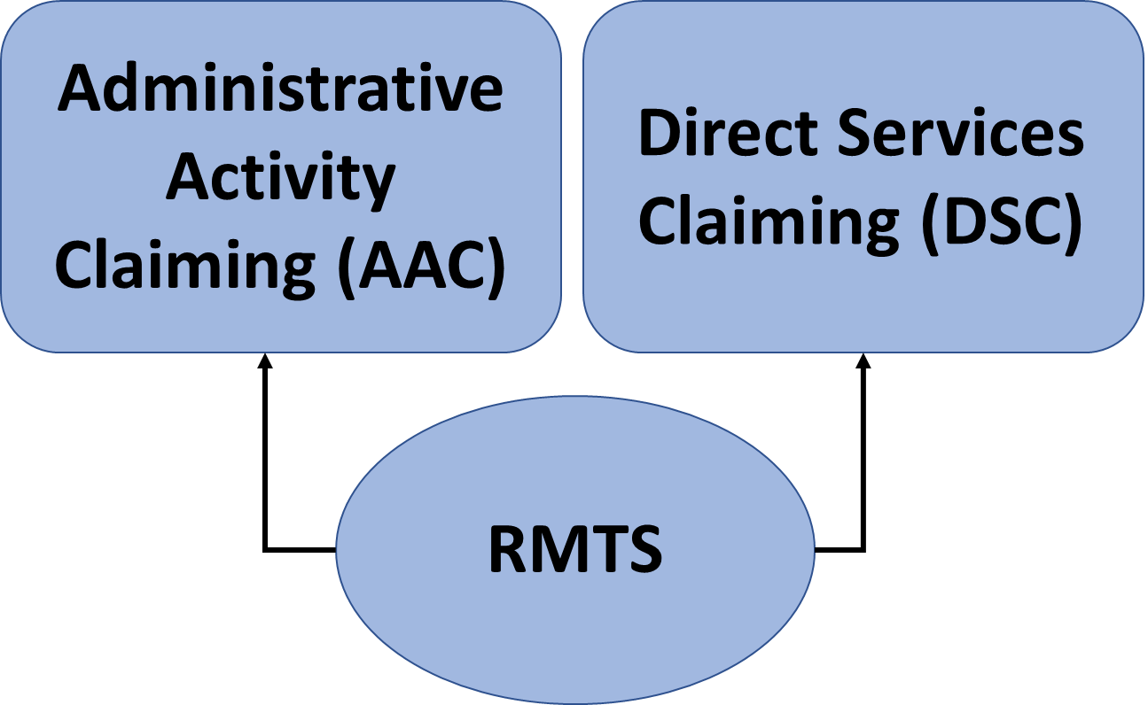
LEAs may choose to participate in one or both reimbursement streams, however RMTS participation is required for either one.

Clinical Leadership Role
Clinical leaders are challenged to pull together all the pieces to reach your organization’s full potential.
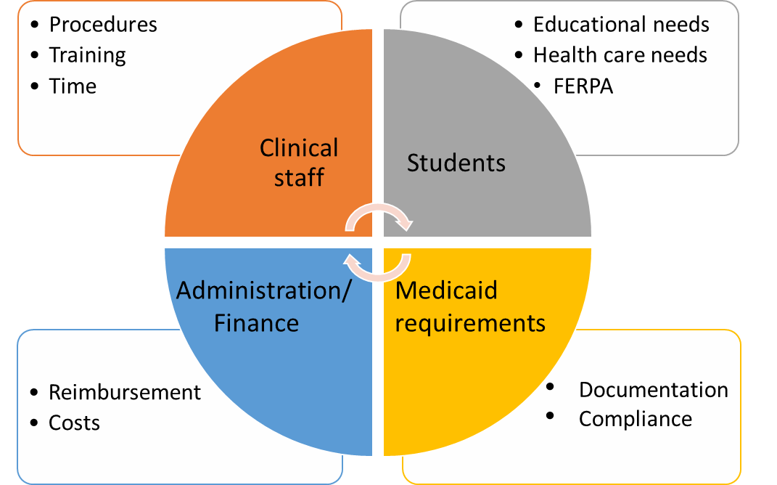

What is Direct Service Claiming (DSC)?
- The Direct Service Claiming (DSC) program is the mechanism through which LEAs seek federal reimbursement for the provision of direct services.
- The SBMP covers direct medical services provided in the school-setting including speech, occupational and physical therapies, psychological counseling, skilled nursing services, audiology services, personal care services, and Applied Behavior Analysis (ABA) therapy services when all Medicaid claiming requirements are met.
- The SBMP program provides reimbursement for the provision of Medicaid Covered Services that meet Medicaid’s definition of medical necessity and all other program requirements, whether services are pursuant to an IEP, or not.
- LEAs submit interim claims for Covered Services provided to eligible MassHealth-enrolled members through MassHealth’s Medicaid Management Information System (MMIS).
- Providers must submit per-unit claims for all services for which they seek reimbursement in the annual Direct Services Cost Report (Cost Report).

Medicaid-Covered Direct Services
- The services listed below are the MassHealth Covered Services within the scope of the SBMP
SBMP Covered Services
- Applied Behavior Analysis Services
- Audiology
- Dental Assessments / Screenings
- Medical Nutritional Services
- Mandated Health / Behavioral Health Screenings
- Occupational Therapy
- Personal Care Services
- Physical Therapy
- Physician Medical Evaluations
- Psychological Counseling
- Skilled Nursing Services
- Speech-Language Therapy
- Vision Services
- All services listed are covered, regardless of inclusion in an IEP, when all other coverage requirements are met
- Refer to the LEA Covered Services & Qualified Practitioners document

Reimbursable Services Requirements
- If a Covered Service is delivered, the following requirements must be met to be considered a Reimbursable Service:
- Practitioner RMTS Direct Service Pool Participation (for in-district services)
- Practitioner Licensure Qualifications
- Medicaid’s Definition of Medical Necessity
- Service Authorization
- Service Documentation
- LEAs must ensure that each of the five requirements is met before an interim claim is submitted to MMIS for adjudication.
- The LEA must maintain and produce upon request documentation of compliance with these requirements for each reimbursable service. Failure to produce documentation for the five reimbursable services requirements in the event of a state or federal inquiry or audit may result in recoupment.
- When responding to an RMTS moment, participants must meet reimbursable services requirements to respond that they were providing services in compliance with program guidelines.

Interim Claiming is Required
Whenever an LEA provides a Reimbursable Service (for which your LEA seeks reimbursement) to an eligible MassHealth enrolled student…
… submit an interim claim!
EVERY time a qualified practitioner (who participates in a Direct Service RMTS pool if providing in-district services) provides a MassHealth Covered Service with the required authorization and service documentation that meets Medicaid’s definition of Medical Necessity (i.e. is a Reimbursable Service) to a MassHealth-enrolled student, an interim claim should be submitted.

Interim Billing Submission
LEAs are expected to submit interim bills consistent with the rules specified below:
- Claims must be submitted in electronic format in accordance with Health Insurance Portability and Accountability Act (HIPAA) guidelines using the 837P claim format or through Direct Data Entry (DDE) via the POSC.
- LEAs may perform the billing themselves using the POSC DDE option, purchase software that will generate the required 837P claim files, or contract with a third party to perform the billing for the district.
- Interim claims must be submitted within 90 days of the date of service and must include the appropriate Procedure Code and a clinically appropriate ICD code.
- All claims are subject to audit. LEAs are responsible for ensuring the appropriate documentation can be produced in the event of an audit or other request by MassHealth or other state or federal compliance agency. Failure to do so may result in a recoupment and/or termination from the program as described in the Provider Contract.

Clinical Leadership for Medicaid Compliance
Clinical leaders play an important role in Medicaid program compliance, particularly in these areas:
- Help translating Medicaid requirements and trainings to school-based practitioners
- Monitoring clinical licensure status and ensuring supervision where required
- Clinical training for LEA procedures around documentation of plans of care and service delivery
- Clinical input and perspective in the design of interfaces/processes that support Medicaid billing
- LEAs are responsible for ensuring that the appropriate documentation can be produced in the event of an audit or other request by MassHealth or other state or federal compliance agency. Failure to do so may result in a recoupment or termination from the program as described in the Provider Contract

Clinical Leadership for Licensure Compliance
It is important as a clinical leader in your LEA to understand the licensure requirements for any participating staff. See “LEA Covered Services and Qualified Practitioners” document (available on the Resource Center): https://www.mass.gov/files/documents/2019/02/27/sbmp-lea-csqp-0219%20%28rev%29.pdf
- Medicaid qualified providers must follow their individual clinical licensing regulations regarding scope of practice and supervision requirements
- For example, the Board of Registration of Allied Health Professionals (pursuant to 259 CMR 3 and 5) defines the scope of clinical practice for Occupational and Physical Therapists and Assistants. The board’s guidance indicates:
  - OTAs or PTAs may not initiate or alter a treatment program without prior evaluation by and approval of the supervising occupational or physical therapist.
  - OTAs or PTAs may not interpret data beyond the scope of their occupational or physical therapy assistant education.
  - But it is not a board requirement for OTAs and PTAs to have their service documentation co-signed.
Clinical Leadership Support for RMTS
Your LEA’s RMTS Coordinator needs support from clinical leadership to appropriately identify staff who should be included in one of the Direct Services Pools.
- Only staff who will meet ALL requirements for reimbursement under the Direct Service claiming program should be included in a Direct Service RMTS Pool. Requirements include:
- Have an active clinical license for their service specialty (as required)
- See “LEA Covered Services and Qualified Practitioners” document (available on the Resource Center): https://www.mass.gov/files/documents/2019/02/27/sbmp-lea-csqp-0219%20%28rev%29.pdf
- Provide Direct Services that meet Medicaid reimbursement requirements
- The LEA submits interim claims to MMIS
- Resources for details regarding requirements for reimbursement of direct services are detailed in the “SBMP Direct Service Claiming (DSC) Guide” available on the Resource Center (https://www.mass.gov/info-details/sbmp-resource-center).

Participant/Staff Pools – Direct Services
Each staff member should be considered individually – not included based on job title
Mental/Behavioral Health | Therapy Services | Medical Services
Autism Specialist (incl. Assistant  Applied Behavior Analyst)  Licensed Applied Behavior Analyst  Licensed Clinical Social Worker  Licensed Independent Clinical Social Worker  Licensed Marriage and Family Therapist  Licensed Mental Health Counselor  Licensed Psychiatrist  Licensed Psychologist  Licensed Educational Psychologist  DESE Licensed School Psychologist | Licensed Audiologist  Licensed Hearing Instrument Specialist  Licensed Occupational Therapist  Licensed Occupational Therapy Assistant  Licensed Physical Therapist  Licensed Physical Therapy Assistant  Licensed Speech-Language Pathologist  Licensed Speech-Language Pathology Assistant | Dental Hygienist  Licensed Nutritionist/Dietitian  Licensed Physician  Optometrist  Personal Care Service Provider  Licensed Practical Nurse (LPN)  Registered Nurse (RN)

Clinical Leadership for Service Documentation
Clinical leadership should ensure that providers document their services consistent with clinical standards of practice and develop a system for doing so.
- Service documentation substantiates that the requirements for Medicaid reimbursement were met.
- LEAs are responsible for ensuring that practitioners complete sufficient clinical documentation for all covered services provided to students for whom the LEA seeks reimbursement.
- Documentation may be completed using a paper form, chart, or medical record; or an electronic health record of the LEA’s choosing, as long as all requirements for clinical documentation and practitioner signature/electronic signature are met.
- MassHealth does not endorse any particular clinical documentation form, process, or system.
Note: Service documentation is not a billing form or the interim claim record, it’s the clinical documentation that supports that a medically necessary, reimbursable service was provided, which must be present and compliant prior to submitting an interim claim.

Clinical Leadership for the Medicaid Billing Process
Clinical leaders will want to have input and provide the practitioner clinical perspective in the development and/or selection of interfaces/processes that support recordkeeping and documentation required for Medicaid billing.
- Service capture/documentation
  - Does it work for all type of practitioners? If not, do we need to develop different processes for different types of practitioners?
  - Does it work for all types of services and settings, including evaluations, IEP-prescribed services, non-IEP services, services provided in context, telehealth services, home services, etc.?
  - Does it integrate with…
    - IEP service requirements data? Processes for providing progress notes?
Plans of care?
  - How will it support needs for clinical supervision and oversight?
- Medicaid billing
  - How is it integrated with your service documentation process(es)?
  - Does it work for all types of practitioners, services and settings?

Clinical Leadership for Staff Training
The detailed requirements for the Direct Service Claiming (DSC) program are found in the SBMP Direct Service Claiming (DSC) Guide, which is published on the SBMP Resource Center (https://www.mass.gov/info-details/sbmp-resource-center).
Clinical leaders must review the DSC guide in full and are responsible for understanding the program requirements. Clinical leadership should require that all staff who are providing Medicaid-covered services for which your LEA seeks reimbursement receive appropriate training and oversight to ensure program compliance.
Frequently misunderstood concepts are:
- Diagnosis (ICD) codes
- Medical necessity
- Service authorization
- Service documentation vs. billing forms
These concepts are addressed in Medicaid 101 Module 8 for Direct Service Providers, which is a good starting point for building your LEA’s training program.

ICD Diagnosis and/or Signs and Symptoms Codes
Per HIPAA requirements, all claims must include a clinically appropriate ICD code that is supported by service documentation and explains the reason/need for the service.
- ICD codes don’t necessarily mean you made a formal diagnosis.
- Many ICD codes identify presenting signs and symptoms.
- LEAs are responsible for submitting at least one clinically appropriate ICD code on each interim claim.
- When appropriate, an ICD code provided by a qualified practitioner not employed by or contracted with the LEA, such as a physician or nurse practitioner, may be reported on an interim claim, as long as the LEA maintains written and signed documentation of such diagnosis.
- Some LEAs work with their billing vendor or professional coders to come up with a list of common ICD codes. Some professional practice organizations may have a public-facing or member-only list of common ICD codes.
- As a reminder, ABA therapy is covered only when provided to students with a documented autism spectrum disorder (ASD) diagnosis, and an appropriate ASD diagnosis code must be included on the claim.

Medical Necessity
Medical necessity and educational needs can and sometimes do overlap.
- Medically necessary services have a clinical basis and may also help students achieve educational goals and access the curriculum.
- The amount, frequency, and duration of services must be consistent with professionally recognized standards of practice for the clinical service specialty.
- The DSC guide includes clarifications in the Medical Necessity section to assist providers to understand and implement requirements.

Service Authorization
Service authorization is often the Plan of Care or Treatment Plan.
- Authorization is documentation by a qualified practitioner demonstrating that the service is medically necessary and consistent with standards of practice.
- IEPs themselves do not constitute a service authorization.
- If an evaluation and treatment plan was written by a qualified practitioner, then it may constitute a service authorization.

Service Documentation
Service documentation is not a “billing form”
- MassHealth considers Service Documentation to be the practitioner’s clinical service delivery treatment notes. The billing forms or software that many LEAs use to generate a claim are separate and not considered Service Documentation.
- Service Documentation must meet MassHealth’s minimum standards as outlined in the DSC Guide, and also must comply with standards of clinical practice for the practitioner’s clinical licensing board and professional practice organization.

Next Training Steps
There may be other modules in the Medicaid 101 training series that apply to your specific training needs.
Training Module | Intended Audience
Module 2: SBMP for LEA Administrators | LEA Administrators, such as superintendents, business managers, health services and special education directors
Module 3: SBMP for LEA Random Moment Time Study (RMTS) Coordinators | Designated LEA RMTS Coordinators, including those who support an RMTS coordinator with required information
Module 5: SBMP for Financial Leadership | LEA financial leadership, such as business managers, accounting managers
Module 6: SBMP for Legal/Regulatory Leadership | LEA administrators, such as superintendents, compliance staff, finance directors, legal and contracts staff
Module 7: SBMP for Technology Leadership | LEA technology directors/managers
Module 8: SBMP for Direct Service Practitioners | LEA staff who participate in the Direct Medical Services reimbursement portion of the SBMP
Module 9: For LEA RMTS Participants performing Medicaid Administrative Activities | LEA staff who participate in the RMTS

Contact Information & Resources
MassHealth School-Based Medicaid Program information:
www.mass.gov/masshealth/schools
UMMS School-Based Help Desk:
SchoolBasedClaiming@umassmed.edu
1-800-535-6741
M-F 7:30 a.m. – 7:30 p.m.

