Medicaid 101: For LEA Financial Leadership
Executive Office of Health and Human Services
April 2021

Distributed April 2021
This training was distributed in April 2021 and was accurate at the time of distribution. As always, Local Education Agencies are responsible for reviewing information on the School-Based Medicaid Program website (www.mass.gov/masshealth/schools) to determine whether subsequent guidance has superseded the content shared here. MassHealth plans to update these trainings periodically as needed.

Introduction to Medicaid 101 Training Series
The Medicaid 101 training series is designed to provide the essentials to understanding the School-Based Medicaid Program (SBMP). Some modules are designed for a broad, general audience. Other modules are targeted to the learning needs of a specific audience within each Local Education Agency (LEA).
Training Module | Intended Audience
Module 1: Introduction | Everyone
Module 2: SBMP for LEA Administrators | LEA Administrators, such as superintendents, business managers, health services and special education directors
Module 3: SBMP for LEA Random Moment Time Study (RMTS) Coordinators | Designated LEA RMTS Coordinators, including those who support an RMTS coordinator with required information
Module 4: SBMP for Clinical Leadership | LEA clinical leadership staff, such as health directors and nursing directors
Module 5: SBMP for Financial Leadership* (this module) | LEA financial leadership, such as business managers, accounting managers

Introduction to Medicaid 101 Training Series
The Medicaid 101 Training Series, continued
Training Module | Intended Audience
Module 6: SBMP for Legal/Regulatory Leadership | LEA Administrators, such as superintendents, compliance staff, finance directors, legal and contracts staff
Module 7: SBMP for Technology Leadership | LEA technology directors/managers
Module 8: SBMP for Direct Service Practitioners | LEA staff who participate in the Direct Medical Services reimbursement portion of the SBMP
Module 9: SBMP for LEA RMTS Participants performing Medicaid Administrative Activities | LEA staff who participate in the RMTS

Training Agenda
- Training Objectives
- The Financial Leader’s Contribution to your LEA’s Medicaid Team
- Overview of allowable expenditures for SBMP reimbursement
- Requirements for Reporting Expenditures for Federal Match through the School-Based Medicaid Program (SBMP)
- Financial Reporting for Administrative Activity Claims (AAC)
- Financial Reporting for Direct Service Claiming (DSC) Cost Reports
- Dates & Deadlines
- Resources and Next Training Steps

Training Objectives
By the conclusion of this training, you will:
- Understand the key role a financial leader plays in your LEA’s Medicaid reimbursement program
- Understand the requirements for identifying and reporting allowable expenditures
- Return to your LEA with information, ideas and perspective on areas where your LEA may need to review and improve procedures and controls to ensure data submitted for claiming purposes will be accurate and successful
- Have an understanding of the allowable expenditures for claiming Medicaid federal matching funds and be able to determine whether your LEA is receiving the maximum allowable Medicaid reimbursement while remaining fully compliant with claiming requirements to minimize any audit risks.

Your Contribution to your LEA’s Medicaid Team
Successful participation in the School-Based Medicaid Program (SBMP) requires coordination and collaboration among people responsible for managing each of the key pieces of the Medicaid program.
Financial leadership involvement and oversight of your LEA’s reimbursement program is key to ensuring that your LEA maximizes your reimbursement potential while fully complying with program requirements for allowable expenditures.
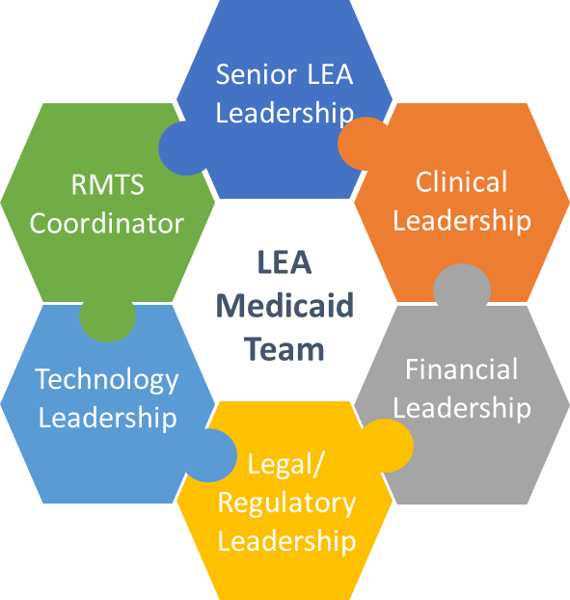

Financial Leadership Role
A financial leader plays a key role in ensuring accurate expenditure reporting and should be empowered to institute procedures that will efficiently and effectively identify allowable expenditures and ensure reimbursement and compliance.
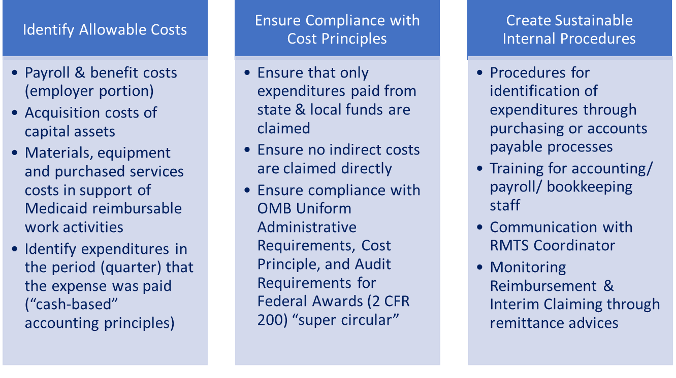

SBMP Revenue Streams
The School-Based Medicaid Program (SBMP) gives LEAs the opportunity to receive federal matching dollars for state and local expenditures in the areas of:
- Medicaid Administrative Activities – work your school staff does that provides and promotes access to health care services for students (and families)
- Direct Medical Services Activities – the provision of health care services to students
The cost-based reimbursement methodology used to determine each LEA’s reimbursement requires quarterly or annual cost reporting – which is simply a record of the allowable state and local expenditures made by the LEA related to either Medicaid Administrative Activities or Direct Medical Services Activities.
High-Level Cost-Based Reimbursement Methodology:

Understanding Cost-Based Reimbursement
DSC & AAC Calculation:
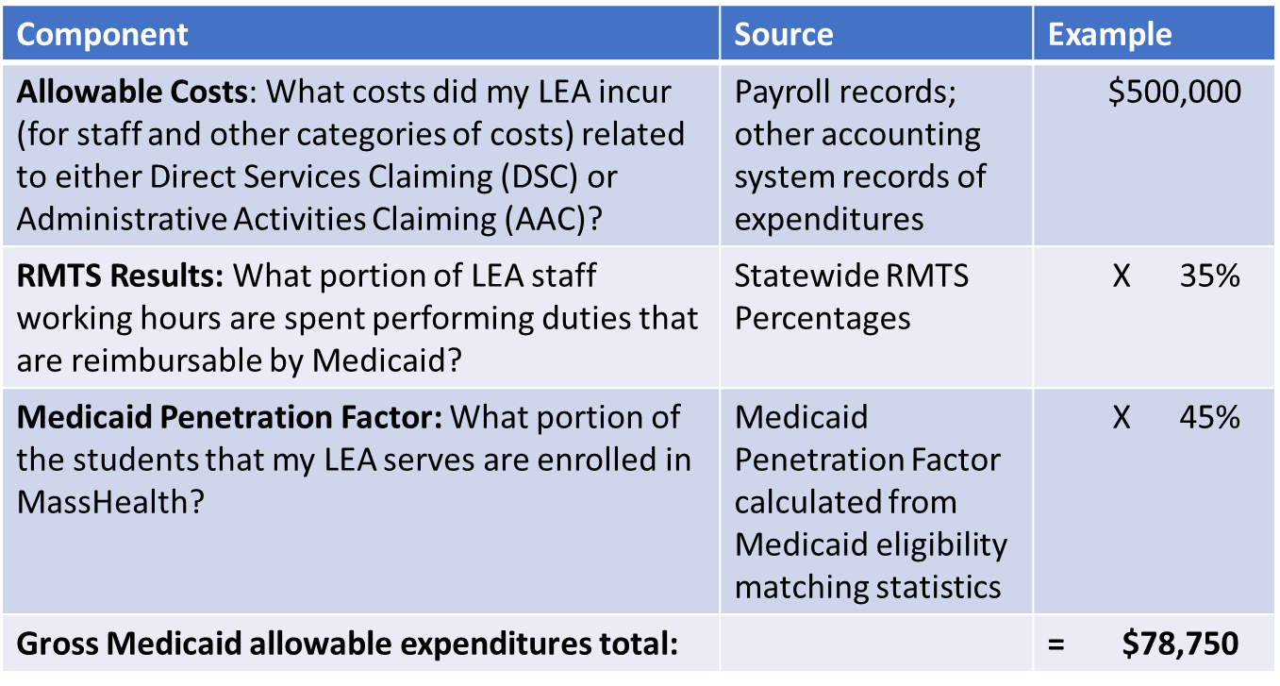

Allowable Costs for Medicaid Administrative Activities
Reimbursable Administrative Activities include:
- Outreach* – Informing eligible or potentially eligible individuals/families about MassHealth and how to access it.
- Application assistance* – Assisting individuals/families to apply for MassHealth
- Participating in activities to develop strategies to improve the delivery of Covered Services, including when performing collaborative activities with other agencies regarding health-related services
- Making referrals to health services, coordinating, or monitoring the delivery of Covered Services
- Assisting an individual to obtain MassHealth-covered transportation
- Translation and interpretation services, when required to access health-related services
- Providing or receiving school staff training related to Medicaid topics
*Medicaid Penetration Rate does not apply

Allowable Costs for Medicaid Administrative Activities
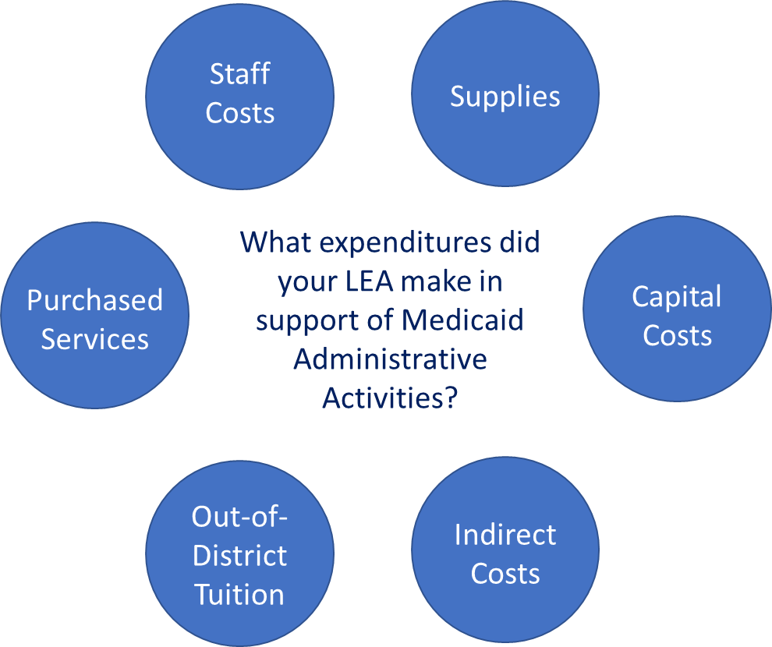

Allowable Costs for Specialized Transportation
- The SBMP program methodology allows LEAs to receive reimbursement for expenditures related to the provision of specialized transportation through the AAC claims.
- These costs are claimed through a cost allocation method allowed by CMS and reported with the quarterly AAC.
- The allowable costs for specialized transportation are:
  - Payments to transportation provider/company
  - Salary and benefits of drivers
  - Costs to operate and maintain specialized transportation vehicles
Specialized transportation definition:
Specialized transportation is defined as transportation in a vehicle that is specially equipped, adapted, or staffed to accommodate students with specialized medical needs to transport them to school where the student receives Medicaid-covered services or to receive medical services from a provider outside of school.

Allowable Costs for Direct Medical Services
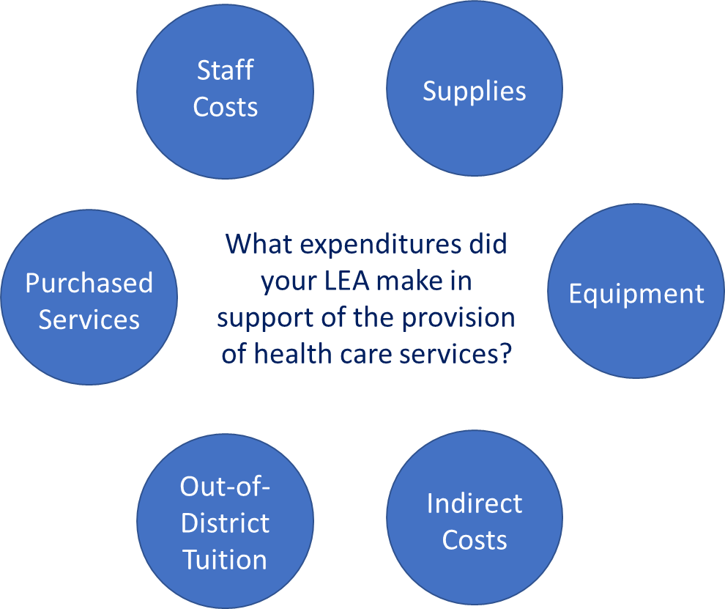

Applicable Laws, Regulations, and Published Guidance
Any LEA or subcontractor participating in the SBMP must comply with applicable federal and state laws, regulations, published guidance, and the terms of the provider contract. These include, but are not limited to:
- Section 1902(a) of the Social Security Act
- Code of Federal Regulation (CFR) Titles 42, 45
- OMB Uniform Administrative Requirements, Cost Principle, and Audit Requirements for Federal Awards (2 CFR 200) “super circular:” https://www.federalregister.gov/documents/2013/12/26/2013-30465/uniform-administrative-requirements-cost-principles-and-audit-requirements-for-federal-awards
- OMB Circular A-133 Audits of States, Local Governments and Non-Profit Organizations
- MassHealth School-Based Medicaid Program Bulletins
- MassHealth School-Based Medicaid Program Instruction Guides
- Massachusetts School-Based Medicaid Program Provider Contract

Requirements for Reporting Expenditures
LEAs must report all expenditures as actual expenditures during the period in which the expenditure occurred (i.e., the “check date” of the expenditure determines the reporting period, not the service date that the expenditure may have been for). The only exception to this rule is that prepaid expenditures must be claimed in the period in which the services were rendered.
Example:
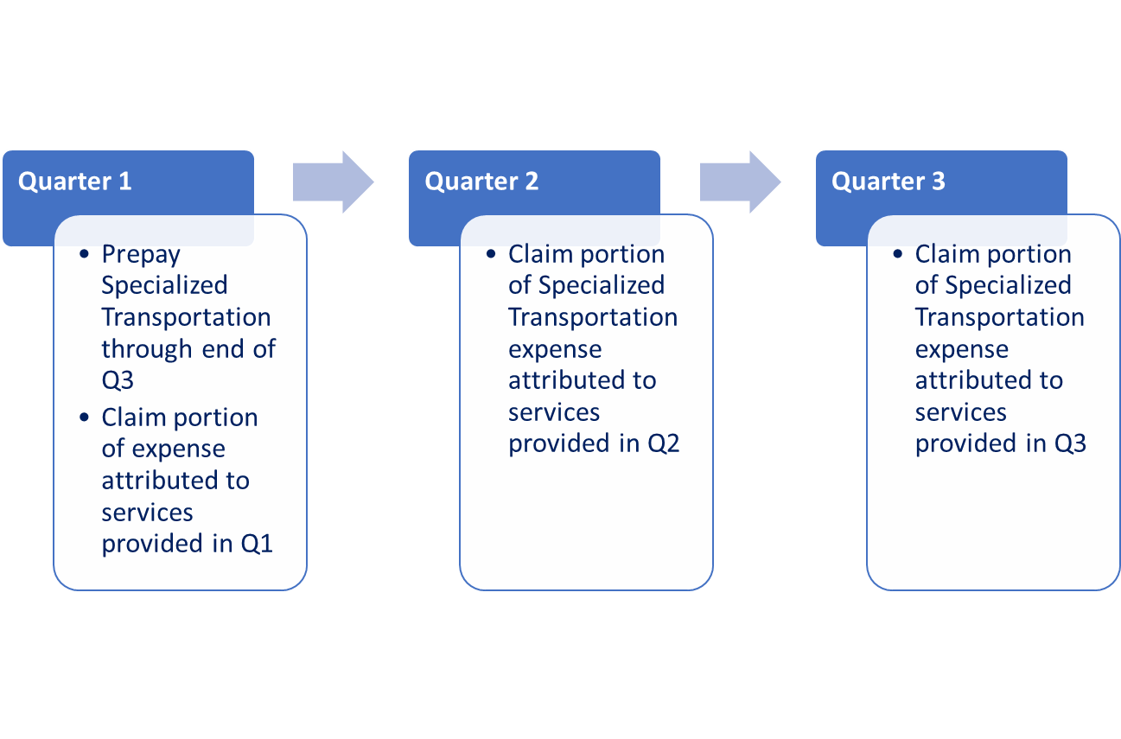

Requirements for Reporting Expenditures
- Excluded Expenditures (applicable to ALL expenditure categories):
  - LEAs must exclude restricted federal funding from the report of actual LEA expenses. Only state/local funding sources may be included.
  - LEAs must exclude expenditures that were used to satisfy a federal matching requirement (2 C.F.R. 200.306).
  - Any expenditures (including staff salaries) included in the LEA’s Indirect Cost Rate must be excluded.
  - In the Direct Service Cost Report:
        - Costs related to Medicaid billing contractors/vendors that are paid on a contingency fee (percent of claim) basis must be excluded.
        - Costs related to the provision of medical service types without corresponding interim claims must be excluded.

Personnel Expenditures
- Only staff (employed and contracted) who were included in the first possible RMTS participant list following their date of hire or change in job position may be claimed
- Only include expenditures related to each staff member’s performance of the job position that qualified them for reimbursement in the SBMP
  - Costs related to separate and unrelated duties must be excluded, such as:
    - Stipends paid for supervision of extracurricular activities (such as athletic coach or club advisor) must be excluded
    - If staff hold two job positions, only those costs attributable to the position that is qualified for SBMP reimbursement can be claimed
- All costs claimed must be actual expenditures as supported by payroll or other accounting records of the LEA
- Only the employer paid portion of benefits can be claimed

Indirect Costs
The annual indirect cost rates for each LEA are calculated and published by DESE and prepopulated in the AAC and Cost Report systems. LEA costs that are reported on the Chart of Accounts (COA) in the following object codes are included in the calculation of each LEA’s Indirect Cost Rate by DESE. Therefore, the LEA must exclude them from AAC and Direct Service Cost Reports.
- Administration—1000 series (specifically includes 1210, 1220, 1230, 1410, 1420, 1430, 1450);
- School Security (3600);
- Maintenance—4000 series (all);
- Employee insurance (5200)—(Only exclude costs when related to salaries in the excluded 1000 series codes);
- Retired-employee insurance (5250);
- Other insurance (5260);
- Rental lease (5300); and
- Other fixed charges (5500)
- (DESE COA: http://www.doe.mass.edu/finance/accounting/eoy/chartofaccounts.docx)

Indirect Costs
Indirect Cost Rates for Charter Schools
- AACs and Direct Service Cost Reports for charter schools will be processed using a 10% de minimis Indirect Cost Rate per 2 C.F.R. § 200 .414.
- Charter schools are instructed to follow the same guidelines as other SBMPs, and exclude from RMTS participation claims and cost reports costs related to staff who are part of central administration. These staff members include superintendent, assistant superintendent, professional and clerical support staff, grants manager, director of planning, school business manager or chief financial officer, director of human resources, districtwide information and technology staff, or any equivalent schoolwide administration staff.
See also: School-Based Medicaid Provider Bulletin 28 (July 2015): https://www.mass.gov/doc/school-based-medicaid-bulletin-28-school-based-medicaid-program-guidance-on-indirect-cost-rates/download

Record Retention and Audit Preparedness
- LEAs are responsible for ensuring program compliance and must certify, under penalties of perjury, that all Administrative Activity claims and annual cost reports are accurate.
- The federal government regularly audits the SBMP, and all costs are subject to audit review by MassHealth and other state and federal agencies.
- LEAs are responsible for ensuring that the appropriate documentation can be produced in the event of an audit or other request by MassHealth or other state or federal compliance agency. Failure to do so may result in a recoupment or termination from the program as described in the Provider Contract. This includes ALL DATA used to support claims and cost reports, such as:
  - Payroll records
  - Accounting records
  - Copies of invoices paid
  - Student data reports used as the source for student eligibility statistics
  - Source data to support acquisition costs of capital assets
  - All related financial records used as the source data for claimed expenditures
- Record retention period is 6 years from the date of cost settlement (7 years from end of each fiscal year).

Administrative Activity Claiming
- This training module will review a few key areas where financial leadership by an individual with the skills and training of a school business manager or finance officer is especially needed due to the frequency with which LEAs have historically reported data incorrectly.
- Complete instructions for all data elements and expenditures reported in Administrative Activity Claims are provided in the “LEA Instruction Guide for Administrative Activity Claiming (AAC)” published on the SBMP Resource Center (https://www.mass.gov/info-details/sbmp-resource-center).
- Financial leadership and oversight of the entire reporting process, including implementing procedures and controls to ensure that staff assigned to gather data for claiming purposes will be accurate and successful, is essential to ensure that your LEA receives the maximum allowable Medicaid reimbursement while remaining fully compliant with claiming requirements to minimize any audit risks.
- Therefore, financial leadership should plan to review the AAC guide in full.

AAC: Annual Capital Cost Allocation Factor
- LEAs can include the actual acquisition cost of capital assets in active use and occupancy by the LEA during the fiscal year. These costs are used to calculate a capital percentage allocation rate that is applied to the AAC claim. Claimable costs of capital assets fall into one of three categories:
- buildings and fixed assets;
- major movables; or
- net interest expense.
- Capital assets described in this section are reported on an annual basis and cannot vary throughout the year unless amendments are filed for prior quarters within the same fiscal year to make the corrections.
- Reported costs “must be supported by adequate property records, and physical inventories must be taken at least once every two years to ensure that the assets exist and are usable, used, and needed” (2 C.F.R. §200.436).
- Additionally, LEAs must report the annual total budgeted district-wide salaries and benefits amount and full-time equivalent (FTE) that are used in the calculation of the capital percentage allocation rate.

AAC Capital: Buildings and Fixed Assets
- LEAs must enter the acquisition cost of buildings and fixed assets in active use and occupancy by the LEA during the fiscal year. LEAs are required to report the actual acquisition cost of capital assets, not insured values or replacement values.
  - Note: “For an asset donated to the non-Federal entity by a third party, its fair market value at the time of the donation must be considered as the acquisition cost” (2 C.F.R. § 200.436).
  - Acquisition costs of buildings and fixed assets include costs related to “Building shell (including construction and design costs)” and “building services systems (e.g., elevators, HVAC, plumbing system and heating and air-conditioning system)” (2 C.F.R. § 200.436( d)(3));
  - “Capital expenditures for improvements to land, buildings…which materially increase their value or useful life” (2 C.F.R. § 200.439(b)(3), such as land improvements, such as paved parking areas, fences, and sidewalks; and
  - “Fixed equipment (e.g., sterilizers, casework, fume hoods, cold rooms, and glassware/ washers)” (2 C.F.R. § 200.436(d)(3)).

AAC Capital: Major Movables
Major Movable Valuation includes:
The acquisition costs of the school district’s equipment that is not included in the value of buildings and fixed assets, which meet the definition of:
  - equipment, which means “tangible personal property (including information technology systems) having a useful life of more than one year and a per-unit acquisition cost which equals or exceeds the lesser of the capitalization level established by the non-Federal entity for financial statement purposes, or $5,000 (2 C.F.R. § 200.33); or
  - general purpose equipment, which means “equipment which is not limited to research, medical, scientific or other technical activities. Examples include office equipment and furnishings, modular offices, telephone networks, information technology equipment and systems, air conditioning equipment, reproduction and printing equipment, and motor vehicles.” (2 C.F.R. § 200.48).
- “Capital expenditures for improvements to equipment which materially increase their value or useful life” (2 C.F.R. § 200.439(b)(3)).

AAC Capital: Net Interest
- Because claims are filed during the fiscal year, the net interest expense consists of the LEA’s budgeted interest expenses minus earned interest for the fiscal year associated with financing costs to acquire, construct, or replace capital assets.
- Capital assets are defined in 2 C.F.R. § 200.12: Capital assets. An asset cost includes (as applicable) acquisition costs, construction costs, and other costs capitalized in accordance with GAAP.
- The LEA may include no other interest expenses on the claim.
- Allowable interest costs and interest earnings offsets must meet the conditions described in 2 C.F.R. §200.449.

AAC Capital: Annual Total Budgeted District-Wide Salaries and Benefits and FTE
LEAs should report the grand total budgeted amount for the fiscal year of all salaries and benefits for all employees of the school district.
Because this amount will be used in the calculation of the capital percentage rate as an allocation factor, all salaries and employer shares of benefits for all district staff must be reported in the Administrative Activity claim, including part-time and full-time staff, district administration, athletic staff, teaching staff, paraprofessional staff, custodial staff, etc.

AAC: Materials and Supplies
- LEAs should enter actual quarterly material and supply expenditures related to the delivery of Medicaid administrative activities.
- Only material and supply costs funded by state or local revenue that assist in the performance of reimbursable Medicaid administrative activities by staff who participated in the RMTS should be included in the AAC.
- Examples of costs that can be included are: forms, brochures, fliers, and office supplies related to reimbursable administrative activities (e.g., Medicaid outreach and scheduling or arranging specialized transportation).
Excluded Expenditures:
- The cost of materials and supplies used in the delivery of health-related services should not be included in AAC.
- These costs may be reimbursable through the Direct Service reimbursement portion of the SBMP when all requirements for reimbursement are met.

AAC: Purchased Services
LEAs should enter actual quarterly purchased services expenditures related to the delivery of Medicaid administrative activities. Examples of costs that can be included are
- an expenditure to a printing service to print flyers that qualify as Medicaid Outreach such as an informational brochure about well-child exams or physicals available through school
- costs incurred for a consultant who trained direct service practitioners on current clinical best practices or other health-related professional development topic
- Cost of external physician to review and update nursing standing orders
Excluded Expenditures.
- The cost of purchased services related to the delivery of health-related services should not be included. These costs may be reimbursable through the Direct Service reimbursement portion of the SBMP when all requirements for reimbursement are met. See the SBMP Direct Service Claiming (DSC) Program Guide for additional information.

Direct Services Cost Report
- This training module will review a few key areas where financial leadership by an individual with the skills and training of a school business manager or finance officer is especially needed due to the frequency with which LEAs have historically reported data incorrectly.
- Complete instructions for all data elements and expenditures reported in Direct Service Cost Reports are provided in the “LEA Instruction Guide for Direct Service Cost Report” published on the SBMP Resource Center (https://www.mass.gov/info-details/sbmp-resource-center).
- Financial leadership and oversight of the entire reporting process, including implementing procedures and controls to ensure that staff assigned to gather data for claiming purposes will be accurate and successful, is essential to ensure that your LEA receives the maximum allowable Medicaid reimbursement while remaining fully compliant with claiming requirements to minimize any audit risks.
  - Therefore, financial leadership should plan to review the DSC Cost Report guide in full

Cost Report: Materials and Supplies
Claimable expenditures include:
- Actual quarterly material and supply expenditures related to the delivery of Medicaid-covered medical services
  - Materials and supply costs are allowable if used exclusively for the delivery of health care services for which the LEA is including allowable personnel (employed or contracted) costs.
Materials & Supplies-specific Excluded expenditures:
- The cost of materials and supplies used in the performance of Medicaid administrative activities should not be included in the cost report.

Cost Report: Purchased Services
Claimable expenditures include:
- Actual quarterly purchased services expenditures related to the delivery of Medicaid-covered medical services, such as:
  - An expenditure for a Medicaid-covered private duty nurse or personal care services provider that is incurred over and above the tuition cost for a student placed in an out-of-district program.
  - Costs incurred for the services of a contracted Medicaid-qualified optometrist to provide EPSDT-covered vision screenings in school over a brief period, which makes it unreasonable to include the optometrist in the RMTS.
(Note: for both of these examples, the practitioner cannot be included in the RMTS, but all other requirements for reimbursement remain, including interim claiming)
Excluded expenditures:
- The cost of purchased services related to the performance of Medicaid administrative activities should not be included in the cost report.

Cost Report: Medical Equipment
Claimable expenditures include:
- Actual quarterly expenditures for medical equipment related to the delivery of Medicaid-covered medical services
  - Medical equipment costs are allowable if used exclusively for the delivery of health care services for which the LEA is including personnel (employed or contracted) costs.
Excluded expenditures:
- Any item with a per unit cost in excess of $5,000 and a useful life of at least one year is considered a capital expense and should not be included in the cost report.

Plan to Meet all Deadlines
Most deadlines in the Medicaid program have been in place for over 10 years. All deadlines are published in corresponding instruction guides and also published in an annually updated, easy to reference, one-page overview on the SBMP Resource Center (https://www.mass.gov/info-details/sbmp-resource-center).
Annual Direct Service Cost Report deadline: December 31st following the end of the fiscal year (for example, FY21 ends 6/30/21 and the cost report will be due 12/31/21)
Administrative Activity Claims quarterly deadlines: All AAC can be submitted on a quarterly basis to maintain steady cash flow. However, the last possible deadline to submit AAC for a fiscal year is October 15th following the end of the fiscal year.
Qtr | Claim Qtr Dates | Earliest Claim Deadline | Earliest Certification Deadline | Latest Claim Deadline | Latest Certification Deadline
Q1 | Jul 1 – Sep 30 | Jan 15 | Jan 20 | Oct 15 | Oct 20
Q2 | Oct 1 – Dec 31 | Apr 15 | Apr 20 | Oct 15 | Oct 20
Q3 | Jan 1 – Mar 31 | Jul 15 | Jul 20 | Oct 15 | Oct 20
Q4 | Apr 1 – Jun 30 | Oct 15 | Oct 20 | Oct 15 | Oct 20

Reimbursement Timeframes
Administrative Activity Claiming (AAC):
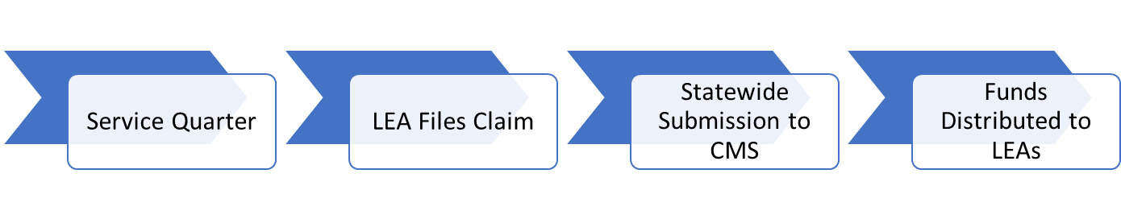

Examples:
Q1 FY20: 7/1/19-9/30/19 | Earliest deadline: 1/15/20 | 1/31/20 | Estimated between 4/1/20-5/31/20
 | 4/15/20 | 4/30/20 | Estimated between 6/1/20-6/30/20
 | 7/15/20 | 7/31/20 | Estimated between 10/1/20-11/30/20
 | Latest deadline: 10/15/20 | 10/31/20 | Estimated between 1/1/21-2/28/21

Reimbursement Timeframes
Direct Service Claiming (DSC): Interim Claims:
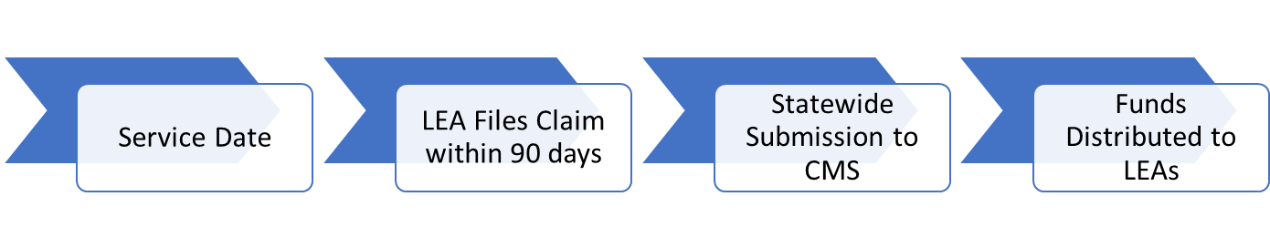
Examples:
9/6/20 | If adjudicated for payment by:  9/30/20 | 10/31/20 | Estimated between 1/1/21-2/28/21
 | If adjudicated for payment by:  12/31/20 | 1/31/21 | Estimated between 4/1/21-5/31/21

Reimbursement Timeframes
Direct Service Claiming (DSC): Cost Settlement
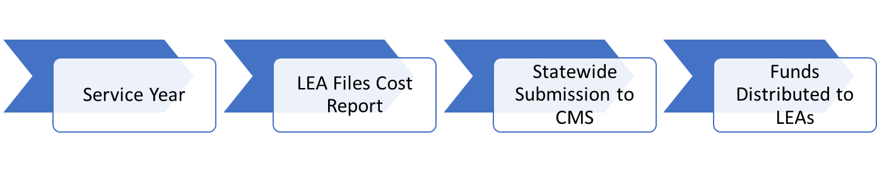
Examples:
FY 2020: 7/1/19-6/30/20 | Deadline:12/31/20 | 4/30/21 | Estimated between 6/1/21-6/30/21

Next Training Steps
There may be other modules in the Medicaid 101 training series that apply to your specific training needs.
Training Module | Intended Audience
Module 2: SBMP for LEA Administrators | LEA Administrators, such as superintendents, business managers, health services and special education directors
Module 3: SBMP for LEA Random Moment Time Study (RMTS) Coordinators | Designated LEA RMTS Coordinators, including those who support an RMTS coordinator with required information
Module 4: SBMP for Clinical Leadership | LEA clinical leadership staff, such as health directors and nursing directors
Module 6: SBMP for Legal/Regulatory Leadership | LEA administrators, such as superintendents, compliance staff, finance directors, legal and contracts staff
Module 7: SBMP for Technology Leadership | LEA technology directors/managers
Module 8: SBMP for Direct Service Practitioners | LEA staff who participate in the Direct Medical Services reimbursement portion of the SBMP
Module 9: For LEA RMTS Participants performing Medicaid Administrative Activities | LEA staff who participate in the RMTS

Next Training Steps
The SBMP Resource Center (https://www.mass.gov/info-details/sbmp-resource-center) includes a lot of additional information and resources. Of particular interest to the topics reviewed in this training:
- “LEA Instruction Guide for Administrative Activity Claiming (AAC)”
- “LEA Instruction Guide for Direct Service Cost Report”
Additionally, all designated AAC Claim Preparers have access to online training videos, “step-by-step” instruction manuals, and other resources once logged in with your User ID and password to the AAC system (https://cbe-aac.chcf.umms.org/).
And all designated Cost Report preparers have access to “step-by-step” instruction manuals and other resources once logged in with your User ID and password to the Cost Report system (https://macostreport.chcf-umms.org/).

Contact Information & Resources
MassHealth School-Based Medicaid Program information:
www.mass.gov/masshealth/schools
UMMS School-Based Help Desk:
SchoolBasedClaiming@umassmed.edu
1-800-535-6741
M-F 7:30 a.m. – 7:30 p.m.

