Medicaid 101: For LEA Legal & Compliance Leadership
Executive Office of Health and Human Services
April 2021

Distributed April 2021
This training was distributed in April 2021 and was accurate at the time of distribution. As always, Local Education Agencies are responsible for reviewing information on the School-Based Medicaid Program website (www.mass.gov/masshealth/schools) to determine whether subsequent guidance has superseded the content shared here. MassHealth plans to update these trainings periodically as needed.

Introduction to Medicaid 101 Training Series
The Medicaid 101 training series is designed to provide the essentials to understanding the School-Based Medicaid Program (SBMP). Some modules are designed for a broad, general audience. Other modules are targeted to the learning needs of a specific audience within each Local Education Agency (LEA).
Training Module | Intended Audience
Module 1: Introduction | Everyone
Module 2: SBMP for LEA Administrators | LEA Administrators, such as superintendents, business managers, health services and special education directors
Module 3: SBMP for LEA Random Moment Time Study (RMTS) Coordinators | Designated LEA RMTS Coordinators, including those who support an RMTS coordinator with required information
Module 4: SBMP for Clinical Leadership | LEA clinical leadership staff, such as health directors and nursing directors
Module 5: SBMP for Financial Leadership | LEA financial leadership, such as business managers, accounting managers

Introduction to Medicaid 101 Training Series
The Medicaid 101 Training Series, continued
Training Module | Intended Audience
Module 6: SBMP for Legal/Regulatory Leadership* (this module) | LEA Administrators, such as superintendents, compliance staff, finance directors, legal and contracts staff
Module 7: SBMP for Technology Leadership | LEA technology directors/managers
Module 8: SBMP for Direct Service Practitioners | LEA staff who participate in the Direct Medical Services reimbursement portion of the SBMP
Module 9: SBMP for LEA RMTS Participants performing Medicaid Administrative Activities | LEA staff who participate in the RMTS

Training Agenda
- Training Objectives
- Your Contribution to Your LEA’s Medicaid Team
- Legal / Regulatory Leadership Role
- Review of regulatory, sub-regulatory and program guidance sources and documents
- Review of key legal/regulatory/compliance concepts and areas of impact in the SBMP
- Next Training Steps
- Contact Information & Resources

Training Objectives
By the conclusion of this training, you will:
- Be familiar with the various regulatory, sub-regulatory, contractual, and program requirements impacting your LEAs participation in the SBMP.
- Return to your LEA with ideas about areas of compliance to follow-up on to ensure that your LEA has appropriate processes, procedures and controls in place to remain compliant and to respond to a potential audit or review.
NOTE: This training is an introductory “101” level. The intention is to provide an overall description of concepts and processes, but not all the necessary details that you need to know. This is a great place to start to build foundational knowledge. Resources and training opportunities for additional information will be provided within the presentation.

Identifying Your LEA’s Medicaid Team Members
Successful participation in the School-Based Medicaid Program (SBMP) requires coordination and collaboration among people responsible for managing each of the key pieces of the Medicaid program.
Leadership support in the area of legal and regulatory compliance is key to ensuring that your SBMP reimbursement program remains compliant with all requirements so that you can maximize your federal claiming while minimizing audit risks.
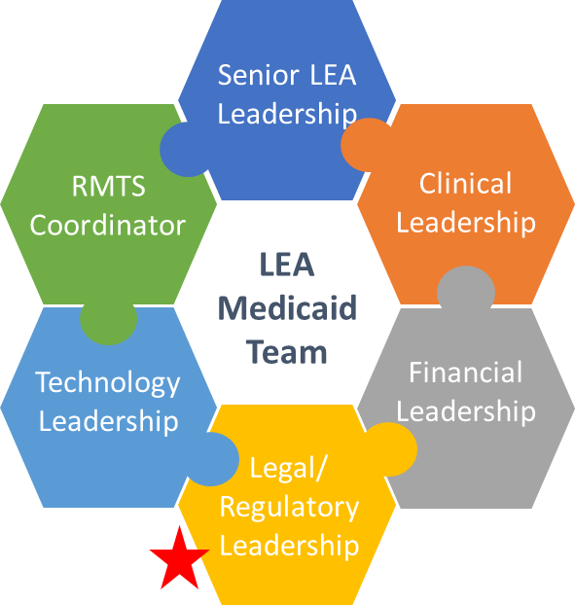

Legal/ Regulatory Leadership Role
LEAs are responsible for compliance with the terms of the LEA Provider Contract and state and federal regulations and guidance. Since there are so many moving pieces to monitor, LEAs should designate someone to be responsible for monitoring LEA compliance, addressing contract issues and providing audit responses.
- A model SBMP provider contract is published on the SBMP Resource Center for easy reference: https://www.mass.gov/doc/school-based-medicaid-program-amended-contract-and-appendix-a-for-fy20/download
- In addition to FERPA privacy regulations, participation in the Medicaid program also requires compliance with any relevant provisions of the Health Insurance Portability and Accountability Act of 1996 (HIPAA)
- The SBMP mandatory School District Contact Information form requires LEAs to identify a primary point of contact for audits, PERM reviews, program compliance, record requests, etc. Be sure to keep this important contact information up to date by updating the form as needed. The form can be downloaded from the SBMP Resource Center: https://www.mass.gov/doc/school-district-contact-information-forrm/download

Applicable Laws, Regulations, and Published Guidance
Any LEA or subcontractor participating in the SBMP must comply with applicable federal and state laws, regulations, published guidance, and the terms of the provider contract. These include, but are not limited to:
- Section 1902(a) of the Social Security Act
- Code of Federal Regulation (CFR) Titles 42, 45
- OMB Uniform Administrative Requirements, Cost Principle, and Audit Requirements for Federal Awards (2 C.F.R. §200)
- OMB Circular A-133 Audits of States, Local Governments and Non-Profit Organizations
- MassHealth School-Based Medicaid Program Bulletins
- MassHealth School-Based Medicaid Program Instruction Guides
- Massachusetts School-Based Medicaid Program Provider Contract

Certification of Public Expenditure
All Administrative Activity Claims and Direct Service Cost Reports require a Certification of Public Expenditure that is signed by an officer of the LEA (typically the superintendent or business manager), certifying several statements. As a leader for legal/regulatory and compliance issues, you should be evaluating the processes and controls in place to ensure that your LEA can confidently make these statements.
- “…to the best of my knowledge and belief they are true and correct statements prepared from the books and records of the public agency in accordance with applicable cost report instructions.”
- “The expenditures included in this statement are based on the actual cost of allowable expenditures for activities that support the implementation of the Medicaid state plan.”
- “The required amount of public funds were available and used to pay for the total allowable expenditures included in this statement, and such public funds are not Federal funds, or are federal funds authorized by federal law to be used to match other federal funds.”

Certification of Public Expenditure
- “I understand that federal matching funds are being claimed on the expenditures identified in this report.”
- “No expenditures claimed directly in this statement are duplicative of any costs included in the claim through the application of the Indirect Cost Rate.”
- “I am the officer authorized by the referenced public agency to submit this form to the single state Medicaid agency and I have made a good faith effort to assure that all information reported is true and accurate.”
- “I understand that this information will be used by the single state Medicaid agency as a basis for claims for federal funds and that falsification or concealment of a material fact by me may result in my prosecution under federal or state civil or criminal law.”

LEA Enrollment Overview
- To participate in the School-Based Medicaid Program (SBMP), LEAs must enroll with MassHealth. After enrollment is completed and the LEA has started to participate in its first quarter of the RMTS, the LEA may begin billing for direct services and may have its costs reimbursed if the reimbursable services requirements are met. For detailed instructions about the RMTS, please see the LEA RMTS Coordinator Guide for Random Moment Time Study (RMTS) available in the SBMP Resource Center [https://www.mass.gov/doc/dates-deadlines-fy21/download].
- To enroll as an SBMP provider, contact the MassHealth Customer Service Center at providersupport@mahealth.net or (800) 841-2900.
- Pursuant to the Health Insurance Portability and Accountability Act of 1996 (HIPAA), all LEAs must obtain a National Provider Identifier (NPI) and must include this 10-digit number on all claims and correspondence submitted to MassHealth. To register for an NPI, contact the National Plan & Provider Enumeration System (NPPES). [https://nppes.cms.hhs.gov/#/]

Record Retention and Audit Preparedness
- LEAs are responsible for ensuring program compliance and must certify, under penalties of perjury, that all Administrative Activity claims and annual cost reports are accurate.
- The federal government regularly audits the SBMP, and all costs are subject to audit review by MassHealth and other state and federal agencies.
- LEAs are responsible for ensuring that the appropriate documentation can be produced in the event of an audit or other request by MassHealth or other state or federal compliance agency. Failure to do so may result in a recoupment or termination from the program as described in the Provider Contract. A model contract is available on the SBMP Resource Center (https://www.mass.gov/info-details/sbmp-resource-center).

Claims Repayment and Disallowance of FFP
- Your LEA’s Provider Contract with MassHealth and Massachusetts General Law (M.G.L. c.44, §72) require LEAs to provide any supporting documentation deemed necessary to support any claim for federal payments.
- LEAs historically had common, avoidable problems in audit and desk review responses
  - Failure to respond
  - Responding with inaccurate or incomplete information
  - Responding with incorrect or irrelevant information
  - Failure to comply with HIPAA for transmission of protected information when providing audit responses
Per the terms of the Provider Contract, “In the event that a review by either EOHHS or CMS reveals that the Provider did not administer this Contract in accordance with the terms specified herein or applicable state and/or federal laws, EOHHS retains the right to retroactively disallow the FFP claimed and recover the disallowed amount from any FFP paid or due to the Provider as a result of FFP claims processed for Medicaid services delivered under this Contract. Such reviews and subsequent disallowances and recoveries may occur following termination of this Contract.” (section 2.3.C.3.; bold added for emphasis.)

Other Contractual Obligations
- Provider obligations are outlined in the School-Based Medicaid Program Provider Contract. For a comprehensive list of provider obligations, please refer to the SBMP Provider Contract directly. A model SBMP contract is available on the SBMP Resource Center for reference (https://www.mass.gov/info-details/sbmp-resource-center).

Data Management and Confidentiality
- As per the Provider Contract, Appendix A, all LEAs must comply with obligations relating to the privacy, security and management of personal and other confidential information, including compliance with the Privacy Rule defined by the Standards for Privacy of Individually Identifiable Health Information at 45 CFR Parts 160 [https://www.govinfo.gov/app/details/CFR-2004-title45-vol1/CFR-2004-title45-vol1-part160] and 164 [https://www.govinfo.gov/app/details/CFR-2007-title45-vol1/CFR-2007-title45-vol1-part164].
- The LEA must implement administrative, physical, and technical safeguards that reasonably and appropriately protect the confidentiality, integrity, and availability of PI, and that prevent the use or disclosure of such data other than as specifically required for the operation of the School-Based Medicaid Program per the terms of the SBMP Provider Contract.
- All obligations to protect the privacy and security of Protected Information from unauthorized release or disclosure apply to the LEA, its employees and agents, and to any subcontractors of the LEA, including any contracted staff or contracted billing agent engaged in the performance of any activities on behalf of the LEA related to the SBMP.

Excluded Persons or Entities
- As per the Provider Contract, the LEA must search the U.S. Department of Health and Human Services Office of the Inspector General’s List of Excluded Individuals/Entities (LEIE) and the General Services Administration’s Exclusions database in the System for Award Management (SAM) (https://www.sam.gov/SAM/pages/public/extracts/samPublicAccessData.jsf) for the names of agents or managing employees of the provider at least monthly to ensure that EOHHS does not pay for services provided by excluded persons or entities.
- The LEIE exclusions database can be accessed online at the website of the Office of Inspector General [https://exclusions.oig.hhs.gov/] of the U.S. Department of Health and Human Services.

DESE Guidance Regarding Parental Consent
- The Department of Elementary and Secondary Education (DESE) is the state agency responsible for overseeing the Federal Educational Rights and Privacy Act (FERPA) and Individuals with Disabilities Education Act (IDEA) in Massachusetts.
- DESE has provided guidance that parental consent is required before an LEA can access a student’s MassHealth benefits, which includes the submission of interim claims and including students in the Medicaid eligibility statistics for calculating the annual cost report.
- For more information about parental consent, refer to www.doe.mass.edu/sped/28mr/ or contact DESE at (781) 338-3010 or achievement@doe.mass.edu.

Reimbursable Services Requirements
- If a Covered Service is delivered, the following requirements must be met to be considered a Reimbursable Service:
- Practitioner RMTS Direct Service Pool Participation (for in-district services)
- Practitioner Licensure Qualifications
- Medicaid’s Definition of Medical Necessity
- Service Authorization
- Service Documentation
- LEAs must ensure that each of the five requirements is met before an interim claim is submitted to MMIS for adjudication.
- The LEA must maintain and produce upon request documentation of compliance with these requirements for each reimbursable service. Failure to produce documentation for the five reimbursable services requirements in the event of a state or federal inquiry or audit may result in recoupment.
- When responding to an RMTS moment, participants must meet reimbursable services requirements to respond that they were providing services in compliance with program guidelines.

Signature Requirements – Documentation
Documentation includes orders, plans of care/treatment plans, evaluation reports, service documentation/progress notes, and discharge plans.
Both handwritten and electronic signatures are allowable.
The guidelines for using an electronic signature are:
- Systems and software products must include protections against modification, and you should apply administrative safeguards that correspond to standards and laws
- The individual whose name is on the alternate signature method and the provider bear the responsibility for the authenticity of the attested information
LEAs should check with legal counsel before using alternative (non-handwritten) signature methods.
Handwritten signatures must be legible or a printed name below the illegible signature can be provided or the illegible signature can be validated by comparing to a signature log or attestation statement.
All signatures (handwritten or electronic) must be dated.
- An order or Plan of Care cannot be created after the fact or backdated

Signature Requirements – Certification of Public Expenditure
The required Certification of Public Expenditure statements for quarterly Administrative Activity Claims and the annual Direct Services Cost Report can be provided electronically, via email, as a scanned or imaged document.
The original “wet ink” signature on all CPE statements/letters should be retained by the LEA along with all other supporting documentation and records that support the costs claimed, for the record retention period of 6 years required by the Provider Contract.

Interim Billing Submission
LEAs are expected to submit interim bills consistent with the rules specified below:
- Claims must be submitted in electronic format in accordance with Health Insurance Portability and Accountability Act (HIPAA) guidelines using the 837P claim format or through Direct Data Entry (DDE) via the POSC.
- LEAs may perform the billing themselves using the POSC DDE option, purchase software that will generate the required 837P claim files, or contract with a third party to perform the billing for the district.
- Interim claims must be submitted within 90 days of the date of service and must include the appropriate Procedure Code and a clinically appropriate ICD-10 Diagnosis code.
- Claims must be submitted per SBMP guidance, for more information see the Direct Service (Interim) Claiming Guide.
- All claims are subject to audit. LEAs are responsible for ensuring the appropriate documentation can be produced in the event of an audit or other request by MassHealth or other state or federal compliance agency. Failure to do so may result in a recoupment and/or termination from the program as described in the Provider Contract. For more information about documentation requirements, see the Direct Service (Interim) Claiming Guide.

RMTS Supporting Documentation
- Pursuant to section 4.2 of the Provider Contract, LEAs must retain records to support activities recorded in response to the RMTS for at least 6 years after the date of submission of the Administrative Claim or Cost Report which is supported by such documentation.
- LEAs are expected to identify and implement internal processes/procedures (if not already established) and oversee compliance to ensure that RMTS participants provide supporting documentation for the activities recorded in any assigned RMTS moments. These records should be maintained by the LEA in an organized and retrievable fashion to be available upon audit.

Pathway to Compliance
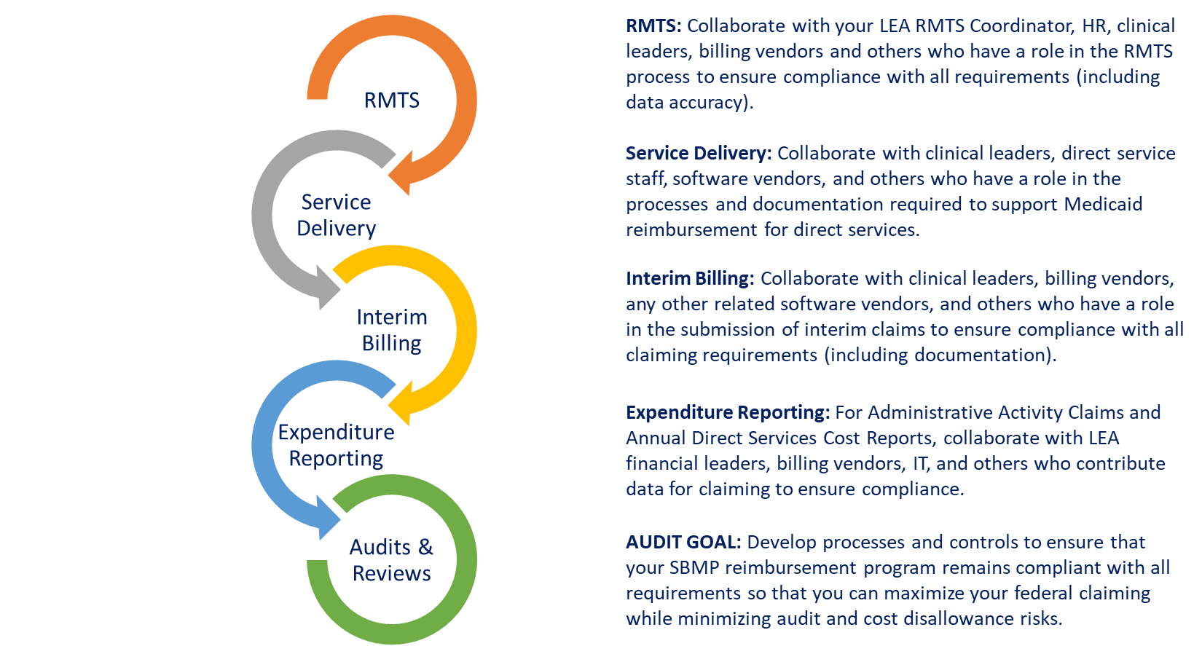

Next Training Steps
There may be other modules in the Medicaid 101 training series that apply to your specific training needs.
Training Module | Intended Audience
Module 2: SBMP for LEA Administrators | LEA Administrators, such as superintendents, business managers, health services and special education directors
Module 3: SBMP for LEA Random Moment Time Study (RMTS) Coordinators | Designated LEA RMTS Coordinators, including those who support an RMTS coordinator with required information
Module 4: SBMP for Clinical Leadership | LEA clinical leadership staff, such as health directors and nursing directors
Module 5: SBMP for Financial Leadership | LEA financial leadership, such as business managers, accounting managers
Module 7: SBMP for Technology Leadership | LEA technology directors/managers
Module 8: SBMP for Direct Service Practitioners | LEA staff who participate in the Direct Medical Services reimbursement portion of the SBMP
Module 9: For LEA RMTS Participants performing Medicaid Administrative Activities | LEA staff who participate in the RMTS

Next Training Steps
The SBMP Resource Center (https://www.mass.gov/info-details/sbmp-resource-center) includes a lot of additional information and resources. Of particular interest to the topics reviewed in this training:
- “School-Based Medicaid Program Amended Contract and Appendix A for FY20”
- “SBMP Direct Service Claiming (DSC) Guide Updated Aug 20”
- “LEA Instruction Guide for Administrative Activity Claiming (AAC)”
- “LEA Instruction Guide for Direct Service Cost Report”
- “Local Education Agencies Covered Services and Qualified Practitioners”
Additionally, all MassHealth Program Bulletins for the School-Based Medicaid Program are available here:
https://www.mass.gov/lists/sbmp-program-bulletins

Contact Information & Resources
MassHealth School-Based Medicaid Program information:
www.mass.gov/masshealth/schools
UMMS School-Based Help Desk:
SchoolBasedClaiming@umassmed.edu
1-800-535-6741
M-F 7:30 a.m. – 7:30 p.m.

