Medicaid 101: For LEA Technology Leadership
Executive Office of Health and Human Services
April 2021

Distributed April 2021
This training was distributed in April 2021 and was accurate at the time of distribution. As always, Local Education Agencies are responsible for reviewing information on the School-Based Medicaid Program website (www.mass.gov/masshealth/schools) to determine whether subsequent guidance has superseded the content shared here. MassHealth plans to update these trainings periodically as needed.

Introduction to Medicaid 101 Training Series
The Medicaid 101 training series is designed to provide the essentials to understanding the School-Based Medicaid Program (SBMP). Some modules are designed for a broad, general audience. Other modules are targeted to the learning needs of a specific audience within each Local Education Agency (LEA).
Training Module | Intended Audience
Module 1: Introduction | Everyone
Module 2: SBMP for LEA Administrators | LEA Administrators, such as superintendents, business managers, health services and special education directors
Module 3: SBMP for LEA Random Moment Time Study (RMTS) Coordinators | Designated LEA RMTS Coordinators, including those who support an RMTS coordinator with required information
Module 4: SBMP for Clinical Leadership | LEA clinical leadership staff, such as health directors and nursing directors
Module 5: SBMP for Financial Leadership | LEA financial leadership, such as business managers, accounting managers

Introduction to Medicaid 101 Training Series
The Medicaid 101 Training Series, continued:
Training Module | Intended Audience
Module 6: SBMP for Legal/Regulatory Leadership | LEA Administrators, such as superintendents, compliance staff, finance directors, legal and contracts staff
Module 7: SBMP for Technology Leadership* (this module) | LEA technology directors/managers
Module 8: SBMP for Direct Service Practitioners | LEA staff who participate in the Direct Medical Services reimbursement portion of the SBMP
Module 9: SBMP for LEA RMTS Participants performing Medicaid Administrative Activities | LEA staff who participate in the RMTS

Training Agenda
- Training Objectives
- Your Contribution to your LEA’s Medicaid Team
- Technology Needs for Random Moment Time Study
- Technology Needs for Medicaid Billing
- Technology Needs for Student Enrollment Data
- Technology Needs for Salary & Benefit Reporting
- Technology Needs for Accounting Data
- Technology Role in Security and Compliance
- Next Training Steps
- Contact Information & Resources

Training Objectives
By the conclusion of this training, you will:
- Understand the variety of data needs involved in participation in the School-Based Medicaid Program
- Identify opportunities for technology leaders to become involved in improving the accuracy, timeliness, data integrity and operational efficiencies of maintaining, retrieving and storing SBMP related information that supports
  - Random Moment Time Study
  - Cost Reporting
  - Documentation of services provided to students (and other related information)
  - Interim Billing
  - Audit preparedness and record retention

Your Contribution to your LEA’s Medicaid Team
Successful participation in the School-Based Medicaid Program (SBMP) requires coordination and collaboration among people responsible for managing each of the key pieces of the Medicaid program.
Virtually all other team members utilize technology in some piece of their work related to the Medicaid program, but may or may not have reached out for assistance.
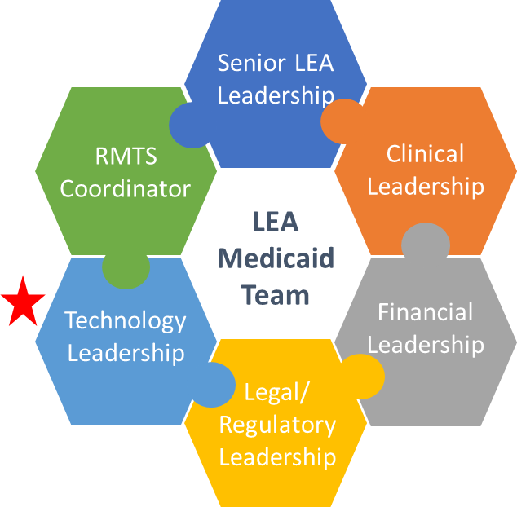

Technology Needs for Random Moment Time Study: Email
Key areas for a technology leader to be involved with the Random Moment Time Study are:
- Staff are notified that they have been selected to participate in the time study via email. Spam blockers should recognize emails from SchoolBasedClaiming@umassmed.edu as a “safe sender.”
- All staff participating in the RMTS need a school email account before they can be included in the time study. Set up email accounts for new and contracted staff members quickly and communicate that information to the RMTS coordinator.
- Help address technology access issues for staff who might not have a dedicated personal computer.

Technology Needs for Random Moment Time Study: Internet Access
Additional areas for a technology leader to be involved with the Random Moment Time Study are:
- Staff respond to the time study by accessing the RMTS website. Participants need internet connectivity and updated internet browsers to complete their online moment responses, and firewall settings need to allow access to the URL.
- Review or establish and communicate policies so participants know if they can answer their moments on smart phones or tablets
- Review annually updated “RMTS Technical Notes & System Requirements” from UMMS. (You can obtain a copy from your RMTS Coordinator or contact UMMS help desk for a copy at SchoolBasedClaiming@umassmed.edu)

Technology Needs for Random Moment Time Study: Information Flow
Additional opportunities for technology assistance in solving reporting and communication needs for the Random Moment Time Study Coordinator are:
- Develop technology solutions and create reports to facilitate notification to RMTS Coordinator of pertinent staffing changes:
  - New Hires
  - Job Position Changes
  - Long term leaves of absence
  - Name Changes
  - Email Address Changes
  - School Building/work location changes

Technology Needs for Medicaid Billing
Key areas for a technology leader to be involved with the Medicaid billing process are:
- Interfacing of data between IEP data, student records, student health data, and Medicaid billing software or vendor
- Tracking student Medicaid ID numbers
- Tracking parental consent for Medicaid billing
- Evaluation and selection of Medicaid billing software or vendor
- Ensuring compliance with relevant privacy laws (FERPA and HIPAA)

Electronic Claim Submission
- Interim claims must be submitted to the Medicaid Management Information System (MMIS). LEAs are responsible for ensuring that claims are submitted to MMIS.
- The interim claim must be submitted in electronic format in accordance with HIPAA guidelines, using the 837P claim format or through direct data entry (DDE) via the Provider Online Service Center (POSC). LEAs may bill by
  - using the POSC DDE option;
  - purchasing software to generate the required 837P claim files; or
  - contracting with a third party to bill on behalf of the LEA.
- For information about 837P file requirements, please refer to the MassHealth Companion Guide to HIPAA Compliant Electronic Data Interchange Transactions document that is available from the MassHealth Customer Service Center
- For information about submitting claims using the POSC please see https://www.mass.gov/how-to/submit-claims.
- For assistance in identifying your LEA’s primary account holder or with accessing the POSC, contact the MassHealth Customer Service Center at 1-800-841-2900.

Electronic Claim Submission
- LEAs are responsible for ensuring compliance with all SBMP program requirements related to all billing activities, even if a third-party bills on the LEA’s behalf. LEAs should develop internal controls for quality assurance of submissions made by their vendor or by LEA internal billing staff.
- Some third-party billing vendors will require reports or electronic files from LEA software/systems to gather student, IEP and/or medical service delivery information for the purpose of Medicaid billing.
- Remittance advices detailing the adjudication status of all electronically submitted claims are available through the POSC and through the HIPAA 5010 electronic remittance advice files in 835 format.
  - These remittance advices are made available to the entity or organization that submitted a claim file weekly.
  - To monitor claim payments and denials, LEAs should review remittance advices.
  - If another entity, such as a billing vendor, submits claims on behalf of the LEA, the LEA is responsible for requesting the remittance advices from the entity.
  - Reviewing remittance advices is required to ensure that claims submissions are being adjudicated and paid appropriately.

Technology Needs for Student Enrollment Data
Some of the major pieces of data needed for the Medicaid program are likely part of your LEA’s Student Information Management system. Technology leaders can help in several ways relative to this data.
- Design queries or provide required student enrollment demographic data for quarterly Medicaid eligibility matching process
- Identify and track of IEP students and their related services data
- Identify and track student Medicaid ID and eligibility information

Technology Needs for Financial Data
A technology leader can provide important assistance and support with retrieving financial data from human resources, payroll and other accounting systems needed for cost reporting:
- Technical assistance and support for creating automated processes and solutions to track and retrieve required data in financial/accounting systems and payroll/HR systems
- This is crucial to program success, as the use of reports jointly developed by technology leaders and end users can significantly reduce the chance of human error and audit risk

Technology Role in Security and Compliance
With most of the information related to Medicaid program activities housed in computer systems/applications, technology leadership is needed to:
- Ensure compliance of technology with provisions of the Health Insurance Portability and Accountability Act of 1996 (HIPAA)
- Ensure system(s) compliance with 6-year record retention requirement per the terms of the Medicaid provider contract

Data Management and Confidentiality
- As per the Provider Contract, Appendix A, all LEAs must comply with obligations relating to the privacy, security and management of personal and other confidential information, including compliance with the Privacy Rule defined by the Standards for Privacy of Individually Identifiable Health Information at 45 CFR Parts 160 and 164.
- The LEA must implement administrative, physical, and technical safeguards that reasonably and appropriately protect the confidentiality, integrity, and availability of PI, and that prevent the use or disclosure of such data other than as specifically required for the operation of the School-Based Medicaid Program per the terms of the SBMP Provider Contract.
- All obligations to protect the privacy and security of Protected Information from unauthorized release or disclosure apply to the LEA, its employees and agents, and to any subcontractors of the LEA, including any contracted staff or contracted billing agent engaged in the performance of any activities on behalf of the LEA related to the SBMP.

Record Retention and Audit Preparedness
- LEAs are responsible for ensuring program compliance and must certify, under penalties of perjury, that all Administrative Activity claims and annual cost reports are accurate.
- The federal government regularly audits the SBMP, and all costs are subject to audit review by MassHealth and other state and federal agencies.
- LEAs are responsible for ensuring that the appropriate documentation can be produced in the event of an audit or other request by MassHealth or other state or federal compliance agency. Failure to do so may result in a recoupment or termination from the program as described in the Provider Contract. A model contract is available on the SBMP Resource Center at https://www.mass.gov/info-details/sbmp-resource-center#model-sbmp-contract-.

Next Training Steps
There may be other modules in the Medicaid 101 training series that apply to your specific training needs.
Training Module | Intended Audience
Module 1: Introduction | Everyone
Module 2: SBMP for LEA Administrators | LEA Administrators, such as superintendents, business managers, health services and special education directors
Module 3: SBMP for LEA Random Moment Time Study (RMTS) Coordinators | Designated LEA RMTS Coordinators, including those who support an RMTS coordinator with required information
Module 4: SBMP for Clinical Leadership | LEA clinical leadership staff, such as health directors and nursing directors
Module 5: SBMP for Financial Leadership | LEA financial leadership, such as business managers, accounting managers
Module 6: SBMP for Legal/Regulatory Leadership | LEA administrators, such as superintendents, compliance staff, finance directors, legal and contracts staff
Module 8: SBMP for Direct Service Practitioners | LEA staff who participate in the Direct Medical Services reimbursement portion of the SBMP
Module 9: For LEA RMTS Participants performing Medicaid Administrative Activities | LEA staff who participate in the RMTS

Contact Information & Resources
MassHealth School-Based Medicaid Program information:
www.mass.gov/masshealth/schools
UMMS School-Based Help Desk:
SchoolBasedClaiming@umassmed.edu
1-800-535-6741
M-F 7:30 a.m. – 7:30 p.m.

