Medicaid 101: For Local Education Agency (LEA) Random Moment Time Study (RMTS) Participants performing Medicaid Administrative Activities
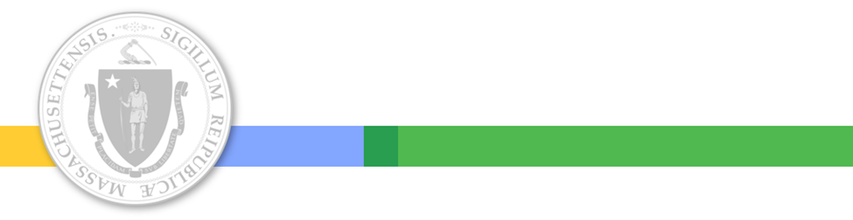
Executive Office of Health and Human Services
April 2021

Distributed April 2021
This training was distributed in April 2021 and was accurate at the time of distribution. As always, Local Education Agencies are responsible for reviewing information on the School-Based Medicaid Program website (www.mass.gov/masshealth/schools) to determine whether subsequent guidance has superseded the content shared here. MassHealth plans to update these trainings periodically as needed.

Introduction to Medicaid 101 Training Series
The Medicaid 101 training series is designed to provide the essentials to understanding the School-Based Medicaid Program (SBMP). Some modules are designed for a broad, general audience. Other modules are targeted to the learning needs of a specific audience within each Local Education Agency (LEA).
Training Module | Intended Audience
Module 1: Introduction | Everyone
Module 2: SBMP for LEA Administrators | LEA Administrators, such as superintendents, business managers, health services and special education directors
Module 3: SBMP for LEA Random Moment Time Study (RMTS) Coordinators | Designated LEA RMTS Coordinators, including those who support an RMTS coordinator with required information
Module 4: SBMP for Clinical Leadership | LEA clinical leadership staff, such as health directors and nursing directors
Module 5: SBMP for Financial Leadership | LEA financial leadership, such as business managers, accounting managers

Introduction to Medicaid 101 Training Series
The Medicaid 101 Training Series, continued:
Training Module | Intended Audience
Module 6: SBMP for Legal/Regulatory Leadership | LEA Administrators, such as superintendents, compliance staff, finance directors, legal and contracts staff
Module 7: SBMP for Technology Leadership | LEA technology directors/managers
Module 8: SBMP for Direct Service Practitioners | LEA staff who participate in the Direct Medical Services reimbursement portion of the SBMP
Module 9: SBMP for LEA RMTS Participants performing Medicaid Administrative Activities * (this module) | LEA staff who participate in the RMTS

Training Agenda
- Training Objectives
- How does Administrative Activity reimbursement work?
- Overview of reimbursable Administrative Activities
- Random Moment Time Study (RMTS) participation & documentation of Administrative Activities
- Next training steps

Training Objectives
By the conclusion of this training, you will:
- Understand the kinds of work activities school staff perform that are partially reimbursable through the School-Based Medicaid Program (SBMP) and why you have been included in the Random Moment Time Study (RMTS)
  - Be prepared to reflect on your job duties and discover work that you do that qualifies for Medicaid Administrative reimbursement
- Understand how the RMTS works and what is involved in documenting your work activities when selected to respond to a random moment
- Come away with a framework to better understand the RMTS process and expectations so that you’ll feel confident that you’re doing your part to effectively document reimbursable Administrative work activities to help your Local Education Agency (LEA) (and LEAs statewide) receive the maximum allowable reimbursement.

How Does Administrative Activity Reimbursement Work?
- There is no billing or “billing documentation” for Administrative Activities.
- Instead, the SBMP quantifies the amount of time school staff spend performing reimbursable Administrative Activities through the Random Moment Time Study (RMTS).
- The results of the RMTS are used to allocate staff costs to determine the portion of staff costs that is eligible for Medicaid Administrative reimbursement.
- For all School-Based RMTS participants included in all RMTS participant pools, work activities performed, which support the Medicaid state plan, are reimbursable in the Medicaid Administrative Claiming portion of the SBMP.

I don’t do Medicaid administrative work… Or do I?
- There is a crucial link between student health and well-being and student academic success.
- MassHealth’s mission is to improve the health outcomes of our diverse members and their families by providing access to integrated health care services that sustainably and equitably promote health, well-being, independence, and quality of life.
- The common goal shared by educators and the Medicaid program is to ensure access to health care services for all students, particularly those students who are affected by health inequities.
- That’s where the Medicaid Administrative Claiming program comes in: Administrative activities link students to health care services, coordinate and monitor health care services to ensure students are receiving the services that they need, and help students and families enroll with MassHealth and maintain and access their MassHealth benefits.
- The SBMP provides an opportunity for reimbursement for these crucial activities.

Reimbursable Administrative Activities
There are seven types of reimbursable administrative activities:
Medicaid Outreach: informing eligible or potentially eligible individuals and families about MassHealth and accessing MassHealth benefits. Examples include, but are not limited to
1
- Providing a student’s family with literature about the benefits and availability of EPSDT (Early and Periodic Screening, Diagnostic, and Treatment) programs or other Medicaid programs (including managed care); and
- Informing students and families how to effectively access, use, and maintain participation in MassHealth resources.

Reimbursable Administrative Activities
MassHealth Application Assistance: assisting individuals or families to apply or renew eligibility for MassHealth. Examples include, but are not limited to
2
- Talking with a family about the Medicaid eligibility process, including helping them complete the Medicaid application, or connecting the family with a certified application counselor, who can help them apply; and
- Gathering information from the family related to the Medicaid application process.

Reimbursable Administrative Activities
Provider Networking/Program Planning/Interagency Coordination: participating in activities to develop strategies to improve the delivery of covered services, including collaborative activities with other agencies regarding covered services. Examples include, but are not limited to
3
- Developing advisory or work groups of health professionals to provide consultation and advice regarding the delivery of health care services to school populations, such as developing school or district-wide procedures for uniform asthma screenings, including working with an outside entity advising the procedures;
- Reviewing and updating standing orders for school nurses;
- Developing strategies to assess or increase the capacity of school-based medical/ behavioral health programs;
- Identifying gaps to improve the coordination and delivery of Medicaid-covered health services; and
- Working with agencies to improve the coordination and collaboration of Medicaid services they provide, including opportunities to expand access to those services.

Reimbursable Administrative Activities
Individual Care Planning, Monitoring, Coordination, and Referral for Covered Services: making referrals to covered services, coordinating, or monitoring the delivery of covered services. Examples include, but are not limited to
4
- Collaborating with other health care providers to coordinate students’ health care services;
- Making referrals for or coordinating medical examinations and necessary medical/ behavioral health evaluations;
- Responding to a student’s health plan’s inquiry to better coordinate in- and out-of-school services;
- Arranging for Medicaid-covered medical, diagnostic, or treatment service as a result of a specifically identified medical condition;
- Coordinating the completion of the prescribed services, termination of services, and the referral of the child to other Medicaid service providers for continuity of care; and
- Participating in a meeting/discussion to coordinate or review a student’s needs for health care services covered by Medicaid (other than an IEP or 504 meetings).

Reimbursable Administrative Activities
Arranging MassHealth-covered transportation. Examples include, but are not limited to
5
- Scheduling a student’s transportation to a Medicaid-covered service appointment outside school; and
- Scheduling or coordinating transportation that is specially equipped or adapted to meet the needs of a student with a disability to attend school where Medicaid-covered services will be provided to the student.

Reimbursable Administrative Activities
Arranging or providing translation or interpretation services when required to access covered services. Examples include, but are not limited to
6
- Arranging translation or interpretation services that help the student or family access and understand necessary health-related care or treatment.

Reimbursable Administrative Activities
Training: participating in and coordinating (including providing) training related to Medicaid topics. Examples include, but are not limited to
7
- Providing or coordinating training that teaches or reinforces clinical best practices in patient care, such as training for school nurses on asthma-management plans; and
- Attending a School-Based Medicaid Program-related training or webinar.

Non-Reimbursable Activities
LEAs and their staff should understand that the SBMP is a Medicaid health program, not an educational program. Therefore, educational activities that are not medically necessary are not reimbursable. Some examples of non-reimbursable activities include:
- Planning, preparing for, or attending IEP meetings;
- Working to obtain parental consent to meet DESE (FERPA) requirements;
- Remedial education;
- Providing student supervision or daycare;
- Services that are purely educational, academic, vocational or social in nature, or do not require the skill level of a qualified practitioner.
- Medicaid billing activities are part of the Direct Service reimbursement portion of the Medicaid program. These activities are not reimbursable under AAC.

RMTS Participation
Since Administrative reimbursement to schools is determined by the percent of time that school staff perform reimbursable Administrative activities, as measured by the RMTS, all staff (employed or contracted) who are reasonably expected to perform that type of work need to be included in the LEA’s RMTS participant list.
- Some staff have been included in RMTS primarily for their work as qualified Direct Medical Services practitioners
  - Remember: staff included in any Direct Service pool are eligible for reimbursement for both Direct Medical Services and Administrative Services that clinical practitioners routinely perform.
- The Administrative Only Pool is an opportunity for each LEA to identify additional staff who routinely perform Medicaid Administrative work activities, but who don’t qualify for a Direct Service pool.

Participant/Staff Pools – Administrative
Administrative Only Pool “job descriptions”
- The actual job titles for staff participating in the Administrative Only pool can vary
- For RMTS purposes, identify the primary Medicaid Administrative duty that each staff member is expected to perform which qualifies them for participation
Administrative Only Pool
- Medicaid Outreach Worker
- Health Services Director/Manager/Administrator
- Health Services Referral Specialist
- Specialized Transportation Coordinator
- Health Care Case Manager/Coordinator
- Interpreter/Translator

What does an RMTS response look like?
- When randomly selected, assigned a specific date and time. You’ll be asked a series of questions:
  - What type/category of activity were you doing?
  - What were you doing more specifically?
  - Where were you?
  - Who were you working or interacting with?
  - Why were you performing this activity?
- Before responding to your moment, look at the date and time that it was assigned for and think about what you were doing at that specific minute. The pre-defined responses cover most work activities as well as non-working time.
  - If you were multitasking, identify the primary activity.
- If the options do not sufficiently describe your activity, you may choose “Other” and use the free-text section to provide adequate detail.

Quality of RMTS responses is important
- RMTS responses must clearly indicate that a reimbursable work activity has, or has not, occurred during the assigned minute snapshot.
- You’re conveying to the reader (coder), who was not present, the essence of what was taking place, much like when you’re describing an event or experience that made an impact on you.
- When you answer your moment, imagine another person looking at your responses through the lens of your words in order to understand the topic, purpose, context, and content of your work activity.

Avoid Common RMTS Mistakes
Try to provide more than just a “physical description” of your work activity by explaining purpose, intent and context:
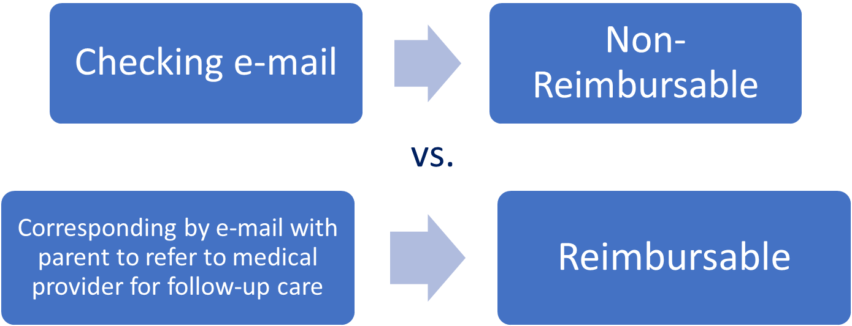

Avoid Common RMTS Mistakes
Try to provide sufficient detail so that your responses clearly indicate that a reimbursable activity occurred:
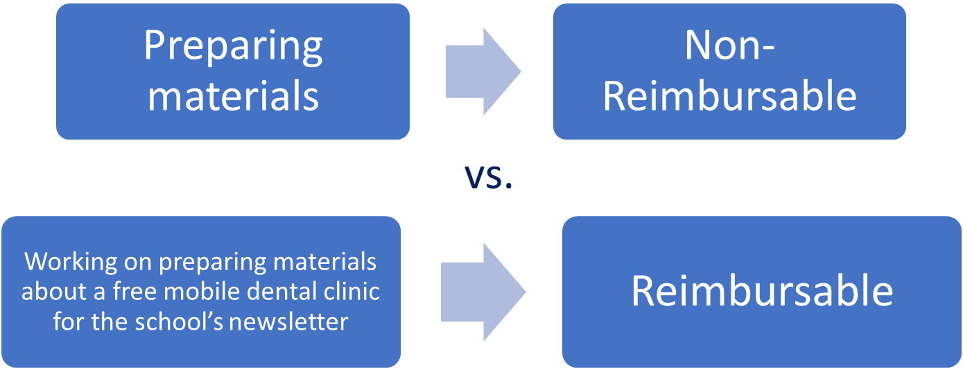

Avoid Common RMTS Mistakes
Be sure to document your work activity. Don’t tell us what you weren’t doing, tell us what you were doing:
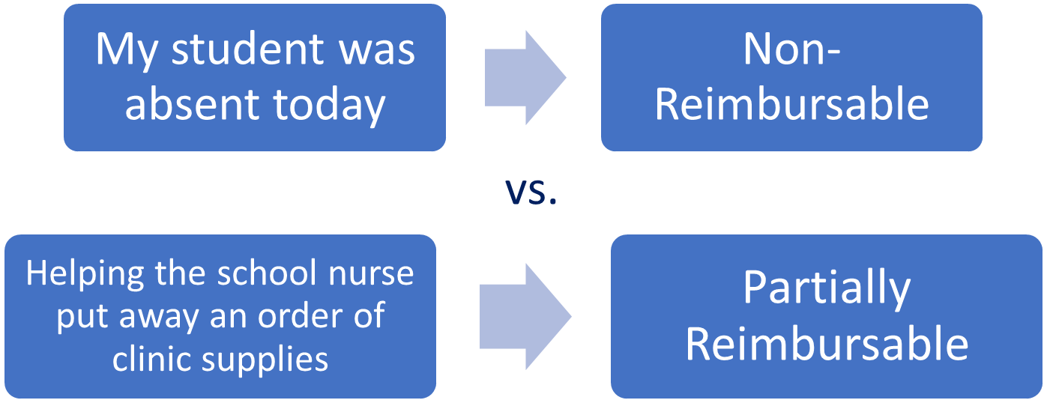

Tips for Completing a Random Moment:
- Remember that the RMTS corresponds to one minute. We are not concerned with what you were doing before or after the one assigned minute.
- Before submitting your moment, please review your answers to ensure that they make sense and do not contain any contradictions, since many of the options are similar.
- Avoid using acronyms in your response, or be sure to define them.
- A sufficient response will provide adequate detail on the topic, context, purpose, and content of the activity being performed.
- An insufficient response will only provide a literal/physical description of the activity.
- If you were engaged in communication at the time of your moment (either in person or via email or on the telephone), please describe the topic and purpose of the conversation/communication.

Overcome Common Misperceptions
Myths / Fears | Facts
My school district is “checking up on me” to see what I’m doing using the RMTS. | The only purpose of the RMTS is for the School Based Medicaid Program. Your moment responses are not shared with your school district.
I am being singled out unfairly and I’m getting extra moments. | The moments are completely randomly assigned by a computer program. Due to the nature of random selection, it is possible to get 2 moments in the same day or no moments at all.
It’s no one’s business why I took time off from work. Why do I get asked follow-up questions? | The RMTS only needs to identify whether each moment was assigned during “paid” time – including paid time off, which is partially reimbursable. You do not need to share why you were taking time off.

Overcome Common Misperceptions
Myths / Fears | Facts
I don’t work with the Medicaid program or Medicaid students, so I don’t qualify for reimbursement. | Your school district identified you as someone who performs reimbursable work activities. You never need to identify whether any student that you are working with is enrolled in Medicaid for the purpose of RMTS.
I work in a school, so everything I do is educational, not medical. | We hope that this training module has addressed this misperception. If you are a related services provider, we encourage you to view Module 8 for direct service practitioners for more information.

SBMP-Provided Participant Training
- The federally-required required online training video is available for RMTS Coordinators at www.chcf.net/chcfweb/ and for RMTS participants within the RMTS Moments application (https://cbe-rmts.chcf-umms.org/ ).
- Offers overview of the RMTS and walks participants through the mechanics of responding to moments.
- The RMTS System tracks each participant’s training status. Participants out of compliance with the training requirement will be prompted to complete the training upon login.

Next Training Steps
There may be other modules in the Medicaid 101 training series that apply to your specific training needs.
Training Module | Intended Audience
Module 2: SBMP for LEA Administrators | LEA Administrators, such as superintendents, business managers, health services and special education directors
Module 3: SBMP for LEA Random Moment Time Study (RMTS) Coordinators | Designated LEA RMTS Coordinators, including those who support an RMTS coordinator with required information
Module 4: SBMP for Clinical Leadership | LEA clinical leadership staff, such as health directors and nursing directors
Module 5: SBMP for Financial Leadership | LEA financial leadership, such as business managers, accounting managers
Module 6: SBMP for Legal/Regulatory Leadership | LEA administrators, such as superintendents, compliance staff, finance directors, legal and contracts staff
Module 7: SBMP for Technology Leadership | LEA technology directors/managers
Module 8: SBMP for Direct Service Practitioners | LEA staff who participate in the Direct Medical Services reimbursement portion of the SBMP

Contact Information & Resources
MassHealth School-Based Medicaid Program information:
www.mass.gov/masshealth/schools
UMMS School-Based Help Desk:
SchoolBasedClaiming@umassmed.edu
1-800-535-6741
M-F 7:30 a.m. – 7:30 p.m.

