Youth
@
Work

Summer Jobs

Scenarios

Day Camps | Child Care | Grounds Maintenance
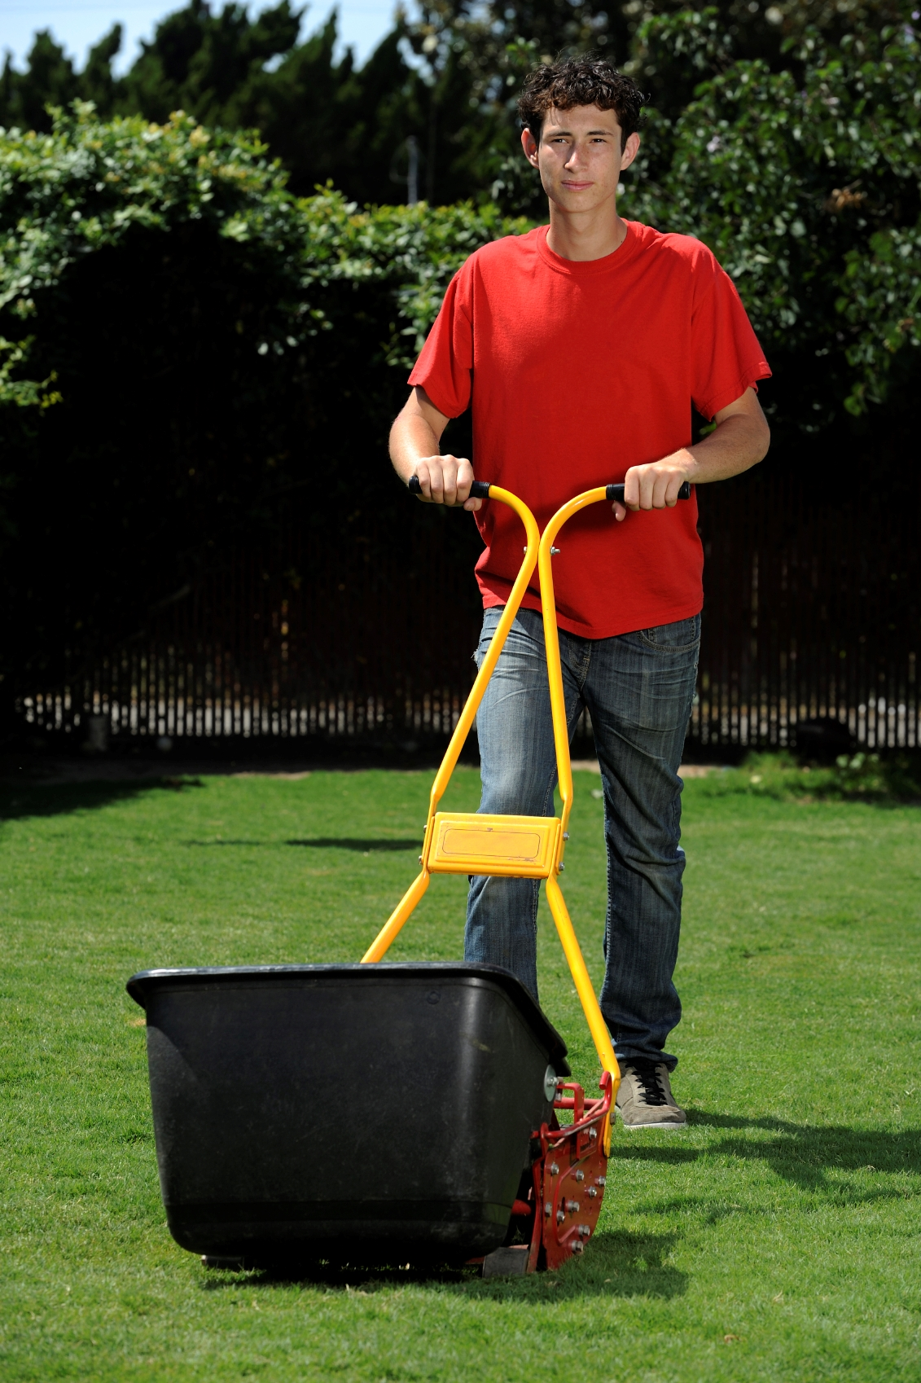




Using the Scenarios
The following scenarios were specifically developed to reflect the types of jobs many youth are placed in through Massachusetts summer jobs programs. These are largely based on the real life experiences of Massachusetts young workers.

These scenarios may be used in the $25,000 Safety Pyramid game in Lesson 3: Making the Job Safer, or as a conversation starter at any point throughout Youth @ Work: Talking Safety.
Note to Teachers
The examples of solutions listed under each scenario are intended to show a range of possible injury prevention steps. Keep in mind that there may be similar work situations in which every solution listed is not practical, and there may be additional solutions not included on the lists.

Day Camp Scenarios

Chris’ Story
(Pool Safety/Slips)

Chris, who is 17-years-old, was a member of the Pool Staff at a summer day camp. One afternoon, he was in the locker room lining up his kids to go to the pool. He was moving at his usual working pace—not to fast and not too slow—and walked through the shower area to grab a towel. Water had collected in an uneven part of the shower floor, and when Chris stepped there his sneaker slid and he fell backwards banging his head on a stainless steel door. He had an “egg on his head” when a co-worker placed ice on it and called an ambulance. He hit his head so hard he couldn’t even remember the ambulance ride to the hospital.

“What solutions can you think of that might prevent this injury from happening again?”

Remove the Hazard: Fix the uneven floor so water cannot collect in that spot.
Work Policies: Post “Caution” signs or stands to warn workers about the slip hazard. Employees should not be allowed to wear regular sneakers in the shower room.
Personal Protective Equipment: Non-slip shoes.

Nicole’s Story
(Clutter/Cleanliness)

Nicole, age 16, had a summer job at a recreation center for kids. While preparing for game time one afternoon, she was in the equipment closet grabbing carts to put volleyballs in. The closet was small and doubled as storage for maintenance tools and gear, so items were packed in wherever they could fit. As Nicole wheeled out a cart, a heavy metal shovel came loose and fell and hit her on the forehead. She found her boss who told her it was bleeding badly and that her eye was swelling. Other staff members administered first aid while Nicole waited for her mother to pick her up and drive her to the hospital where she received 5 stitches.

“What solutions can you think of that might prevent this injury from happening again?”

Remove the Hazard: Keep maintenance equipment kept in different closet, away from recreation equipment.
Work Policies: Keep closets better organized and tidy so equipment is easily accessible. Assign employees for collecting larger or awkwardly stored equipment. Keep heavy objects tied back so they cannot fall out of place.
Personal Protective Equipment: None.

Child Care Scenarios

Morgan’s Story
(Infection)

Morgan is 16-years-old and had a summer job at a daycare facility located in a high school. One Monday, Morgan noticed that a child was rubbing his eyes a lot and that they were tearing up. She wiped his eyes throughout the day using a tissue, but not realizing the toddler had bacterial conjunctivitis (pink eye), she rubbed her own eye once before washing her hands later on. Morgan went to see her Doctor two days later because her own eyes were red, tearing up, and felt really gritty. She had to miss work on both Thursday and Friday because she caught the infection.

“What solutions can you think of that might prevent this injury from happening again?”

Remove the Hazard: Children should be sent home from daycare if they have certain contagious infections, such as pink eye, strep throat and chicken pox.
Work Policies: Employers should have temporary exclusion policies for children with varying illnesses and be sure that employees/parents of children know the rules. Employees should always wash hands after coming in contact with children’s nose/eyes/mouth or bodily fluids. Hand washing signs should be posted to remind staff of the policy.
Personal Protective Equipment: None.

Emily’s Story
(Lifting)

Emily, age 18, worked as a daycare teaching assistant in the toddler room. One afternoon, while the kids ate lunch with another teacher, Emily tasked herself with putting away the many toys strewn across the play area. To save time, Emily was picking up and carrying multiple toys at a time. While holding a bag of blocks in one arm, she bent over to also pick up a large toy truck and suddenly felt a sharp pain in her lower back. She dropped the blocks and truck she was holding because it hurt so badly, and had to sit out of work for the rest of the day.

“What solutions can you think of that might prevent this injury from happening again?”

Remove the Hazard: Ensure toys are put away when not in use.
Work Policies: Have a rule that a toy gets put away when it is through being used. Wait until after lunch to pick up so that children and other teachers can help, to avoid constant bending and carrying multiple toys at a time.
Personal Protective Equipment: None. (proper lifting would fall in this tier)

Ask the class:
“What is the proper way to lift heavy objects?”
1. Don’t pick up objects over 30 pounds by yourself.
2. Keep the load close to your body.
3. Lift with your legs. Bend your knees and crouch down, keep your back straight, and then lift as you start to stand up.
4. Don’t twist at your waist. Move your feet instead.

Grounds Maintenance Scenarios

James’ Story
(Chemical/Pool Safety)

James is 15-years-old and on the buildings and ground crew at a local school. One afternoon, he was working in the pool storage room, bringing things out of the room in order to clean it. As he was carrying out a box, he stepped on a plastic container of concentrated chlorine. It cracked open at the top, so when James picked it up and put it on top of the box he was carrying to take it out of the room, he was overcome by fumes. James had to seek immediate medical attention for chemical burns in his lungs and throat.

“What solutions can you think of that might prevent this injury from happening again?”

Remove the Hazard: Keep chlorine stored away from other equipment, and out of the way from foot traffic.
Work Policies: Keep the storage room better organized, to prevent trip hazards. Ensure chlorine and other chemicals are labeled correctly and visibly. Store chlorine and other chemicals appropriately.
Personal Protective Equipment: Note: while a face respirator could technically protect against the chlorine fumes, it is an unlikely solution for use in casual pool maintenance where most tasks involve no or limited chemical exposure, as each employee would need to have a personal respirator professionally fitted for them.

Austin’s Story
(Heat Safety)

Austin is 16 and had a job as a groundskeeper at a golf course. His typical day was spent outdoors trimming hedges, planting flowers, weeding and mulching. One very hot day, Austin was working by himself unloading 30 pound bags of mulch from his wheelbarrow. He felt a bit dizzy but didn’t think much of it. Suddenly, the dizziness increased and he had to put down the bag of mulch that he was carrying. Before he could go somewhere to rest, he blacked out and fell to the ground. When he woke up, two other workers were beside him asking if he was OK. When he fell, his chin and teeth hit the wheelbarrow. A co-worker called an ambulance to take Austin to the emergency room.

“What solutions can you think of that might prevent this injury from happening again?”

Remove the Hazard: Limit outdoor work on very hot days.
Work Policies: Schedule more strenuous work during the coolest part of the day. Schedule regular rest/shade breaks, especially on hot days. Make water accessible to outdoor workers. Train workers on recognizing signs of heat stress and how to keep from getting overheated. Work in teams to watch one another for signs of overheating (such as dizziness).
Personal Protective Equipment: A hat to provide shade. Water to drink. Lightweight, light-colored clothing to help block out sun. A cooling vest.

Rachel’s Story
(Illness/Allergy)

Rachel, age 17, was hired to do light landscaping work at a local hospital. One Friday, she was using a weed whacker near the inner and outer sides of a surrounding fence. Rachel and other workers had previously seen poison ivy on the grounds, but she hadn’t noticed any among the weeds she was cutting. She had no problems that day, but by Saturday when she woke up Rachel noticed that her eyes were swollen from poison ivy. By Sunday morning, almost her whole body was covered and she had to go the emergency room. She had been wearing long pants,, but the rest of her body was not protected from poison ivy flying everywhere from the weed whacker. It spread throughout her body from sweating and touching her skin.

“What solutions can you think of that might prevent this injury from happening again?”

Remove the Hazard: Have poison ivy professionally removed from the grounds.
Work Policies: Label poison ivy so workers are aware of its location. Train employees on how to recognize poison ivy. Train employees on how to properly clean tools and equipment used near poison ivy so the oil does not spread, and how to clean skin if potentially exposed.
Personal Protective Equipment: Long sleeves. Protective goggles.

Jon’s Story
(Machinery)

Jon, who is 18-years-old, was mowing the range tee in front of the parking lot at the Golf Course where he worked. He was using a standard push mower. He was pushing the lawn mower up a slight incline when he bent down to pick up a stick. The mower rolled back down over his hand and cut two fingers. The mower had no emergency off switch but was supposed to turn off automatically if a worker let go of the blade engagement switch. Jon said the people at work knew it was broken but had not replaced it yet. After he was injured, Jon had to wait for his mom to arrive to take him to the hospital to get treatment for his fingers.

“What solutions can you think of that might prevent this injury from happening again?”

Remove the Hazard: Have the mower repaired. Remove the broken mower from the site.
Work Policies: Ensure regularly scheduled maintenance for all machinery. Only buy mowers with emergency off switches. Report all malfunctioning equipment to supervisor right away. Remove broken equipment from the site until repaired. Train employees on how to respond in case of equipment malfunction.
Personal Protective Equipment: Protective gloves (heavy/leather or suede).

