INDOOR AIR QUALITY ASSESSMENT

Brockton Public School Administration Building
43 Crescent Street
Brockton, MA

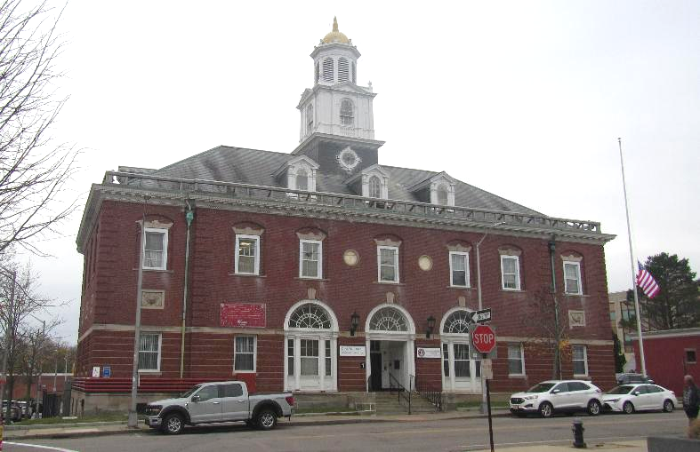

Prepared by:
Massachusetts Department of Public Health
Bureau of Climate and Environmental Health
Division of Environmental Health Regulations and Standards
November 2025

BACKGROUND
Building: | Brockton Public School Administration Building
Address: | 43 Crescent Street, Brockton, MA
Assessment Coordinated Through: | Zachariah Costa and Danielson DeAndrade, Department of Labor Standards (DLS) and the Brockton School Facilities Department
Reason for Request: | DPH and DLS received reports of water damage and asbestos issues
Date of Assessment: | November 12, 2025
Massachusetts Department of Public Health, Bureau of Climate and Environmental Health, Division of Environmental Health Regulations and Standards (MDPH/BCEH/EHRS) Staff Conducting Assessment: | Ruth Alfasso, Environmental  Engineer, EHRS
Building Description: | The building at 43 Crescent Street in Brockton was originally built as a Post Office in the late 1800s. The Brockton Public School District has been using the building for many years. It is a three-story brick building with a partly-peaked roof which is mostly shingled. Windows in the building are openable.

BACKGROUND
The Department of Labor Standards (DLS) has been involved with the City of Brockton, including this building, in the past for asbestos issues. DLS identified several types of damaged building materials that may contain asbestos (suspect asbestos-containing materials, or ACM), some of which had been identified previously, and ordered building managers to have the material sampled and analyzed to address these issues immediately. The building facility department had the materials sampled and analyzed that same week and are complying with other requirements from the DLS inspection. According to information from the facility department, several types of floor tile were found to be ACM, some materials in the boiler room were ACM, while ceiling tiles and wall materials were not found to be ACM.
While DLS can inspect for a variety of health and safety issues, they have no enforceable standards for water damage or mold. The DPH IAQ unit frequently inspects public buildings for water damage/mold in response to complaints like this, and issues reports based on observations and findings. The IAQ unit’s reports, such as this one, are advisory and do not include any orders/conditions.

METHODS
Please refer to the indoor air quality (IAQ) Manual for methods, sampling procedures, and interpretation of results (MDPH, 2015). Only selected areas were tested.

RESULTS AND DISCUSSION
Measurements for IAQ parameters are summarized below:
- Carbon dioxide measurements were below the MDPH guideline of 800 parts per million (ppm) indicating adequate fresh air in the space. Note that most of the areas examined were unoccupied on the day of assessment.
- Temperature was within or close to the recommended range of 70°F to 78°F in areas tested.
- Relative humidity was below the recommended range of 40% to 60% in all areas tested, which is common during the heating season.
- Carbon monoxide levels were non-detectable (ND) in all areas tested including the boiler room.
- Fine particulate matter (PM2.5) concentrations were all below the National Ambient Air Quality Standard (NAAQS) level of 35 μg/m³ in all areas tested and most were ND.

Ventilation
A heating, ventilating, and air conditioning (HVAC) system has several functions. First, it provides heating and, if equipped, cooling. Second, it is a source of fresh air. Finally, an HVAC system will dilute and remove normally occurring indoor environmental pollutants by not only introducing fresh air but also filtering the airstream and ejecting stale air to the outdoors via exhaust ventilation. Even if an HVAC system is operating as designed, point sources of respiratory irritation may exist and affect symptoms in sensitive individuals. The following analysis examines and identifies components of the HVAC system and likely sources of respiratory irritant/allergen exposure due to water damage, aerosolized dust, and/or chemicals found in the indoor environment.
Fresh air is supplied by HVAC units that were not examined during this visit. Fresh air is delivered through supply vents (Picture 1) and returned through exhaust vents (Picture 2). Radiators for heating are located along many exterior walls of the building. The HVAC system also supplies cooling.
The ventilation system should be on and operational to supply fresh air continuously during occupied periods. Without adequate fresh air supply and removal of stale air, common indoor air pollutants can build up and cause irritation. It is recommended that HVAC systems be re-balanced every five years to ensure adequate air systems function (SMACNA, 1994).
The HVAC system is supplied with filters to remove particulate matter from outdoor and recirculated air. Boxes of filters of a Minimum Efficiency Reporting Value (MERV) of both 8 and 10 were found (Pictures 3 and 4) of different sizes suggesting they are for different portions of the HVAC system. MERV 8 filters or better are recommended to remove pollen and mold spores from outside air (ASHRAE, 2012). Where higher-rated filters can be used in an HVAC system they can provide additional filtration of pollutants. Filters are reportedly changed 2 times a year; changing filters 2 to 4 times a year is recommended for most HVAC systems. Note that the unused filters examined were stored in the boiler room, which can be a dirty environment including dust, products of combustion, moisture, and mold (See Microbial/Moisture Concerns section below) and some of the boxes were open, allowing ambient dirt to settle on otherwise clean filters.

Microbial/Moisture Concerns
The main reason for DPH visiting this facility was concern about water damage and mold. Significant water damage issues were found in the building, mostly from leaks in the roof, which has a complicated shape and mostly covered in shingles which may be original to the building. Some repairs to the roof were made recently and some of the areas examined were reportedly no longer becoming wet with every rainstorm, however water-damaged materials are still present.
The areas of most significant concern are: the ceiling of Room 128, the “Hall of Supplies”, and the Boiler Room. Room 128 is a main office area next to a conference room. Pictures 5 through 7 show the water-damaged ceiling tiles, missing ceiling tiles, peeling paint on the underside of the roof, and debris from damaged ceiling tiles on surfaces in the office. DLS staff were concerned that the ceiling tiles may be asbestos-containing materials (ACM), which complicates cleanup. DLS staff recommended, and the IAQ staff concurred, that this room be sealed to prevent access until the ceiling tiles could be sampled and, if confirmed to be ACM, until appropriate repair or abatement could be conducted. Later reports indicate that the ceiling tiles are not ACM, however cleanup should still be done before re-occupancy.
The Hall of Supplies is a long exterior hallway on the upper floor with windows along one side. This area is used to store educational items. Significant water damage has occurred to the ceiling, and walls of this room (Pictures 8 through 11) including water-damaged ceiling tiles, water damage to insulation above the ceiling tiles, water-damaged wall plaster, water damage to and behind coving, and water damage to stored materials. Buckets for water collection were also found, some with standing water in them (Picture 12). Some of the ceiling tiles appeared to be mold-colonized (dark staining). Flooring in this area is also very damaged (Picture 13). Due to the potential presence of ACM in damaged building materials, DLS and IAQ staff recommended this area also be sealed until the suspect ACM can be addressed. Note that floor tiles were found to be ACM, but wall and ceiling materials were not.
Since most of the stored materials were in cardboard boxes, some on the floor, and some of which had obvious water stains, much of this material will also need to be discarded. Non-porous items, items that were stored off the floor, and items sealed in plastic totes are likely to be able to be cleaned and used again. While roof leaks are the main cause of water damage in this room, windows in this hallway were also cracked (Picture 14), which can make it more difficult to keep water out and maintain temperature control.
The boiler room was also examined. While mechanical equipment seemed to be in good condition, water damage has occurred in this room in the past. A large amount of stored materials were found here (Picture 15). These are reportedly old files, plans, and other papers that are no longer needed. Some of the materials in this pile are water-damaged, and the pile is large enough that items on the bottom are becoming crushed. In addition, having a large amount of paper in this room is a fire hazard and attractive to pests.
Water-damaged walls were found in the women’s restroom. In addition, the faucet could not be turned all the way off. Other areas of water damage were found, including other hallways and stairwells where paint, plaster, wood, ceiling tiles, and other materials were damaged (Pictures 16 and 17). All of these water-damaged materials can lead to mold growth, and damaged plaster can create irritating dust. DLS staff flagged potential ACM in these areas as well.
Water damage should be remediated in accordance with the US EPA’s Mold Remediation in Schools and Commercial Buildings (https://www.epa.gov/mold/mold-remediation-schools-and-commercial-buildings-guide-chapter-1). Porous materials that are water-damaged should be discarded, while non-porous items may be able to be cleaned.
In general, porous items should not be stored in areas with known active leaks. Storage of items should be neat and organized, up off the floor on shelves, or in plastic containers. Staff should work on finding an alternative location for the items that still need to be stored until the leaks and other issues in the building have been addressed.

Other IAQ Concerns
All applicable laws, regulations, and guidance should be followed regarding repair and abatement of asbestos/ACM. Any other construction, water-damage remediation, and movement of materials should be conducted using the DPH guidance https://www.mass.gov/info-details/construction-and-renovation-generated-pollutants-in-occupied-buildings.
Note that most office areas of the building are carpeted. Carpeting should be cleaned regularly using a vacuum equipped with a high efficiency particulate arrestance (HEPA) filter, and deep cleaned once or twice a year. Additional cleaning should be performed after remediation (including abatement) is completed to remove any dusts related to abatement/renovations.
Supply and return vents were noted to be dusty. This material can become aerosolized or may be moistened by condensation, which can lead to mold growth. Vents should be cleaned periodically.

CONCLUSIONS/RECOMMENDATIONS
Significant issues were found in the building regarding both asbestos-containing/potential asbestos-containing materials and water damage. Identification and remediation of ACM should be conducted following all laws, citations, and guidance supplied by DLS.
While remediation of water damage is not regulated in the same way, many of the same principles apply including isolation of areas where remediation is needed or taking place, and discarding of materials that will not be able to be cleaned. Note that the office areas examined that are not described above seemed to be in good condition with relatively new carpeting.
These recommendations are divided into short-term recommendations that should be done as soon as possible, and long-term recommendations that may require capital funding or other plans to accomplish.

Short-term recommendations

Ventilation recommendations
- Operate supply and exhaust ventilation in all areas during occupied periods.
- Have the HVAC system balanced every 5 years in accordance with SMACNA recommendations (SMACNA, 1994).
- Ensure filters are replaced on HVAC units at least two to four times a year or as per the manufacturers’ recommendations. Continue to use filters with a Minimum Efficiency Rating Value (MERV) of 8 or better. Store all filters in a clean, dry area in closed boxes until they are used.
- Ensure thermostats and building-wide control systems are set in a consistent manner, including any nighttime or weekend setbacks.
- Clean supply and return vents periodically to remove accumulated dust.

Water damage recommendations
- Porous stored items that have become water-damaged should be discarded unless they are valuable enough to require special archival cleaning.
- Non-porous water-damaged items can be cleaned. For items which have not been exposed to asbestos fibers, this cleaning can be conducted by staff using normal cleaning methods including wet wiping, use of a HEPA-equipped vacuum cleaner, and mild detergent.
- No porous items should be stored in the Hall of Supplies until major repairs to the roof and other building materials have been made. No porous items should be stored in the Boiler Room unless they are directly related to the operation of the equipment.
- Continue with planned repairs/patching to the roof to reduce water leaks.
- Where roof leaks continue until more comprehensive repairs can be made, methods can continue to be used to catch and direct water away from building materials and occupied spaces. Any sheeting, tubing, or buckets used need to be emptied frequently and kept clean to avoid odors.
- Discard all water-damaged ceiling tiles. Contain them in plastic bags after removal to avoid carrying the material through occupied spaces.
- Remove and replace water-damaged insulation such as in the Hall of Supplies. Water-damaged insulation no longer works properly and can be mold-colonized.
- Water-damaged ceiling tiles should be replaced. New tiles should fit snugly in the ceiling tile grid so that the surface is continuous to avoid dust from above affecting occupied spaces. In accordance with DLS, replacement tiles used should not be ACM.
- Remove loose plaster and paint from areas used by staff including stairwells. Follow applicable laws and guidance if materials may contain asbestos or lead and avoid dust generation in general. Refinish these areas as time or funding allows, or make temporary repairs.
- If gypsum wallboard is present in areas of water damage, remove all water-damaged materials and at least one foot higher than the visible water damage to ensure all affected materials are removed. Inspect the wall cavity for additional water damage during this process.
- For more information on mold remediation, refer to the US EPA’s “Mold Remediation in Schools and Commercial Buildings,” available at: http://www.epa.gov/mold/mold-remediation-schools-and-commercial-buildings-guide.
- Repair or seal broken windows to prevent water infiltration.
- Ensure all doors to the exterior are tight-fitting using weatherstripping to prevent water and pest access.

Other short-term recommendations
- Repair or abate damaged ACM flooring in accordance with DLS requirements and recommendations. Damaged flooring that is not ACM should also be repaired or covered to reduce tripping hazards and improve cleanability.
- Make other repairs required by the DLS inspection, including tripping hazards and electrical hazards.
- Clean carpeting in accordance with IICRC recommendations (IICRC, 2012).
- Consider other long-term options for storage of materials such as those in the Hallway of Supplies. Materials should be periodically sorted to discard anything damaged or no longer needed to reduce the need for long-term storage. Storage should be organized and labeled, and be off the floor on shelving, cabinets, or in totes to prevent water damage, dust contamination, and pest harborage.
- For buildings in New England, periods of low relative humidity during the winter are often unavoidable. Therefore, scrupulous cleaning practices should be adopted to minimize common indoor air contaminants whose irritant effects can be enhanced when the relative humidity is low. To control dust, a high efficiency particulate arrestance (HEPA) filter equipped vacuum cleaner in conjunction with wet wiping of all surfaces is recommended. Avoid the use of feather dusters. Drinking water during the day can help ease some symptoms associated with a dry environment (throat and sinus irritations).
- Refer to resource manual and other related IAQ documents located on the MDPH’s website for further building-wide evaluations and advice on maintaining public buildings. These documents are available at: http://mass.gov/dph/iaq.

Long-term recommendations
- Make comprehensive repairs to the roof.
- Replace or permanently cover all damaged flooring.
- Refinish areas of water-damaged plaster and wood.
- Repair windows in the Hall of Supplies.

REFERENCES
ASHRAE. 2012. American Society of Heating, Refrigeration and Air Conditioning Engineers (ASHRAE) Standard 52.2-2012 – Method of Testing General Ventilation Air-Cleaning Devices for Removal Efficiency by Particle Size (ANSI Approved).
IICRC. 2012. Institute of Inspection, Cleaning and Restoration Certification. Carpet Cleaning: FAQ.
MDPH. 2015. Massachusetts Department of Public Health. Indoor Air Quality Manual: Chapters I-III. Available at: https://www.mass.gov/lists/indoor-air-quality-manual-and-appendices.
SMACNA. 1994. HVAC Systems Commissioning Manual. 1st ed. Sheet Metal and Air Conditioning Contractors’ National Association, Inc., Chantilly, VA.
US EPA. 2008. “Mold Remediation in Schools and Commercial Buildings”. Office of Air and Radiation, Indoor Environments Division, Washington, DC. EPA 402-K-01-001. September 2008. Available at: http://www.epa.gov/mold/mold-remediation-schools-and-commercial-buildings-guide.

Picture 1
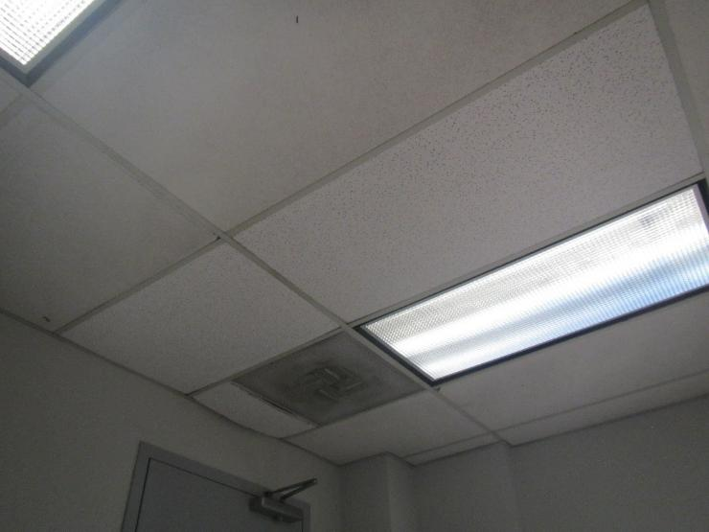
Supply vent, note louvers are dusty
Picture 2
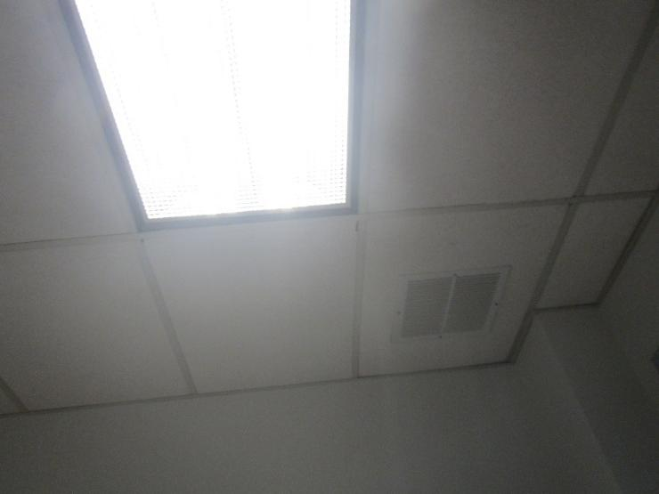
Return vent

Picture 3
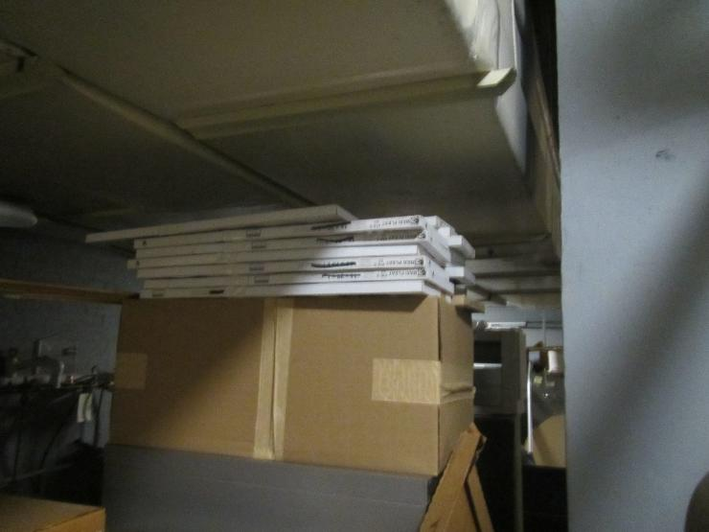
Pleated filters on top of a box in the boiler room
Picture 4
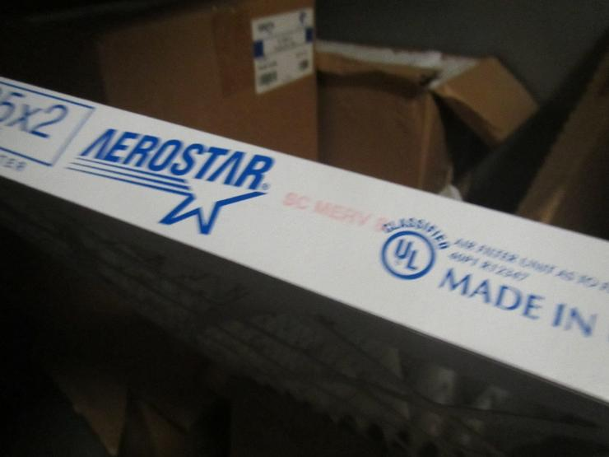
Filters with MERV 8 rating

Picture 5
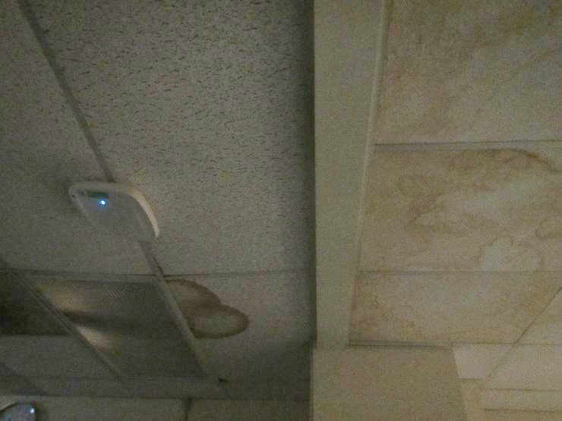
Water-damaged ceiling tiles in room 128 showing at least 2 different types of tiles

Picture 6
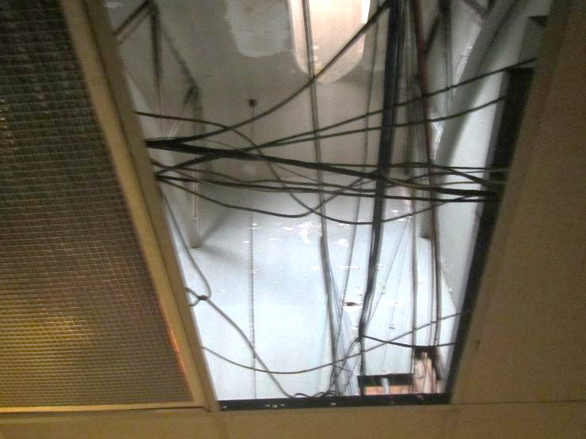
The underside of the roof above removed ceiling tiles in room 128; note peeling paint
Picture 7
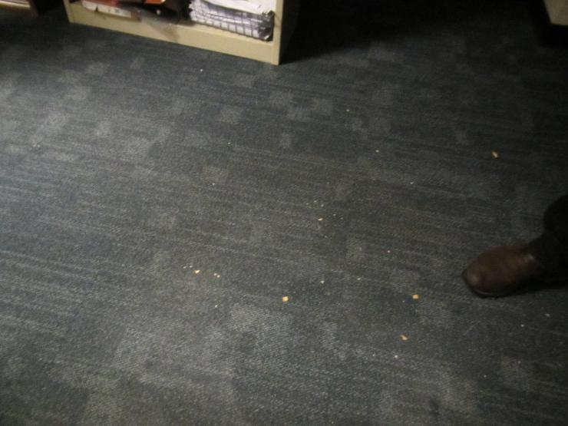
Debris on the floor from where ceiling tiles were damaged

Picture 8
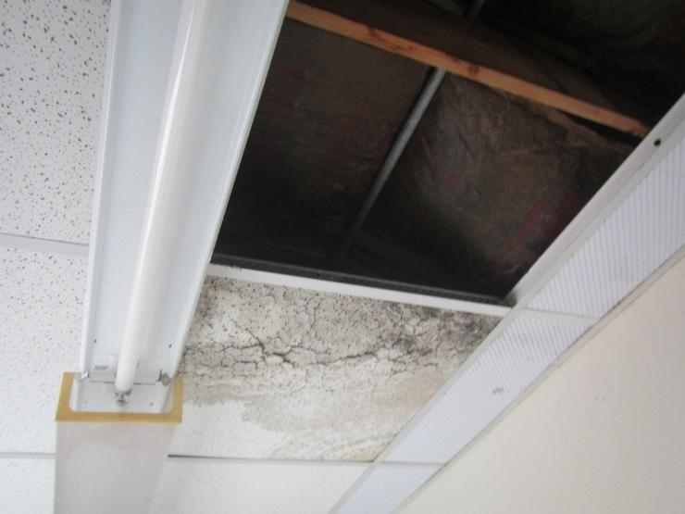
Water-damaged/missing ceiling tiles in the Hall of Supplies; dark staining may be mold
Picture 9
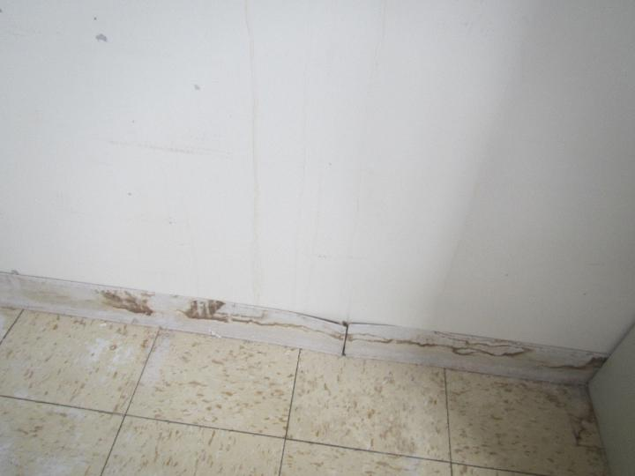
Water-damaged base coving with water-damaged wall behind it

Picture 10
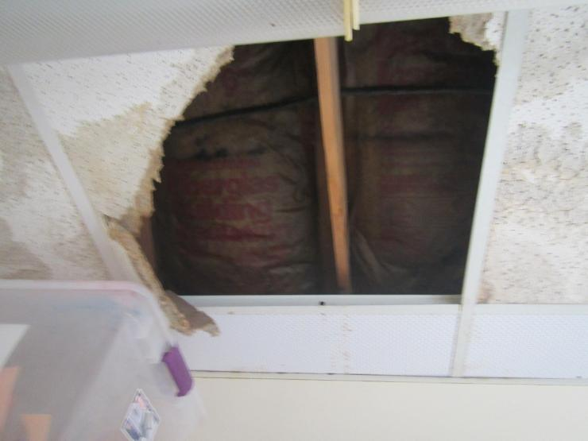
Water-damaged insulation above ceiling tiles
Picture 11
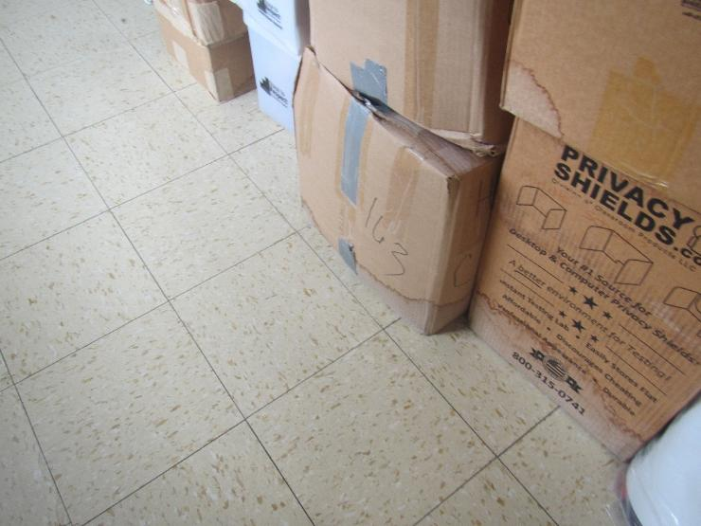
Water stained and water-damaged boxes

Picture 12
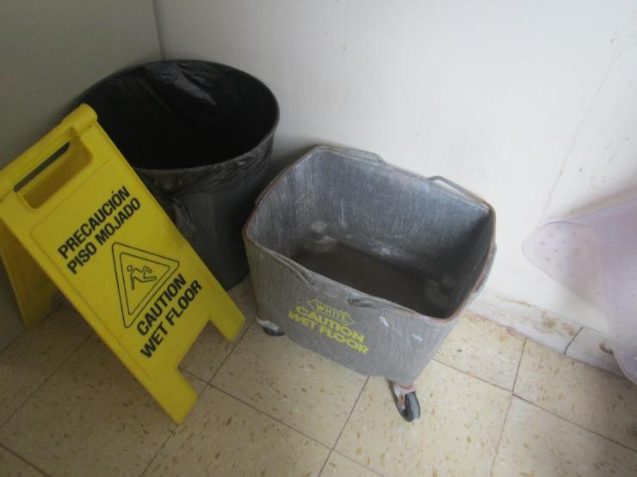
Water collection bucket with standing water
Picture 13
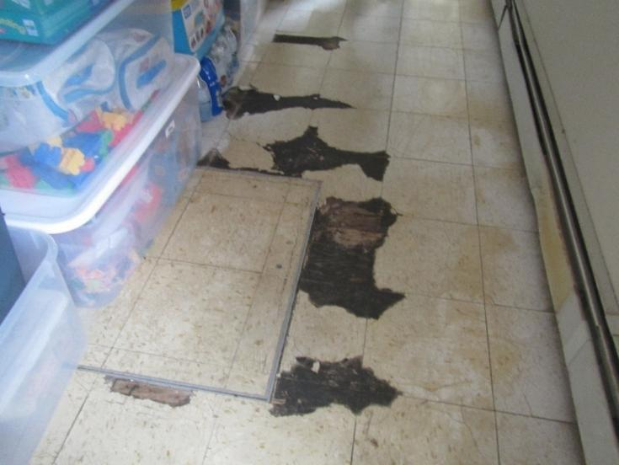
Damaged flooring with water stains

Picture 14
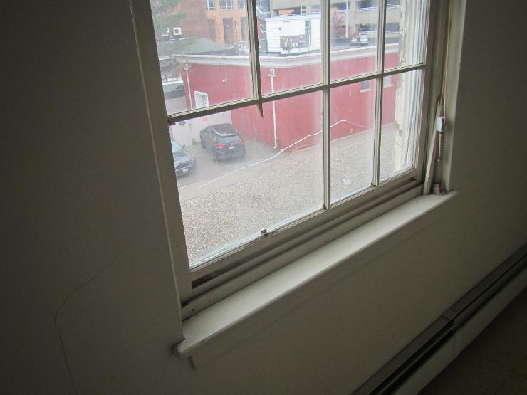
Cracked window in the Hall of Supplies
Picture 15
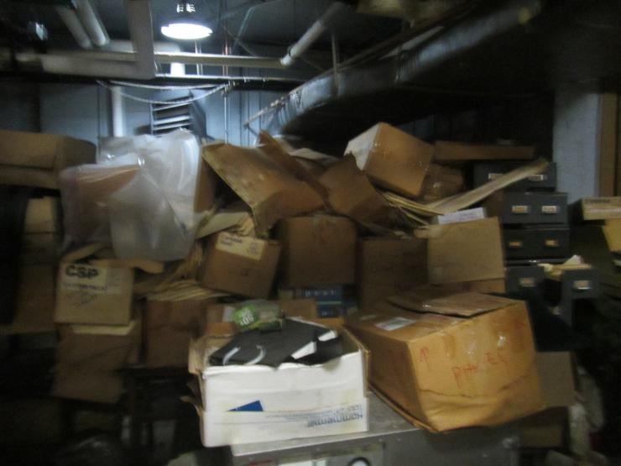
Pile of water-damaged boxes and papers in the boiler room

Picture 16
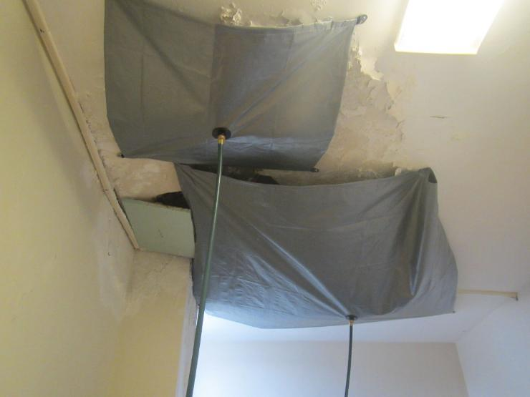
Water catching plastic on the ceiling and water-damaged plaster
Picture 17
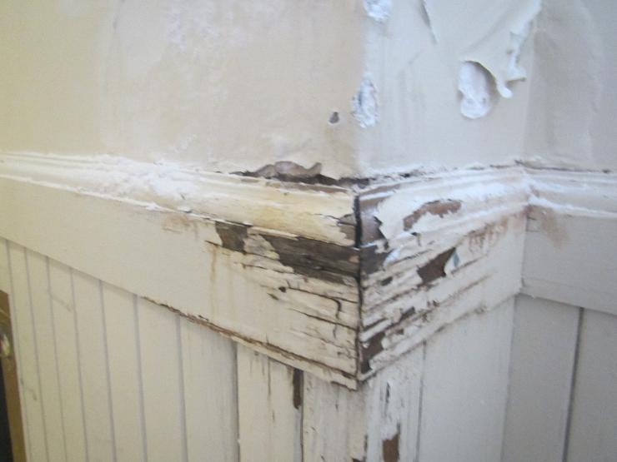
Water-damaged wood and plaster

Location | Carbon  Dioxide  (ppm) | Carbon Monoxide  (ppm) | Temp  (°F) | Relative  Humidity  (%) | PM2.5  (µg/m³) | Occupants  in Room | Windows  Openable | Ventilation |  | Remarks
 |  |  |  |  |  |  |  | Supply | Exhaust | Remarks
Background | 405 | ND | 45 | 48 | 1 |  |  |  |  | Cool and cloudy
Room 128 | 513 | ND | 73 | 22 | ND | 3 | Y | Y | Y | WD and missing ceiling tiles, view to WD peeling ceiling paint under roof
Second Floor hallway | 515 | ND | 72 | 23 | ND | 0 | Y | Y | Y | WD walls
Hall of Supplies | 542 | ND | 69 | 27 | ND | 0 | Y | Y | Y | Damaged flooring, WD CT (some likely moldy), WD insulation above CT, WD boxes, WD walls behind coving (possible mold)
Back Corridor |  |  |  |  |  |  | Y | Y | Y | WD CT, water collection sheets on ceiling, WD walls
Maple Ave Stairwell |  |  |  |  |  |  | Y |  |  | WD and missing CT
2nd floor women’s restroom |  |  |  |  |  |  | Y |  | Y | WD wall, missing light shield, faucet leaking
Various office areas | 503-610 | All ND | 71-76 | 21-23 | ND-4 |  |  |  |  | Many carpeted, with carpet in good condition
Boiler room |  | ND |  |  |  |  |  |  |  | Big pile of WD boxes and papers, other stored items, HVAC filters stored some in open boxes

