Commonwealth of Massachusetts
Executive Office of Health and Human Services

Office of Medicaid
www.mass.gov/masshealth

MassHealth

School-Based Medicaid Provider Bulletin 28
July 2015

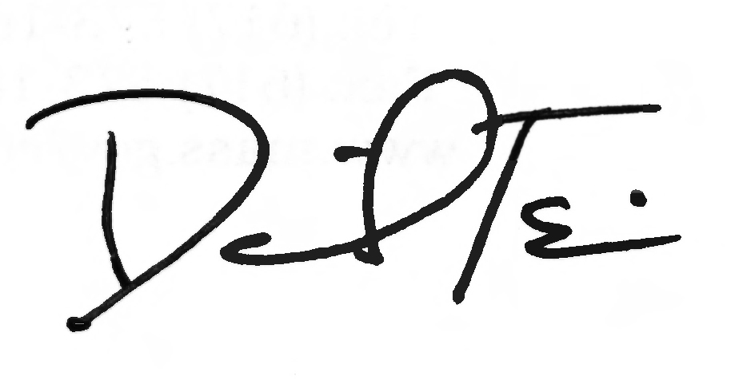
TO: School-Based Medicaid Providers Participating in MassHealth

FROM: Daniel Tsai, Assistant Secretary for MassHealth

RE: School-Based Medicaid Program Guidance on Indirect Cost Rates

Background

The Executive Office of Health and Human Services/MassHealth issues this bulletin to inform local educational authorities (LEAs) that the Massachusetts Department of Elementary and Secondary Education (DESE) has issued updated indirect cost rates for FY2013. The new indirect cost rates should be used by all participating School-Based Medicaid Program (SBMP) providers for state fiscal year 2015 and going forward until further notifications (starting July 1, 2014 and going forward). Requirements for submitting and amending claims using the FY2013 indirect cost rates are detailed in this bulletin.
Furthermore, this bulletin provides additional information about the calculation of the indirect cost rates and responsibility of the LEAs to insure that there is no duplication of expenditures claimed directly and indirectly in school-based Medicaid administrative activity claims (AACs) and direct service cost reports. This requirement is consistent with the CMS Medicaid School-Based Administrative Claiming Guide published in May 2003 (Section 6.E., page 45).
Finally, this bulletin provides information about indirect cost rates to be used by charter schools in a manner consistent with the instructions of this bulletin and with the rest of the LEAs participating in this program.

Exclusion of Expenditures from AAC Claims and Cost Reports

LEA costs that are reported on the chart of accounts (COA) in the following object codes are included in the calculation of each LEA’s indirect cost rate by DESE, and therefore the LEA must exclude them from direct claims in AACs and direct service cost reports:
- District Leadership & Administration – 1000 series (specifically includes 1210, 1220, 1230, 1410, 1420, 1430, 1450)
- School Security (3600)
(continued on next page)

MassHealth

School-Based Medicaid Provider Bulletin 28

July 2015

Page 2

Exclusion of Expenditures from AAC Claims and Cost Reports, (cont.)

- Operation and Maintenance of Plant – 4000 series – All
- Insurance Programs (5200) *Only exclude costs when related to salaries in the excluded 1000 series codes
- Insurance for Retired School Employees (5250)
- Other Non Employee Insurance (5260)
- Rental-Lease of Equipment (5300)
- Other Charges (5500)

(The DESE chart of accounts can be found here: www.doe.mass.edu/finance/accounting/eoy/ChartOfAccounts.pdf)
AACs for FY2015 (quarters ending September 30, 2014, December 31, 2014, March 31, 2015, and June 30, 2015) and the FY2015 direct service cost report must not include any of these excluded costs. The LEA must remove any salaries or fringe benefits that are reported under these object codes.
Any AACs that the LEA has already submitted that include any of these expenditures must be amended to remove those costs no later than the October 15, 2015, annual claim filing deadline.

Exclusion of Staff from Random Moment Time Study (RMTS) Participation

Staff members whose salaries appear in any of the excluded object codes must be excluded from participation in the RMTS and must not be included on any time study participant lists or uploads. This requirement is effective immediately, beginning with the participant lists for the October 1, 2015–December 31, 2015 quarter.

Deadline for Amending Administrative Claims with FY2013 Indirect Cost Rates

The recently published FY2013 Medicaid unrestricted indirect cost rates are available on the DESE website (www.doe.mass.edu/Grants/essential.html). LEAs must submit these rates in all AACs and the direct service cost report for FY2015. LEAs must amend any AACs already submitted using old indirect cost rates no later than the October 15, 2015, annual claim filing deadline.

(continued on next page)

MassHealth

School-Based Medicaid Provider Bulletin 28

July 2015

Page 4

Indirect Cost Rates for Charter Schools

Charter schools may submit AACs and direct service cost reports using a 10% indirect cost rate per OMB 2 CFR Part 225: Cost Principles for State, Local, and Indian Tribal Governments (OMB Circular A-87). Information on indirect costs is provided in the following appendices: Appendix A to Part 225—General Principles for Determining Allowable Costs; Appendix D to Part 225—Public Assistance Cost Allocation Plans; and Appendix E to Part 225—State and Local Indirect Cost Rate Proposals.

Charter schools are instructed to follow the same guidelines as other school-based Medicaid providers and exclude from RMTS participation and all claims and cost reports any costs related to staff who are part of central administration, including a superintendent, assistant superintendent, professional and clerical support staff, grants manager, director of planning, school business manager or chief financial officer, director of human resources, district-wide information and technology staff, or any equivalent school-wide administration staff.

Questions

For additional assistance or clarification, please contact the School-Based Medicaid Program at SchoolBasedClaiming@umassmed.edu or 1-800-535-6741.

