Commonwealth of Massachusetts
Executive Office of Health and Human Services

Office of Medicaid
www.mass.gov/masshealth
MassHealth

School-Based Medicaid Provider

Bulletin 29
September 2015

TO: School-Based Medicaid Providers Participating in MassHealth

FROM: Daniel Tsai, Assistant Secretary for MassHealth 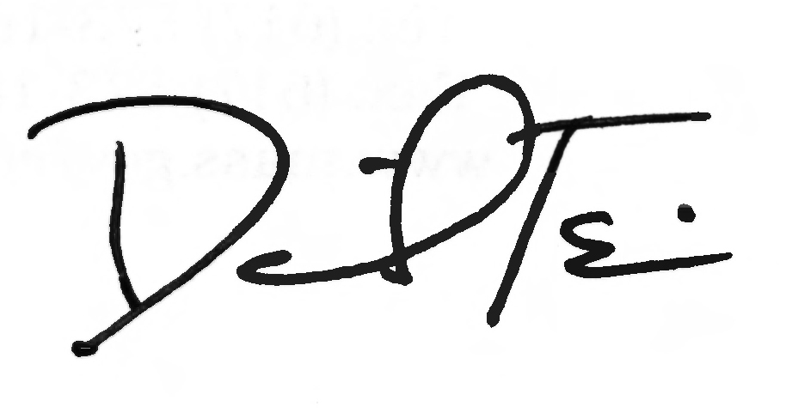

RE: Expansion of School-Based Medicaid Program to Include Autism Services

Summary

This bulletin provides information for Local Educational Authorities (LEAs) participating in the School-Based Medicaid Program. Effective October 1, 2015, the program will expand to include reimbursement for expenditures related to the practice of applied behavior analysis (ABA) services provided to treat individuals with autism spectrum disorders.
As with all SBMP services, the service must be authorized by the MassHealth child’s Individualized Education Plan (IEP) in order for the service to be covered; additionally the service must be provided by a practitioner who holds the appropriate qualifications and was included in the participant pool for the Random Moment Time Study. All program requirements—defined in the MassHealth School-Based Medicaid Program User Guide, School-Based Medicaid Administrative Claims Guide, School-Based Medicaid Random Moment Time Study Guide, SBMP Bulletins, and Provider Contract—also must be met.
For further information on autism services refer to M.G.L. c. 112, §163.

Definition of Autism Services

Per M.G.L. c. 112, §163, the practice of applied behavior analysis is defined as “the design, implementation and evaluation of systematic instructional and environmental modifications, using behavioral stimuli and consequences, to produce socially significant improvements in human behavior, including the direct observation and measurement of behavior and the environment, the empirical identification of functional relations between behavior and environmental factors, known as functional assessment and analysis, and the introduction of interventions based on scientific research and which utilize contextual factors, antecedent stimuli, positive reinforcement and other consequences to develop new behaviors, increase or decrease existing behaviors and elicit behaviors under specific environmental conditions that are delivered to individuals and groups of individuals; provided, however, that the “practice of applied behavior analysis” shall not include psychological testing, neuropsychology, diagnosis of mental health or developmental conditions, psychotherapy, cognitive therapy, sex therapy, psychoanalysis, psychopharmacological recommendations, hypnotherapy, or academic teaching by college or university faculty.”
(continued on next page)
MassHealth
School-Based Medicaid Provider
Bulletin 29
September 2015
Page 2

Applied Behavioral Analysis (ABA) Covered Services

Discreet Trial Training/Teaching (DTT)
Early Intensive Behavioral Intervention (EIBI)
Pivotal Response Training/Treatment (PRT)
Verbal Behavior Intervention/Therapy (VB or VBI)
Functional Behavioral Assessment (FBA)
Early Start Denver Model (ESDM)

Provider Qualifications

LEAs may only submit claims for services delivered by qualified practitioners who are acting within the scope of their license, or as detailed below.
For autism services, the practitioner is required to be licensed by the Board of Registration of Allied Mental Health and Human Services Professions as an Applied Behavior Analyst (ABA), or if prior to January 6, 2016, may be a Board Certified Behavior Analyst (BCBA). In addition, services may be reimbursed if provided by a licensed physician, psychologist, or psychiatrist providing ABA within the scope of his or her licensure; or an Assistant Applied Behavior Analyst (AABA) or other paraprofessional working under the supervision of a licensed ABA. If prior to January 6, 2016, AABA or paraprofessionals may be working under the supervision of a BCBA.
Application forms and instructions for these two new professional licenses (ABA and AABA) are available on the state’s Office of Consumer Affairs website at www.mass.gov/ocabr/licensee/dpl-boards/mh/forms/.
As set forth above, services provided by practitioners holding an AABA license and other non-licensed ABA providers must be supervised by a licensed ABA or other licensed professional providing ABA services within the scope of their licensure, as described above, or, if prior to January 6, 2016, may be supervised by a BCBA, in order for the service to be reimbursable.

Random Moment Time Study Participation

Effective October 1, 2015, LEAs seeking reimbursement for any autism services must include all ABA, AABA, and other appropriate staff providing autism services in their quarterly Random Moment Time Study (RMTS) Participant List.

(continued on next page)
MassHealth

School-Based Medicaid Provider

Bulletin 29

September 2015

Page 3

Interim Rates and Service Codes

School-Based Medicaid providers must use the following service codes and rates to bill for services provided on or after October 1, 2015, for the following per-unit autism services.

Service Code  and  Modifier | Service Description | Interim Rate | Practitioner
H0031-TM | Evaluation/Assessment for autism services (pursuant to an IEP), per hour with a maximum of four hours | $44.54 | Applied Behavior Analyst or professional employee meeting the requirements of the school or agency’s licensure standards
H0031-TM-U1 | Evaluation/Assessment for autism services (pursuant to an IEP) (in private residential school), per hour with a maximum of four hours | $22.27 | Applied Behavior Analyst or professional employee meeting the requirements of the school or agency’s licensure standards
H2012-TM | Direct behavioral instruction by an ABA (pursuant to an IEP), per 15 minutes, may bill multiple units | $16.71 | Applied Behavior Analyst or professional employee meeting the requirements of the school or agency’s licensure standards
H2012-TM-U1 | Direct behavioral instruction by an ABA (pursuant to an IEP), per 15 minutes (in private residential school) may bill multiple units | $8.35 | Applied Behavior Analyst or professional employee meeting the requirements of the school or agency’s licensure standards
H2012-TM-U2 | Direct behavioral instruction by an ABA, group, two or more individuals (pursuant to an IEP), per 15 minutes, may bill multiple units | $8.35 | Applied Behavior Analyst or professional employee meeting the requirements of the school or agency’s licensure standards

(continued on next page)

MassHealth

School-Based Medicaid Provider

Bulletin 29

September 2015

Page 4

Interim Rates and Service Codes (cont.)

Service Code  and  Modifier | Service Description | Interim Rate | Practitioner
H2012-TM-U1-U2 | Direct behavioral instruction by an ABA, group, two or more individuals (pursuant to an IEP), per 15 minutes (in private residential school), may bill multiple units | $4.17 | Applied Behavior Analyst or professional employee meeting the requirements of the school or agency’s licensure standards
H2019-TM | Direct behavioral instruction by a paraprofessional (pursuant to an IEP), per 15 minutes, may bill multiple units | $10.31 | Assistant Applied Behavior Analyst or other staff qualified to provide autism services
H2019-TM-U1 | Direct behavioral instruction by a paraprofessional (pursuant to an IEP), per 15 minutes (in a private residential school), may bill multiple units | $6.19 | Assistant Applied Behavior Analyst or other staff qualified to provide autism services
H2019-TM-U2 | Direct behavioral instruction by a paraprofessional, group, two or more individuals (pursuant to an IEP), per 15 minutes, may bill multiple units | $5.16 | Assistant Applied Behavior Analyst or other staff qualified to provide autism services
H2019-TM-U1-U2 | Direct behavioral instruction by a paraprofessional, group, two or more individuals (pursuant to an IEP), per 15 minutes (in private residential school), may bill multiple units | $2.58 | Assistant Applied Behavior Analyst or other staff qualified to provide autism services

Documentation of Services

LEAs must document health-related autism services provided to those students for whom the provider claims payment under its SBMP Agreement. At a minimum, providers must document the child’s name, the type of ABA therapy, the date of service, the length of time (units) the service was provided.
In order to submit claims and be reimbursed for the ABA services, the provider must prescribe such services in the student’s Service Delivery Needs in the IEP. If the ABA Therapy is not yet specified in the IEP but the student has a diagnosis of autism in the IEP, claims may be submitted, provided, however, that by January 6, 2016, the ABA therapy
(continued on next page)

MassHealth

School-Based Medicaid Provider

Bulletin 29

September 2015

Page 5

Documentation of Services (cont.)
must be included in the Service Delivery Needs of the IEP. In this situation, supplementary documentation sources specifying the ABA services being provided is required to include type of personnel providing the ABA therapy and the duration/frequency of such therapy. The documentation should match the ABA services that will be included with the IEP amendment.
For additional detail on required documentation data elements and all other program regulations, please refer to the School-Based Medicaid Program User Guide (revised 2014), SBMP Administrative Guide, and SBMP RMTS Guide (revised 2015), as well as the Municipally Based Health Services Bulletin 9 (October 2003), Municipally Based Health Service Bulletin 10 (January 2004), and the Provider Contract.
It is the responsibility of the LEA to ensure that all subcontractors, including private schools, Chapter 766 schools, and collaboratives, maintain proper documentation of all autism services provided. Refer to the Massachusetts Department of Elementary and Secondary Education memo on the documentation of services and form 28M/12 available at http://www.doe.mass.edu/news/news.aspx?id=6695, dated February 23, 2012.

Other Considerations

Section 4.3B of the School-Based Medicaid Program Provider Contract details the LEA’s responsibilities regarding the security and protection of Protected Information (PI) as it relates to the School-Based Medicaid Program. Each LEA should review this section in detail. Steps should be taken to ensure that all obligations are being met by the LEA and any subcontractors, such as billing agents.

PI shall mean any “Personal Data” as defined in M.G.L. c. 66A; any “Personal Information” as defined in M.G.L. c. 93H; any “Patient Identifying Information” as defined in 42 CFR Part 2; any “Protected Health Information” as defined in the Standards for Privacy of Individually Identifiable Health Information, at 45 CFR Parts 160 and 164; and any other confidential, individually identifiable information under any federal and state law that the provider uses, maintains, discloses, receives, creates or otherwise obtains under this Contract.
Information, including aggregate information, is considered PI if it is not fully deidentified in accord with 45 CFR § 164.514 (a), (b), and (c). (See School-Based Medicaid Program Provider Contract, Section 4.3.A.4.)

Questions

For additional assistance or clarification, please contact the School-Based Medicaid Program at SchoolBasedClaiming@umassmed.edu or 1-800-535-6741.

Follow us on Twitter @MassHealth.

