### Connecting Massachusetts Students to Behavioral Health Services

**The Impact of the School Health Services Line ( 4590 - 0250 )**

The Department of Public Health’s Bureau of Community Health and Prevention is expanding access to mental health and substance use services to students across the Commonwealth through core programs funded by the state’s school health services line (4590-0250). These initiatives fund schools, school districts, and school- based health centers to hire additional behavioral health staff, build partnerships between schools and community-based providers, and train the school health workforce to respond to youth behavioral health needs. This resource highlights the programs funded on the school health line and the behavioral health services provided.

**The School Based Health Center Program** Funds and supports School-Based Health Centers (SBHCs) to improve access to care for children and adolescents in schools and communities where access to care is low and health inequities are high. DPH-funded SBHCs are required to [staff](https://www.mass.gov/info-details/school-based-health-centers-who-we-are) a full-time behavioral health clinician, a full-time medical provider and full-time community health worker (CHW), expanding access to low-barrier comprehensive health services.

#### In FY23, DPH-Funded SBHCs Provided

 28,005 Behavioral Health Visits  26,355 Primary Care Visits

6,265 Reproductive Health Visits

**The School Health Services Program** Supports all public and nonpublic school districts and their nurses in the state.

Promotes a whole-child/whole-family approach through nurse-managed care.

Oversees and support the implementation of school-based substance use screening, brief intervention, and referral to treatment Provides professional development to support school nurses in responding to student behavioral health needs and coordinating necessary referrals.

Provides funding to 188 schools and districts through the Comprehensive School Health Services grant to support schools in meeting increasing student and family health needs, including social determinants of health.

**The School Behavioral Health Workforce and Service Expansion Program**

 Provides funding to school districts to hire and retain clinical and non-clinical behavioral health personnel.

funded

33 Schools/

districts

## 41

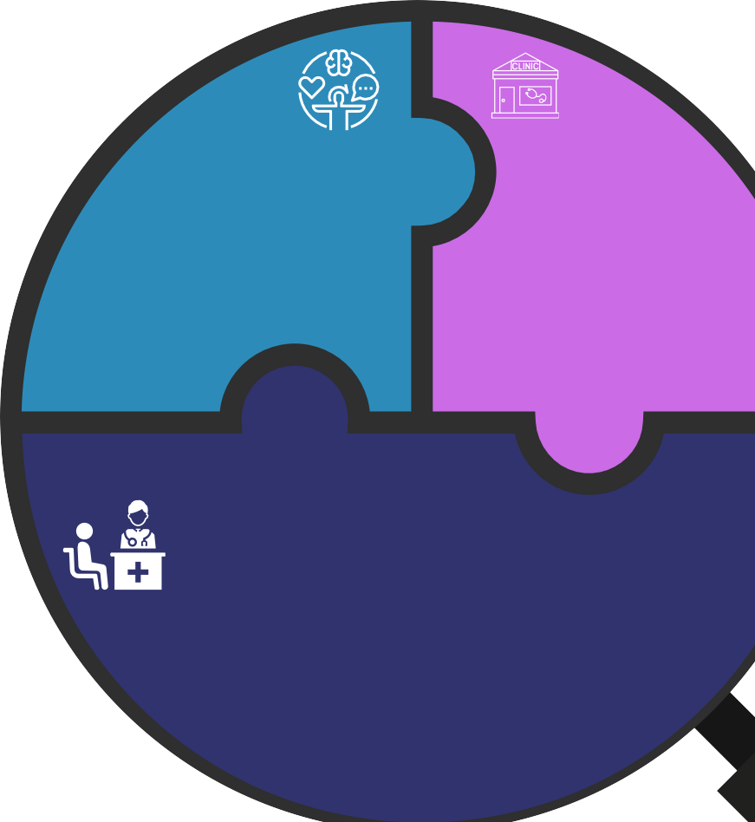School Based Health Centers

Supports partnerships between schools and

w i t h

## 73,000+

serving 42 schools

community-based providers.

Expands individual and group therapy, social

enrolled students

with

## 54,000+

emotional learning, de-escalation and crisis response, and behavioral health promotion, prevention, and early intervention.

e n r o l l e d s t u d e n t s

#### In FY23, SBHE-funded Schools

Hired 23 new behavioral health providers

Supports all School Nurses in all public and non- public schools

Established 9 new partnerships between schools and community-based providers

w i t h

## 911,000+

e n r o l l e d s t u d e n t s

*The data in the microscope is from state Fiscal Year 2023*

### The School Health Line:

**Advancing EOHHS Behavioral Health Priorities**

Invests in expanding the school behavioral health workforce

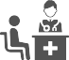Provides training and professional development to the existing school health workforce

Integrates behavioral health and primary care

Supports prevention and early intervention services before needs intensify Supports mental health and substance use screening, including

nicotine/vaping

Builds partnerships between schools and community health clinics and reduces barriers to care

## Supporting Multi-Tiered Systems of Support

**a n d a c o n n e c t i o n t o c a r e a c r o s s t h e c o n t i n u u m**

# Tier 3

More Intensive Services

For Students With the Highest Needs

# Tier 2

Targeted Early Intervention For Some Students

# Tier 1

Crisis intervention and de-escalation Assessment and diagnosis

Medication prescription and administration Individualized therapy and comprehensive management

School-based bridge programs to support students returning from extended mental health related absences

Referrals to intensive treatment and community-based care

Focused individual and group therapy

Substance use education and alternatives to discipline

Social emotional learning Mental health and

Behavioral Health Promotion + Prevention For All Students

substance use screening School climate + positive youth development initiatives

**The school health services line funds multiple DPH programs, including school health services, school-based health centers, and school behavioral health workforce and service expansion. These programs fund services across all three tiers of the multi-tiered system of support framework and facilitate referrals to additional community-based services and support.**