Scientific Data Review Method – documentation for ERR:
Visit the CDC National Environmental Public Health Tracking Network at the following link:
National Environmental Public Health Tracking Network | Home (cdc.gov)
Scroll down and click on “Explore Data”
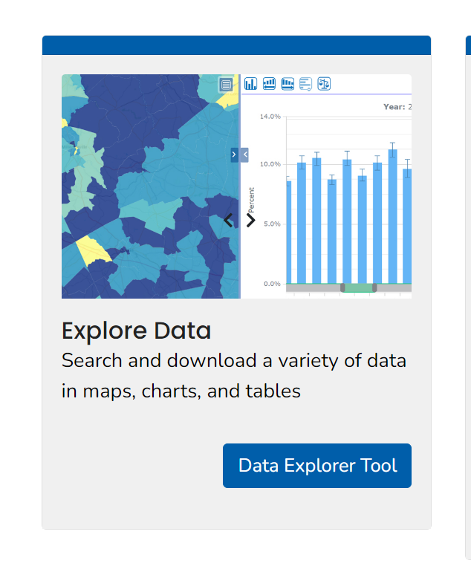

Under Step 1: Content choose “Radon”, “Radon Tests from Labs” and “Mean Pre-mitigation Radon Level in Tested Buildings over a 10-year period”.
Under Step 2: Geography Type choose “State by County”
Under Step 3: Geography choose “Massachusetts”
Under Step 4: Time choose 2008- 2017 then click the green “Go” button
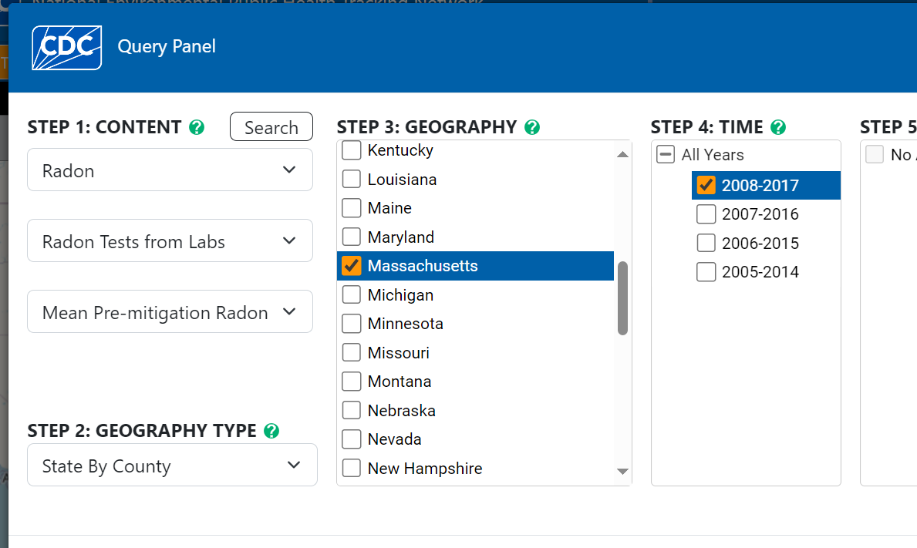
Clicking “Go” will bring you to a map of radon levels in Massachusetts broken out by county:
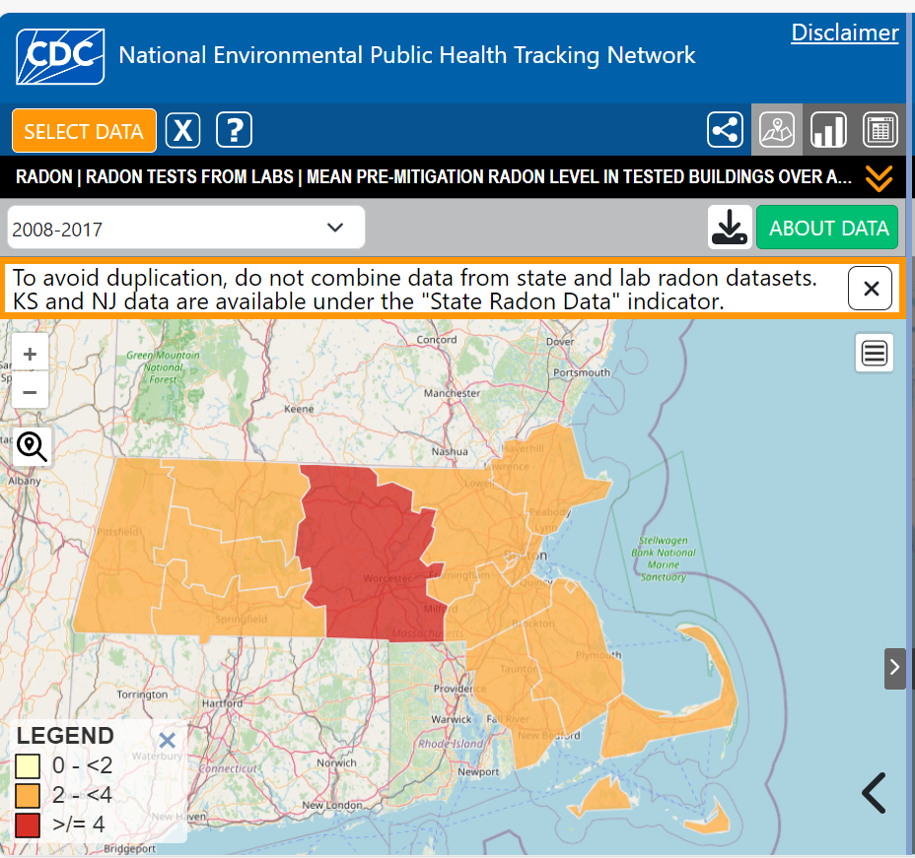
You should screenshot this page and save it as part of the ERR.
Next click on the “table” icon at the top right of the screen to get radon levels by county.
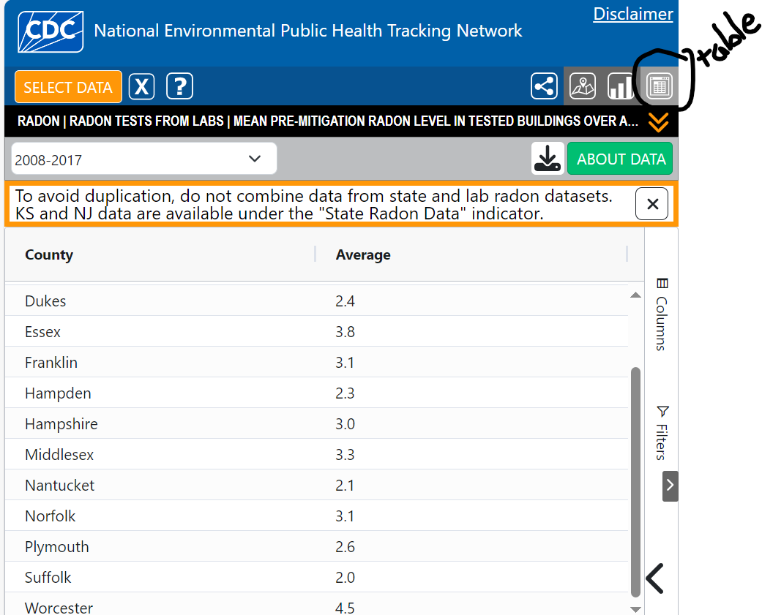
You should screenshot this page and save it as part of the ERR. Make sure that your county is visible.
Please document on the Statutory Checklist under Toxic Sites whether or not further compliance will be needed. Reference the CDC National Environmental Public Health Tracking Network website and map/table. The HUD policy requires mitigation if the 4.0 level is demonstrated. At the current time, only Worcester County is higher than the allowable limit, therefore further compliance steps will be required for non-exempt projects taking place within Worcester County.

