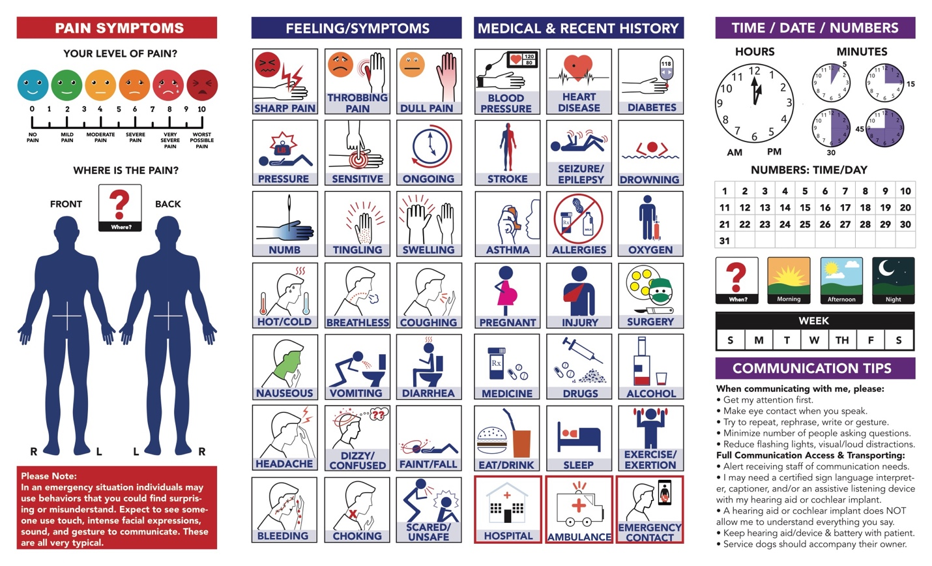

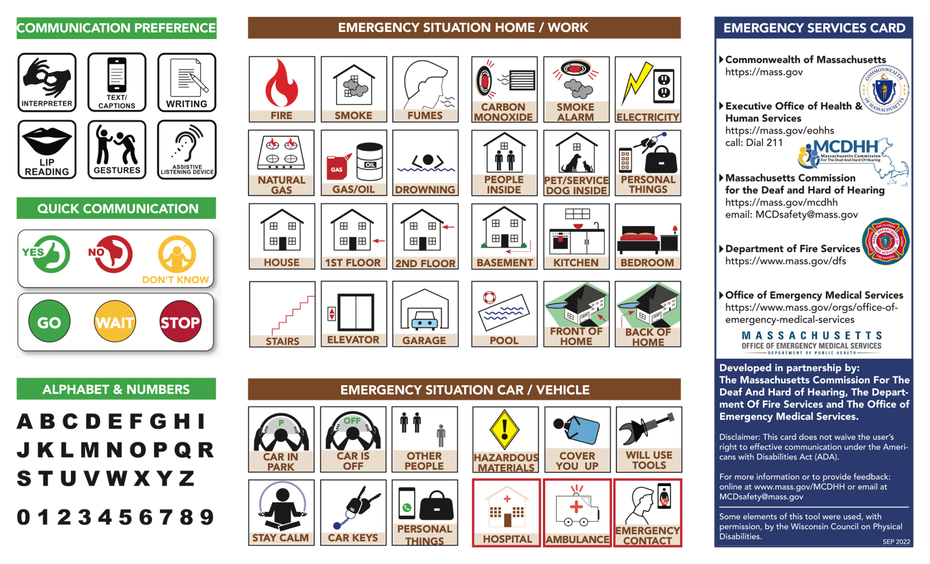

Emergency Services Card

Page One, first panel
Pain Symptoms
A scale from 0 to 10 with 0 being no pain, 2 being mild pain, 4 being moderate pain, 6 being severe pain, 8 being very severe pain and 10 being the worst pain possible.

Where is the Pain?
A body, front and back, to indicate where the pain is.

Text:
Please Note:
In an emergency situation individuals may use behaviors that you could find surprising or misunderstand. Expect to see someone use touch, intense facial expressions, sound, and gesture to communicate. These are all very typical.

Page One, second Panel
Feeling/Symptoms
Icons 21 total (7 rows, 3 columns) left to right: sharp pain, throbbing pain, dull pain, pressure, sensitive, ongoing, numb, tingling, swelling, hot/cold, breathless, coughing, nauseous, vomiting, diarrhea, headache, dizzy/confused, faint/fall, bleeding, choking, scared/unsafe.

Page One, third panel
Medical & Recent History
Icons 21 total (6 rows, 3 columns) left to right: Blood pressure, heart disease, diabetes, stroke, seizure/epilepsy, drowning, asthma, allergies, oxygen, pregnant, injury, surgery, medicine, drugs, alcohol, eat/drink, sleep, exercise/exertion, hospital, ambulance, emergency contact.

Page One, fourth panel
Time/Date/Numbers
Hours/Minutes
A clock on the left to indicate hours and four smaller clocks to the right to indicate 5 minutes, 15 minutes, 30 minutes or 45 minutes.

Numbers: Time/Day
A set of numbers from 1 through 31

Icons 4 total (1 row) left to right: When, Morning, Afternoon, Night

Days of the Week
S, M, T, W, TH, F, S

Communication Tips
When communicating with me, please:
- Get my attention first.
- Make eye contact when you speak.
- Try to repeat, rephrase, write or gesture.
- Minimize number of people asking questions.
- Reduce flashing lights, visual/loud distractions.

Full Communication Access & Transporting:
Alert receiving staff of communication needs.
- I may need a certified sign language interpreter, captioner, and/or an assistive listening device with my hearing aid or cochlear implant.
- A hearing aid or cochlear implant does NOT allow me to understand everything you say.
- Keep hearing aid/device & battery with patient.
- Service dogs should accompany their owner.

Page Two, panel one
Communication Preference
Icons 6 left to right in 3 columns and 2 rows: Interpreter, Text/captions, writing, lip reading, gestures, assistive listening devices

Quick Communication
Images 2 rectangles, stacked one on top of the other. Each rectangle has three options in each: The first: Yes, No, Don’t know. The second: GO, Wait Stop

Alphabet & Numbers
Four rows of text.
First row: letter A, B, C, D, E, F, G H, I
Second row: J, K, L, M, N, O, P, Q, R
Third row: S, T, U, V, W, X, Y, Z
Fourth row: numbers 0, 1, 2, 3, 4, 5, 6, 7, 8, 9

Page Two, panel 3 and 4 combined
Emergency Situation Home/Work
Icons 24 left to right in 6 columns 4 rows: Fire, smoke, fumes, carbon monoxide, smoke alarm, electricity, natural gas, gas/oil, drowning, people inside, pet/service dog inside, personal things, house 1st floor, 2nd floor, basement, kitchen, bedroom, stairs, elevator, garage, pool, front of home, back of home

Emergency Situation Car/Vehicle
Icons 12 left to right in 6 columns 2 rows: Car in park, car is off, other people, hazardous materials, cover you up, will use tools, stay calm, car keys personal things, hospital, ambulance, emergency contact

Page Two fourth panel
Emergency Services Card
Commonwealth of Massachusetts
https://mass.gov
Logo: Commonwealth of Massachusetts

Executive Office of Health & Human Services
https://mass.gov/eohhs
call: Dial 211

Logo: Massachusetts Commission for the Deaf and Hard of Hearing
Massachusetts Commission for the Deaf and Hard of Hearing
https://mass.gov/mcdhh
email: MCDsafety@mass.gov

Logo: Department of Fire Services
Department of Fire Services
https://www.mass.gov/dfs

Office of Emergency Medical Services
https://www.mass.gov/orgs/office-of-emergency-medical-services
Logo: Office of Emergency Medical Services

Developed in partnership by:
The Massachusetts Commission for the Deaf and Hard of Hearing, The Department of Fire Services and The Office of Emergency Medical Services.

Disclaimer: This card does not waive the user’s right to effective communication under the Americans with Disabilities Act (ADA).

For more information or to provide feedback: online at www.mass.gov/MCDHH or email at MCDsafety@mass.gov

Some elements of this tool were used, with permission, by the Wisconsin Council on Physical Disabilities.

Sep 2022

