Screening and Monitoring Programs for Your Baby’s Health

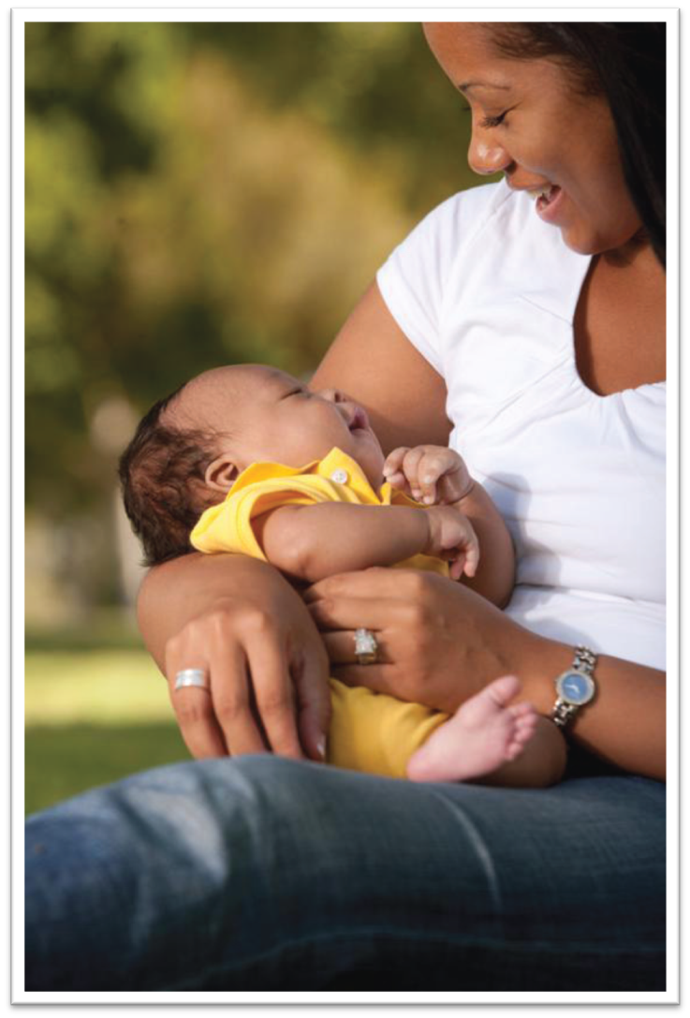

Massachusetts Department of Public Health
Overview

This brochure describes three programs to improve the health of babies and young children in Massachusetts.

- The New England Newborn Screening Program tests newborns for serious health concerns at birth.

- The Universal Newborn Hearing Screening Program tests newborns for hearing loss.

- The Massachusetts Birth Defects Monitoring Program collects information about birth defects from medical providers.

The information collected in these programs is required by law and is protected by the Commonwealth’s confidentiality laws and regulations.

These programs are available to all Massachusetts families.

Newborn screening and monitoring can find problems early to give children and families a head start in finding information, needed care and support.

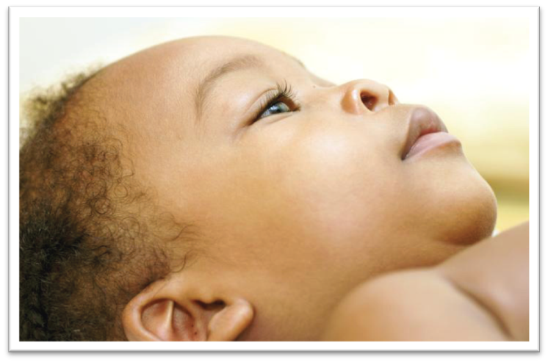
“We can’t thank the Hearing Screening Program enough for helping Henry get such a great start!”
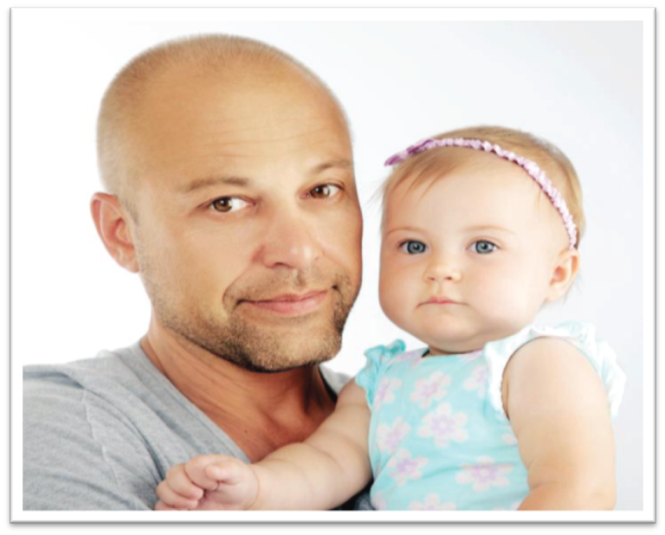
“Every day, we are thankful that Sophia was born in a state that screens for this extremely rare condition.”

New England Newborn Screening Program
This program screens all babies born in Massachusetts for many conditions, such as cystic fibrosis, that are serious and treatable.

Screening all newborns is important because these conditions are often not obvious.

The test needs only a few drops of blood taken from your baby’s heel in the hospital after birth.

Your baby’s doctor will call you right away if the blood test shows signs of one of these conditions. The doctor can help you get more tests and treatment, if needed.

A Family’s Story

Almost two years ago, my husband and I had the pleasure of meeting Sophia, the most beautiful baby girl we had ever seen. We thought nothing of the routine heel prick that she got before we left the hospital.

Three days later, we got the call that saved our daughter’s life. The newborn screening test had found a rare condition which affects 1 in 85,000 babies. Every day, we are thankful that Sophia was born in a state that screens for this extremely rare condition.

Without newborn screening, Sophia likely would have gone into a coma in her first week of life. However, because she was diagnosed so early, we were able to begin treatment immediately, and she is a healthy, happy baby!

Universal Newborn Hearing Screening Program
Babies born in Massachusetts have a screening test to check their hearing after birth. A special machine shows if your baby responds to sounds. The test is simple, and does not hurt. You will get the results before your baby leaves the hospital. If the test shows that your baby may have a hearing loss, he or she will need more testing.

This program can help you to set up this further testing and connect you with other services. The program also provides:

- Family support
- Family education
- Information and referral to helpful programs

A Family’s Story

When our son Henry was born with a severe-to-profound hearing loss, our family was taken completely by surprise.

Thankfully, the hearing screen helped us get an early diagnosis, which set into motion a chain of services that have made a huge impact on Henry’s healthy development.

Henry was enrolled in the Early Intervention Program, fitted for hearing aids, and connected with specialists, including a teacher of the deaf. He is now thriving, and we can’t thank the hearing screening program enough for helping Henry get such a great start!

Birth Defects Monitoring Program
This program collects information about birth defects, such as heart defects, and monitors them over time. Information about birth defects found during pregnancy and in children up to the age of 3 is collected from hospitals and doctors.

The Birth Defects Monitoring Program (BDMP), unlike the two screening programs, is not set up to offer services to individual children. Rather, Massachusetts collects this information to:

- Monitor the cases of birth defects in the Commonwealth

- Identify services that children with birth defects may need

- Report information on birth defects to the public

- Provide data for birth defects researchers

Even One Child Can Alert the BDMP to Something Important

Because of this program, we became aware of a child with birth defects whose mother had taken a particular medication during pregnancy. This medication is sometimes used by people with organ transplants or certain autoimmune conditions.

The child’s birth defects were like those of a few other children reported in medical journals whose mothers were exposed to the same medication. This child helped us to make an important connection between a medication and birth defects that will inform other families and their health care providers.

Further information available at:

New England Newborn Screening Program
University of Massachusetts Medical School
Telephone: 617-983-6300
http://nensp.umassmed.edu/

Massachusetts Universal Newborn Hearing Screening Program
Telephone: 800-882-1435
TTY: 617-624-5992
www.mass.gov/dph/newbornhearingscreening

Massachusetts Birth Defects Monitoring Program
Toll Free: 888-302-2101
Telephone: 617-624-5510

www.mass.gov/dph/birthdefects

