Slide 1: Special Commission on State Institutions

March 21, 2024

3:00 - 4:30 pm

Virtual / Zoom

Evelyn Mateo Co-chair

Matt Millett Co-chair

Slide 2: Agenda

1. Welcome and introductions
2. Recap of Last Meeting
3. Vote to approve minutes from 1/18/24 meeting
4. Presentation of Power Point templates for SCSI; update on YouTube Channel
5. Recent developments regarding Bridgewater; Tewksbury State Hospital and Fernald State School
6. Update from Workgroups
7. Next steps
8. Vote to adjourn

Slide 3: New Commission Member-

* Sister Linda Bessom-a family member of a current resident of the Hogan Development Center.

Slide 4: Recap of Last Meeting

Vote to approve minutes from 1/18/2024 meeting

Slide 5: Update on YouTube Channel

Presentation of Power Point templates for SCSI

Slide 6: SCSI Branding & Template Sample #1

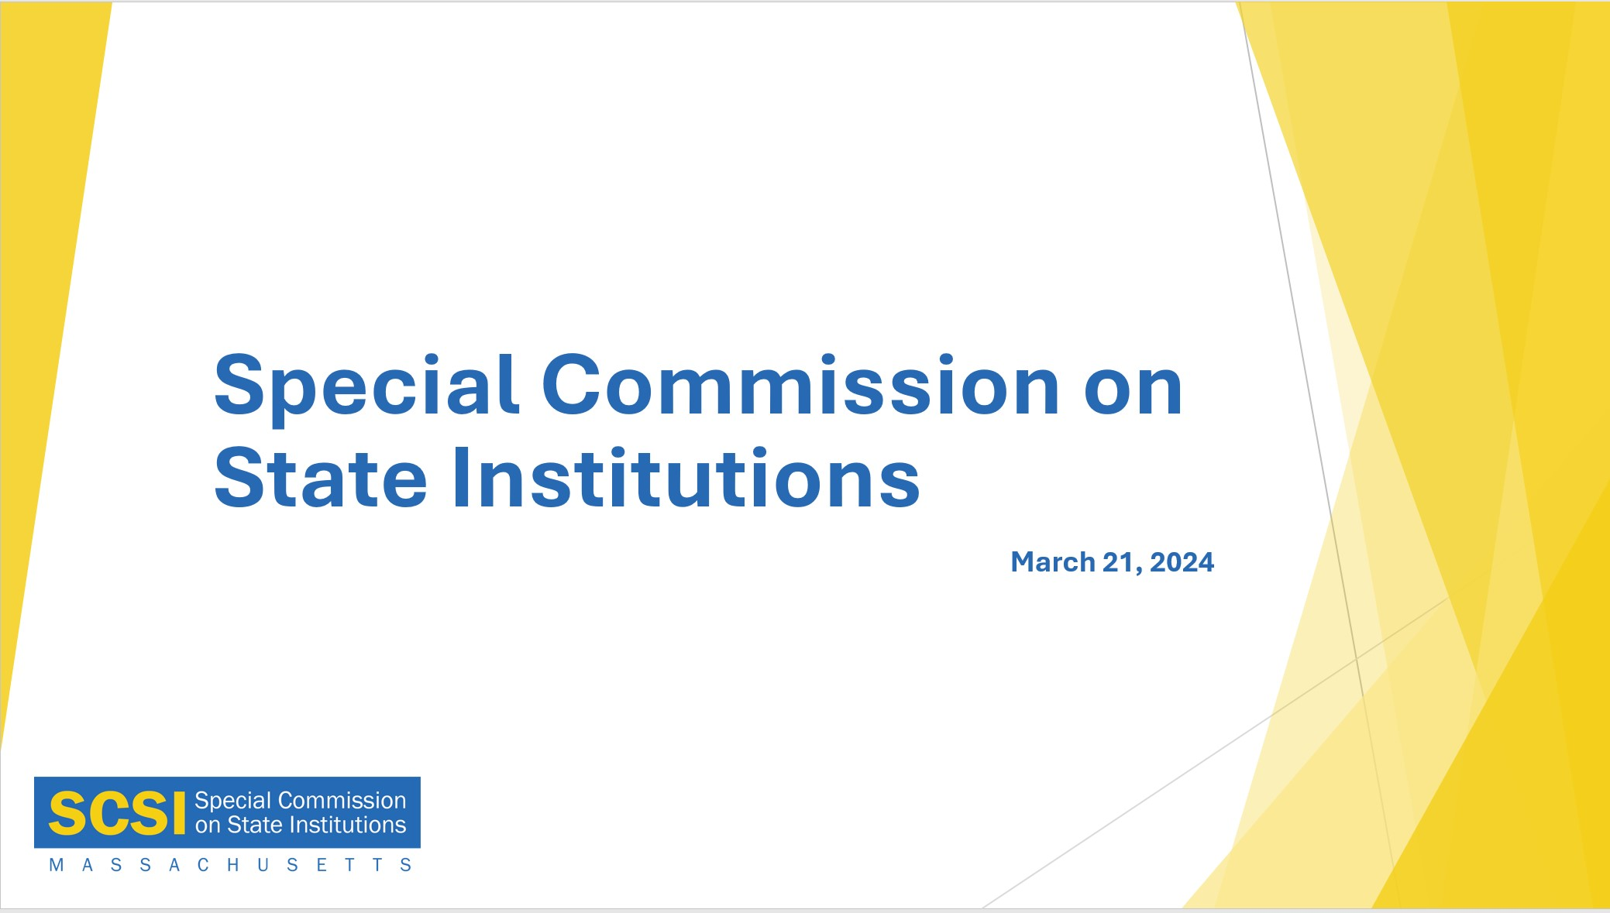

Slide 7: SCSI Branding & Template Sample #2

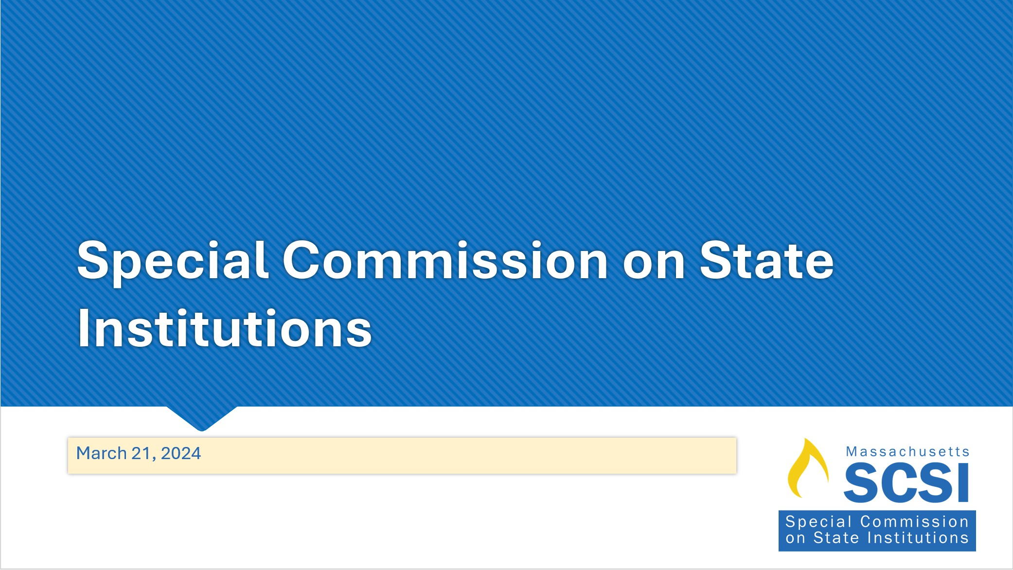

Slide 8: SCSI Branding & Template Sample #3

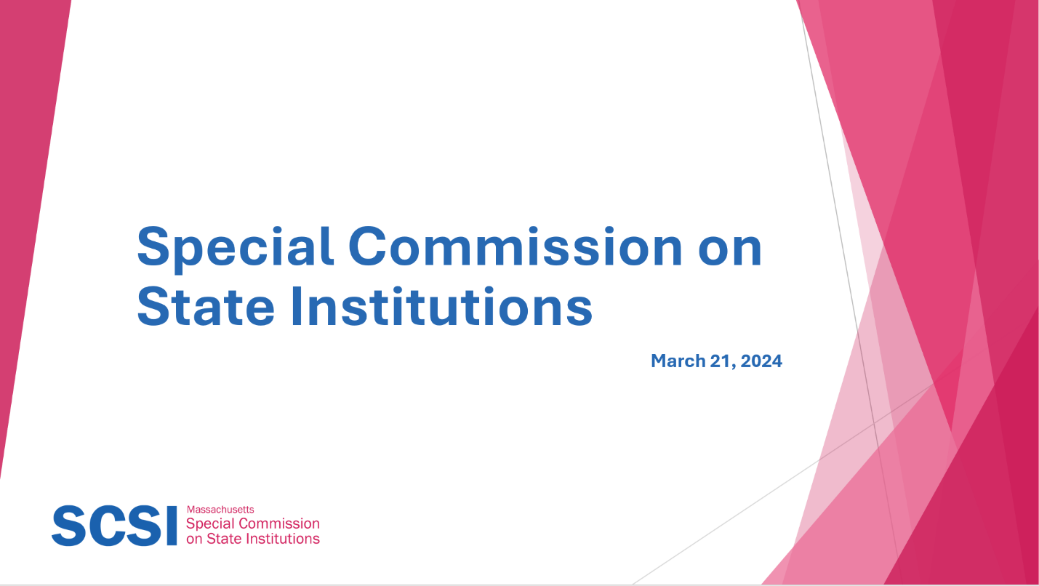

Slide 9: Recent Developments

* Bridgewater State Hospital
  + Disability Law Center Report
* Conditions at Tewksbury State Hospital
* Updates on the Fernald State School

Slide 10: Updates From Workgroups

* Workgroup 1: Letter of Inquiry
* Workgroup 2: Records
* Workgroup 3: Burials
* Workgroup 4: Framework for Memorials
* Please contact CDDER at [SCSI_Support@umassmed.edu](mailto:SCSI_Support@umassmed.edu) if you would like to join a workgroup.

Slide 11: Letter of Inquiry- Reggie Clark

5 requests:

* + Look for any remaining records at the closed institutions
  + Address any record security issues identified
  + Develop an easy-to-follow process to make record requests
  + Create a clear process for how all confidential records stored and when these records are allowed to be destroyed
  + Provide a list of records that may be stored at facilities or government offices still in operation

Requested a preliminary response in 90 days

Slide 12: Letter of Inquiry

**Vote** on whether to approve and send the Letter of Inquiry

Slide 13: Records and Records Access Alex Green

Discussed:

* Legal views of Public Record Law
* Partnering with law school for research assistance
* Current legislative activity re: Public Records Law

Next Steps:

* Map out state record retention guidelines
* Seek key informant interviews
* Supervisor of Records
* Division of Open Government
* Individuals who have attempted to access records

Slide 14: Burials and Burial Locations-Kate Benson

Discussed

* What is known about the status of existing cemeteries and burial locations

Next Steps

* Create a Gap Analysis
* Request current burial practices from active institutions
* Interview Key Informants

Slide 15: Framework for Remembrance – Rania Kelly

Discussed:

* Mission/Vision and Goal of the Remembrance
* Examples from MA and from other states
* Possibility of partnering with architecture/design programs from local university

Next Steps: Presentation from Belchertown State School Friends Association in April.

Slide 16: Next Steps

Next Steps

Vote to Adjourn