# Special Commission on State Institutions

**February 13th, 2025 3:00PM – 5:00PM**

**Virtual / Zoom**

**Kate Benson Matt Millett Co-chair Co-chair**

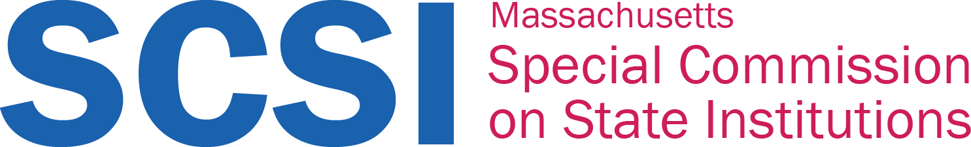

# Agenda

1. Welcome and Announcements
2. Recap of Last Meeting
3. Vote to Approve 01/23/25 Meeting Minutes
4. Purpose of the SCSI
   * Process for the Report Working Group
5. SCSI Outcomes Examples
6. Next Steps
7. Vote to Adjourn

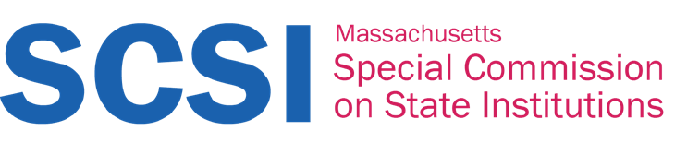

# Welcome and Announcements

* Introductions and Goodbyes:
  + Thank you, Mary Mahon McCauley – Massachusetts Office on Disability
* Recap of Last Meeting:
  + Spring meeting times: 3 PM – 5 PM
  + Spring meeting dates: 3/13, 4/10, 5/8
* Vote to approve 01/23/25 meeting minutes



**Purpose of the SCSI**



**The Summary Report:**

# Special Commission on State Institutions



**What is a summary?**

## A summary is a short statement (1-5 pages) that goes at the beginning of the big report that CDDER created. It tells the Senate President, Speaker of the House, and Governor:

* + - Who we are
    - What this whole thing is all about
    - What we’ve done
    - What we’ve found
    - What we recommend



# Who is it for?

## Even though we send the summary to government leaders, it is meant for anyone to read, and it might include things that people other than the Senate President, Speaker of the House, and Governor might need to do.

* + For example, we might say some things just so that the public knows they are going on. One example is:
    - People have had a very hard time getting the state to give them records about their relatives who lived in institutions.



# What types of things can we say?

* + The CDDER report is big and has lots of details. It is meant to share the facts.
  + The summary should be clear, firm, and express our *informed* opinion based on the facts.
  + Here is an example from 1999, from the U.S. Government’s report on stolen gold and artwork hidden by supporters of the Nazis:
    - *“The cumulative facts and conclusions contained in this report should evoke a sense of injustice and a determination to act. Now, half a century later, this generation’s challenge is to complete the unfinished business of the Second World War to do justice while its surviving victims are still alive. To do justice is in part a financial task. But it is also a moral and political task that should compel each nation involved in these tragic events to come to terms with its own history and responsibility.”*



# How are we creating it?

* + CDDER finds information and sends it to us (like the report).
  + The Whole Commission discusses this information and makes suggestions about what we want to say about what CDDER found.
  + The Report Working Group organizes and summarizes that information and brings it back to the Whole Commission
  + The Whole Commission looks at the cleaned-up summaries and talks about what we like, don’t like, and want to change; one by one.
  + Everything is pulled together into a summary.
  + The Whole Commission looks at what we all liked, what some of us liked, and what some of us didn’t like and work together to get to a place where we vote on the summary. If a majority of people support the summary, then we put it in the final report and send it to the state on June 1st.



# Four kinds of things we want to say:

## What we did

* + - For Example: We got the state to share some cemetery records.

## What we found (and how we feel about it)

* + - For Example: We found that people have a hard time getting records about their loved ones and we feel that is not right.

## What we think people need to know and do (and who they are)

* + - For Example: We think schools should teach this history in Massachusetts

## They are connected

* + - For Example: People don’t know about this history so they don’t know why it’s such a problem that other people can’t get



records.

# What else?

* + Include a letter at the front from the Senator and Representative who sponsored this legislation
  + A press release



# A First Step, A First Vote! Plain Language Summary?

## What is plain language?

* + Why would we want to do it?
    - We don’t have a lot of space for the summary. It’s short!
    - We want people with disabilities to be able to read it.
    - It is the most clear kind of writing.

## Why would we not want to do it?

* + - It is very blunt.



# A Second Step, A Second Vote! Person First or Disability First?

* + Person first language is a way of talking about disability that reminds other people that we are people, not just our disabilities.
    - An example is “We are people with disabilities.”
  + Disability first language is a way of talking about disability that says we know that our disabilities are a big part of who we are, and we are unashamed of it.
    - An example is “We are disabled people.”
  + Both are used by disabled people, and both have good things about them and bad things about them. Each one is a different belief, so we will want to choose which one we will use for the summary.



**Impact on Today…**



# Impact on Today…

## In the meeting of the Report Working Group members shared the different ways that the things we found in the report have an impact on disabled peoples’ lives today.

* + Members said:
    - It shows that the we are honoring the lives of those who came before us.
    - It shows that education is needed in many ways.
    - It shows that people need to know these things because we are repeating the past right now, because we haven’t been able to get and share these stories.



**SCSI Outcome Examples**



**Now let’s go through some examples…**



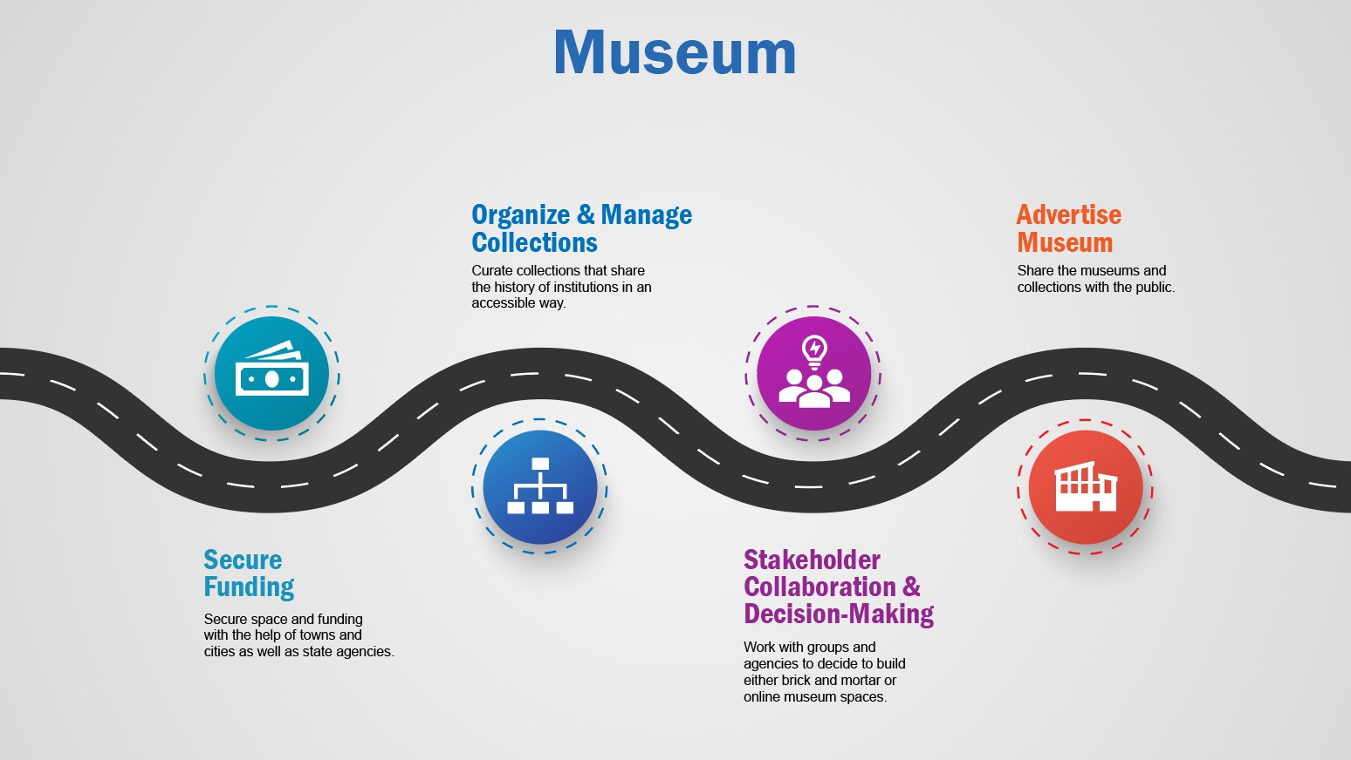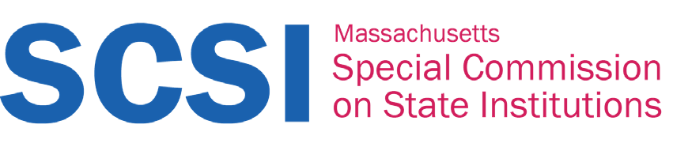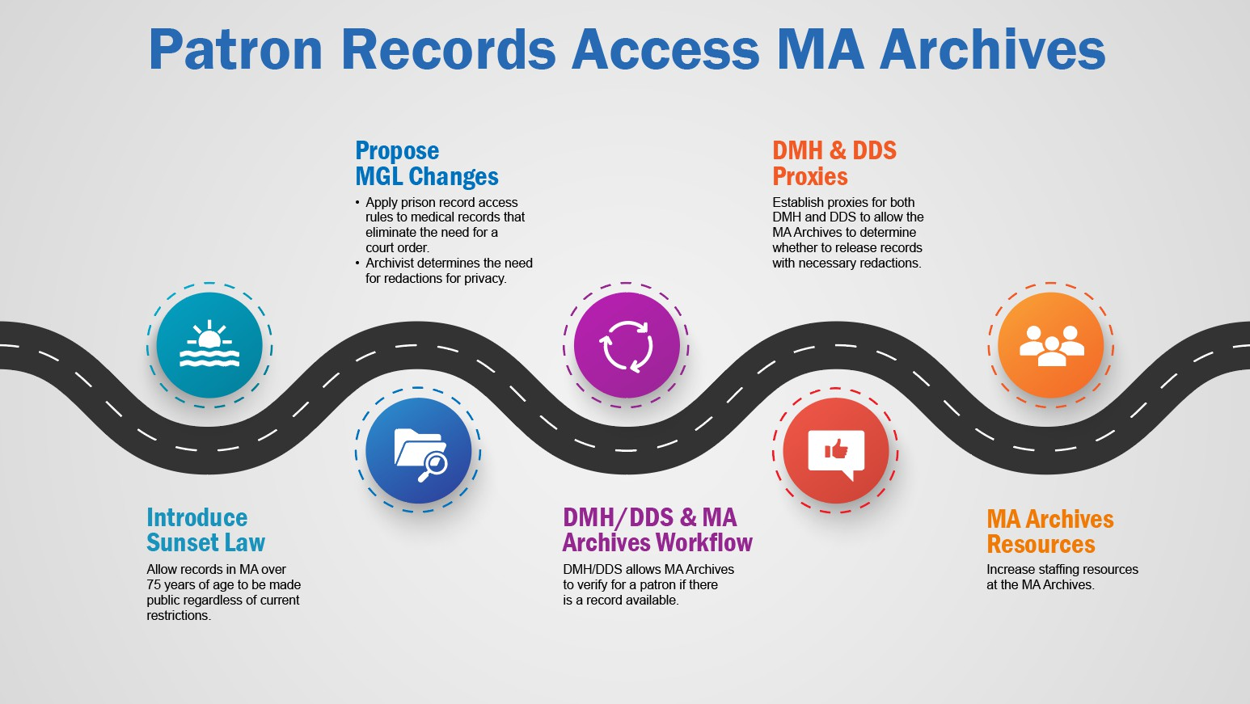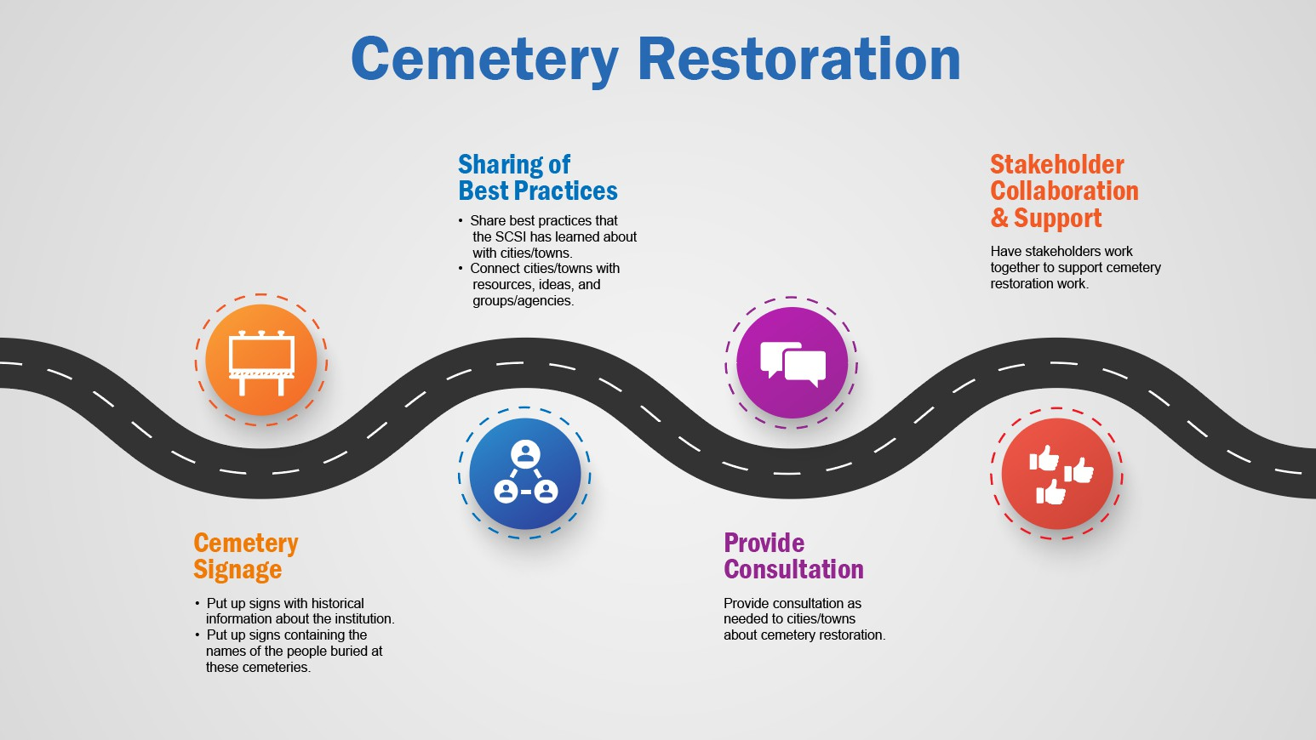

**Impact on Tomorrow…**



# Impact on Tomorrow…

* What do you want to accomplish before the SCSI is done?



# Next Steps

* Vote to Adjourn

