Special Commission on State Institutions
December 12, 2024
3:00 PM – 5:00 PM

Virtual / Zoom

Kate Benson Matt Millett Co-chair Co-chair



Agenda
- Welcome
- Recap of last meeting
- Vote to approve minutes from 11/14/24 meeting
- Commission Roles and Vacant Seats
- Upcoming Work of Special Commission
- Summary Review of CDDER Draft Report
- Next steps
- Vote to adjourn



Welcome
  - Recap of Last Meeting
  - Vote to approve 11/14/24 meeting minutes
  - Commission Roles and Vacant Seats

Commission Roles and Vacant Seats
    - Vacant Position-Vice Chair
    - Approved by vote in November SCSI Meeting
    - The vice chair would be responsible for:
      - Coordinating regularly with the co-Chairs
      - Chairing meetings in the absence of one of the co-Chairs
      - Acting as Chair when requested to do so by one of the co-Chairs
      - Assisting with tasks as requested
    - Vacant Commission Seat
      - Family member of a current resident of the Wrentham Developmental Center

Upcoming Work
December 2024 to June 2025

Upcoming Work of the Special Commission

    - Upcoming Work
      - Review CDDER Report
      - Generate Recommendations
      - Write the SCSI Report- Due June 1, 2025

2025 Commission Meetings

    - Frequency of Meetings
    - Day and time of meetings

Report Review Working Group

    - SCSI voted to approve a Report Review Working Group
    - The Purpose of working group is to collect feedback, comments and edits on the CDDER Draft Report
    - Working group is looking for 2-3 additional Commission members

Summary of Draft Report

Warning of Use of Words

    - The upcoming slides use words to describe people with disabilities that are offensive.
    - The words will be shown as they were used in the past to label schools, asylums and other institutions to show the full history of institutions in the state.

Records and Records Access: Remaining Topics
      - Evolution of Governing Bodies of State Institutions
      - Patient Records Examples (Past vs. Present)
      - MA Public Records Law & Related Governing Bodies
      - Regulations Governing Access to Patient Records
      - Record Collections Held by Secretary of the Commonwealth
      - Records Held by DMH and DDS
      - Private Collections of Institutional Records
      - Personal Experiences
      - Areas for Additional Research

Massachusetts Commission on Mental Diseases (1916-1919)
    - Chapter 285 of the Acts of 1916 eliminated the Board of Insanity and established the Massachusetts Commission on Mental Diseases.
      - Section 1 required all records, books, and property to be transferred.
    - First annual report in 1916 highlighted importance of scientific research
at the School for the Feeble-Minded.
    - Chapter 318 of the General Acts established:
      - Free community clinics for people the "feeble-minded.”
      - Registry for the feeble-minded for tracking and treatment purposes.
        - Registry not subject to public inspection, except by public officials or other people having authority over the feeble-minded person.

Department of Mental Diseases (1920-1938)
    - Chapter 350 of the General Acts of 1919 replaced the Commission on Mental Diseases with the Department of Mental Diseases.
    - By 1920, major changes in the Massachusetts public welfare system included the consolidation of over 100 state departments to just 20.
      - The Department of Mental Diseases was not impacted by these changes.
    - In 1923, two new divisions were introduced:
      - Division of Mental Hygiene
      - Division for the Feeble-minded
        - In 1926, was renamed to Division of Mental Deficiency.

Questions/Feedback

Evolution of Governing Bodies of State Institutions

Type of Information Collected
    - Patient Records:
      - Demographic Information: Marital status, birthplace, diagnosis, number of previous commitments, and the method of commitment.
      - Patient Registration Number: Each patient was assigned a unique number for record-keeping purposes.
    - Annual Reports:
      - Operations and expenditures: Financial details about hospital operations.
      - Patient movement: Commitments, admissions, transfers, discharges, and deaths.
      - Department reports: Religious services, social work, pathology, etc.
      - Recommendations and requests: Proposed changes to the law and funding requests for institutional improvements and expansion.
      - Mental health conditions and general health of the population.

Record Preservation and Storage (late 1800’s – early 1900’s)
  - MA General Law has mandated that government entities must provide fire-resistant and fireproof rooms, safes, or vaults for safeguarding public records since the late 1800’s.
  - Annual reports document requests for funds to comply with record storage requirements.
    - In 1916, Grafton State Hospital’s Superintendent requested
$900 to create a fireproof room for storing records.
    - In 1923, the Belchertown State School’s Superintendent requested funds for an administration building with a fireproof vault.

Special Committee of Superintendents for Uniform Records (1918 – 1919)
- In 1918, a special committee of superintendents was formed to standardize record-keeping across state institutions.
- By 1919, there were several improvements in records:
  - The Boston Psychopathic Hospital - Detailed clinical histories, and it made sure that records were easy to access.
  - Worcester State Hospital - Held clinical meetings to review patient summaries, physical and mental health findings, and social service reports.
  - Grafton State Hospital - Typewritten pathology records, which were organized into volumes.
  - Boston State Hospital - Patient records were maintained chronologically, including all patient history and actions taken.

Record-Keeping Practices (Past vs. Present)
- A Brief History of the Taunton Lunatic Hospital 1854 - 2016 by Joseph Langlois.
  - Informal analysis of the medical records stored at Taunton State Hospital
  - Illustrated a gradual improvement in the quality and thoroughness of medical records, shifting from brief, sparse documentation to more detailed, structured records.
- Key Informant Interviews: State hospitals kept inpatient admission cards in alphabetical order by patient name and the year they were admitted and could include information about the patient's death
  - Unclear how long the records are kept or the specific periods they cover
  - Some records from Taunton and Foxborough are securely stored at Taunton State Hospital

Questions/Feedback

Patient Records Examples (Past vs. Present)

MA Public Record Law
- Right to Access: In Massachusetts, everyone has the right to see public records held by state and local government offices. You can look at, copy, or get copies of these records for a reasonable fee.
- Definition of Public Records: Public records include many types of materials made or received by government offices. This can be books, papers, maps, photos, financial records, and other documents.
- Presumption of Public Access: Most records held by the government are open to the public unless there is a special reason not to share them. This helps people see how the government is working.

MA Public Records Law – Some Exemptions
- Personal Identifying Information: Personal details like names, Social Security numbers or private addresses are kept private to protect people's privacy
- Juvenile Delinquency Records: These records are kept private and not available to the public
- Criminal Offender Record Information (CORI): Criminal records are not available to the public unless allowed by law
- Personnel and Medical Files: Personnel and medical records that could harm privacy are kept private
- Exemption for Institutional Records: the law specifically exempts records related to individuals from certain state institutions

Who Oversees Public Records?
Public Records are managed under the Secretary of the Commonwealth
- Records Conservation Board (RCB):
  - Maintains the Statewide Records Retention Schedule (SRRS)
  - Agencies need RCB's permission to destroy records or to move them to the State Archives
  - Some records from closed institutions have been destroyed during times when the policy allowed it
- Supervisor of Records:
  - Decides if a government record should be made public or if it is exempt from being shared under the Public Records Law
  - Oversees the appeal process to decide if access should be granted

Who Oversees Public Records? (Cont.)

- Records Management Unit (RMU)
  - Ensures proper storage and preservation of government records
  - Assists state agencies in managing and securing their records
  - Provides guidance on various record-keeping issues
- Records Access Officers (RAO)
  - Manage requests for records made to their agency
  - Both DDS and DMH have Records Access Officers

Request Process for Public Records
- Requests can be made to a Records Access Officer (RAO) in person, by mail, fax, or email.
- RAO’s have 10 business days to reply.
- RAO must provide an explanation if
  - They don’t have certain records; or
  - They are unable to share the records.
- RAO must provide information about the requestor’s Right of Appeals
  - Appeals are made to the Supervisor of Records

Five-Minute Break

Questions/Feedback

MA Public Records Law & Related Governing Bodies

Access Rules for Institutional Patient Records
- Privacy of Patient Records:
  - Require records to be kept private and secure, with some exceptions:
    - Court Order
    - Legally Authorized Representatives
    - Patient or Attorney Request
    - Best Interest of the Patient
    - Where otherwise required by law
- Retention of Medical Records:
  - A 20-year retention period is mandated for medical records under state law.
  - Records cannot be destroyed or transferred to the MA State Archives without prior approval from the Records Conservation Board.

Current DMH & DDS Regulations on Records

- DDS and DMH’s most recent regulations on records include:
  - DDS Regulation 115 CMR 4.00 (last updated in 2009)
  - DMH Regulation 104 CMR 27.00 (last updated in 2021)
- Outline the requirements for patient records to ensure comprehensive, accessible, and accountable record-keeping for people receiving services
- Establishes quality standards for record keeping, including privacy and confidentiality of patient records.

Record Request for Former or Current Service Recipients
  - Process is outlined on the DMH and DDS webpages
    - Requests may be denied or partially redacted (blacked out) based on legal restrictions when the records include sensitive personal or medical information.
  - DMH's Restrictions: Until a court order or valid Personal Representative authorization is provided, DMH cannot:
    - Release any medical records.
    - Confirm if a person was ever served by DMH.
    - Confirm whether records are still under DMH's custody or control.

Questions/Feedback

Regulations Governing Access to Patient Records

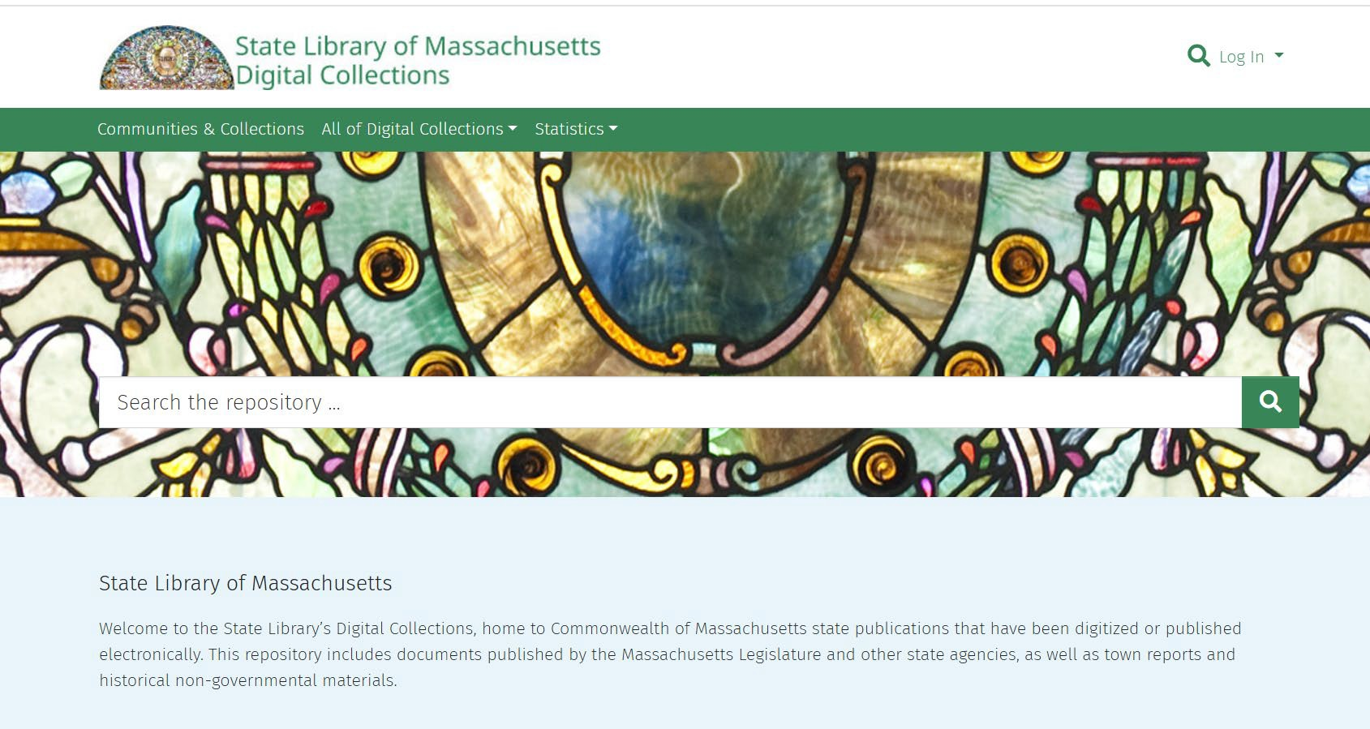
Record Collections Held by Secretary of the Commonwealth: State Library of MA
- Public Document Series
  - Annual reports from state hospitals and asylums, vital statistics, boards of charity, health, and insanity, among many others.
  - Provide insights into how these institutions were run in the past
  - Available online through the library’s digital collection: https://archives.lib.state.ma. us/home

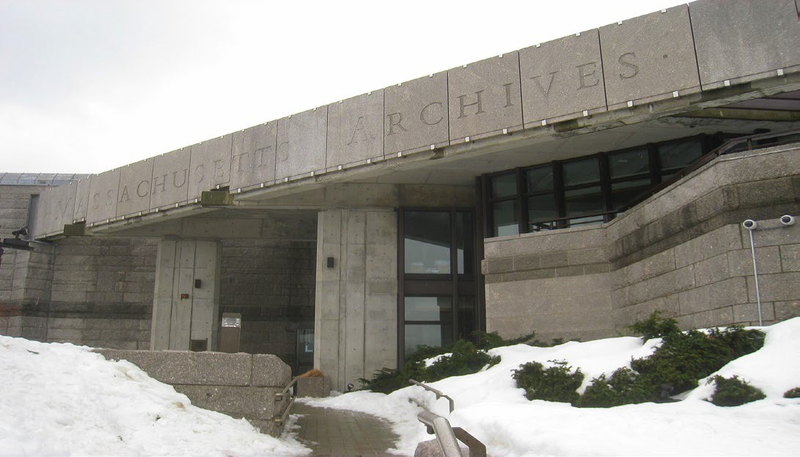
Record Collections Held by the Secretary of the Commonwealth: MA State Archives
- Human Services Collection:
  - Lists the institutional records from DMH and DDS:
    - Medical Records (restricted)
    - Registration Information (restricted)
    - Business Records
    - Death Records
    - Cemetery/Burial Records
- Access to Human Services Collection:
  - Policy allows access to most records typically after a 75-year waiting period.
  - Timeline is not explicitly set in Massachusetts General Law and may vary depending on the type of record and any associated restrictions.

Collections Held at the Massachusetts State Archives

Boston State Hospital:1856-1985 | Medfield State Hospital: 1896-1948
Bridgewater State Hospital: 1887-1967 | Metropolitan State Hospital: 1930-1992
Danvers State Hospital: 1878-1980 | Northampton State Hospital: 1858-1993
Fernald State School: 1852-1969 | Tewksbury State: 1860-1896
Grafton State Hospital:1877-1955 | Westborough State Hospital: 1886-1960, 1970-1977

Questions/Feedback

Record Collections Held by the Secretary of the Commonwealth

Records Held by DMH and DDS
- Storage Locations and Conditions:
  - Active DDS and DMH facilities
  - Area and Central offices of each agency
  - Old buildings on institutional campuses still open
    - Storage conditions lack important safeguards (e.g., sprinkler and heating/ventilation systems).
  - Most records are in paper form, which makes them more likely to get damaged by things like humidity, light, and age.
  - Question of storage capacity at the MA Archives

DDS and DMH Facility Storage Examples
- Medfield State Hospital: Records likely stored in unsafe buildings; can’t enter
  - SCSI has asked EOHHS when the buildings will be inspected
- Fernald State School: Records with PII found in old campus buildings in 2024
  - DDS has taken action to retrieve records found in unsecured buildings
- Wrentham Developmental Center: In 2024 someone trespassed and broke into a closed building and found old records from another state school stored there
  - DDS has taken extra security measures, but challenges remain.
- Paul A Dever State School (2014): Records from the 1960’s were found and left unsecured in an old campus building
  - Similar discoveries made at other closed state hospitals by urban explorers
- Foxborough State Hospital (2000): Patient records not stored at the State Archives, and some are Taunton State Hospital
  - Many records are presumed to be missing

Questions/Feedback

Records Held by DMH and DDS

Private Collections of Institutional Records
- Many old records are held by private libraries in different institutions like colleges and universities.
- Private collections have different record access rules:
  - National Security Risk: May contain information that could pose a risk.
  - Privacy Laws: May include sensitive personal or medical information.
  - Preservation Needs: Fragile, old records restricted to protect condition.
  - Donor Agreements: Restrictions may be set by donors, such as limited access or delayed availability.
- Some records may not be available because they are “unprocessed.”

Countway Library at Harvard Medical School
- 15 different collections of records related to state institutions:
  - Patient Information: Includes consent forms for experiments, test results, autopsy reports, case studies, and patient records, which some include personal identifiers (e.g., names), initials or numbers.
  - Research Findings: Detailed studies and records of clinical studies conducted in state hospitals.
  - Institutional Oversight: Records of hospital operations, including inspection reports and patient care documentation.
  - Trustee Reports: Includes Trustee meeting minutes, reports on the conditions of care, and significant events in the hospitals.
  - Surplus Records: Some records were considered surplus by the State and transferred to the Countway Library for preservation.

Countway Access Rules and Restrictions
- Institutional Review Board (IRB) regulates access to patient records.
  - Researchers or individuals must get IRB approval to access sensitive data
  - In most collections, patient records are closed for 80 years from the date of creation to protect patient privacy.
    - Access granted earlier upon approval from the Institutional Review Board
  - Reports about hospital management may be restricted if they contain sensitive details about abuse or operational practices.
- The State Archives is aware of the private collections housed at Countway, and there is collaboration between these two institutions, especially regarding the handling of closed records.

Yakovlev-Haleem Collection (1926 – 1936)
- Dr. Yakovlev was a physician who worked at the Monson State Hospital for Epileptics, Metropolitan State Hospital, and Fernald.
  - Conducted studies on patient brains to learn about causes of disabilities
  - Collection has 900 + brains that were curated by Mohamad Haleem
- Collection is part of the Neuroanatomical Collections of the National Museum of Health and Medicine.
  - Not available to the public but can be viewed by qualified researchers by appointment
  - Parts of the collection were once held by the Eunice Kennedy Shriver Center; also transferred to National Museum of Health and Medicine.

Belchertown State School Friends Association
- Housed at University of Massachusetts Amherst
- Records related to the Belchertown State School
  - Legal cases associated with the institution
    - Massachusetts v. Russell W. Daniels
    - Ricci v. Greenblatt (later Ricci v. Okin)
- Open for research without restrictions

Samuel Bayard Woodward (1832 – 1846)

- Housed at University of Massachusetts Chan Medical School
- Dr. Samuel Bayard Woodward
  - First superintendent of the State Lunatic Hospital in Worcester
  - Co-founder of the Association of Medical Superintendents of American Institutions for the Insane
- Collection is digitized and includes writings by Woodward, such as essays, addresses, obituaries, letters, and verses.
- Open for research without restrictions

Samuel Gridley Howe Library
- Housed at Brandeis University - Robert D. Farber University Archives
- Collection includes a diverse range of materials related to the Walter E. Fernald Developmental Center.
- The collection was transferred to Brandeis in 2010 after the closure of the Howe Library on the Fernald campus.
- The collection contains books, papers, case studies, pamphlets, and journals on topics like eugenics, mental disabilities, and disability studies.
- It includes materials from prominent figures in the disabilities field (Irving Kenneth Zola and Rosemary and Gunnar Dybwad)
- The collection is not yet processed, but once it is, materials containing patient information will likely have restricted access.

Questions/Feedback

Private Record Collections

Personal Experiences
Attempts to Access Institutional Records
- How the Information was Collected
  - Four key Informant Interviews conducted by CDDER with family members of former residents of state institutions who attempted to access their deceased family member’s records from state institutions.
  - Referenced books written by local authors who documented their experiences accessing records from state institutions when researching their family history

Key Themes from Interviews
- Barriers to Accessing Records:
  - Legal barriers, such as the need for probate court orders or specific permissions, were significant obstacles in all cases.
- Problems with Record Keeping:
  - Records were poorly maintained or destroyed over time.
  - Records were transferred to other institutions.
  - Some key informants being unsure whether records even still existed.
  - Records were scattered, inaccessible or in danger of being destroyed.
- Desire to Understand Family History:
  - These searches are not just about obtaining information—Key informants describe a deep, emotional need to understand the lives of family members who were separated from them due to institutionalization.

Advocacy for Change
- Key Informants called for more transparency and accountability in the records access process.
- Criticism of the system which they say as for prioritizing staff privacy over that of the former residents.
- Advocate for the creation of funds to help families navigate the probate process.
- Would like for public acknowledgment of the history of institutions like Fernald and apologies for the mishandling of records.

Questions/Feedback

Personal Experiences

Areas for Additional Research
- Evolution of Governing Bodies of State Institutions (to present day)
- Changes to the Statewide Record Retention Requirements
- Records stored at DMH and DDS Facilities and Offices
- Summary of Records Destroyed
- Records from State Institutions available online
- Researcher Access to Records
- Harvard Legal Clinic Analysis
  - Comparative Standards from other States
    - Records Access
    - Death/Cemetery Records and HIPAA

Framework for Remembrance
Summary of Draft Report

Framework for Remembrance Major Topics
- Summary of Remembrance Projects
  - Belchertown State School Friends Association
  - Danvers State Memorial Committee
  - California Memorial Project
  - Willowbrook Mile
- Key Themes and Lessons Learned
- Areas for Additional Research

The Belchertown State School Friends Association
- Focus on establishing a memorial and museum at the site of the former Belchertown State School.
- The memorial will provide a space to share the history of special education, institutionalization, and the broader story of disability rights.
- The group’s mission includes preserving the state school administration building and offering community space for education and reflection.
- In partnership with the Belchertown Historic Commission and the Belchertown Cultural Alliance, the Friends Association is working on projects such as an interpretive trail and museum.

Danvers State Memorial Committee
- The Danvers State Memorial Committee was led by former patients and community advocates that focused on the restoration and proper memorialization of the neglected cemeteries at Danvers State Hospital.
- Understood the importance of land redevelopment and influenced plans for the property
  - Proceeds from its sale would be used to create adequate housing for individuals with mental health needs.
  - Responsibilities for the care and maintenance of the cemeteries were included in the sale of the land
- Efforts were rooted in a desire to honor the past while fostering a more inclusive future

California Memorial Project
- The California Memorial Project was established and is run by peer advocates
- Dedicated to honoring individuals with mental health and developmental disabilities who lived and died in California state institutions.
- Over 45,000 people lived in California state institutions, many of whom were buried in unmarked graves without recognition.
- Established in 2002 through legislation (Senate Bill 1448)
  - Cemetery restoration projects
  - Annual Day of Remembrance across the state each year on the 3rd Monday in September
- Annual remembrance ceremonies include speeches, personal stories, and artistic contributions.
- Oral Histories are being recorded and posted on the project’s website

The Willowbrook Mile Walking Trail
- Remembers the history of Willowbrook State School in Staten Island, NY
- The trail has 12 stops that tell the story of the school and the challenges the people who lived there faced
- It is designed to be accessible so that everyone, no matter their abilities, can learn about Willowbrook's history.
  - Pathways are wheelchair-friendly, with smooth surfaces, ramps, and benches
  - Information panels feature large print and braille, and guided audio tours
  - ASL interpreters available, and video presentations include captions.
  - Materials in Plain and other languages to accommodate non-English speakers
- The Mile is a powerful tool for education and advocacy-ensuring the history of the institution is remembered and promoting greater inclusion and justice for people with disabilities.

Questions/Feedback

Summary of Remembrance Projects

Key Themes
- Collaboration with Stakeholders: Former residents, families, advocates, government agencies, and community
  - Ensures a broad range of perspectives are included
  - Honors the diverse histories of the individuals involved
- Inclusivity and Accessibility: Design with accessibility in mind
  - Create spaces that are welcoming and engaging for individuals with a wide range of physical, sensory, and cognitive abilities.
- Focus on Education and Reflection: Provide educational opportunities
  - Museums, trails, and interpretive materials
  - History of institutionalization and the social justice issues surrounding disability rights
- Community Engagement and Advocacy: Remembering and honoring the past
  - Advocate for systems change and improved care for individuals with disabilities.

Lessons Learned: Organizing
- Know Your Stakeholders: Involve a wide range of people from the beginning, including families, advocates, and officials. This makes sure the project reflects many viewpoints.
- Encourage Member Voices: Let people with lived experiences share their stories. Listening to former patients helps build trust and involvement.
- Create a Shared Vision: Work together to form a common goal. A united vision helps everyone feel invested in the project.
- Take Time to Plan: Plan carefully but be flexible. Big projects take time and need proper planning, like securing funding or handling unexpected problems.
- Safeguard Your Message: Stay true to the mission. Don’t let outside pressures distract you from the main goal.
- Be Ready for a Long Ride: Advocacy projects can take years. Stay patient and keep pushing for the change you want, even when it’s slow.

Lessons Learned: Supporting People with Lived Experience
- Prepare Agendas: Organize meetings with clear agendas to stay on track. This helps members feel prepared and valued.
- Foster a Respectful Atmosphere: Create a space where everyone feels heard and respected, even if they have different opinions.
- Level the Playing Field: Encourage open communication by treating everyone equally. This helps people feel comfortable sharing their ideas.
- Recognize Diverse Leadership Styles: Not all leaders are the same. Some lead by listening or organizing, so appreciate all kinds of leadership.
- Cultivate Leadership Skills: Give members the chance to practice leadership, like public speaking, so they can feel confident.
- Engage the General Membership: Keep members involved by hosting regular events and encouraging them to share their thoughts and memories.
- Invite Participation in Public Forums: Encourage members to attend public meetings where they can share their views and help shape decisions.

Areas for Additional Research

- MetFern Cemetery Restoration
- Westborough Cemetery Project
- DDS Cemetery Restoration and Annual Memorial Ceremonies

Questions/Feedback

Key Themes and Lessons Learned

Next Steps

- Vote to Adjourn

