### Special Commission on State Institutions

**December 12, 2024**

**3:00 PM – 5:00 PM**

**Virtual / Zoom**

**Kate Benson Matt Millett Co-chair Co-chair**



### Agenda

1. Welcome
2. Recap of last meeting
3. Vote to approve minutes from 11/14/24 meeting
4. Commission Roles and Vacant Seats
5. Upcoming Work of Special Commission
6. Summary Review of CDDER Draft Report
7. Next steps
8. Vote to adjourn



### Welcome

* + Recap of Last Meeting
  + Vote to approve 11/14/24 meeting minutes
  + Commission Roles and Vacant Seats



### Commission Roles and Vacant Seats

* + - Vacant Position-Vice Chair
    - Approved by vote in November SCSI Meeting
    - The vice chair would be responsible for:
      * Coordinating regularly with the co-Chairs
      * Chairing meetings in the absence of one of the co-Chairs
      * Acting as Chair when requested to do so by one of the co-Chairs
      * Assisting with tasks as requested
    - Vacant Commission Seat
      * Family member of a current resident of the Wrentham Developmental Center



# Upcoming Work

**December 2024 to June 2025**



### Upcoming Work of the Special Commission

* + - Upcoming Work
      * Review CDDER Report
      * Generate Recommendations
      * Write the SCSI Report- **Due June 1, 2025**



### 2025 Commission Meetings

* + - Frequency of Meetings
    - Day and time of meetings



### Report Review Working Group

* + - SCSI voted to approve a Report Review Working Group
    - The Purpose of working group is to collect feedback, comments and edits on the CDDER Draft Report
    - Working group is looking for 2-3 additional Commission members



**Summary of Draft Report**



### Warning of Use of Words

* + - The upcoming slides use words to describe people with disabilities that are offensive.
    - The words will be shown as they were used in the past to label schools, asylums and other institutions to show the full history of institutions in the state.



**Records and Records Access: Remaining Topics**

* + - * Evolution of Governing Bodies of State Institutions
      * Patient Records Examples (Past vs. Present)
      * MA Public Records Law & Related Governing Bodies
      * Regulations Governing Access to Patient Records
      * Record Collections Held by Secretary of the Commonwealth
      * Records Held by DMH and DDS
      * Private Collections of Institutional Records
      * Personal Experiences
      * Areas for Additional Research



### Massachusetts Commission on Mental Diseases (1916-1919)

* + - Chapter 285 of the Acts of 1916 eliminated the Board of Insanity and established the **Massachusetts Commission on Mental Diseases**.
      * Section 1 required all records, books, and property to be transferred.
    - First annual report in 1916 highlighted importance of **scientific research**

at the School for the Feeble-Minded.

* + - Chapter 318 of the General Acts established:
      * **Free community clinics** for people the "feeble-minded.”
      * **Registry for the feeble-minded** for tracking and treatment purposes.
        + Registry not subject to public inspection, except by public officials or other people having authority over the feeble-minded person.



### Department of Mental Diseases (1920-1938)

* + - Chapter 350 of the General Acts of 1919 replaced the Commission on Mental Diseases with the **Department of Mental Diseases**.
    - By 1920, major changes in the Massachusetts public welfare system included the consolidation of over 100 state departments to just 20.
      * The Department of Mental Diseases was not impacted by these changes.
    - In 1923, two new divisions were introduced:
      * Division of Mental Hygiene
      * Division for the Feeble-minded
        + In 1926, was renamed to Division of Mental Deficiency.



# Questions/Feedback

## Evolution of Governing Bodies of State Institutions



### Type of Information Collected

* + - Patient Records:
      * Demographic Information: Marital status, birthplace, diagnosis, number of previous commitments, and the method of commitment.
      * Patient Registration Number: Each patient was assigned a unique number for record-keeping purposes.
    - Annual Reports:
      * Operations and expenditures: Financial details about hospital operations.
      * Patient movement: Commitments, admissions, transfers, discharges, and deaths.
      * Department reports: Religious services, social work, pathology, etc.
      * Recommendations and requests: Proposed changes to the law and funding requests for institutional improvements and expansion.
      * Mental health conditions and general health of the population.



### Record Preservation and Storage (late 1800’s – early 1900’s)

* + MA General Law has mandated that government entities must provide fire-resistant and fireproof rooms, safes, or vaults for safeguarding public records since the late 1800’s.
  + Annual reports document requests for funds to comply with record storage requirements.
    - In 1916, Grafton State Hospital’s Superintendent requested

$900 to create a fireproof room for storing records.

* + - In 1923, the Belchertown State School’s Superintendent requested funds for an administration building with a fireproof vault.



### Special Committee of Superintendents for Uniform Records (1918 – 1919)

* In 1918, a special committee of superintendents was formed to standardize record-keeping across state institutions.
* By 1919, there were several improvements in records:
  + The Boston Psychopathic Hospital - Detailed clinical histories, and it made sure that records were easy to access.
  + Worcester State Hospital - Held clinical meetings to review patient summaries, physical and mental health findings, and social service reports.
  + Grafton State Hospital - Typewritten pathology records, which were organized into volumes.
  + Boston State Hospital - Patient records were maintained chronologically, including all patient history and actions taken.



#### Record-Keeping Practices (Past vs. Present)

* *A Brief History of the Taunton Lunatic Hospital 1854 - 2016* by Joseph Langlois.
  + Informal analysis of the medical records stored at Taunton State Hospital
  + Illustrated a gradual improvement in the quality and thoroughness of medical records, shifting from brief, sparse documentation to more detailed, structured records.
* Key Informant Interviews: State hospitals kept inpatient admission cards in alphabetical order by patient name and the year they were admitted and could include information about the patient's death
  + Unclear how long the records are kept or the specific periods they cover
  + Some records from Taunton and Foxborough are securely stored at Taunton State Hospital



# Questions/Feedback

**Patient Records Examples (Past vs. Present)**



### MA Public Record Law

* Right to Access: In Massachusetts, everyone has the right to see public records held by state and local government offices. You can look at, copy, or get copies of these records for a reasonable fee.
* Definition of Public Records: Public records include many types of materials made or received by government offices. This can be books, papers, maps, photos, financial records, and other documents.
* Presumption of Public Access: Most records held by the government are open to the public unless there is a special reason not to share them. This helps people see how the government is working.



### MA Public Records Law – Some Exemptions

* Personal Identifying Information: Personal details like names, Social Security numbers or private addresses are kept private to protect people's privacy
* Juvenile Delinquency Records: These records are kept private and not available to the public
* Criminal Offender Record Information (CORI): Criminal records are not available to the public unless allowed by law
* Personnel and Medical Files: Personnel and medical records that could harm privacy are kept private
* Exemption for Institutional Records: the law specifically exempts records related to individuals from certain state institutions



### Who Oversees Public Records?

Public Records are managed under the Secretary of the Commonwealth

* Records Conservation Board (RCB):
  + Maintains the Statewide Records Retention Schedule (SRRS)
  + Agencies need RCB's permission to destroy records or to move them to the State Archives
  + Some records from closed institutions have been destroyed during times when the policy allowed it
* Supervisor of Records:
  + Decides if a government record should be made public or if it is exempt from being shared under the Public Records Law
  + Oversees the appeal process to decide if access should be granted



### Who Oversees Public Records? (Cont.)

* Records Management Unit (RMU)
  + Ensures proper storage and preservation of government records
  + Assists state agencies in managing and securing their records
  + Provides guidance on various record-keeping issues
* Records Access Officers (RAO)
  + Manage requests for records made to their agency
  + Both DDS and DMH have Records Access Officers



### Request Process for Public Records

* Requests can be made to a Records Access Officer (RAO) in person, by mail, fax, or email.
* RAO’s have 10 business days to reply.
* RAO must provide an explanation if
  + They don’t have certain records; or
  + They are unable to share the records.
* RAO must provide information about the requestor’s Right of Appeals
  + Appeals are made to the Supervisor of Records



**Five-Minute Break**



# Questions/Feedback

## MA Public Records Law & Related Governing Bodies



### Access Rules for Institutional Patient Records

* Privacy of Patient Records:
  + Require records to be kept private and secure, with some exceptions:
    - Court Order
    - Legally Authorized Representatives
    - Patient or Attorney Request
    - Best Interest of the Patient
    - Where otherwise required by law
* Retention of Medical Records:
  + A 20-year retention period is mandated for medical records under state law.
  + Records cannot be destroyed or transferred to the MA State Archives without prior approval from the Records Conservation Board.



#### Current DMH & DDS Regulations on Records

* DDS and DMH’s most recent regulations on records include:
  + DDS Regulation 115 CMR 4.00 (last updated in 2009)
  + DMH Regulation 104 CMR 27.00 (last updated in 2021)
* Outline the requirements for patient records to ensure comprehensive, accessible, and accountable record-keeping for people receiving services
* Establishes quality standards for record keeping, including privacy and confidentiality of patient records.



### Record Request for Former or Current Service Recipients

* + Process is outlined on the DMH and DDS webpages
    - Requests may be denied or partially redacted (blacked out) based on legal restrictions when the records include sensitive personal or medical information.
  + DMH's Restrictions: Until a court order or valid Personal Representative authorization is provided, DMH cannot:
    - Release any medical records.
    - Confirm if a person was ever served by DMH.
    - Confirm whether records are still under DMH's custody or control.



# Questions/Feedback

## Regulations Governing Access to Patient Records



### Record Collections Held by Secretary of the Commonwealth: State Library of MA

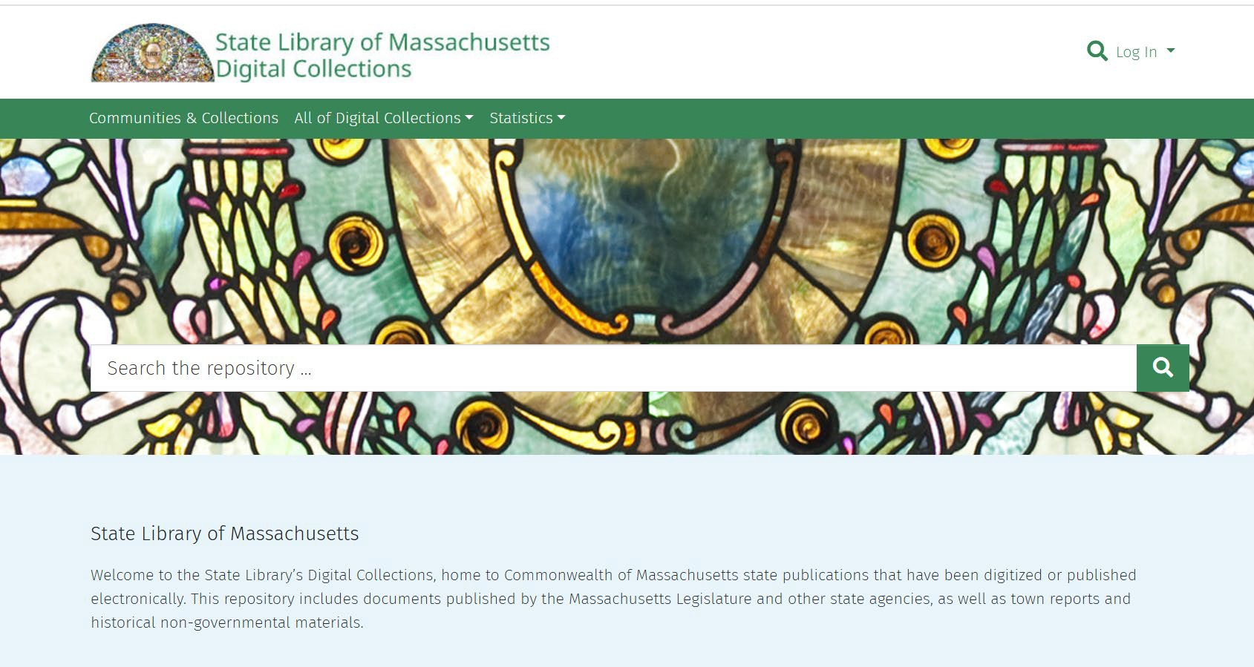

* Public Document Series
  + Annual reports from state hospitals and asylums, vital statistics, boards of charity, health, and insanity, among many others.
  + Provide insights into how these institutions were run in the past
  + Available online through the library’s digital collection: **https://archives.lib.state.ma. us/home**



### Record Collections Held by the Secretary of the Commonwealth: MA State Archives

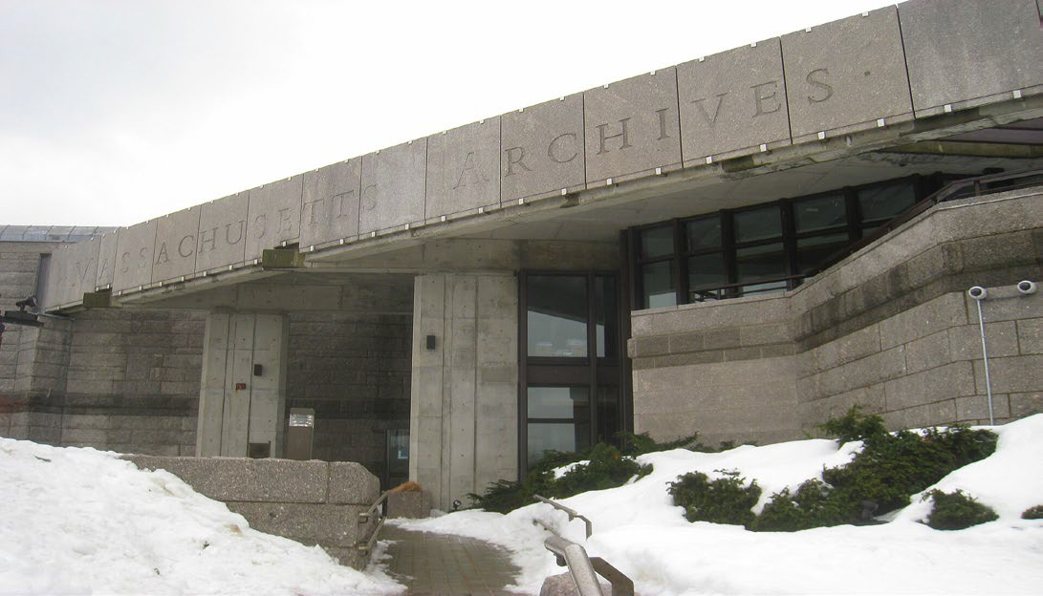

* Human Services Collection:
  + Lists the institutional records from DMH and DDS:
    - Medical Records (restricted)
    - Registration Information (restricted)
    - Business Records
    - Death Records
    - Cemetery/Burial Records
* Access to Human Services Collection:
  + Policy allows access to most records typically after a 75-year waiting period.
  + Timeline is not explicitly set in Massachusetts General Law and may vary depending on the type of record and any associated restrictions.



**Collections Held at the Massachusetts State Archives**

|  |  |
| --- | --- |
| Boston State Hospital:1856-1985 | Medfield State Hospital: 1896-1948 |
| Bridgewater State Hospital: 1887-1967 | Metropolitan State Hospital: 1930-1992 |
| Danvers State Hospital: 1878-1980 | Northampton State Hospital: 1858-1993 |
| Fernald State School: 1852-1969 | Tewksbury State: 1860-1896 |
| Grafton State Hospital:1877-1955 | Westborough State Hospital: 1886-1960, 1970-1977 |



# Questions/Feedback

## Record Collections Held by the Secretary of the Commonwealth



### Records Held by DMH and DDS

* Storage Locations and Conditions:
  + Active DDS and DMH facilities
  + Area and Central offices of each agency
  + Old buildings on institutional campuses still open
    - Storage conditions lack important safeguards (e.g., sprinkler and heating/ventilation systems).
  + Most records are in paper form, which makes them more likely to get damaged by things like humidity, light, and age.
  + Question of storage capacity at the MA Archives



### DDS and DMH Facility Storage Examples

* Medfield State Hospital: Records likely stored in unsafe buildings; can’t enter
  + SCSI has asked EOHHS when the buildings will be inspected
* Fernald State School: Records with PII found in old campus buildings in 2024
  + DDS has taken action to retrieve records found in unsecured buildings
* Wrentham Developmental Center: In 2024 someone trespassed and broke into a closed building and found old records from another state school stored there
  + DDS has taken extra security measures, but challenges remain.
* Paul A Dever State School (2014): Records from the 1960’s were found and left unsecured in an old campus building
  + Similar discoveries made at other closed state hospitals by urban explorers
* Foxborough State Hospital (2000): Patient records not stored at the State Archives, and some are Taunton State Hospital
  + Many records are presumed to be missing



# Questions/Feedback

## Records Held by DMH and DDS



#### Private Collections of Institutional Records

* Many old records are held by private libraries in different institutions like colleges and universities.
* Private collections have different record access rules:
  + National Security Risk: May contain information that could pose a risk.
  + Privacy Laws: May include sensitive personal or medical information.
  + Preservation Needs: Fragile, old records restricted to protect condition.
  + Donor Agreements: Restrictions may be set by donors, such as limited access or delayed availability.
* Some records may not be available because they are “unprocessed.”



**Countway Library at Harvard Medical School**

* 15 different collections of records related to state institutions:
  + Patient Information: Includes consent forms for experiments, test results, autopsy reports, case studies, and patient records, which some include personal identifiers (e.g., names), initials or numbers.
  + Research Findings: Detailed studies and records of clinical studies conducted in state hospitals.
  + Institutional Oversight: Records of hospital operations, including inspection reports and patient care documentation.
  + Trustee Reports: Includes Trustee meeting minutes, reports on the conditions of care, and significant events in the hospitals.
  + Surplus Records: Some records were considered surplus by the State and transferred to the Countway Library for preservation.



### Countway Access Rules and Restrictions

* Institutional Review Board (IRB) regulates access to patient records.
  + Researchers or individuals must get IRB approval to access sensitive data
  + In most collections, patient records **are closed for 80 years** from the date of creation to protect patient privacy.
    - Access granted earlier upon approval from the Institutional Review Board
  + Reports about hospital management may be restricted if they contain sensitive details about abuse or operational practices.
* The State Archives is aware of the private collections housed at Countway, and there is collaboration between these two institutions, especially regarding the handling of closed records.



#### Yakovlev-Haleem Collection (1926 – 1936)

* Dr. Yakovlev was a physician who worked at the Monson State Hospital for Epileptics, Metropolitan State Hospital, and Fernald.
  + Conducted studies on patient brains to learn about causes of disabilities
  + Collection has 900 + brains that were curated by Mohamad Haleem
* Collection is part of the Neuroanatomical Collections of the National Museum of Health and Medicine.
  + Not available to the public but can be viewed by qualified researchers by appointment
  + Parts of the collection were once held by the Eunice Kennedy Shriver Center; also transferred to National Museum of Health and Medicine.



### Belchertown State School Friends Association

* Housed at University of Massachusetts Amherst
* Records related to the Belchertown State School
  + Legal cases associated with the institution
    - Massachusetts v. Russell W. Daniels
    - Ricci v. Greenblatt (later Ricci v. Okin)
* Open for research without restrictions



### Samuel Bayard Woodward (1832 – 1846)

* Housed at University of Massachusetts Chan Medical School
* Dr. Samuel Bayard Woodward
  + First superintendent of the State Lunatic Hospital in Worcester
  + Co-founder of the Association of Medical Superintendents of American Institutions for the Insane
* Collection is digitized and includes writings by Woodward, such as essays, addresses, obituaries, letters, and verses.
* Open for research without restrictions



### Samuel Gridley Howe Library

* Housed at Brandeis University - Robert D. Farber University Archives
* Collection includes a diverse range of materials related to the Walter E. Fernald Developmental Center.
* The collection was transferred to Brandeis in 2010 after the closure of the Howe Library on the Fernald campus.
* The collection contains books, papers, case studies, pamphlets, and journals on topics like eugenics, mental disabilities, and disability studies.
* It includes materials from prominent figures in the disabilities field (Irving Kenneth Zola and Rosemary and Gunnar Dybwad)
* The collection is not yet processed, but once it is, materials containing patient information will likely have restricted access.



# Questions/Feedback

## Private Record Collections



**Personal Experiences**

**Attempts to Access Institutional Records**

* How the Information was Collected
  + Four key Informant Interviews conducted by CDDER with family members of former residents of state institutions who attempted to access their deceased family member’s records from state institutions.
  + Referenced books written by local authors who documented their experiences accessing records from state institutions when researching their family history



### Key Themes from Interviews

* Barriers to Accessing Records:
  + Legal barriers, such as the need for probate court orders or specific permissions, were significant obstacles in all cases.
* Problems with Record Keeping:
  + Records were poorly maintained or destroyed over time.
  + Records were transferred to other institutions.
  + Some key informants being unsure whether records even still existed.
  + Records were scattered, inaccessible or in danger of being destroyed.
* Desire to Understand Family History:
  + These searches are not just about obtaining information—Key informants describe a deep, emotional need to understand the lives of family members who were separated from them due to institutionalization.



### Advocacy for Change

* Key Informants called for more transparency and accountability in the records access process.
* Criticism of the system which they say as for prioritizing staff privacy over that of the former residents.
* Advocate for the creation of funds to help families navigate the probate process.
* Would like for public acknowledgment of the history of institutions like Fernald and apologies for the mishandling of records.



# Questions/Feedback

## Personal Experiences



### Areas for Additional Research

* Evolution of Governing Bodies of State Institutions (to present day)
* Changes to the Statewide Record Retention Requirements
* Records stored at DMH and DDS Facilities and Offices
* Summary of Records Destroyed
* Records from State Institutions available online
* Researcher Access to Records
* Harvard Legal Clinic Analysis
  + Comparative Standards from other States
    - Records Access
    - Death/Cemetery Records and HIPAA



# Framework for Remembrance

**Summary of Draft Report**



### Framework for Remembrance Major Topics

* Summary of Remembrance Projects
  + Belchertown State School Friends Association
  + Danvers State Memorial Committee
  + California Memorial Project
  + Willowbrook Mile
* Key Themes and Lessons Learned
* Areas for Additional Research



### The Belchertown State School Friends Association

* Focus on establishing a memorial and museum at the site of the former Belchertown State School.
* The memorial will provide a space to share the history of special education, institutionalization, and the broader story of disability rights.
* The group’s mission includes preserving the state school administration building and offering community space for education and reflection.
* In partnership with the Belchertown Historic Commission and the Belchertown Cultural Alliance, the Friends Association is working on projects such as an interpretive trail and museum.



### Danvers State Memorial Committee

* The Danvers State Memorial Committee was led by former patients and community advocates that focused on the restoration and proper memorialization of the neglected cemeteries at Danvers State Hospital.
* Understood the importance of land redevelopment and influenced plans for the property
  + Proceeds from its sale would be used to create adequate housing for individuals with mental health needs.
  + Responsibilities for the care and maintenance of the cemeteries were included in the sale of the land
* Efforts were rooted in a desire to honor the past while fostering a more inclusive future



### California Memorial Project

* The California Memorial Project was established and is run by peer advocates
* Dedicated to honoring individuals with mental health and developmental disabilities who lived and died in California state institutions.
* Over 45,000 people lived in California state institutions, many of whom were buried in unmarked graves without recognition.
* Established in 2002 through legislation (Senate Bill 1448)
  + Cemetery restoration projects
  + Annual Day of Remembrance across the state each year on the 3rd Monday in September
* Annual remembrance ceremonies include speeches, personal stories, and artistic contributions.
* Oral Histories are being recorded and posted on the project’s website



### The Willowbrook Mile Walking Trail

* Remembers the history of Willowbrook State School in Staten Island, NY
* The trail has 12 stops that tell the story of the school and the challenges the people who lived there faced
* It is designed to be accessible so that everyone, no matter their abilities, can learn about Willowbrook's history.
  + Pathways are wheelchair-friendly, with smooth surfaces, ramps, and benches
  + Information panels feature large print and braille, and guided audio tours
  + ASL interpreters available, and video presentations include captions.
  + Materials in Plain and other languages to accommodate non-English speakers
* The Mile is a powerful tool for education and advocacy-ensuring the history of the institution is remembered and promoting greater inclusion and justice for people with disabilities.



# Questions/Feedback

## Summary of Remembrance Projects



#### Key Themes

* Collaboration with Stakeholders: Former residents, families, advocates, government agencies, and community
  + Ensures a broad range of perspectives are included
  + Honors the diverse histories of the individuals involved
* Inclusivity and Accessibility: Design with accessibility in mind
  + Create spaces that are welcoming and engaging for individuals with a wide range of physical, sensory, and cognitive abilities.
* Focus on Education and Reflection: Provide educational opportunities
  + Museums, trails, and interpretive materials
  + History of institutionalization and the social justice issues surrounding disability rights
* Community Engagement and Advocacy: Remembering and honoring the past
  + Advocate for systems change and improved care for individuals with disabilities.



### Lessons Learned: Organizing

* Know Your Stakeholders: Involve a wide range of people from the beginning, including families, advocates, and officials. This makes sure the project reflects many viewpoints.
* Encourage Member Voices: Let people with lived experiences share their stories. Listening to former patients helps build trust and involvement.
* Create a Shared Vision: Work together to form a common goal. A united vision helps everyone feel invested in the project.
* Take Time to Plan: Plan carefully but be flexible. Big projects take time and need proper planning, like securing funding or handling unexpected problems.
* Safeguard Your Message: Stay true to the mission. Don’t let outside pressures distract you from the main goal.
* Be Ready for a Long Ride: Advocacy projects can take years. Stay patient and keep pushing for the change you want, even when it’s slow.



### Lessons Learned: Supporting People with Lived Experience

* Prepare Agendas: Organize meetings with clear agendas to stay on track. This helps members feel prepared and valued.
* Foster a Respectful Atmosphere: Create a space where everyone feels heard and respected, even if they have different opinions.
* Level the Playing Field: Encourage open communication by treating everyone equally. This helps people feel comfortable sharing their ideas.
* Recognize Diverse Leadership Styles: Not all leaders are the same. Some lead by listening or organizing, so appreciate all kinds of leadership.
* Cultivate Leadership Skills: Give members the chance to practice leadership, like public speaking, so they can feel confident.
* Engage the General Membership: Keep members involved by hosting regular events and encouraging them to share their thoughts and memories.
* Invite Participation in Public Forums: Encourage members to attend public meetings where they can share their views and help shape decisions.



### Areas for Additional Research

* MetFern Cemetery Restoration
* Westborough Cemetery Project
* DDS Cemetery Restoration and Annual Memorial Ceremonies



# Questions/Feedback

## Key Themes and Lessons Learned



### Next Steps

* Vote to Adjourn

