## Special Commission on State Institutions

**April 10, 2025 3:00PM – 5:00PM**

**Virtual / Zoom**

**Dr. Kate Benson Anne Fracht Co-chair Co-chair**



## Agenda

1. Welcome and Announcements
2. Recap of Last Meeting
3. Vote to Approve 3/13/25 Meeting Minutes
4. Upcoming Meetings of the SCSI
5. Proposed Recommendations
6. Next Steps
7. Vote to Adjourn



## Welcome and Announcements

* + Introductions:
    - Welcome Camille Karabaich, Mass Office on Disability
  + Recap of Last Meeting
  + Vote to approve 3/13/25 meeting minutes



## Upcoming Meetings

* + - Meeting scheduled for May 8
    - Additional meeting on May 15



## Framework for Remembrance- Disability History Museum

* + - The creation of a museum of disability history, innovation, and inclusion to preserve the history of residents of state institutions; document the history of the independent living movement, deinstitutionalization and the inclusion of people with disabilities; and
    - Serve as a hub of information to resources for former patients/families seeking their records.
    - To facilitate this process, we recommend the creation of a feasibility committee to deliver a report on options for potential physical and digital spaces



## Brainstorming Pros and Cons

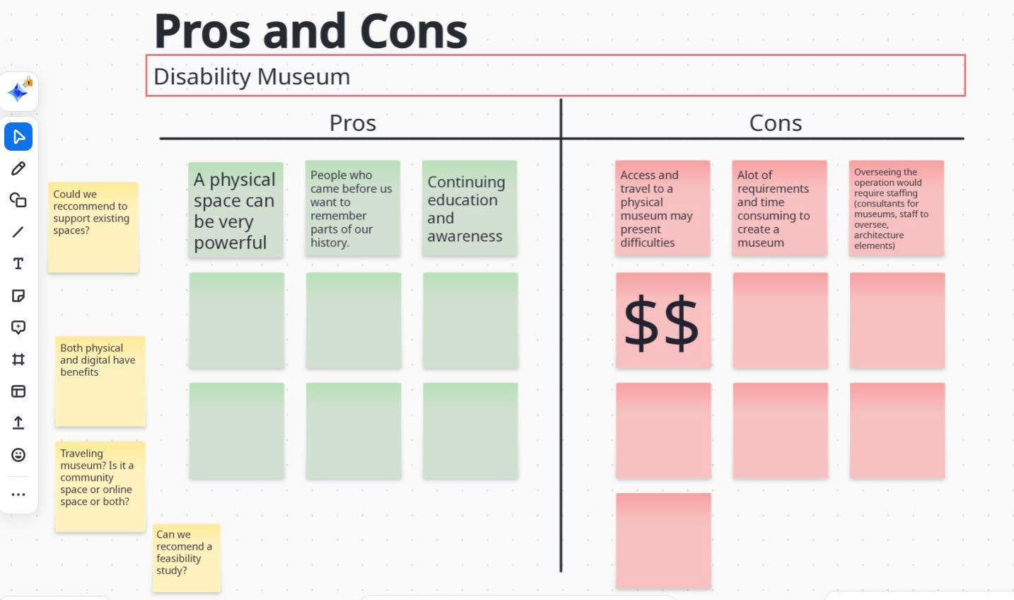

**Proposed Recommendations**

## Records and Records Access



**Recommendation Groupings**

* + - Recommendations for Changes to management, preservation, and access rules.
    - Recommendations for Changes to laws around record access.
    - Recommendations to Improve access for former patients/residents or their families and researchers.
    - Recommendations to Create a pathways for the return of institutional records to MA Archives.



## Changes to Management, Preservation and Access Rules

* + - **Recommendation 1:** Issue a Moratorium on Destruction of Records
      * Halt the destruction of institutional records scheduled for destruction until the proposed changes are implemented. This ensures that no historical records are lost while the necessary actions are put in place.
    - **Recommendation 2:** Identify Key Record Sub-Categories for Retention:
      * Establish categories of historical records to prioritize for retention. Not all records are significant, so defining important categories will help preserve the most valuable documents for future generations and scholars.
    - **Recommendation 3:** Revise Document Retention Schedules:
      * Update the state’s retention schedules to ensure that historically important records from institutions like DMH, DDS, and EOHHS are preserved when transferred to the Massachusetts Archives. The current schedules could lead to the destruction of important documents if unchanged.



## Changes to Management, Preservation and Access Rules

* + - **Reccomendaton 4:** Develop a Clear Workflow for Record Requests
      * Establish a clear, consistent process between DDS, DMH, and Archives for handling requests, including allowing Archives to confirm whether they hold specific individual records. This coordination will streamline access and ensure transparency in records management**.**
    - **Recommendation 5:** Delegate Redaction and Release Decisions to Archives
      * Empower Archives' staff, like the Head of Reference and Archivists, to determine when and how to release records, making necessary redactions in line with state law. This would reduce duplicative work and inconsistencies across agencies.
    - **Recommendation 6:** Expand Archives’ Staffing
      * Hire additional full-time staff, including a Reference Archives Assistant and a Processing Archivist, to handle the expected increase in record requests and ensure proper management of the collections.



# Discussion

**Changes to Management, Preservation and Access Rules**



# 5 Minute Break



## Changes to laws around record access

* + - **Recommendation 7:** Pass the Sunset Law (H.3335/S.2102)
      * This law would make institutional records over 75 years old public, with restrictions to protect personal information. This move is in line with actions taken in other states and would not affect medical documents protected under HIPAA.
    - **Recommendation 8:** Implement Use Restrictions for Public Records
      * The Massachusetts Archives should establish rules to prevent the unchecked digitization and distribution of documents containing personal information. Each request for dissemination should be reviewed individually to prevent misuse.
    - **Recommendation 9:** Modify Laws Regarding Restricted Medical Records
      * Change existing laws to allow researchers to access medical records within 50 years of an individual's death upon proving the person is deceased. This would eliminate the need for court orders, which can be costly and complex, and ensure records are made available with privacy protections in place.



# Discussion

**Changes to laws around record access**



## Improve Access to Records

* + - **Recommendation 10**: Post Clear Instructions for Records Access
      * Provide plain-language, easy-to-understand instructions for accessing records that are consistent across agencies. This removes barriers caused by complex or inaccessible language, making it easier for the public to access records.
    - **Recommendation 11:** Create a Searchable Public Inventory
      * Develop an accurate and searchable inventory of all institutional records. This will help the public easily find records they are looking for and avoid wasting time on documents that no longer exist.
    - **Recommendation 12:** Train Peer Guides for Individuals with Disabilities
      * Offer trained peer guides for people with disabilities who are reviewing their records. This support is crucial as navigating records can be confusing or emotionally difficult, and peer guides can provide essential assistance.



## Improve Access to Records

* + - **Recommendation 13:** Waive Probate Fees and Simplify Filing for Institutional Records
      * Eliminate probate fees and create clear, plain-language requirements for individuals seeking institutional records of deceased relatives. This will reduce financial and legal barriers, making it easier for descendants to access important records.
    - **Recommendation 14:** Clarify Access to Institutional Cemetery Burial Records
      * Issue guidance to ensure institutional cemetery burial records are treated like other vital records and made available to the public, with appropriate redactions for personal medical information. This is important for addressing long-standing restrictions on accessing burial records for people who died in institutions.



# Discussion

**Changes to Improve access**



## Create Pathways for the Return of Records

* + - **Recommendation 15:** Temporary Moratorium on Prosecution for Returning Documents
      * Implement a temporary moratorium on prosecuting individuals who return institutional documents they have found or kept. These documents might have been saved by staff who worked at a facility or found them in abandoned facilities. They should not face legal repercussions for preserving these records if they return them to the state.
    - **Recommendation 16:** Cease-and-Desist Order for Online Marketplaces
      * Issue a cease-and-desist order to online platforms selling institutional documents that were not intended for public sale. Pursue and act against sellers to recover these documents, as the sale of such materials, especially those related to specific individuals, has been documented and needs to stop.
    - **Recommendation 17:** Demand the Return of Documents from Private Entities
      * Private institutions, universities, non-profits, towns, and other groups that currently have institutional records should return them to the Massachusetts Archives. They should also provide a detailed list of the documents they hold. Over time, non-state organizations have collected these documents in various ways, making it harder for researchers, descendants, and survivors to access them. The documents need to be returned to the state to ensure they are stored and accessible properly.



# Discussion

**Create a pathways for the return of institutional records**



## Other Recommendations?

* + - What else should we consider?



## Next Steps

* + - Vote to Adjourn

