Operational Services Division Quick Guide
How to Find a Certified Minority and Women Owned Business Enterprise (M/WBE)
Overview of this Quick Guide
This quick guide will assist users to find a certified M/WBE in a few different locations from the OSD website. There may be times when doing business that you will need to find a certified M/WBE. These may include vendors for:

Incidental Purchases
By using a certified M/WBE with Incidental Purchases, the money spent will go towards your department’s Affirmative Market Programs annual benchmarks.

Small Procurements
Departments are encouraged to use a certified M/WBE when making purchases for small procurements. When executive agencies are doing a small procurement, if the request for response (RFR) is not being posted on Comm-PASS, departments must send the RFR to a minimum of three potential vendors, one of which must be a certified M/WBE, if available.

Where to Find a M/WBE
- Comm-PASS Business Directory
The Comm-PASS Business Directory lists vendors who are subscribed to Comm-PASS. When setting up a subscription, these vendors can build their own profile to market themselves to potential public purchasers and vendors. They will have to enter their company’s FEIN (Federal Employer Identification Number) which will be matched up against SOMWBA’s database. If there is a match, then this will be listed in the Comm-PASS Business Directory.
- AMP Website
- SOMWBA Website
Finding a certified M/WBE with the Comm-PASS Business Directory
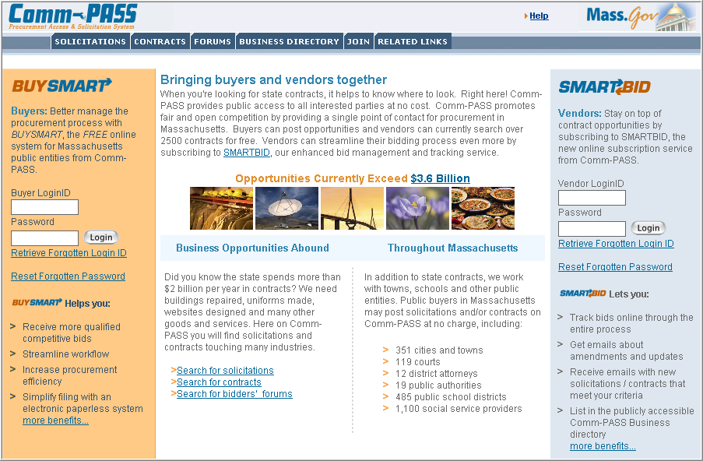
- Go to www.comm-pass.com.
- Select Business Directory from the tab at the top of the screen.
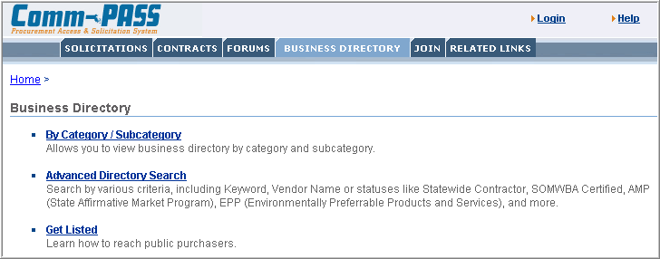
- Select Advanced Directory Search.
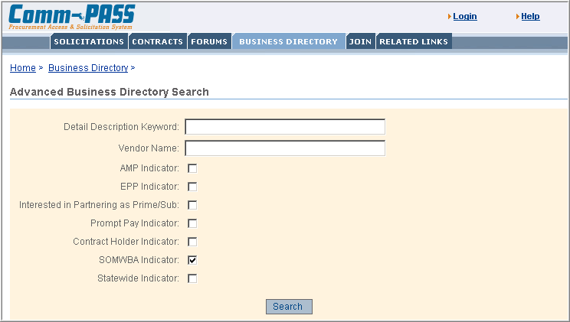
- Select SOMWBA Indicator.
- Select Search.
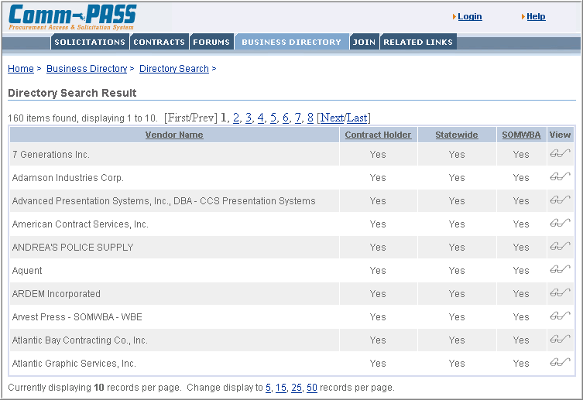
- The vendors will be listed in alphabetical order. At the top of the screen you will be able to move to another page by selecting a page number or the Next/Last hyperlink.
- To view a company’s information, select the View  icon.
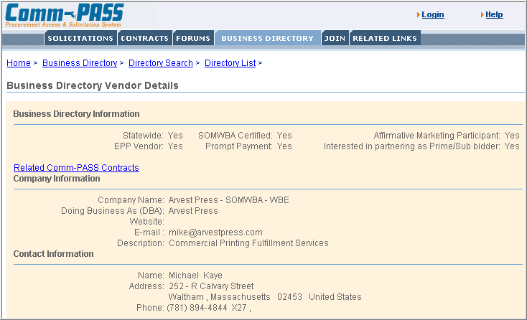
- From the vendor details page, you will see the programs they are associated with, what contracts the currently have posted on Comm-PASS, a description of the vendors work and their contact information.

How to find a certified M/WBE on the AMP Website
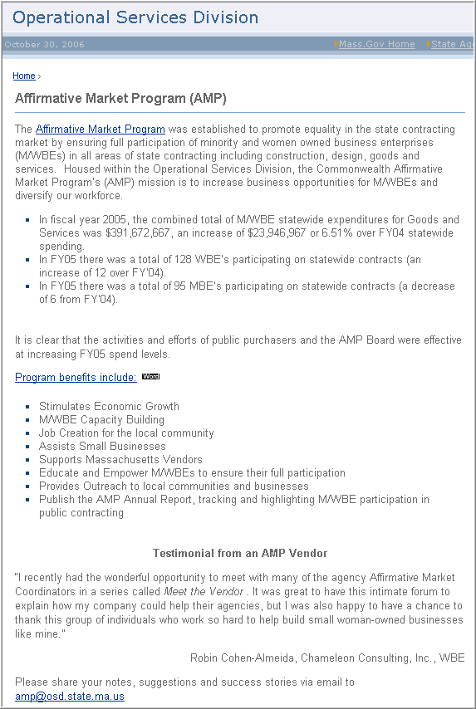
- Go to www.mass.gov/amp.
- Select the Affirmative Market Program link.
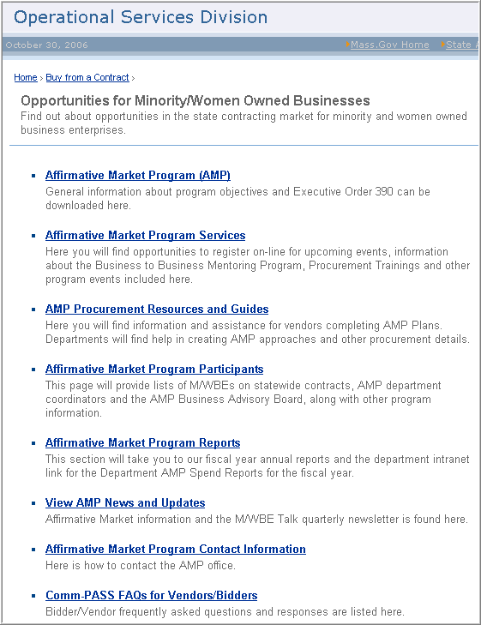
- Select the Affirmative Market Program Participants.
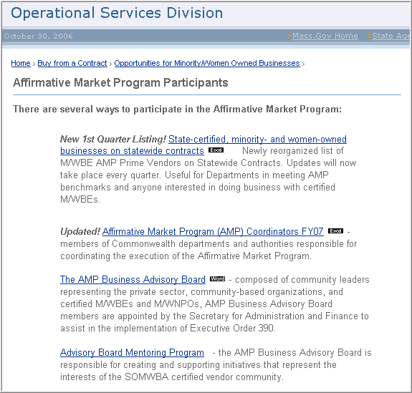
- Select State-certified, minority- and women-owned businesses on statewide contract. Here you will be able to sort the different vendors on Statewide Contract with the contract number, contract name, company name and phone number. From here you can now contact the vendor or go to www.comm-pass.com to see specific information on the contract and the vendor.

Using SOMWBA’s Website
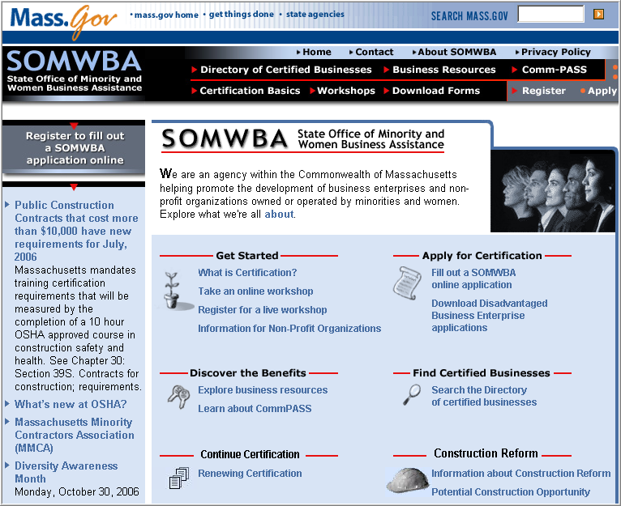
- Go to www.somwba.state.ma.us.
- Select Search the Directory of certified businesses.
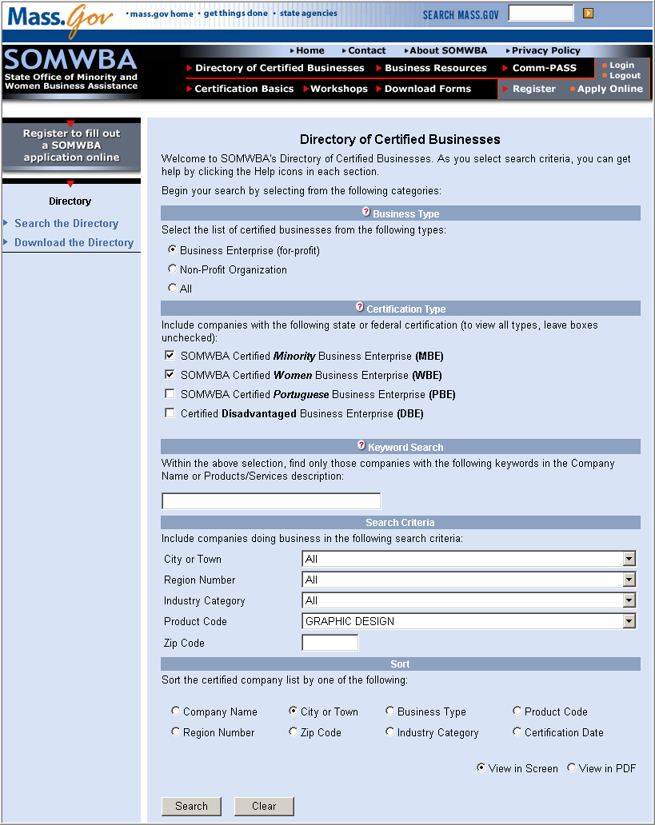
- Compete the search form with as much or little information that you have.
- Select Search.
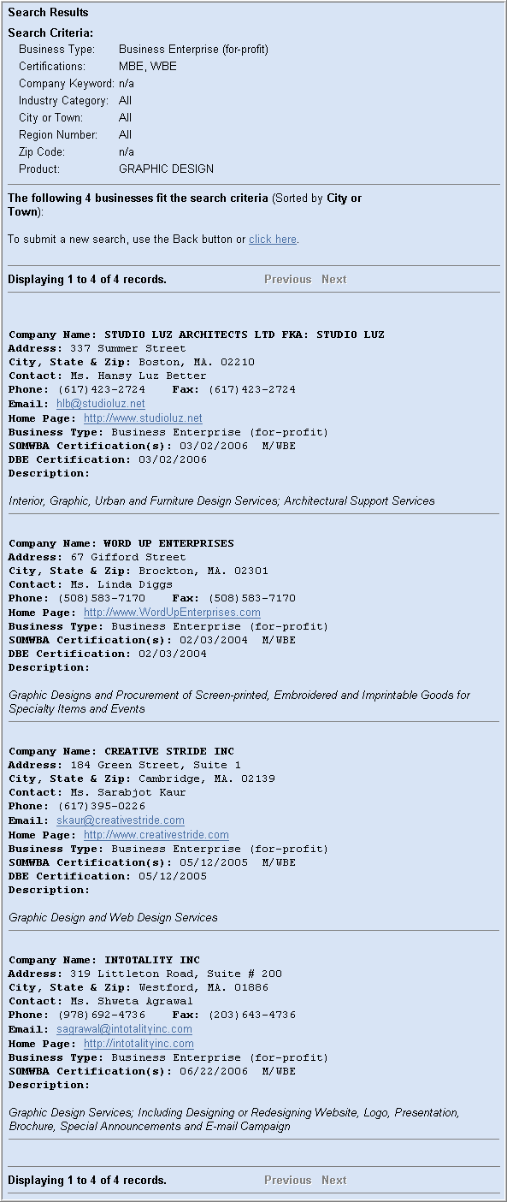
Your search results will be listed with the company’s information and website if available.

