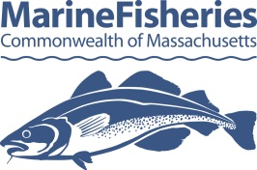

**Form DMF-SH1A**

**Declaration to Participate in Trimester 2**

**Atlantic Sea Herring Fishery in Area 1A**

**2017**

Participation in this fishery is contingent upon submitting this form. Forms must be submitted to MA DMF (c/o Cate O’Keefe) by mail 251 Causeway St, Suite 400, Boston, MA 02114, fax (617-626-1509) or e-mail (catherine.o’keefe@state.ma.us) by no later than noon on May 22, 2017 if you hold a Category A federal permit or 5PM on May 31, 2017 if you hold a Category B or C permit.

**Section 1. Permit Holder Information**

|  |  |
| --- | --- |
| **Permit Holder Name** |  |
| **Address** |  |
| **DMF Permit ID#** |  |
| **Federal Permit ID#** |  |
| **Permit Category (A, C or D)** |  |
| **Vessel Name** |  |
| **Vessel Documentation** |  |
| **Anticipated Gear** |  |

**Section 2. 2016 Fishery Participation (Optional)**

Did you participate in the 2016 Trimester 2 Atlantic Sea Herring Fishery in Management Area 1A. If so, what gear did you use?

|  |
| --- |
|  |
|  |
|  |

**Section 3. Certification**

|  |  |  |
| --- | --- | --- |
| **Permit Holder Signature** |  | **Date** |