**Form DMF-DLR1**

**Dealer Permit**

**Application Form**

**Page 1**

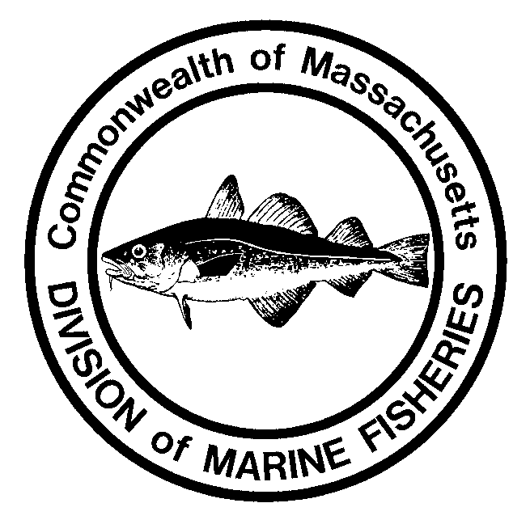[](http://env-fp-nb-002/wiki/images/3/3f/Dmflogo_rgb.png)

**Division of Marine Fisheries**

**251 Causeway Street, Suite 400**

**Boston, MA 02114**

**(617) 626-1520**

**www.mass.gov/marinefisheries**

|  |  |  |  |  |  |  |
| --- | --- | --- | --- | --- | --- | --- |
| **Please type or print business information clearly:** | | | | | | |
| **Business Name:** | | | | | | |
| **Owner:** | | | | **Contact Person:** | | |
| **Telephone Number:** | | | | **Email Address:** | | |
| **Residency Status:** MA Resident?  Yes  No | | | | **Dealer Permit # (if renewal):** | | |
| **Location Address** | | | | | | |
| **Street 1:** | |  | | | | |
| **Street 2:** | |  | | | | |
| **Zip code:** | |  | **City:** | | | **State:** |
| **Mailing Address (If different than above)** | | | | | | |
| **Street 1:** |  | | | | | |
| **Street 2:** |  | | | | | |
| **Zip code:** |  | | **City:** | | **State:** | |

#### DOR Affidavit

By statutory mandate of C. 233 of the Acts of 1983, the Dept. of Revenue is requiring the enclosed affidavit certifying your compliance with the Revenue Laws of the Commonwealth. Failure to accurately execute the enclosed affidavit will result in the non-issuance of your permit. Should you have any questions you may contact the Dept. of Revenue at 1-800-392-6089.

Pursuant to M.G.L. Ch. 62c, s. 49A, I certify under the penalties of perjury that I, to my best knowledge and belief, have filed all state tax returns and paid all state taxes required under law.

Social Security No. or Federal ID No. ________________________________________________

Signature of Individual or Corporate Name ___________________________________________

Corporate Officer (if applicable) by: _________________________________________________

|  |  |  |  |  |
| --- | --- | --- | --- | --- |
| **Permit Type** | **MA Resident** | **Non-Resident** | **Products** | **Activities** |
| Bait Dealer | $65 | $130 | Bait | Conch Processing |
| Retail Boat | $65 | $130 | Conch | Crab Processing |
| Retail Store | $65 | $130 | Finfish | Farmers Market |
| Retail Truck | $65 | $130 | Live Lobsters | Fish Processing |
| Wholesale Broker | $130 | $260 | Lobster/Crab Meat | Lobster Processing |
| Wholesale Dealer | $130 | $260 | Northern Shrimp | Scallop Shucking |
| Wholesale Truck | $130 | $260 | Scallop Meat | Shellfish Processing |
|  | | | Shellfish | Wet Storage |
| Other: _______________ |  |

**Dealer Permit and Endorsement(s) Selection**: Please select **only one** dealer category from the permit list below. Select only those endorsement(s) for which you have been approved. Each dealer permit type requires additional forms as explained in the permit descriptions. If you do not have all the forms or information you need to complete this application, contact the Boston office for assistance.

**Continued on next page >>**

**Form DMF-DLR1**

**Dealer Permit**

**Application Form**

**Page 2**

Use the following checklist to reduce the risk of making errors in completing this application, and a subsequent delay in processing. Please allow 10 business days for processing.

Complete all the requested information on both sides of this application, including the DOR affidavit.

Submit additional information as required (additional requirements explained in permit descriptions), including inspection report if applicable.

Complete and submit a copy of the Primary Buyer & Quota Managed Species Application Form.

Submit a check or money order made payable to the Commonwealth of Massachusetts.

Sign your application below, and return to the Division of Marine Fisheries at 251 Causeway St., Suite 400 Boston, MA, 02114. Thank you!

Sign your application below, and return to the Division of Marine Fisheries at the address listed above. Thank you!

Signature: ________________________________________________ Date: _____________________________





Print Name: _______________________________________________

|  |
| --- |
| **Retail Boat Permit Affidavit** |
| I hereby request that the Division of Marine Fisheries issue me a Retail Dealer's Permit for sale from my boat. I certify that my dealer activities will not involve the actual processing or reshipping of finfish or other marine resources, nor will there be any buildings, processing plants or other facilities involved requiring an inspection by any Department of Public Health, local, state or federal. All finfish will be sold as "whole" fish, lobsters and crabs will be sold alive. Only product taken under authority of my commercial fisherman permit may be sold.  Commercial Permit ID #:____________ Boat Name:_______________________________ MS/Doc #:_______________  Signature:_______________________________________________________ Date:_____________________________ |

|  |
| --- |
| **Wholesale Broker Permit Affidavit** |
| I hereby request that the Division of Marine Fisheries issue me a Wholesale Dealer's Permit for brokerage privileges. I certify that my brokerage activities will not involve the actual processing or reshipping of finfish, shellfish or other marine resources, nor will there be any buildings, processing plants or other facilities involved requiring an inspection by any Department of Public Health, local, state or federal.  Signature:_______________________________________________________ Date:_____________________________ |

I hereby certify under the pains and penalties of perjury that all information contained in this application is true and accurate, and that I have read and agree to comply with all applicable statutes contained in MGL c. 130, and the regulations contained in 322 CMR.

**Dealer Permit Descriptions and Additional Requirements**

**Form DMF-DLR1**

**Dealer Permit**

**Permit Descriptions**

**Bait Dealer Permit:**

* Allows the holder to take (in conjunction with a commercial fisherman permit) and sell marine bait.
* No inspection is required.
* Consult local regulations (i.e. on worms, eels, etc.).

**Retail Boat Seafood Dealer Permit**:

* Allows the holder to sell “whole” fish, lobsters and crabs lawfully harvested under the authority of their commercial fisherman’s permit from his/her boat (does not include shellfish).
* Allows the holder of any commercial lobster permit to transport live lobsters or live crabs, caught aboard the holder's permitted vessel, for sale to the public including to persons and businesses that are not retail or wholesale dealers of raw or processed fish or shellfish.
* A commercial fisherman’s permit is required in addition to this permit.
* A boat waiver **(*see application page 2)** must be filed in lieu of a health inspection.

**Retail Seafood Dealer Permit**:

* Allows the holder to sell raw fish, whether frozen or unfrozen, shellfish and lobsters at one retail location.
* The holder must purchase shellfish only from a holder of a wholesale dealer or wholesale truck permit, or from a certified out-of state wholesale dealer. Shellfish **CANNOT** be purchased directly from a harvester.
* Does not allow the holder to shuck, re-label or repack shellfish.
* An approved inspection from the Massachusetts Food Protection Program is required.
* A copy of the inspection report must be submitted with the application to the Division of Marine Fisheries.
* The name and address must be the same on the inspection report and permit.
* This permit may be endorsed for bait (excluding shellfish). The inspection must specifically state “**Approved for retail and bait permit”.**

**Retail Seafood Truck Dealer Permit**:

* Allows the holder to sell fish or lobsters at retail from a mobile unit (does not include shellfish).
* Does not allow the holder to process, fillet, shuck, cook, etc.
* An inspection is required from a town or county Board of Health.
* A copy of the inspection must be submitted with the application.
* The name and address must be the same on the inspection report and permit.
* A Hawkers and Peddlers permit may also be required. Contact the Division of Standards at (617) 727-3480 for further information.

**Wholesale Seafood Broker Permit**:

* Allows the holder to act as an agent who negotiates contracts of purchase and sale of seafood.
* The brokerage activities will not involve the actual handling, processing or reshipping of finfish, shellfish or other marine resources.
* A “broker only” waiver **(*see application page 2)** must be filed in lieu of a health inspection.

**Wholesale Seafood Dealer Permit**:

* Allows the holder to acquire, handle, store, distribute, process, fillet, ship or sell raw fish and/or shellfish, whether frozen or unfrozen, in bulk or for resale.
* Also allows retail sales from the same single, fixed location.
* An approved inspection from the Massachusetts Food Protection Program is required.
* A copy of the inspection report must be submitted with the application to Division of Marine Fisheries.
* The name and address must be the same on the inspection report and permit.
* This permit may be endorsed for bait (excluding shellfish), the inspection must specifically state, “**Approved for retail and bait permit”.**
* Requires a HACCP plan.

**Wholesale Seafood Truck Dealer Permit**:

* Allows the holder to acquire, handle, distribute, ship or sell raw fish, whether frozen or unfrozen, in bulk or for resale from a truck only.
* Does not allow the holder to process, re-label, repack, or store seafood, whether frozen or unfrozen.
* Does not allow the holder to purchase shellfish directly from harvesters or shuck, re-label or repack shellfish.
* An approved inspection from the Massachusetts Food Protection Program is required.
* A copy of the inspection report must be submitted with the application to the Division of Marine Fisheries.

[](http://env-fp-nb-002/wiki/images/3/3f/Dmflogo_rgb.png)

**Form DMF-DLR1**

**Dealer Permit**

**Instructions**

**Massachusetts Seafood Dealer Permit Application Instructions**

In accordance with M.G.L., c.130, s 80, all persons engaged in the wholesale or retail trade of raw fish, shellfish and lobsters, including marine bait, whether frozen or unfrozen, must obtain a Dealer Permit from the Division of Marine Fisheries.

**Application Instructions: Please complete each step in the correct order**

1. Request an application packet from the Division of Marine Fisheries or download from www.mass.gov/marinefisheries.
2. **Prior to submitting the dealer application to DMF:** Complete the “Inspection Request for Wholesale/Retail Seafood Operations” ( if applicable to the permit type you are applying for) and submit the request by either mail or fax to the Food Protection Program, 305 South Street, Jamaica Plain, MA 02130. Fax (617) 983-6770. Their telephone # is (617) 983-6712. Once the inspection is performed and you have a copy of the inspection report, include a copy of the report in your application packet.
3. Complete the dealer permit application (Form DMF-DLR1).
4. Type of Permit: Refer to permit type descriptions and check the appropriate box on the application.
5. Dealer Permit #: If permit is new, Division of Marine Fisheries will issue a number: If permit is a renewal, write in previous permit number.
6. Check products you seek to sell and activities that you want to be covered by this permit. (Not all products/activities will be approved)

* Live or frozen bait cannot be stored with other products unless the inspection states “Approved for food and bait storage”.

* You may only be endorsed for the products/activities that you were inspected for.

**NOTE:** Wet storage is the process of storing shellfish (not lobsters) in seawater. All off-shore wet storage facilities must be approved by the Division of Marine Fisheries and all on-shore facilities must be approved by the Food Protection Program [(617) 983-6712], prior to receiving authorization.

1. Complete the Primary Buyer & Quota Managed Species Application Form.
2. Submitoriginal permit application, the fee, the Primary Buyer & Quota Managed Species application form, and the inspection report to the Division of Marine Fisheries.

### We will not issue a Dealer’s Permit without the following:

* Completed dealer application (both pages)
* Completed Primary Buyer & Quota Managed Species application form
* Copy of health inspection report or boat/broker waiver form (if applicable)
* Check or money order made payable to Commonwealth of Massachusetts

**A new inspection is required if there is a change of ownership, address, permit type, or the addition of products or activities.**

|  |  |  |
| --- | --- | --- |
| **Permit Type** | **MA Resident** | **Non-Resident** |
| Bait Dealer | $65 | $130 |
| Retail Boat | $65 | $130 |
| Retail Store | $65 | $130 |
| Retail Truck | $65 | $130 |
| Wholesale Broker | $130 | $260 |
| Wholesale Dealer | $130 | $260 |
| Wholesale Truck | $130 | $260 |

**Fee Schedule**