

DCAMM’s Online
Directory
Of Certified Contractors
4/17/2020
Contractor Certification
DIVISION OF CAPITAL ASSET MANAGEMENT AND MAINTENANCE

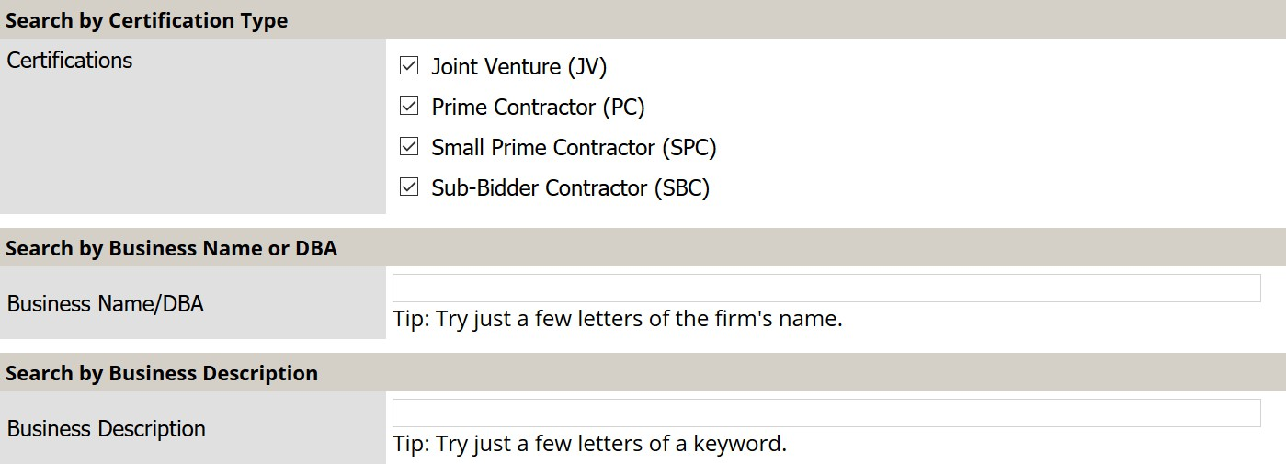
When utilizing our new online directory you can search by any variable available.
You can search by Certification Type
Just check the box
You can search by company name
Or
Business Description
If you are looking for a specific category of work, you can list is in the Business Description box

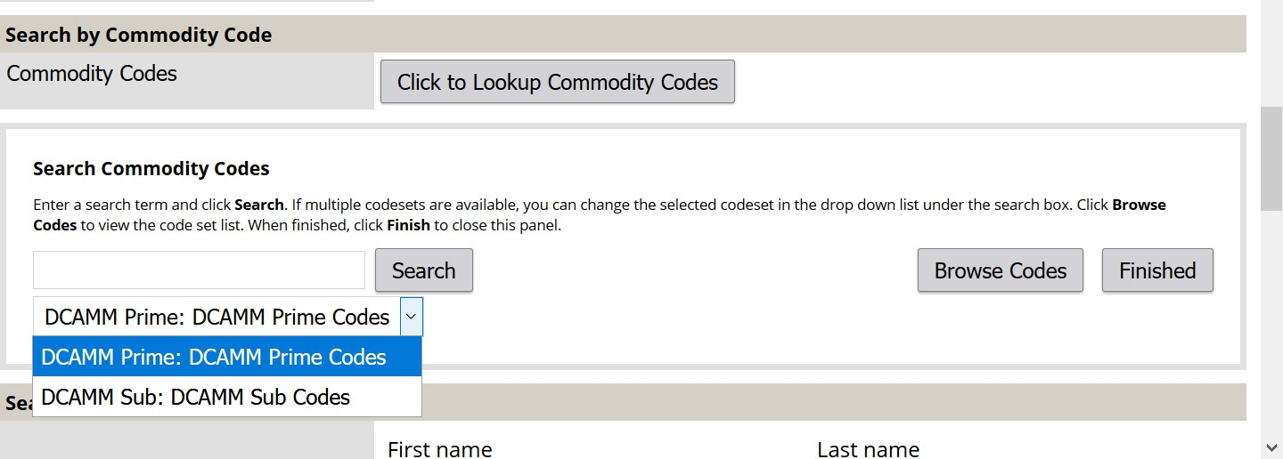
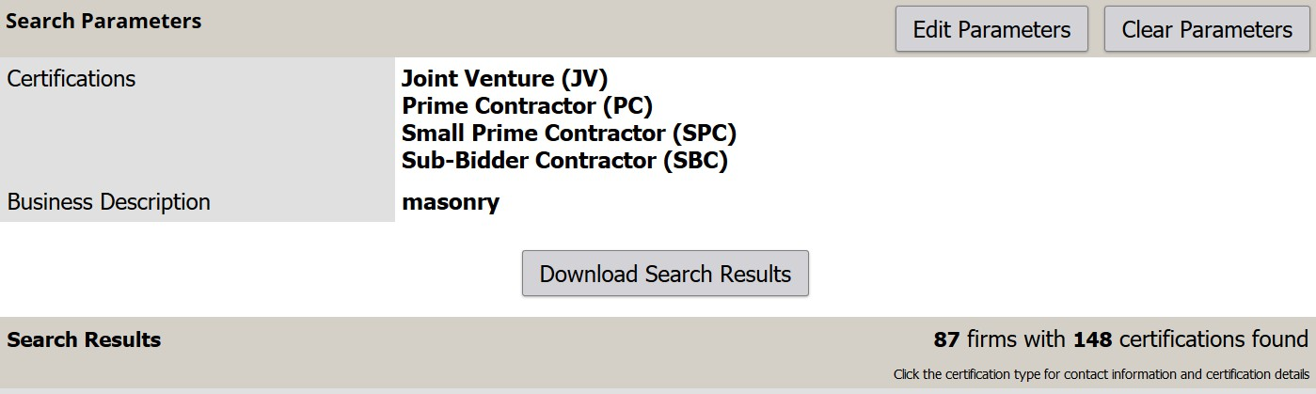
You can search by the category of work.
Select either Prime or Sub codes then
Press Browse Codes to select the
categories of interest

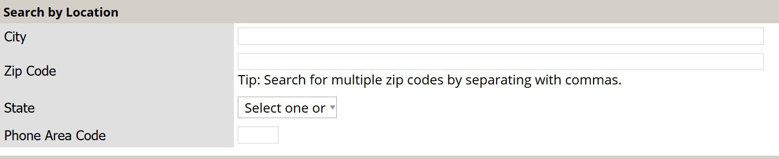
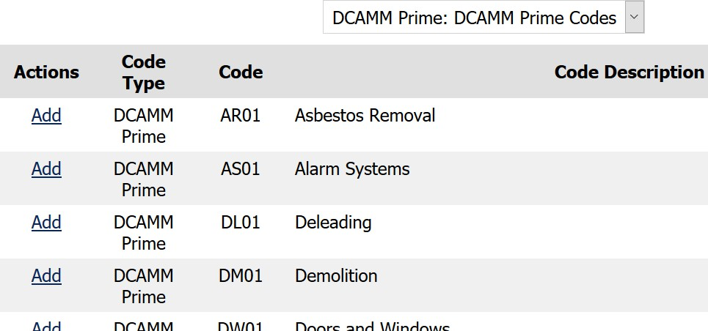
Find the Category of work you are looking for
Under Actions click Add
This will add the category to your search criteria
You can search by location: City, State, zip code or phone area code
(In this example we will search for companies in Springfield)

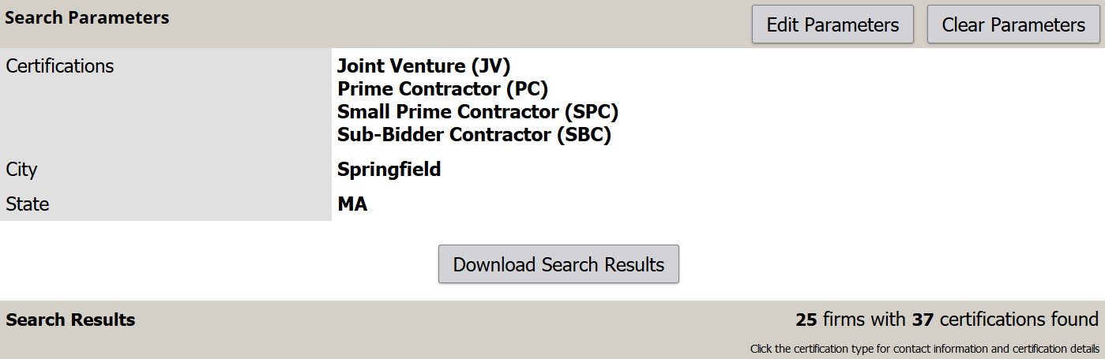
Search results for businesses in Springfield
The 25 companies resulting in this search will appear here

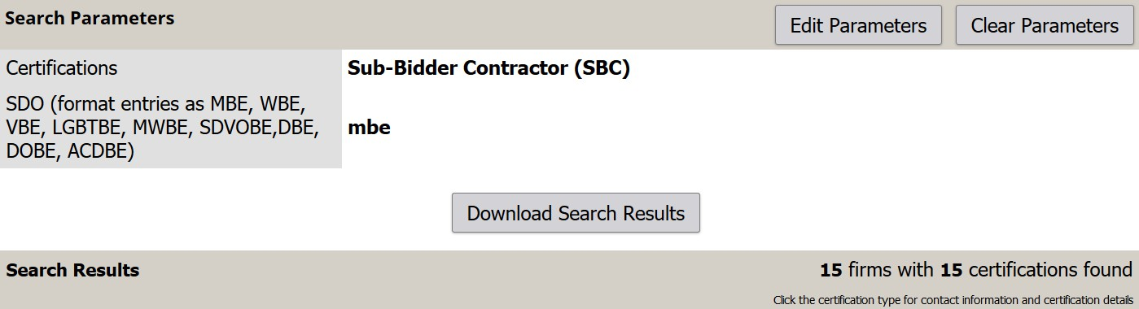
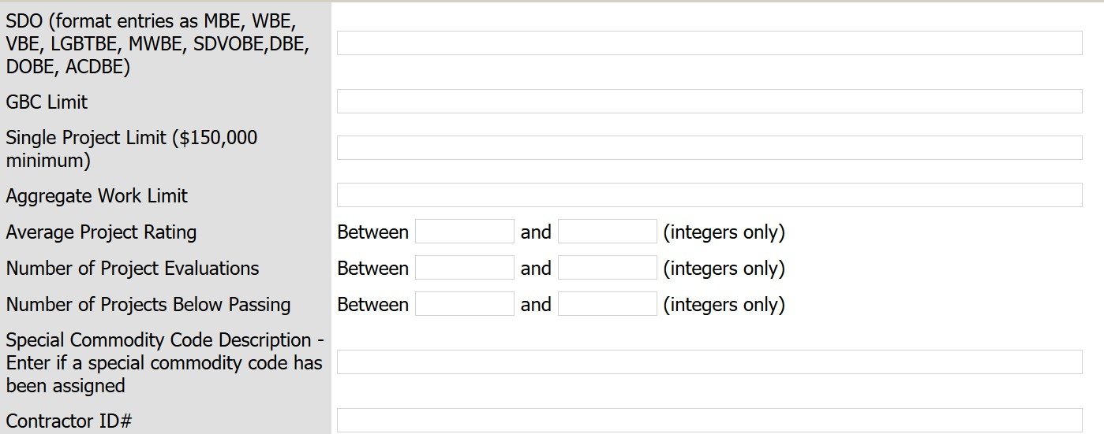
Example of search for a company with the MBE designation
15 Certified companies were found that met our criteria

You can search using any of these fields

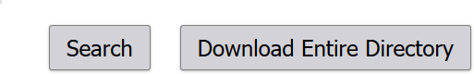
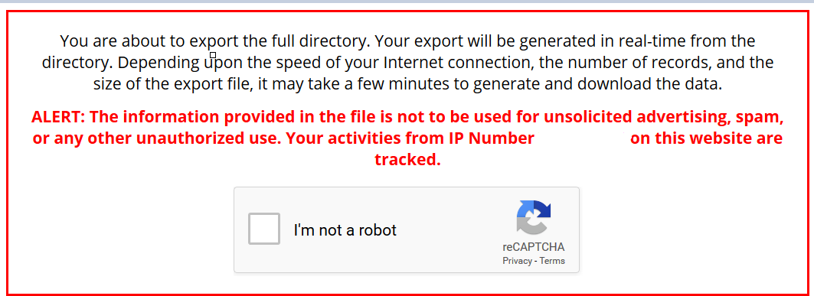
If you download the entire directory, keep in mind, it is just a snapshot in time and will not be updated as other certifications continue to be processed.

You will have to state that you are not a robot and enter a given code exactly as it appears then you will be able to download an Excel format or a CSV format.

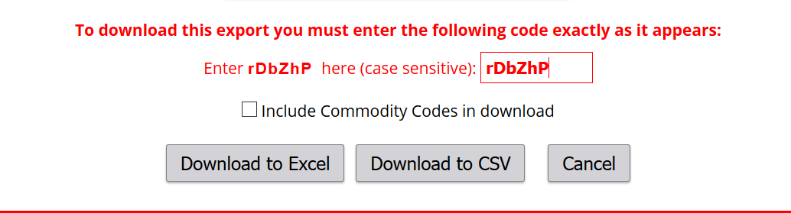
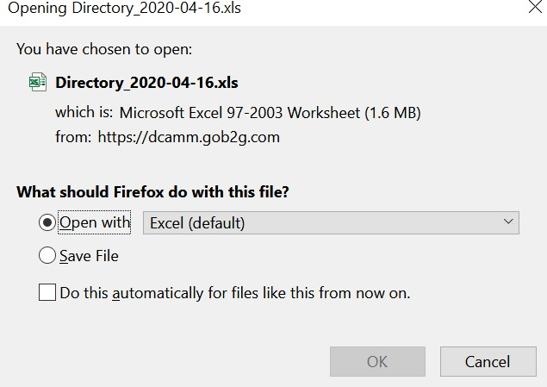
This is useful
because the business’ category of work will be included
√
Once you have opened the excel spreadsheet you will be able to sort and filter the information as you would any excel document

