

# Commonwealth of Massachusetts

## Interagency Task Force on Newborns with Neonatal

Abstinence Syndrome

### Second Task Force Meeting Presentation

**December 19, 2016**

1

* **2017 Policy Academy Update**
* **Advisory Council Recommendation**
* **Inventory of Existing NAS/SEN Services, Programs, & Initiatives**
* **Three Pillars of Data Review**
  1. **Picture of NAS/SEN: What does it tell us?**
  2. **Data Mechanics: What is currently collected?**
  3. **What could a Statewide Plan on data look like?**
* **Health Policy Commission Investments in NAS (separate**

**PPT)**

* **Action Items & Next Steps**



By participating in the Policy Academy, teams will benefit from:

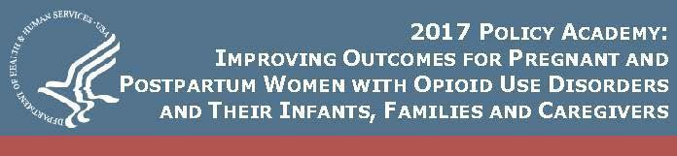

* Presentations by national experts.
* Dialogue with and coaching from sites that have previously received Technical Assistance.
* Hearing about the strategies employed by the Mentor Sites, the barriers they faced, and how they resolved them.
* Dedicated team time to develop an action plan, governance structure and goals.
* Access to a package of technical assistance tools and resources that teams can use in the planning and implementation process.
* Up to six months of follow-up technical assistance from the NCSACW to meet each team’s needs.

**State teams will:**

* Develop a state-specific action plan that describes

current practices, gaps and barriers.

* Identify potential changes in practices, policies and legislation needed to improve outcomes. Build upon collaborative structure and processes.
* Use the Five-Point Framework (Pre-Pregnancy, Prenatal, Birth, Neonatal, Postnatal (throughout Childhood and Adolescence)) for developing action plans.
* Receive up to six months of follow-up technical assistance towards implementing the state-specific action plan (through August).

**Policy Academy Timeline January 10:** Policy Academy webinar **February 7-8:** Policy Academy **March-August:** Technical assistance

**Massachusetts Policy Academy**

**Team Roster**

* Co-leader: **Kim Bishop-Stevens**, DCF
* Co-leader: **Karen Pressman**, DPH
* **Ron Benham**, DPH
* **Judge Gail Garinger**, AG’s Office
* **Katherine Record**, HPC
* **Kelley Saia**, Boston Medical Center
* **Kevin Wicker**, OBH
* **Michael Kelleher**, EOHHS

5



**Advisory Council**

**Recommendation**

**Recruitment Process**

* + RFR posted on 11/15/16
  + Original deadline of 11/28/16 was extended to 12/02/16

**Evaluation and Recommendations Process**

* + The Evaluation Committee, composed of Judge Gail Garinger, Abigail Taylor, Michael Kelleher and Vivian Pham, reviewed all applications on 12/05/16.
  + The Evaluation Committee is recommending **all 41 applicants** for Advisory Council membership to the Task Force.

**Geographic Region\***

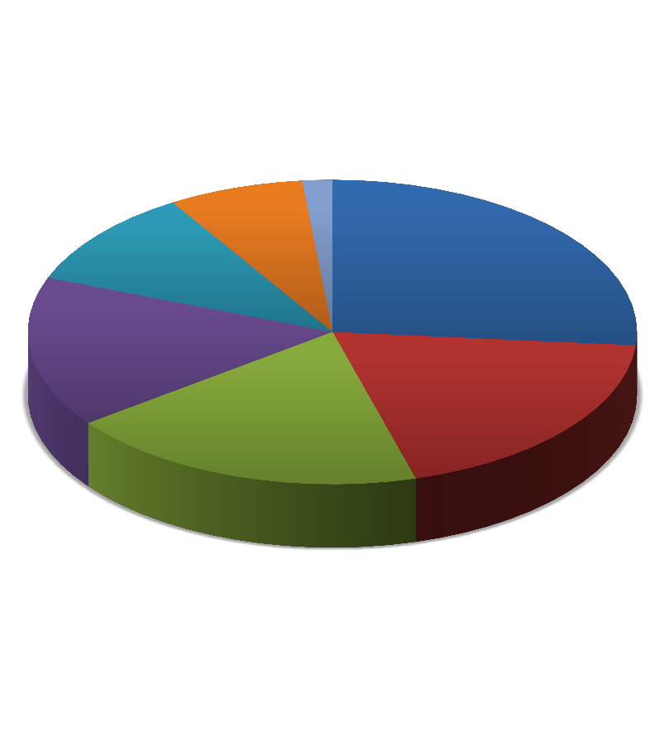

**Area of Expertise\***

**Western**

**(Berkshire), 8**

**Pioneer Valley (Franklin, Hampshire, and Hampden), 15**

**Central (Worcester), 11**

**Cape and Islands (Barnstable, Dukes, Nantucket), 10**

**Northeastern (Essex and Middlesex), 13**

**9 2**

**13**

**Boston area 20**

**(Norfolk and**

**Suffolk), 22**

**24**

**Southeastern (Bristol and Plymouth), 12**

**“Best Practices” in prevention, screening and treatment**

**Screening and intervention protocols**

**33**

**Referral and support services**

**Provider training and staff**

**24 development**

**Data collection and reporting**

**Quality and outcome reporting**

*Applicants listed multiple geographic regions and areas of expertise

**Alternative payment models/Provider**

|  |  |
| --- | --- |
| **Intervention Stage Focus\*** | **#** |
| **Neonatal** | **11** |
| **Throughout Childhood and Adolescence (Postnatal)** | **11** |
| **Pre-pregnancy (Prevention/ education)** | **8** |
| **Birth (inpatient)** | **6** |
| **Prenatal** | **5** |

|  |  |
| --- | --- |
| **Perspective\*** | **#** |
| **NICU provider** | **10** |
| **Public health advocate or expert** | **9** |
| **OBGYN / other maternal health provider** | **8** |
| **Pediatrician/ other pediatric provider** | **8** |
| **Child welfare advocate or expert** | **7** |
| **Social services provider for parents/caregivers** | **6** |
| **Substance use disorder treatment provider** | **5** |
| **Consumer advocacy organizations** | **5** |
| **Social services provider for children** | **3** |
| **Consumers directly impacted by NAS/SEN** | **3** |
| **Administrator of acute hospital w/ birthing/NICU** | **1** |
| **Legal system** | **1** |

*Applicants indicated more than one perspective and intervention stage focus

|  |  |  |  |  |
| --- | --- | --- | --- | --- |
| **First Name** | **Last Name** |  | **Organization** | **Title** |
| **Nichole** | **Aguiar** | March of Dimes | | Director of Advocacy & Government Affairs |
| **Marilyn** | **Augustyn** | Boston Medical Center | | Division Director, Developmental and Behavioral Practices |
| **Debra** | **Bercuvitz** | DPH, BFHN | | Perinatal Substance Use Coordinator |
| **Marjorie** | **Bloom** | Baystate Medical Center | | Medical Social Worker, Labor and Delivery |
| **Annery** | **Brown** | Baystate Medical Center | | Medical Social Worker |
| **Kathleen** | **Charette** | Hudson Public Schools | | Central Regional School Nurse Consultant |
| **Jennifer** | **Childs-Roshak** | Planned Parenthood League of Mass. | | President & CEO |
| **Sharyl** | **Costa** | DCF |  | Social Worker |
| **Mara G.** | **Coyle** | Women & Infants Hospital | | Neonatologist; Professor of Pediatrics |
| **Jonathan M.** | **Davis** | The Floating Hospital for Children at Tufts Medical Center | | Vice-Chair of Pediatrics and Chief od Newborn Medicine |

|  |  |  |  |  |
| --- | --- | --- | --- | --- |
| **First Name** | **Last Name** |  | **Organization** | **Title** |
| **Susan** | **Elsen** | MA Law Reform Institute | | Child Welfare Advocate, lawyer |
| **Norma** | **Finkelstein** | Institute for Health and  Recovery | | Executive Director |
| **Maryanne** | **Frangules** | Mass. Organization for  Addiction Recovery | | Executive Director |
| **Mark** | **Friedman** | Community Catalyst | | Volunteer; retired pediatrician |
| **Munish** | **Gupta** | Beth Israel Deaconess Medical Center; Neonatal Quality Improvement Collaborative | | Neonatologist |
| **Cynthia** | **Horgan** | Cape Cod Children's Place | | Executive Director/Family Support Coordinator |
| **Ronald E.** | **Iverson** | Boston Medical Center | | Physician |
| **Linda** | **Jablonski** | Baystate Franklin Medical  Center | | Assistant Nurse Manager of the Birthplace; Co-Chair  of the Frankling County Perinatal Support Coalition |
| **Leslie S.** | **Kerzner** | Mass. General Hospital | | Associate Medical Director Special Care Nursery; Director of Newborn Developmental Follow-up Program, Director of NAS Program and Task Force |
| **Georganna** | **Koppermann** | AdCare |  | Vice President, Community Services & Marketing |

|  |  |  |  |  |  |
| --- | --- | --- | --- | --- | --- |
| **First Name** |  | **Last Name** |  | **Organization** | **Title** |
| **Claudette** | **Laffan** | | Steward Morton Hospital | | RNC |
| **Jennifer** | **Lee** |  | Beverly/ Boston Children's  Hospital | | Neonatologist |
| **Erin** | **MacIntosh** | | Beth Israel Deaconess Medical  Center | | Pediatric Occupational Therapist, Newborn  Intensive Care/Newborn Nurseries |
| **Mary** | **McGeown** | | MSPCC |  | Executive Director |
| **Amy** | **Miner-Fletcher** | | South Bay Community Services | | Division Director, Early Childhood |
| **Kristy** | **Pereira** | | Umass Amherst, College of Nursing | | Clinical Assistant Professor |
| **Joanne** | **Peterson** | | Learn to Cope, Inc. | | Executive Director |
| **Fabiola** | **Powell** | | South Middlesex Opportunity Council | | Clinical Coordinator for Pregnant and Postpartum Women/Behavioral Health Provider |
| **Karen** | **Pressman** | | DPH, BSAS | | Director, Planning and Development |
| **Julian N.** | **Robinson** | | Brigham & Women's Hospital | | Chief of Obstetrics |

|  |  |  |  |  |
| --- | --- | --- | --- | --- |
| **First Name** | **Last Name** |  | **Organization** | **Title** |
| **Christina** | **Russell** | Cape Cod Children's Place | | Family Support Specialist |
| **Davida** | **Schiff** | Boston Medical Center | | Pediatrician |
| **Nicole** | **Sczekan** | Lahey Beverly Hospital, Essex County OB/GYN Association | | Certified Nurse Midwife; co-director of Maternal Bheavioral Health Integrative Program |
| **Robert** | **Sege** | Health Resources in Action | | Chief Medical Officer |
| **Jeffrey S.** | **Shenberger** | Baystate Children's Hospital | | Chief of Newborn Medicine; Professor of Pediatrics |
| **Rachana** | **Singh** | Baystate Children's Hospital | | Medical Director, NICU |
| **Shannon** | **Snyder** | DCF |  | Supervisor |
| **Julie** | **Stanitis Thompson** | Baystate Franklin Medical Center, Pioneer Women's Health | | OB/GYN, Chair of Obstetrics |
| **Deborah** | **Sweet** | DCF |  | Foster Parent; Foster Parent Ambassador |
| **Marianne** | **Valle** | St. Luke's Hospital | | RN (Maternal child health nurse) |
| **Elisha** | **Wachman** | Boston Medical Center | | Assistant Professor of Pediatrics; Neonatologist |

**distributed into Topic Subgroups**

* Distribute the 41 selected Advisory Council members into subgroups based on self-selected area of expertise (as indicated on their application) as well as geographic representation and/or perspective.
* Staff will ensure subgroups are topic-aligned and representative of the entire state and multiple perspectives. Assign a “lead” to coordinate each sub-group and their interactions outside of TF meetings
* These subgroups listed below will support *Assignment #2*
  + 1. “Best Practices”
    2. **Screening and intervention protocols**
    3. **Referral and support services**
    4. **Provider training and staff development**
    5. **Data collection and reporting**
    6. **Quality and outcome measurement**

**Advisory Council: Next Steps**



* Email notification of selection to the Advisory Council
  + Reminder of responsibilities
  + Required meeting dates
  + Opportunity to opt-out should they no longer be able to commit
* Send survey of inventory of existing NAS/SEN Services, Programs

& Initiatives to all Advisory Council members (*Assignment #1*)

* Once finalized, will provide full roster, contact information and subgroup assignment to all Advisory Council members

15



**Inventory of Existing NAS/SEN Services,**

**Programs & Initiatives**

**Development of Inventory**



**Feedback from the first Task Force meeting**

* + Added geographic region, capacity, and gaps in service/programs

**Inventory Refinement**

* Distributed the draft inventory form for review by (AG’s office, Task Force members, other subject matter experts, as needed)
* Added more detail to capacity, types of interventions, target population, and funding source
* Ensured the survey terms and examples were aligned with federal recommendations (SAMHSA/CSAT)

**Assignment #1: Distribution of Inventory to Advisory Council**

1. **Online Survey & Example**



* + For ease of distribution and data collection, an online survey was created on SurveyMonkey
  + A PDF example was created to demonstrate the level of detail we

are looking to capture from those who complete the survey

* + Parts of the survey are closed ended questions while other areas are open-ended to allow for more detailed content to be submitted

1. **Distribution**
   * Survey link and example PDF were distributed on **12/09** in an email to the Advisory Council
   * Survey closes on **12/30**
   * Results will be reviewed at next Task Force meeting
2. **Contact Information**
3. **Organization; Name of Service/Program/Initiative**
4. **Organization/Program Description as It Relates to NAS/SEN**
5. **Geographic Region(s) Served**
   * **Northeastern; Boston area; Southeastern; Cape and Islands; Central; Pioneer Valley; Western**
6. **Intervention Stage**
   * **Pre-pregnancy; Prenatal; Birth; Neonatal; Postnatal (Throughout Childhood and Adolescence)**
7. **Type of Intervention**
   * **Prevention/Education/Outreach; Screening/Testing/Assessment; Treatment;**

**Social Services, Training, Data Collection; Quality Improvement**

1. **Target population**
   * **Women of childbearing age; pregnant women (with SUD/OUD); mothers; at-**

**risk parents; other caretakers; newborns/infants; older children; providers**

1. **Capacity**
2. **Funding Source and Duration**
   * **State appropriation; grant (federal or state); private; payer reimbursement**
3. **Gaps in Services and Programs**

NAS & SEN Services, Programs and Initiatives Inventory 6. Type of Intervention (please provide a description for all tha·t a.ppfy)

In order to havea full inventory and identify gapsin available services and programs,the Task Force is collectinc: information on the services, programs and initiatives available inthe Commonwealth to serve newborns with neonaal abstinence syndrome and substance exposed newbornsalon'with their mothers and caregrvers.

X Prevention/Education/Outreach

*If applicable,please describe in detail. For example: educational materials and programming,media*

*campaigns*

L Cont rt Information

Name of personcompleting survey:Jane Smi'th Na me of contact person (if different than above): Email: [Janesmtth@gma il.com](mailto:Janesmtth@gmail.com)

Phone:617-123-4567

Relationship to organization:Neonate ogist

The NAS program at Jane Smith Hospitiill proVIdes health education to teens and at-r sk parents,with

.specific matenals and sesstons on the nsks of substance use.

X Saeeninc/Testinc/Assessment

*If applicable,pl eas€ specify rhe type of screeninqf testingf asussment provid ed and UJdiane the instrument/tool that is used. For eKample prenatal self -report,. interviews,. or clinical observations screenings;name of scoring systems; rype of assessment todetermine need and match to seMces*

2.. Organization (and if applicable, name of servic;ef pr·ocram/initiative)

Jane Smith Hos ita!·The NAS Progr<1m

3.Organization/Procram Oe.suiption as It Relates to NAS/SEN

Jane Smith HospiUI provides are for mbnts. and families affected by NAS/SEN through multl-disophnary teams that provide clinial servicesfrom delivery to disch arge.Jane Smtt h Hospita l a.so has the NAS Procr m. which prOVIdes heath educauon f01 teens and at-risk parents.

1. Geogrophic Region Served (please select a ll that apply).

: Northeastern (Essex and Middlesex)

* + Boston area (Norfolk and Suffolk)

X Southeastern (Bristol and Plymouth)

X cape and Islands (Barnstable,Dulces,and Na ntucket)

* + Central {Worcester)

: Pioneer Valley (Franklin, Hampshire,and Hampd en)

- *Western* (Bertshire)

Jane Smnh Hosp1tal uses the Modified Finnegan s NAS s.connc; tool to assess the signs and sevemy of symptoms in mfants

X Treatment

*If applicable,pl ease describe the type of treatment and core provid ed,length of treatment,howpo tient costs are covered,and other relevant informatk>n.For example:pharm acological,. non-pharmacolo gical, inpocient,outpatient,services availobli! in languages other than English,ASAM {American Society of Addiction Medidne) level of core,etc.*

Jane Smrth Hospital provides pharmacologica and non-pharm aco ogical inpatJent care.Current y we are

Increasing our focus on non·pharmacologJC care (roormng·in,breastfeedinc., etc.).

For patients and famihes who ha ve limited E.nglish or a re of deaf and health of hearin,,we provide

edkal inte-rpreter serv ces in :French,Spanish, Hanian Creole,ChinMe, and Russ1an .

:Social Services

*If applicable,please describe what social services are ptovKJ ed and if app Ucoble, what the eligibility criteria is.for example: early intervention,home visiting,housing,childcore,income assistance,etc.*

Pleii.Se indic:at.e Whether the entire region(s) selec:ted is served, or whether you oper;ate within a smaller

,eog phiQI area within the region4

Jane Smith Hospital serves the entJre Sout heastern regions.I n *the* Cape and Islands region our services on extend to Barnstable County

1. lnteJVention Stage (please select all that apply)

X Pre-pregnancy

X Prenatal

X Birth

X Neonatal

* + Postnatal (Through out Childhood and Adolescence)

:Traininc

*If applicable,pleau describe:who receive3f provide3 rhe training, afrraining,length of training,and other relevant information*

: Data wllection

*If app licable,pleau describe in more derail collection methodology and data type.fo r example: The*

*f ederal Treatment Episode Data Set (TEDS) track trends on the percen tage of women who are p regnonr at treatment admission, drug of choice,. number of substances used,prio r treatment admissions,primary source of refe"a l,. etc.*

: Qua lity I mprovement

*If appficable,please describe what measures ore inplace for monitoring and improving quality of core. For emmpte:The Health Policy Commission's •delivery to disdtarge •Ql initiative addresses scoring reliability,pharmaco logic and non--pharmacologic intervention protocols,muttidisdplinary rounds,NJCU transition pro tocols,stoff training and fo llow-up core coordination pro tocols.*

10. Gaps in Services and Procnoms

If you are aware of particular gaps in needed services and programsfor NAS/SEN-.affected families, please identify ttlose gaps here. Please be as specifiC as possible (i.e.identify the specifiC *types* of services al'ld programs that are needed,who those programs/servicesshould be serving, al'ld whether thegap(s) is/are spedfic to particular regions or mte·wide}.

[ Other

*Please descn"be orfter relevant ;nterventions that were not listed above*

Post-pa rtum fol ow·up and postnata care are areas of impt"oveme-nt for Jane Smrth Hospit a .The-re is not enough coordinat1on or re-adiJy ava1lable informatton about services in the area.

7.Tar et Population (please select a ll that apply)

X Women of childbearing age

X Pregnant women (with SUD/OUD) Moth ers

X At-risk parents

_ Other caretakers X Newborns mfants [ Older ch dren

C Providers

8.C.paGity

*Please describe how many individuals or patients th.is initiative serves annually {I.e.the #of patients treated, screening,counseling or other interventions provided}. Add itionally,please prov ide a number for those who ore not served due to lode of resources and theprogram utilization rate against the supply of services {we understand this,.;: tobe an estimate}.*

There were 134 NAS discharges in 2015.All mothers/infants were provided wrth mutti-dis.aplinary care. There is currently not a capacrty issue but we antk:ipate an 1naease 1n mfants with NAS 1n the commg *year.* We are equipped to serve approximately 150 per year.

In the NAS program, there lS a capacrty of 25 indiVIdu als who contmu al y partJCJpate in weekly sess1ons and receive hea'ttl education.There are 10 peop leon the warting hst but due to lack of resoorces physica l space, and staff , we cannot accommodate a larger progra m right now.

9.Funding Source and Duration (please select all that apply)

*State* appropriation

X Grant (federa l or state)

C Private

Payer reimburse:m ent Other

Please also provideinfonnation about the amount of annua l fu001ng and duration of funding.For example:

52.50,000 state gra nt for 1year,with possibility of renewal in 2017.

**Next Steps for Inventory: AC Assignment #2**



* Survey closes on **12/30**
* Staff will aggregate the survey results in multiple ways for analysis and

presentation

* Role of Advisory Council in reviewing survey results
  + We will collect all the open-ended narrative responses for Question 6 (Type of Intervention and description), organize by topic area and distribute to the subgroup for that particular area.
  + We will ask the subgroup to organize itself (provided appropriate support) to review the content and reflect on the following questions (draft):

1. *What can be learned from the various programs/initiatives within this subject area? Is it a “best practice” that could be replicated or an intervention type that is best suited for a particular population/geography/setting?*
2. *Does the response provide direction as to a consensus approach (i.e.. Staff training, screening/assessment, etc.) that should be promoted as a standard policy or procedure?*
3. *Based on the group’s expertise, are these approaches what Task Force should include in the Statewide Plan?*

23



**Overview of NAS/SEN Data**

**Three Pillars of Data Review**



1. **Picture of NAS/SEN:**
   1. What does it tell us?
   2. Based on the data currently collected across the Commonwealth, what can we learn about gaps in needed services, access to existing services and quality of care?
2. **Data Mechanics:**
   1. What is currently collected?
   2. What are the data fields, frequency and reporting?
   3. How complete of a picture do we have on NAS/SEN services, utilization and quality?
3. **Statewide Plan on Data:**
   1. What could a unified statewide plan on data look like?
   2. How far from the end goal are we?

**Review of Data Collection Methodology**



**Three Parts: Picture of NAS/SEN, Data Mechanics, State Plan**

1. **Picture of NAS/SEN in Commonwealth**
   * Geographic region(s) represented
   * Target population
   * Type and Stage of Intervention
   * Gaps in service/programming
2. **Data Mechanics**
   * Data set name
   * Data set owner
   * Data source
   * Data collector
   * Frequency of collection/reporting
   * Reporting produced (what is it used for?)
   * Data gaps
   * Shared/Collaboration?
3. **Statewide Plan on Data Collection and Reporting**

**Rural and Urban Differences in Neonatal Abstinence Syndrome and Maternal Opioid Use, 2004 to 2013**

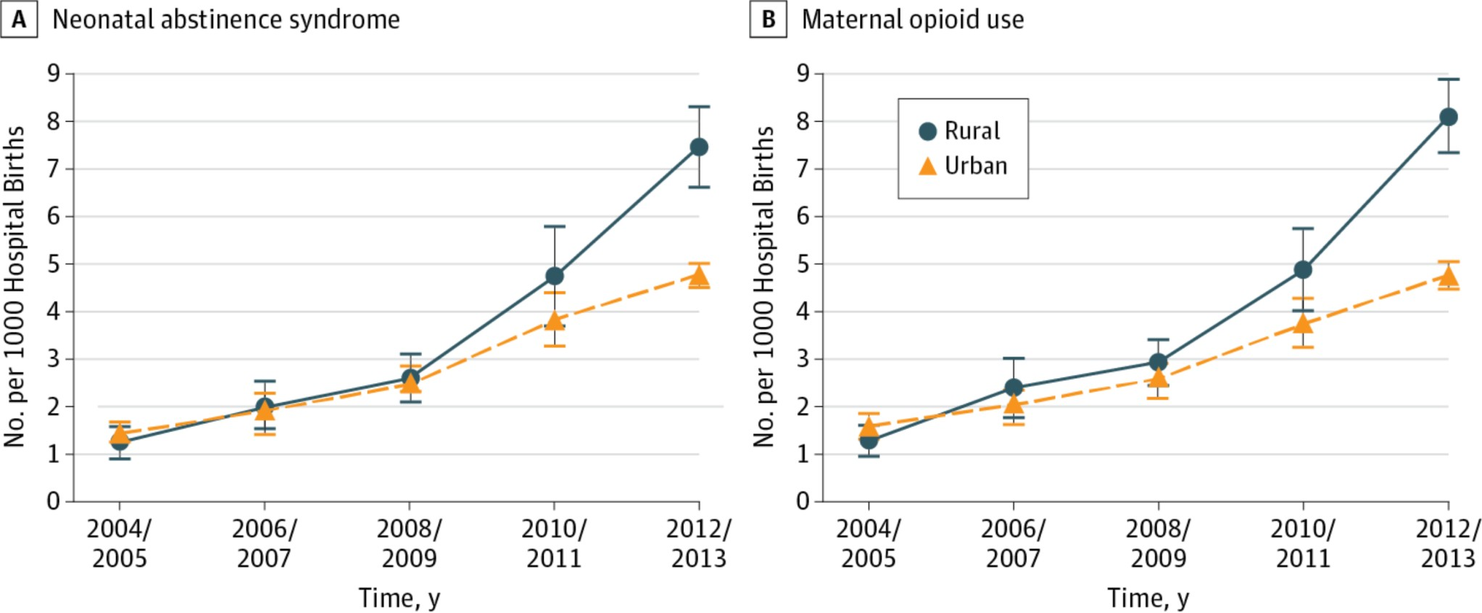

JAMA Pediatr. Published online December 12, 2016. doi:10.1001/jamapediatrics.2016.3750



**National vs. Massachusetts trends in NAS births (2011-2013)**

18

16

14

**29%**

**increase**

12

**NAS Rate per 1,000 births**

10 National

Massachusetts 8

6 **23%**

**increase**

4

2

0

2011 2012 2013

**Year**



1,400

1,200

1,000

**Volume of NAS discharges**

941

1,040

1,190 1,162 1,197

20

18

**Rate of NAS discharges per 1,000 live births**

16

14 13.2

14.9

17.0 16.6 17.2

12

800

600

400

**27%**

increase

in volume

10

**31%**

8 increase

6 in rate

4

200

2

0

2011 2012 2013 2014 2015

0

2011 2012 2013 2014 2015

Source: HPC analysis of Center for Health Information and Analysis, Inpatient Discharge Database 2011-2015



Notes: NAS discharges were identified using ICD-9-CM diagnosis code 779.5 (drug withdrawal syndrome in a newborn).

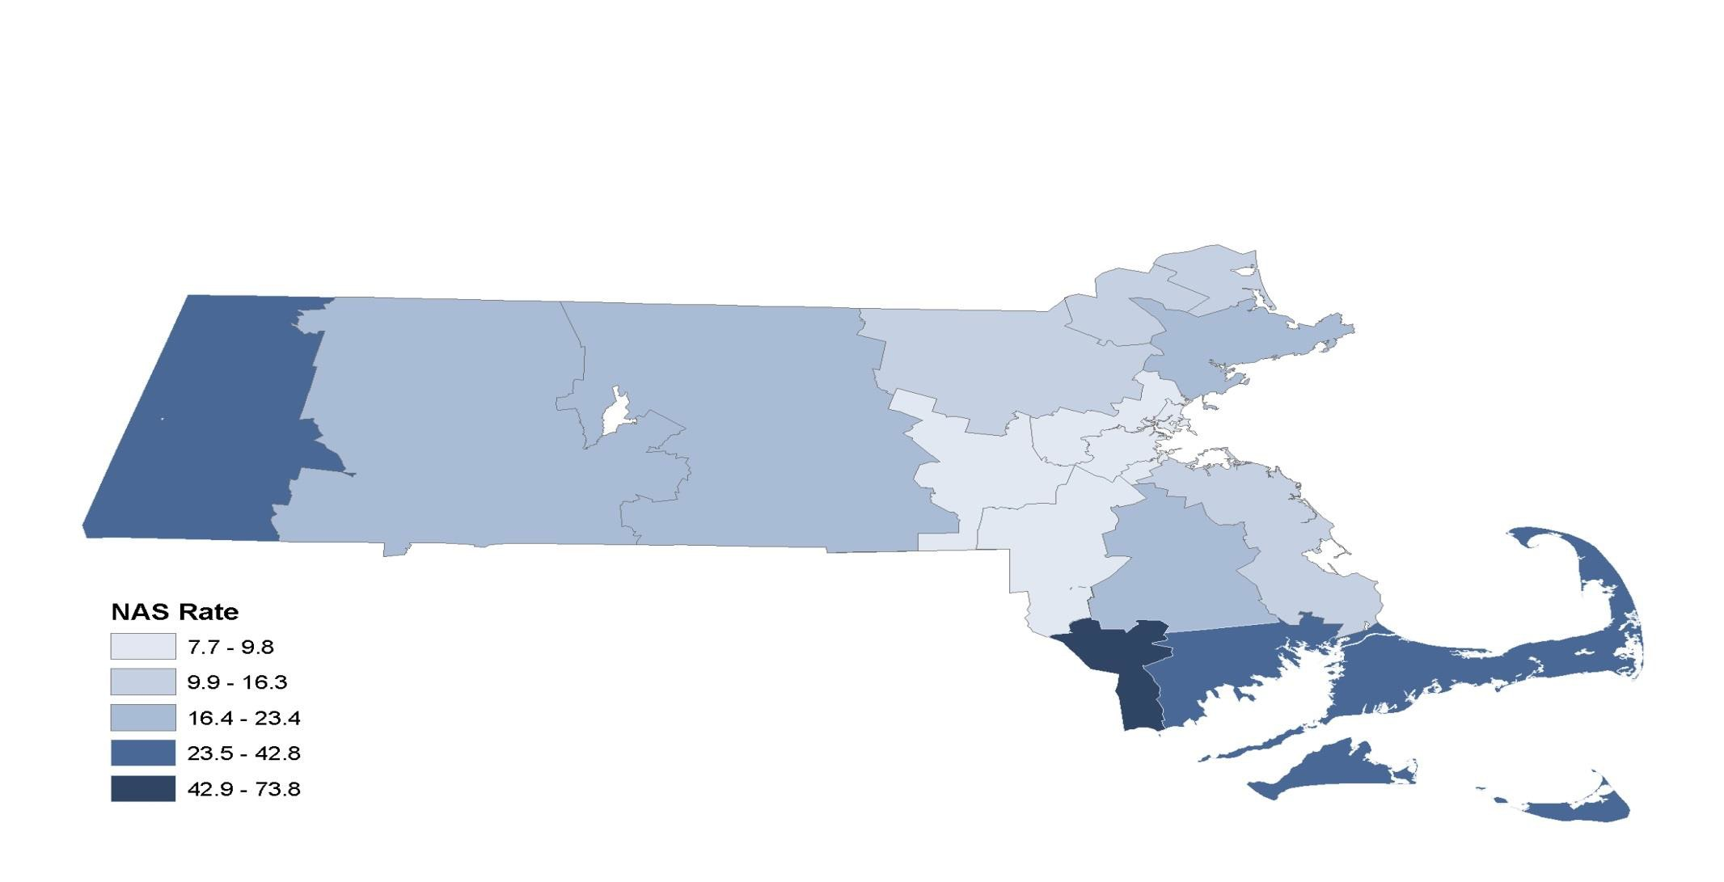

Source: HPC analysis of Center for Health Information and Analysis, Inpatient Discharge Database 2015



Notes: NAS discharges were identified using ICD-9-CM diagnosis code 779.5 (drug withdrawal syndrome in a newborn).

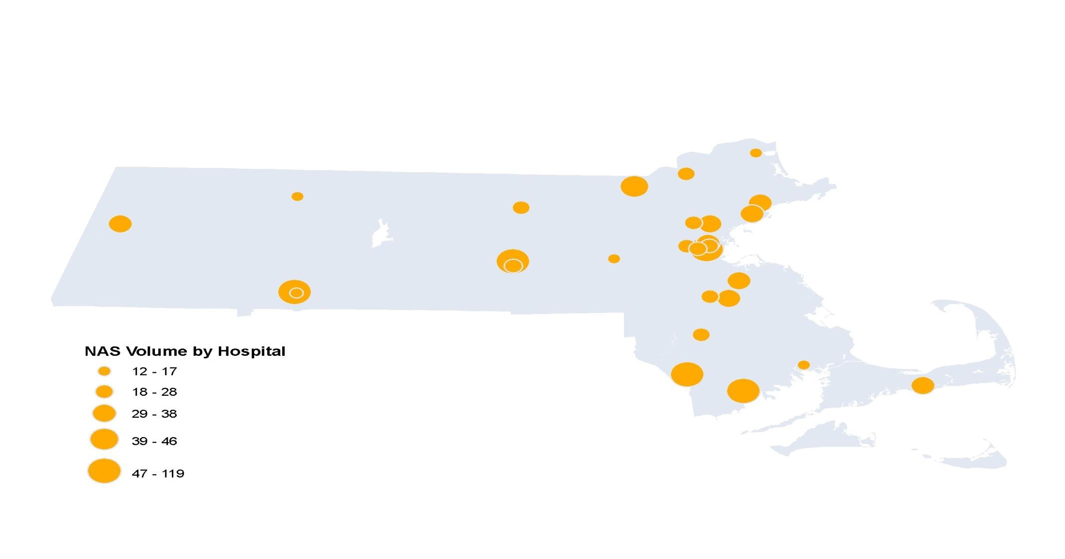

Source: HPC analysis of Center for Health Information and Analysis, Inpatient Discharge Database 2015



Notes: NAS discharges were identified using ICD-9-CM diagnosis code 779.5 (drug withdrawal syndrome in a newborn). Only includes hospitals with 12 or more NAS discharges.

80 75.2

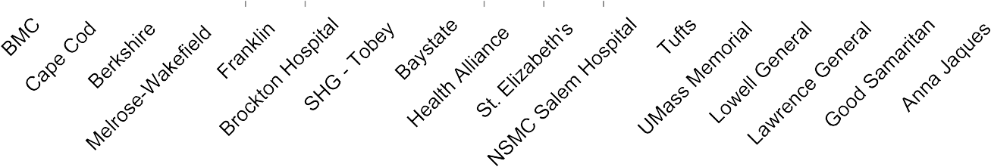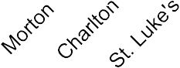

70

**Rate of NAS discharges per 1,000 live births**

60

50

40

30

65.5

53.8

44.7 44.1

41.8 41.6

33.2 32.2

30.4 29.9

26.2 25.8 25.0

**8** CHART

hospitals

**11** non-CHART

#### hospitals

22.7 21.9

19.8 19.5

20

* 1. 16.8

10

0

Source: HPC analysis of Center for Health Information and Analysis, Inpatient Discharge Database 2015



Notes: NAS discharges were identified using ICD-9-CM diagnosis code 779.5 (drug withdrawal syndrome in a newborn). Only includes hospitals with 12 or more NAS discharges.

32

* + - DCF began collecting data at Intake on Substance Exposed Newborns (SENs) in March of 2014. 51A reports that alleged exposure of a newborn to alcohol or drugs during pregnancy were assigned the allegation of SEN.

33

* + - When DCF rolled out the current Intake policy at the end of February 2016, another neglect allegation type was added to capture the number of newborns reported to DCF diagnosed with Neonatal Abstinence Syndrome (NAS).

*Neglect – Substance Exposed Newborn*

*Neglect – Substance Exposed Newborn\Neonatal Abstinence Syndrome*

34

|  |  |  |  |
| --- | --- | --- | --- |
| ■ | **January 2016** | **SEN at 51A Report**  **232** | **NAS at 51A Report**  **Not Available** |
| ■ | **February 2016** | **197** | **Not Available** |
| ■ | **March 2016** | **210** | **20** |
| ■ | **April 2016** | **207** | **23** |
| ■ | **May 2016** | **199** | **13** |
| ■ | **June 2016** | **228** | **19** |
| ■ | **July 2016** | **201** | **14** |
| ■ | **August 2016** | **235** | **18** |
| ■ | **September 2016** | **207** | **17** |
| ■ | **October 2016** | **217** | **15** |

35

* + - * NAS is often not diagnosed at birth and the newborn may not show signs of NAS when the initial report is filed with DCF in which case a Neglect –SEN allegation would be used. *
      * Hospitals may have different definitions of NAS. DCF would not assign the SEN\NAS allegation if the hospital did not specify a NAS diagnosis, even if the hospital talks about some withdrawal signs.
      * DCF staff may need further training to understand the difference between the two allegation categories.

**\* If there is a subsequent diagnosis of NAS, DCF may unsupport the original allegation and add an allegation of SEN\NAS to better capture newborns that are diagnosed with NAS after the initial filing.**

**Data Analysis:** *The* ***whole*** *is greater than the* ***sum*** *of its* ***parts***

**Data Mechanics**: What is currently collected? What are the data fields, frequency and reporting? How complete a picture do we have on NAS/SEN services, utilization and quality?



* Department of Public Health
* Department of Children & Families
* Center for Health Information and Analysis
* Health Policy Commission (CHART and other

investment data)

* Individual Health Systems
* Neonatal Quality Improvement Collaborative
* Other

*Data Set Name Data Set Owner Data Source*

*Data Collected By*

*Frequency of Collection/Reporting Description of Data*

*Geographic Region Included Target Population Intervention Stage*

*Type of Intervention Known Data Gaps*

*Reporting Produced (what is it used for?)*

*Shared/ Collaboration*

**3: *Potential* Statewide Plan for**

**Data-Sharing and Quality Improvement**

1. Recommend Population-Based Metrics for NAS/SEN Improvement Dashboard

Pre-pregnancy/Prenatal Birth/Inpatient/Neonatal Postnatal/Post-Discharge

* + Perinatal substance use incidence
  + Maternal use of medication-

assisted therapy

* + Timeliness of Prenatal Visits
  + Frequency of ongoing prenatal care
* NAS incidence
* Average LOS for infants with NAS
* Inpatient pharmacologic therapy

for infants with NAS

* Breastfeeding in infants with NAS
  + Readmissions for infants with NAS
  + Enrollment in EI for infants with NAS
  + Relapse for mothers on MAT
  + Timeliness of Postpartum Visits
  + Childcare visits in first 15 months

1. Develop and Incent Data-Collection, Data-Sharing and Data-Reporting across the NAS/SEN care continuum
   * + Outpatient clinics
     + PCP Offices
     + Community Health Centers
     + Birthing hospitals
     + Acute hospitals
     + Other birthing centers
     + Outpatient clinics
     + PCP Offices
     + Community Health Centers



1. Address patient-confidentiality and data-sharing in supporting care coordination
2. Review all existing state and federal patient confidentiality and data-sharing protections (HIPPA, 42 CFR Part 2, Chapter 224, 105 CMR.140 and others) to understand what information can be shared among treating clinicians across the care continuum)
3. Identify barriers and challenges (existing in regulations/statutes or in practice) that limit appropriate, necessary and timely care coordination
4. Develop a list of recommendations for needed regulatory or statutory changes as well as state-directed guidance clarifying what information (under what circumstances) is currently permissible to be shared

38



**Health Policy Commission Investments in NAS**

**(separate PPT)**

39



**Next Steps**

**Next Steps**



* **Survey/Inventory**
  + Distribute to Advisory Council, Task Force, and other stakeholders
  + Complete by 12/30
  + Staff to collect and analyze responses
* **January 18th meeting with Task Force AND Advisory Council**
  + Review of inventory survey results
  + Early February, sub-group will recommend priority areas for the coordination of care and services, identified service gaps and recommendations to fill those gaps to the Task Force
  + Sub-group recommendations are to be submitted to staff
  + A designee (“lead”) from each sub-group will present their

recommendations at the final Task Force meeting in February

* **Next Task Force Meeting – January 18th 1-4pm (note the time extension)**

40