​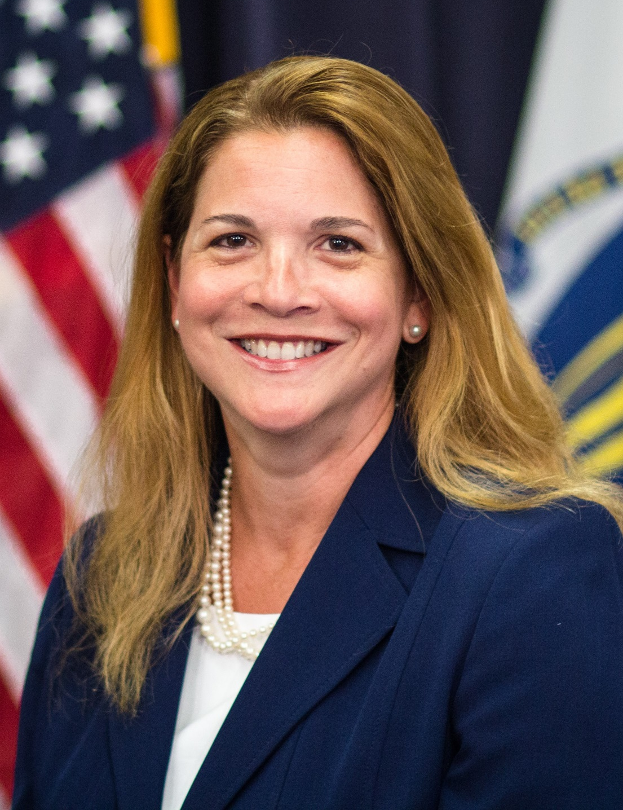

Rosalin Acosta is the newly appointed Secretary of Labor and Workforce Development. Prior to joining the Baker-Polito Administration she was a widely respected financial and banking service professional with over thirty years of experience in Greater Boston financial institutions, most recently as Senior Vice President and Managing Director for Enterprise Wealth Management at Enterprise Bank in Lowell, where she oversaw the operations of the bank’s Wealth Management and Brokerage divisions since 2013. Secretary Acosta has also worked in senior executive roles at TD Bank and Sovereign Bank (now Santander). She has served in many community and civic capacities, including as a Board Member of The Boston Foundation, a Board Overseer at Boston Children’s Hospital since 2009, where she was a founding member of Milagros Para Ninos, and a 14-year Member of the Boston Chapter of the Association of Latino Professionals For America (ALPFA). Acosta was a Director and Planning Member of the Merrimack Valley Workforce Investment Board and was appointed a Northern Essex Community College Trustee by Governor Baker in 2016. Secretary Acosta has been named one of Boston’s Most Influential Women by the Women of Harvard Club in 2014, where she serves on the Leadership Committee, and El Planeta’s Top 100 Most Influential Hispanics in Massachusetts for three consecutive years. Born in Cuba, she earned a Bachelor of Arts from Wesleyan University in Connecticut where she was a member of the Women’s Varsity Ice Hockey Team. She is the proud mother of five children and an avid traveler, runner and cyclist.

