INDOOR AIR QUALITY ASSESSMENT

**Seekonk Public Library**

**410 Newman Ave  
Seekonk, MA**

**April 2025**

Seekonk Public Library
410 Newman Ave
Seekonk, MA


Prepared by:

Massachusetts Department of Public Health

Bureau of Climate and Environmental Health

Division of Environmental Health Regulations and Standards

# CONTENTS

EXECUTIVE SUMMARY 3

BACKGROUND 4

RESULTS AND DISCUSSION 5

Ventilation 5

HVAC System Maintenance 6

Water Damage and Moisture Concerns 6

Sources of Respiratory Irritants/Possible Asthma Triggers 8

CONCLUSIONS AND RECOMMENDATIONS 9

REFERENCES 12

PICTURES 14

Ventilation Pictures 14

Water Damage Pictures 16

External Damage Pictures 21

Respiratory Irritants Pictures 24

Table 1 29

Table 2A 30

Table 2B 31

Table 2C 32

Table 3 33

Table 4 35

# EXECUTIVE SUMMARY

The Massachusetts Department of Public Health’s (MDPH) Division of Environmental Health Regulations and Standards (EHRS) conducted an Indoor Air Quality (IAQ) assessment of the Seekonk Public Library located at 410 Newman Ave., Seekonk, MA on April 3, 2025. The case was referred to EHRS via the Massachusetts Department of Labor Standards.

(Results and Discussion)

The building is experiencing chronic water penetration issues that have resulted in water-damaged building materials and visible mold growth on windowsills and ceiling vents. The major source of water appears to be penetration through damaged siding, which is prevalent around the building. In addition, a number of building components are outdated and past their service life including carpeting, windows, and the mechanical heating, ventilation, and air conditioning (HVAC) system. A Feasibility Study/Building Assessment was conducted by a private consultant in 2024, which concluded:

* HVAC System: Nearly all components of the HVAC system have reached the end of their anticipated service life (25 years), and compatible replacement parts are increasingly hard to find. Therefore, it is recommended to comprehensively renovate the system.
* Windows: Original to the building (~ 50 years old) they have exceeded their service life.
* Structural Assessment:
  + Water leaks observed in many areas, especially along the perimeter of the building, are causing deterioration of the exterior finishes.
  + Numerous cracks in the north, west, and south foundation walls due to settling.
* Architectural Assessment:
  + Exterior cladding is deteriorating in many places and will need to be replaced. It is likely that water infiltration has damaged plywood substate and metal wall studs/framing.
  + The roof was replaced in 2008, however it does not provide the required insulation value.
  + Floor finishes are worn and dingy and ready for replacement.
  + Acoustic ceiling tiles show some areas of damage and discoloration (Tappé Architects, 2024).

As a result of the MDPH/IAQ assessment, a number of primary recommendations were made at the time of assessment and are reiterated below. (Conclusions and Recommendations)

* Make repairs to the building envelope to prevent further water intrusion.
* Remove or clean any water-damaged/mold-contaminated material in accordance with the US EPA’s “Mold Remediation in Schools and Commercial Buildings”.
* Replace HVAC system.
* Replace windows.
* Replace carpeting, and
* Replace water-damaged/discolored ceiling tiles.

As climate change and global warming intensifies, the urgent need for modern, energy-efficient solutions becomes clear. Without significant upgrade of HVAC equipment and other interior components, building conditions and indoor air quality will continue to degrade.

(Conclusions and Recommendations)

# BACKGROUND

|  |  |
| --- | --- |
| Building: | Seekonk Public Library |
| Address: | 410 Newman Avenue, Seekonk, MA |
| Requested by: | Referral by the MA Department of Labor Standards |
| Reason for Request: | General indoor air quality (IAQ) and mold issues |
| Date of Assessment: | April 3, 2025 |
| Massachusetts Department of Public Health/Bureau of Climate and Environmental Health/**Division of Environmental Health Regulations and Standards** (MDPH/BCEH/EHRS) Staff Conducting Assessment: | Cory Holmes, Senior Advisor for Indoor Air Quality Inspections, Audits, Outreach and Training, EHRS |
| Building Description: | |  | | --- | | The library is a one-story building with concrete foundation, wooden siding, and aluminum windows. The roof is flat rubber membrane and was replaced in 2008. Interior materials are carpeting, gypsum wallboard, and suspended ceiling tiles. | |
| Windows: | Windows in the building are openable but are older than their service life; some are reportedly difficult to open. |

# RESULTS AND DISCUSSION

The following is a summary of indoor air testing results (Table 1)

|  |  |  |
| --- | --- | --- |
| * ***Carbon dioxide (CO2)*** | *a measure of the adequacy of ventilation* | Levels were below the MDPH guideline of 800 parts per million (ppm) in areas surveyed, indicating adequate air exchange at the time of assessment. Levels would be expected to be higher with increased occupancy. |
| * ***Temperature*** | *a measure of comfort* | Was within the MDPH recommended range of 70°F to 78°F in occupied areas, however occupants reported temperature control issues, which would be expected with an outdated system past its service life. |
| * ***Relative humidity*** | *a measure of comfort and, when in excess for an extended period, a way to reflect the potential for mold and fungal growth* | Was within or close to the lower level of the MDPH recommended range of 40 to 60% in all areas tested. However, signs of chronic moisture exposure were evident in the form of damaged ceiling tiles and rust/corrosion on metal surfaces/vents. |
| * ***Carbon monoxide***   ***(CO)*** | *a product of combustion that can result in acute and long term cardiovascular, respiratory, and neurological symptoms* | Levels were non-detect (ND) in all occupied areas tested. |
| * ***Particulate matter (PM2.5)*** | *a way to measure inhalable particle distribution in the air* | Concentrations were below the National Ambient Air Quality Standard (NAAQS) of 35 micrograms per cubic meter (μg/m3) in all areas tested. |

## Ventilation

Ventilation refers to both the supply of fresh air and the removal of stale air from a room. The introduction of fresh air into an occupied space will dilute normally occurring pollutants that are generated by occupancy and other activities. In addition, a heating, ventilation and air conditioning (HVAC) system will remove pollutants from a building if operating appropriately. All ventilation systems throughout the building should operate continuously during periods of occupancy.

Fresh air is provided by an air handling unit (AHU) located on the roof (Picture 1). Air from the AHU is filtered, heated/cooled, and delivered via ducted supply diffusers (Pictures 2 and 3). Air is returned/exhausted through wall-mounted exhaust grills (Picture 4). Several complaints of poor air circulation and lack of temperature control were expressed by staff. It is recommended that HVAC systems be re-balanced every five years to ensure adequate air systems function (SMACNA, 1994). It is not known when the last time these systems were balanced.

The various types of ventilation components as well as devices that can move/redirect airflow that were identified in the building are listed in Table 2A, Table 2B and Table 2C.

### HVAC System Maintenance

It is recommended that AHUs be outfitted with pleated filters of a Minimum Efficiency Reporting Value (MERV) of 8 or higher, which are adequate in filtering out pollen and mold spores (ASHRAE, 2012). In addition, filters should be changed 2-4 times a year or in accordance with the manufacturer’s recommendations.

The rooftop AHU and HVAC components are beyond their service life. According to the American Society of Heating, Refrigeration, and Air-Conditioning Engineering (ASHRAE), the service life of this type of unit is 15-20 years, assuming routine maintenance of the equipment (ASHRAE, 1991).

**Balancing**

To have proper ventilation with a mechanical supply and exhaust system, a system must be balanced to provide an adequate amount of fresh air to the interior of a room while also removing stale air from the room. It is recommended that HVAC systems be re-balanced every five years to ensure adequate air systems function (SMACNA, 1994).

(see Ventilation pictures)

## Water Damage and Moisture Concerns

Please note that the MDPH does not recommend conducting mold testing in a typical water damage remediation. For details, please consult [Guidance Regarding Testing for Mold in Water-Damaged Public Buildings](https://www.mass.gov/info-details/guidance-regarding-testing-for-mold-in-water-damaged-public-buildings) | Mass.gov

The application of a mildewcide to moldy porous materials is not recommended.

Molds are found naturally in our environment both indoors and outdoors. Inside, mold growth may occur when items, particularly porous products such as paper or gypsum wallboard, are exposed to moisture. Typical water sources include leaks, floods, and condensation. To avoid mold growth, dry all water-damaged items and affected areas within 24-48 hours and reduce indoor humidity. Some people with chronic respiratory conditions, such as asthma, are more likely to experience health symptoms associated with molds, including allergic reactions and respiratory irritation. Controlling moisture is the key to preventing mold growth and potential health symptoms. [Climate fact sheet: mold growth | Mass.gov](https://www.mass.gov/info-details/climate-fact-sheet-mold-growth)

Hot, humid summers are becoming more frequent due to climate change. Massachusetts has experienced hot, humid, and rainy summers in 2018, 2021, and 2023. July of 2021 was the wettest ever recorded in Massachusetts, and the three-month period from June through August, known as the meteorological summer, was the fourth wettest on record, according to the National Oceanic and Atmospheric Administration’s (NOAA) Centers for Environmental Information (NOAA, 2021). The summers of 2023 and 2024 were also hot, and wet, with 2023 being measured as the second rainiest on record (WBUR, 2023). These conditions are challenging for buildings, particularly those without central air conditioning or with HVAC systems past their service date.

During these hot and wet summers, extended periods of outdoor relative humidity above 70% occurred and public buildings experienced extended periods of water vapor exposure from high relative humidity. When exposed to these conditions, porous materials such as gypsum wallboard, cardboard, and other materials may develope mold colonization, particularly if located in areas that may experience condensation on floors and walls (e.g., below grade space).

In order to reduce mold in buildings, of primary importance is to identify, repair and/or limit the moisture source causing damage in the building. Once the moisture source is remediated, then discarding and/or cleaning of mold contaminated materials can be completed.

All areas examined were assessed for the presence of either mold, moisture, or visible water damage and an exterior evaluation was conducted to identify potential pathways for water penetration. The following issues were noted:

* **Visible mold growth was observed on the wooden windowsill in the IT Room and on the surface of supply vents (Pictures 5 through 7; Table 1)**.
* **Water-damaged ceiling tiles were noted in several areas (Pictures 8 through 11; Table 1),** which can provide a source of mold and should be replaced after a water leak is discovered and repaired.
* **Corroded metal ceiling vents were found (Picture 12),** which indicate chronic issues with managing relative humidity with an outdated HVAC system.
* **Windows in some areas were also sealed with plastic and tape to prevent drafts and moisture infiltration (Picture 13).**
* **A water-damaged laminate countertop was noted in the breakroom (Picture 14**). If a sink backsplash is damaged, it becomes very difficult to keep clean and can lead to mold growth and additional damage to the material underneath.
* **The cabinet was also water-damaged, causing swelling, and resulting in sawdust being generated from opening/closing the cabinet door (Picture 15).**

An exterior evaluation was also conducted to identify potential pathways for water penetration and pest entry. The following issues were noted:

* **Damaged exterior siding/panels (Pictures 16 through 20).**
* **Water infiltration around exterior windows, which can accelerate water damage, lead to mold growth and rot (Picture 5)**, allowing a pathway for drafts, moisture, and pest entry into the building.
* **Overgrown bushes and shrubbery were noted against the building (Picture 21).** Plants near the building can cause water damage to the exterior. In addition, plants shading exterior walls can slow drying. Water can eventually penetrate, subsequently freezing and thawing during the winter. This freezing/thawing action can weaken and damage building materials.

Each of these issues can accelerate water damage, lead to mold growth and rot, allowing a pathway for drafts, moisture, and pest entry into the building.

A list of water damage issues identified inside and outside the building is included as Table 3.

(see Water Damage Pictures)

**Mold Growth**

Porous materials (e.g., gypsum wallboard, ceiling tiles and carpeting) can be dried with fans and heating within 24 to 48 hours of becoming wet (US EPA, 2008).

If porous materials are not dried within this time frame, mold growth may occur.

Moldy materials should be cleaned following the guidance in EPA’s Mold Remediation in Schools and Commercial Building (US EPA, 2008).

## Sources of Respiratory Irritants/Possible Asthma Triggers

Asthma is a lung disease that can make breathing difficult. Without careful management of asthma, some people can have symptoms, like a tight feeling in the chest, shortness of breath, coughing, or wheezing. Although there is no cure for asthma, people with asthma can live healthy, active lives. A safe and healthy environment helps to reduce asthma symptoms.

* **Dust, a common respiratory and eye irritant, can collect on surfaces and items.** Although janitorial and maintenance staff perform routine cleaning, they may not be able to clean as effectively if accumulated items are not picked up or surfaces are cluttered.
* Even with a properly functioning ventilation system, it is necessary to **reduce the use of materials that can be a source of respiratory irritants** to prevent symptoms in individuals who have sensitivity to such pollutants.

Possible asthma triggers and/or airborne pollutants exist in the building. These are listed below as well as in (Table 4).

(see Sources of Respiratory Irritant Pictures)

* **Some areas are covered with wall-to-wall carpet that is soiled/stained and past its service life (Pictures 22 and 23).** Carpeting has a service life of approximately 10-11 years (IICRC, 2002). Carpeting that is beyond its service life becomes increasingly difficult to clean and may release fibers which can be irritating if airborne. Carpets should be vacuumed regularly with a high efficiency particulate arrestance (HEPA) filter equipped vacuum cleaner and cleaned annually (or semi-annually in soiled/high traffic areas) in accordance with Institute of Inspection, Cleaning and Restoration Certification (IICRC) recommendations (IICRC, 2012).
* **Supply, exhaust, return vents and surrounding ceiling tiles had accumulations of dust and debris (Pictures 24 through 27; Table 1).** This dust/debris can be aerosolized under certain conditions, and should be cleaned periodically (e.g., during regular filter changes). It is important to note that the location of these tiles directly in the airstream of mechanical ventilation makes them more susceptible to collecting dust due to constant airflow over the surface of the tile. If these tiles (or vents) cannot be adequately cleaned, they should be replaced.
* **In some areas dust and debris were seen accumulating on windowsills (Pictures 28 and 29; Table 1).** This dust can be aerosolized under certain conditions and can also be a medium for mold growth.
* **During the Covid-19 pandemic many schools and public buildings supplemented fresh air and filtration by using high-efficiency particulate arrestance (HEPA) air purifiers.** HEPA units remove up to 99% of airborne contaminants as small as 0.1 microns including airborne mold/mushroom spores. These are good choices for use in occupied areas. A few of these types of units were observed in the building.
* **Finally, the vacuum cleaner used by cleaning staff was observed to have a full bag (Picture 30).** The bag should be checked regularly to ensure proper connection and changed when full to ensure proper operation.

# CONCLUSIONS AND SHORT-TERM RECOMMENDATIONS

In subsequent conversation with Library Director Kate Hibbert, it was communicated that the following actions have reportedly been taken on-site as a result of the MDPH inspection:

* Mold has been removed from the IT Server Room.
* Ceiling vents and ceiling tiles around vents have been cleaned.
* HVAC filters are changed 2-4 times per year.
* Damaged/stained ceiling tiles were replaced in Staff Room/Kitchen.
* Corroded ceiling vents and return vents were replaced.
* Refrigerator gaskets in the Staff Room were cleaned.

In view of the findings at the time of the visit, the following further recommendations are provided to improve IAQ:

|  |  |  |  |
| --- | --- | --- | --- |
|  | **HVAC System** | | **Helpful Links** |
| 1. If | Ensure all AHUs and restroom exhaust vents are on and operating *continuousl*y during occupied periods. |  | |
|  | Continue to change HVAC filters 2-4 times a year using MERV 8 or the best MERV-rating that can work with current equipment. | [ANSI/ASHRAE Standard 52.2-2017](https://www.ashrae.org/File%20Library/Technical%20Resources/COVID-19/52_2_2017_COVID-19_20200401.pdf) | |
|  | During filter changes, clean dust and debris from the inside of HVAC cabinets. |  | |
|  | Clean dust and debris from vents, ceiling fans, and personal fans periodically, as needed. |  | |
|  | Have the HVAC system balanced if it has been more than 5 years since the last balancing. |  | |
|  | **Water damage** | | |
|  | Consult with a building envelope specialist regarding water penetration and the condition of interior walls around windows, make repairs as needed. |  | |
|  | Remove or clean any water-damaged/mold-contaminated material in accordance with the US EPA’s “Mold Remediation in Schools and Commercial Buildings”. | <http://www.epa.gov/mold/mold-remediation-schools-and-commercial-buildings-guide>  [Construction and renovation generated pollutants in occupied buildings | Mass.gov](https://www.mass.gov/info-details/construction-and-renovation-generated-pollutants-in-occupied-buildings) | |
|  | Ensure any roof and plumbing leaks are repaired promptly and replace any remaining water-damaged suspended ceiling tiles or other porous building materials. |  | |
|  | Replace water-damaged/rusted/corroded supply, exhaust, or return vents. |  | |
|  | Ensure proper drainage on the roof, gutters, and downspouts away from building. |  | |
|  | Replace or make repairs to damaged siding and panels. |  | |
|  | Ensure there is a system for reporting and monitoring leaks. Building occupants should ensure they report active leaks to building management for investigation and repairs. |  | |
|  | Replace/repair water-damaged countertop and cabinet in Breakroom. |  | |
|  | Remove shrubbery and plants from away from exterior walls to allow for better drying of building materials and damage to exterior siding. |  | |
|  | If relative humidity cannot be controlled with the HVAC system, consider using dehumidifiers in combination with fans and AC during summer months/periods of elevated relative humidity. Clean and maintain portable dehumidifying units in accordance with manufacturers’ recommendations. Drain units into sinks/floor drains where possible to reduce daily maintenance. |  | |
|  | **Respiratory Irritants/Possible Asthma Triggers** | | |
|  | Reduce clutter. Periodically remove unwanted items. Store the remaining items neatly and off the floor. |  | |
|  | Clean supply, return, exhaust vents and surrounding ceiling tiles regularly to remove accumulated dust/debris. If ceiling tiles and/or vents cannot be adequately cleaned, replace them. |  | |
|  | To control dusts, a high efficiency particulate arrestance (HEPA) filter equipped vacuum cleaner in conjunction with wet wiping of all surfaces is recommended.  Ensure vacuum bags are changed regularly.  Avoid the use of feather dusters. Drinking water during the day can help ease some symptoms associated with a dry environment (throat and sinus irritations). |  | |
|  | Reduce use of products and equipment that release irritating volatile organic compounds (VOCs) and only use in well-ventilated areas. Minimize the use of air fresheners (e.g., plug-ins), deodorizers, and scented products. | [Clean Air Is Odor Free](https://www.mass.gov/doc/clean-air-is-odor-free-removing-fragrances-to-improve-indoor-air-quality-in-schools-and-offices-0/download) | |
|  | Supplement mechanical ventilation with portable air purifiers equipped with high efficiency particulate arrestance (HEPA) filters. While these do not supply fresh air, they can remove particles including mold spores and microbes.  Units that may produce ozone should not be used. Maintain all in accordance with the manufacturer’s instructions.  Place them so the filtered airstream is in the breathing zone of occupants and away from open doors. | <https://www.epa.gov/indoor-air-quality-iaq/ozone-generators-are-sold-air-cleaners> | |
|  | Until old, worn, soiled carpeting can be replaced, clean annually (or semi-annually in soiled high traffic areas) as per recommendations of the Institute of Inspection, Cleaning and Restoration Certification (IICRC, 2012). |  | |

# Long-Term Recommendations

|  |
| --- |
|  |
| 1. | Make repairs to the building envelope to prevent further water intrusion. |
| 2. | Work with an HVAC engineering firm to determine the operational lifespan of existing equipment and the feasibility of repair vs. replacement. |
| 3. | Replace windows with modern energy effect ones. |
| 4. | Replace carpeting that is beyond its lifespan. |

# REFERENCES

ASHRAE. 1991. ASHRAE Applications Handbook, Chapter 33 “Owning and Operating Costs”. American Society of Heating, Refrigeration and Air Conditioning Engineers, Atlanta, GA.

ASHRAE. 2012. American Society of Heating, Refrigeration and Air Conditioning Engineers (ASHRAE) Standard 52.2-2012 – Method of Testing General Ventilation Air-Cleaning Devices for Removal Efficiency by Particle Size (ANSI Approved).

IICRC. 2002. Institute of Inspection, Cleaning and Restoration Certification. A Life-Cycle Cost Analysis for Floor Coverings in School Facilities.

IICRC. 2012. Institute of Inspection Cleaning and Restoration Certification. Institute of Inspection, Cleaning and Restoration Certification. Carpet Cleaning: FAQ.

NOAA. 2021. Summer 2021 neck and neck with Dust Bowl summer for hottest on record. National Oceanic and Atmospheric Administration, 1401 Constitution Avenue NW, Room 5128, Washington, DC 20230 <https://www.noaa.gov/news/summer-2021-neck-and-neck-with-dust-bowl-summer-for-hottest-on-record>

SMACNA. 1994. HVAC Systems Commissioning Manual. 1st ed. Sheet Metal and Air Conditioning Contractors’ National Association, Inc., Chantilly, VA.

Tappé Architects. 2024. Final Report 11/14/24. Seekonk Public Library Feasibility Study/Building Assessment.

US EPA. 2008. Mold Remediation in Schools and Commercial Buildings. US Environmental Protection Agency, Office of Air and Radiation, Indoor Environments Division, Washington, D.C. EPA 402-K-01-001. <http://www.epa.gov/mold/mold-remediation-schools-and-commercial-buildings-guide>.

WBUR. 2023. “It’s been a summer of rain and flooding misery in Mass.” WBUR local news. September 12, 2023. <https://www.wbur.org/news/2023/09/12/summer-flooding-rain-massachusetts>

(Click to link back to report)

# PICTURES

## Ventilation Pictures

**Picture 1**

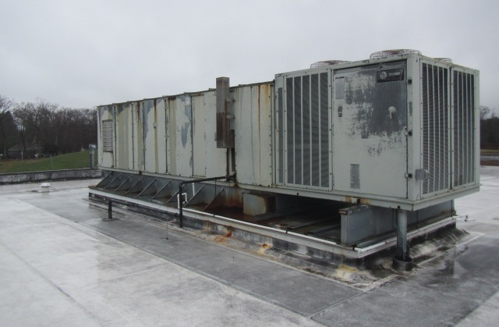

**Rooftop AHU past its service life**

**Picture 2**

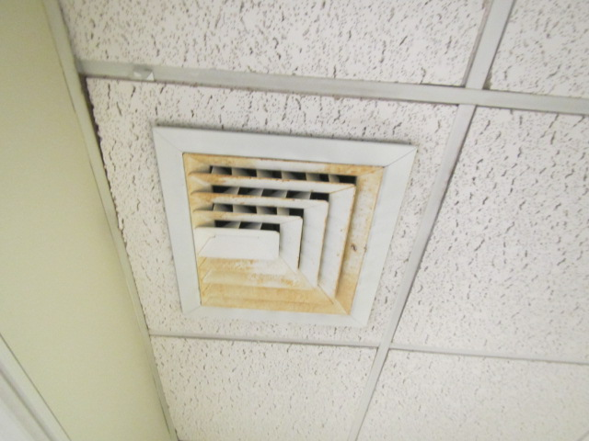

**Ceiling-mounted supply diffuser in Library Director’s Office, note rust/corrosion**

**Picture 3**

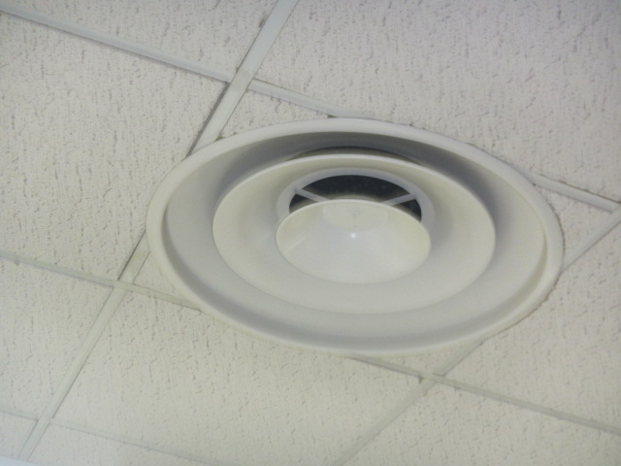

**Round ceiling-mounted supply diffuser in Children’s Library**

**Picture 4**

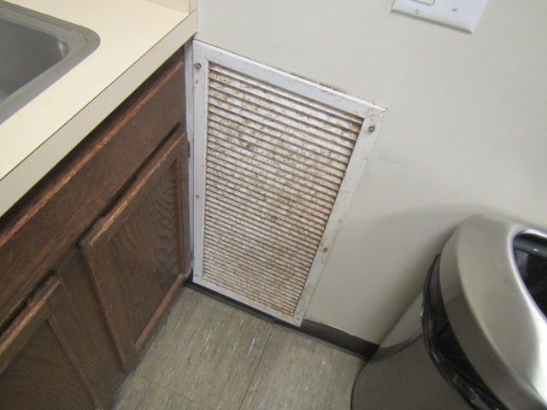

**Wall-mounted return vent in breakroom, note dust/debris accumulation and corrosion**

## Water Damage Pictures

Picture 5

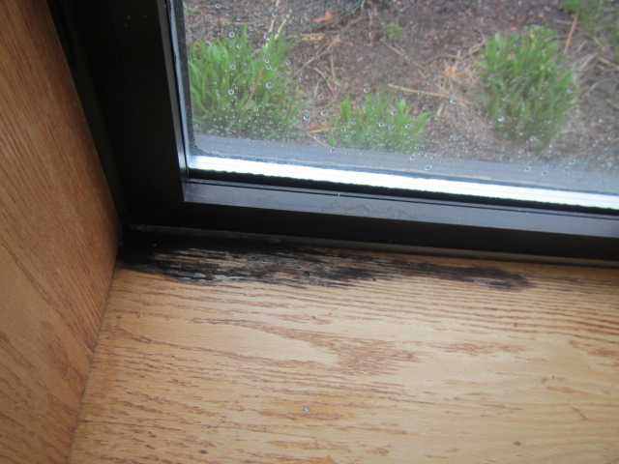

Mold growth (dark staining) on wooden windowsill in IT Room; wood was saturated with moisture at the time of assessment

Picture 6

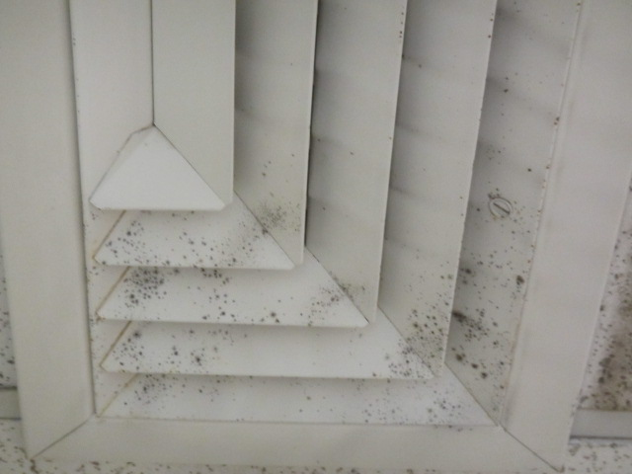

Mold colonies on supply vent in main library area (along windows/rear exit)

Picture 7

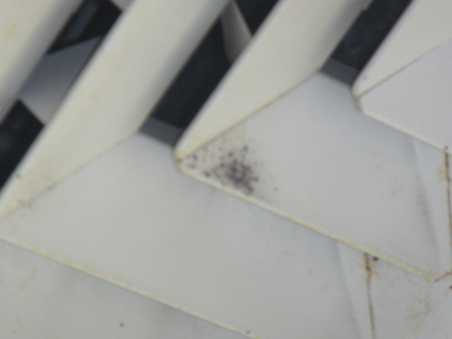

Mold colonies on supply vent in main library area (along windows/rear exit)

Picture 8

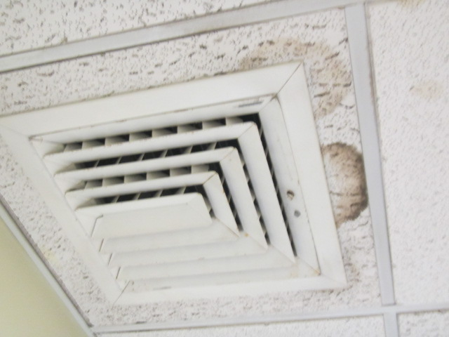

Water-damaged ceiling tiles

Picture 9

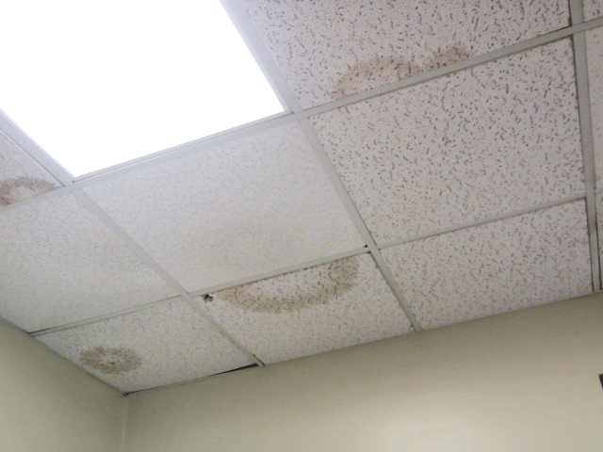

Water-damaged ceiling tiles

Picture 10

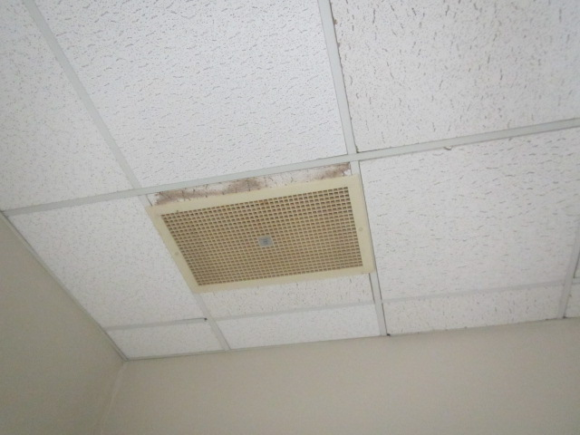

Water-damaged ceiling tiles

Picture 11

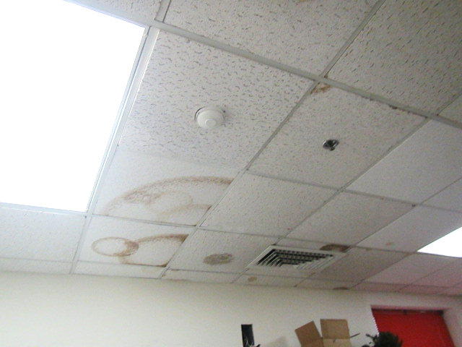

Water-damaged ceiling tiles

Picture 12



Rusted/corroded metal vent in Library Director’s office

Picture 13

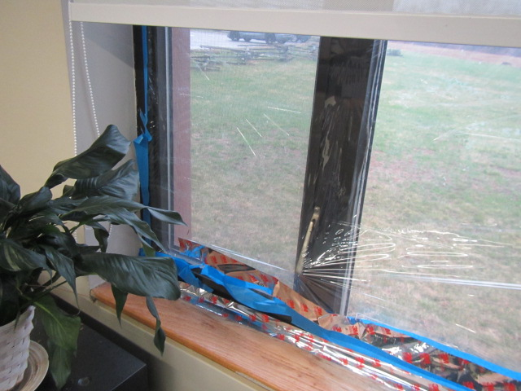

Windows sealed with plastic sheeting and tape to prevent drafts

Picture 14

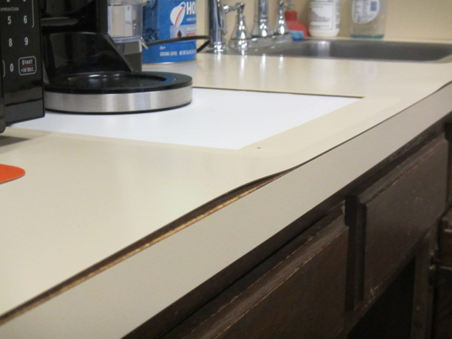

Water-damaged countertop in breakroom

Picture 15

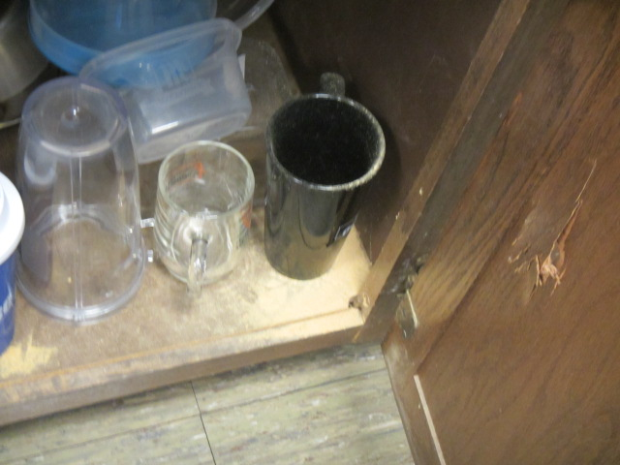

Sawdust (light colored material) accumulated in corner of breakroom cabinet

## External Damage Pictures

Picture 16

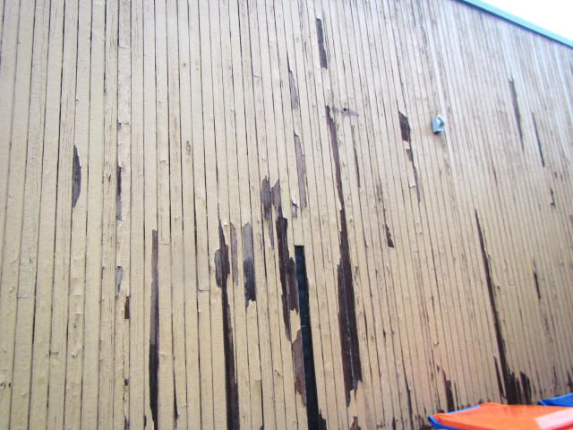

Damaged exterior siding

Picture 17

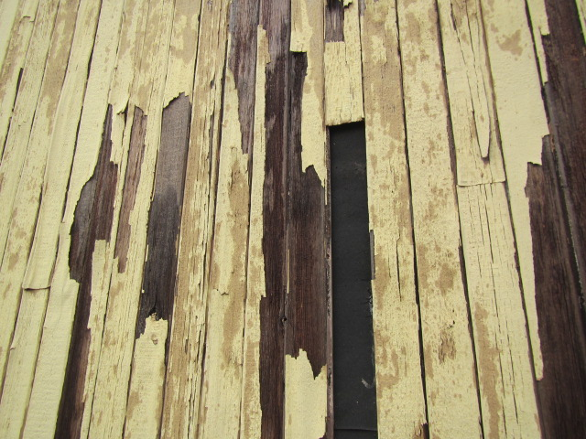

Damaged exterior siding

Picture 18

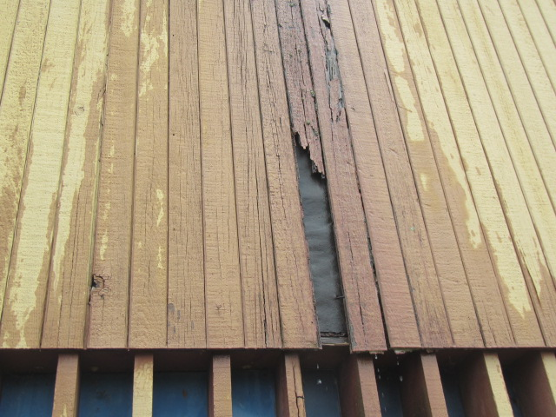

Damaged exterior siding

Picture 19

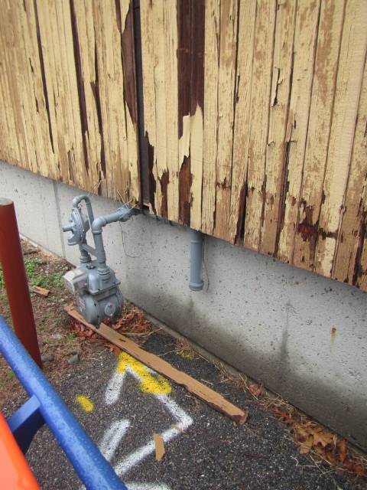

Damaged exterior siding, note pieces on the ground

Picture 20

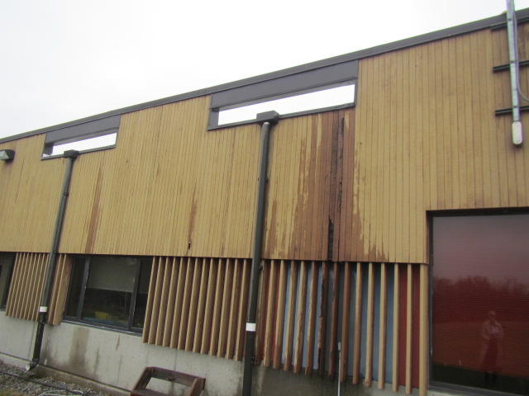

Damaged exterior siding

Picture 21

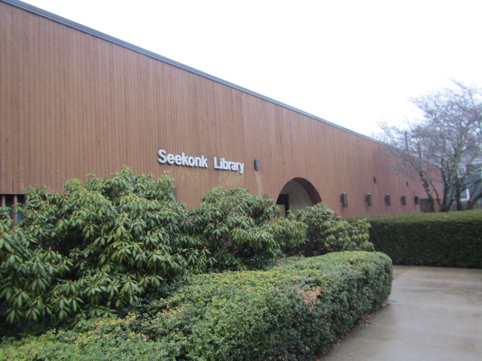

Overgrown bushes and shrubbery, which can lead to chronic moisture exposure of exterior siding

## Respiratory Irritants Pictures

Picture 22

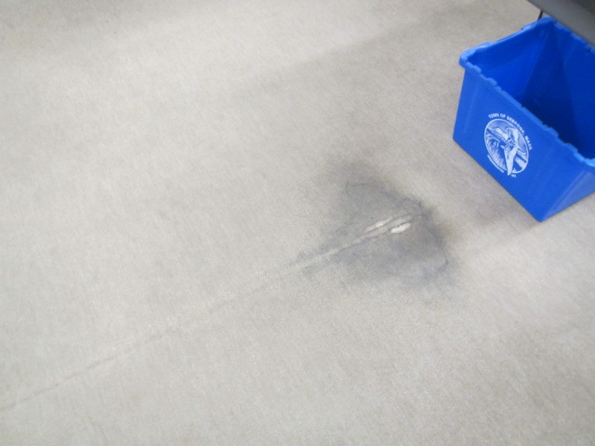

Old, worn/soiled carpeting past its service life

Picture 23

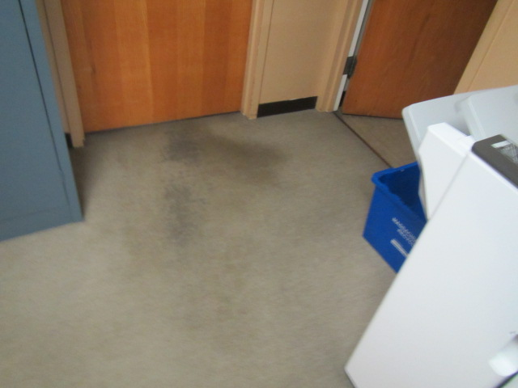

Old, worn/soiled carpeting past its service life

Picture 24

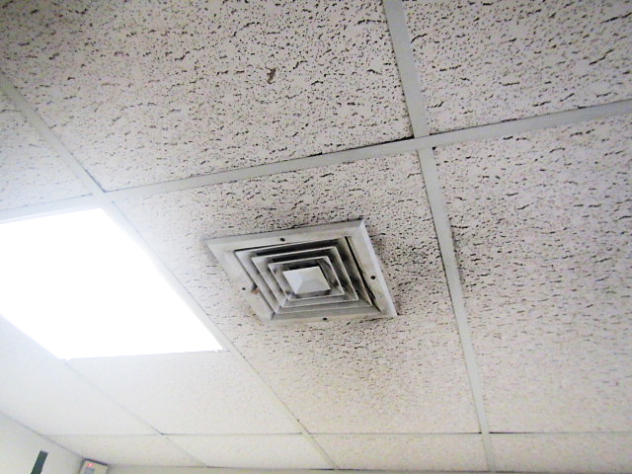

Accumulated dust/debris on supply vent and surrounding ceiling tiles

Picture 25

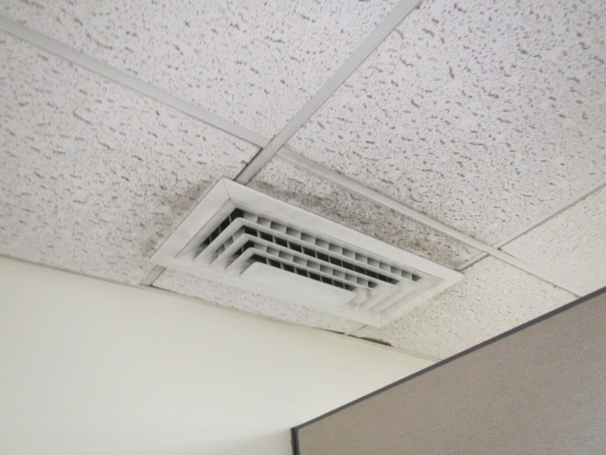

Accumulated dust/debris on supply vent and surrounding ceiling tiles

Picture 26



Accumulated dust/debris on exhaust vent

Picture 27

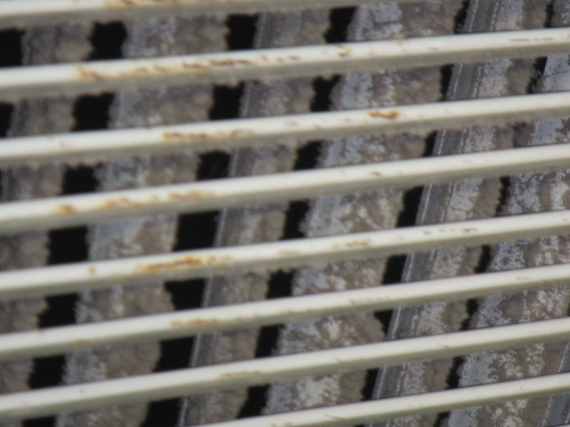

Close-up of clogged vent in the Children’s Library

Picture 28

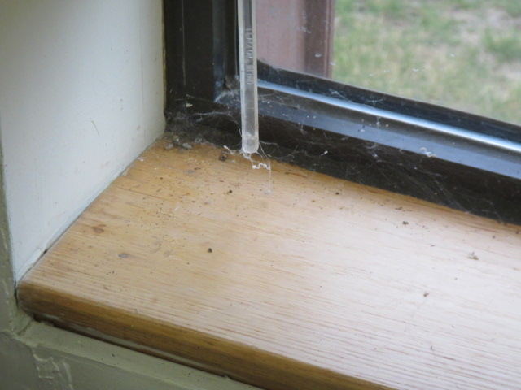

**Dust/debris, dead insects and cobwebs on windowsill**

**Picture 29**

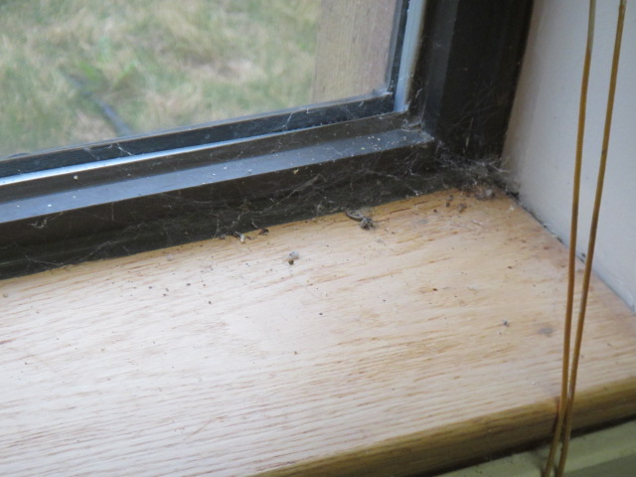

**Dust/debris, dead insects and cobwebs on windowsill**

Picture 30

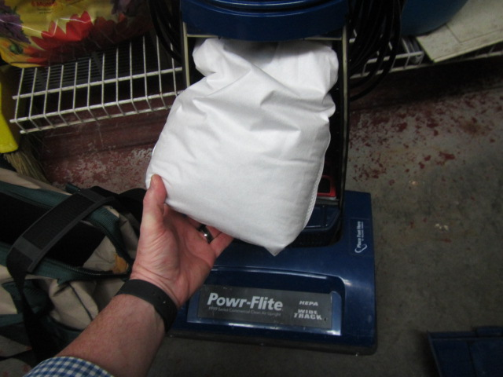

Full bag in vacuum cleaner

Click to link back to report

# Table 1

| **Location** | **Carbon**  **Dioxide**  **(ppm)** | **Carbon Monoxide**  **(ppm)** | **Temp**  **(°F)** | **Relative**  **Humidity**  **(%)** | **PM2.5**  **(g/m3)** | **Occupants**  **in Room** | **Windows**  **Openable** | **Ventilation** | | **Remarks** |
| --- | --- | --- | --- | --- | --- | --- | --- | --- | --- | --- |
| **Supply** | **Exhaust** |
| Background (outside) | 448 | ND | 49 | 100 | ND |  |  |  |  | Cold, wet, rainy & windy |
| Library Director Office | 621 | ND | 71 | 41 | ND | 2 | Y | Y | Y | 3 WD CT, vent corroded, old/soiled carpeting |
| Team Lead | 577 | ND | 71 | 42 | ND | 0 | N | Y | N | Wall to wall carpeting, PF |
| Sullivan Room | 610 | ND | 71 | 38 | ND | 0 | Y | Y | Y | WD CT, plant, PF, wall to wall carpeting |
| Storage Room | 617 | ND | 71 | 39 | ND | 0 | N | U | N | 15 WD CTs |
| Lounge | 770 | ND | 71 | 41 | ND | 0 | Y  Open | Y |  | WD countertop/cabinet, (sawdust under cabinet), AP, WD CTs |
| Staff Bathroom |  |  |  |  |  |  | N | N | Y | Exhaust not functioning |
| Technical Services | 600 | ND | 71 | 42 | ND | 3 | N | Y | Y | 2 WD CTs |
| Mechanical Room |  | ND |  |  | ND |  |  |  |  | Vacuum cleaner bag full (HEPA) |
| IT Room | 503 | ND | 70 | 43 | ND | 0 | Y | Y |  | Dust and debris on vent and surrounding CTs |
| Customer Service | 593 | ND | 72 | 41 | ND | 0 | N | Y | Y |  |
| Circulation Desk | 600 | ND | 72 | 42 | ND | 1 | N | Y | Y |  |

(Click to link back to report)

# Table 2A

|  |  |  |  |  |  |
| --- | --- | --- | --- | --- | --- |
| **Equipment Present in Building**  **(X = Yes)** | **Type of Heating/Cooling Ventilation**  **Equipment** | **Fresh**  **Air**  **Supply**  **(X = Yes)** | **Type of Location(s)** | **Air Filters Installed**  **MERV Rating**  **(1-15, U*)**  **(X = Yes)** | **Comments** |
|  | Univents |  |  |  |  |
| X | Rooftop Air Handling Units | X |  | 8 |  |
|  | Outdoor, Ground-Installed Air Handling Units |  |  |  |  |
|  | Attic/Crawlspace Air Handling Units |  |  |  |  |
|  | Ceiling-Mounted Air Handling Units (including inside plenum) |  |  |  |  |
|  | Basement/Crawlspace-Installed Air Handling Units |  |  |  |  |
|  | Mechanical Room-installed Air Handling Units |  |  |  |  |
|  | Fan Coil Units |  |  |  |  |
|  | Window-Mounted Air Conditioners |  |  |  |  |
|  | Portable air conditioners |  |  |  |  |
|  | Wall Louver-Controlled Gravity Air Supply |  |  |  |  |
| X | Windows | X | Building-wide |  |  |
|  | Fan in window (blowing in) |  |  |  |  |
| X | Built in wall fan (switched) | X | Sullivan Room |  |  |
|  | Heat recovery ventilator unit |  |  |  |  |
|  | Energy recovery ventilator unit |  |  |  |  |
|  | Chilled Beam |  |  |  |  |
|  | Passive combustion supply vent in basement/boiler room |  |  |  |  |

*U = Filter Rating underdetermined due to inaccessibility during building visit

# Table 2B

|  |  |  |  |  |
| --- | --- | --- | --- | --- |
| **Equipment Present in Building**  **(X = Yes)** | **Type of Exhaust Ventilation**  **Equipment** | **Ducted**  **To Outdoors**  **(X = Yes)** | **Type of Location(s)** | **Comments** |
| X | Rooftop Motors/Fans | X | Offices and common areas |  |
|  | Unit Exhaust |  |  |  |
|  | Ceiling Return Vent |  |  |  |
|  | Ceiling Return Vent, Plenum |  |  |  |
|  | Wall Return Vent |  |  |  |
|  | Ceiling fan |  |  |  |
|  | Kitchen Stove Hood |  |  |  |
| X | Restroom Exhaust Vent | X |  | Some not working |
|  | Photocopier Exhaust Vent |  |  |  |
|  | Garage |  |  |  |
|  | Chemical Hood(s) |  |  |  |
|  | Locker Rooms |  |  |  |
|  | Showers |  |  |  |
|  | Clothes Dryers |  |  |  |
|  | Gas Water Heaters |  |  |  |
|  | Furnace-Flue to Chimney |  |  |  |
|  | Furnace/Boiler direct vent or power vent (no combustion air supply) |  |  |  |
|  | Kiln, Pottery |  |  |  |
|  | Dark Room |  |  |  |
|  | Generator Room |  |  |  |
|  | Wood Shop Dust Collector |  |  |  |
|  | Spray Paint Booths |  |  |  |
|  | Fan in window (blowing out) |  |  |  |

# Table 2C

|  |  |  |  |
| --- | --- | --- | --- |
| **Equipment Present in Building**  **(X = Yes)** | **Type of Equipment** | **Type of Location(s)** | **Comments** |
|  | Floor Fans, pedestal |  |  |
| X | Floor Fans, portable |  |  |
| X | Air Purifier (HEPA, other) |  |  |
|  | Floor heaters, portable |  |  |
| X | Refrigerators, Cold Beverage Vending Machines | Breakroom |  |
|  | Radiator, wall-mounted |  |  |
|  | Radiator, floor-mounted |  |  |
|  | Passive Vents (Wall/Door) |  |  |

(Click to link back to report)

# Table 3

| **Found in Building**  **X = Yes** | **Water-Damaged Materials, Building Components or Stored Materials** | **Location** | **Visible Microbial Growth?**  **X = Yes** | **Musty odor detected?**  **X = Yes** | **Comments** |
| --- | --- | --- | --- | --- | --- |
|  | Books-other bound materials |  |  |  |  |
|  | Brick walls – broken, missing mortar |  |  |  |  |
|  | Brick walls – blocked weep holes |  |  |  |  |
|  | Cardboard boxes |  |  |  |  |
|  | Carpet tiles |  |  |  |  |
|  | Carpet - Area rugs |  |  |  |  |
|  | Carpet wall-to-wall |  |  |  |  |
|  | Ceiling tiles - affixed directly to ceiling surface |  |  |  |  |
| X | Ceiling tiles - bowing-in suspended ceiling | Offices, common areas |  |  |  |
|  | Ceiling tiles - water-stained in splined ceiling |  |  |  |  |
| X | Ceiling tiles - water-stained in suspended ceiling | Offices, common areas |  |  |  |
|  | Chairs - laminated |  |  |  |  |
|  | Cloth |  |  |  |  |
| X | Countertops (around sinks) | Breakroom |  |  | Missing/damaged caulking |
|  | Curtains |  |  |  |  |
|  | Dust/debris within AHU, uninvent, HVAC, chilled beam units, etc. (WD through condensation, humidity, or leaks) |  |  |  |  |
|  | Efflorescence (i.e., mineral deposits) |  |  |  |  |
| X | Engineered woods - particleboard, plywood, Masonite | Breakroom Cabinet |  |  |  |
|  | Flooring – loosened tiles |  |  |  |  |
|  | Flooring - wooden |  |  |  |  |
|  | Furniture - laminated |  |  |  |  |
|  | Furniture - upholstered |  |  |  |  |
|  | Gypsum wallboard - ceiling |  |  |  |  |
|  | Gypsum wallboard - restroom wall |  |  |  |  |
|  | Gypsum wallboard - interior wall |  |  |  |  |
|  | Gypsum wallboard – located on exterior wall |  |  |  |  |
|  | HVAC drain pan – lack of draining |  |  |  |  |
|  | HVAC filters |  |  |  |  |
|  | Insulation- attic (paper-backed) |  |  |  |  |
|  | Insulation - inside air handling unit |  |  |  |  |
|  | Insulation - on pipe(s) fiberglass |  |  |  |  |
|  | Insulation - on pipe(s) other/plaster-like material |  |  |  |  |
|  | Insulation - wall cavity |  |  |  |  |
|  | Insulation – ceiling plenum |  |  |  |  |
|  | Modular furniture – walls/cloth partitions |  |  |  |  |
|  | Musical instrument cases |  |  |  |  |
|  | Plaster ceilings |  |  |  |  |
|  | Records/files |  |  |  |  |
|  | Refrigerator - door gasket |  |  |  |  |
|  | Refrigerator - drip pan |  |  |  |  |
|  | Refrigerator - Interior surfaces |  |  |  |  |
|  | Room divider - ceiling-mounted, sliding |  |  |  |  |
| X | Sink backsplash | Breakroom |  |  | Missing/damaged caulking |
|  | Tables – laminated |  |  |  |  |
|  | Wallpaper |  |  |  |  |
|  | Wood - attic/roof materials |  |  |  |  |
|  | Wood - floor joists in basement ceiling |  |  |  |  |
|  | Wood - wall framing |  |  |  |  |
| X | Wood - window sills | IT Room | X |  | Saturated with moisture |
|  | Wood - window-mounted air conditioner framing |  |  |  |  |
| X | OTHER | Exterior wall panels and siding |  |  | Damaged in many areas, moss growth and staining due to chronic water exposure |

WHAT ARE ENVIRONMENTAL ASTHMA TRIGGERS?

Asthma triggers are any chemical, pollutant, or allergen that can make your asthma worse. Asthma triggers can also be strong chemical smells, dust, or pets. Your asthma triggers may be different from those of other people. Not all asthma triggers affect people the same way. Environmental asthma triggers are found both indoors and outdoors. DPH link: [Asthma and Your Environment (mass.gov)](https://www.mass.gov/doc/asthma-and-your-environment-english/download)

(click to link back to report)

# Table 4

| **Condition Present**  **X = Yes** | **Possible asthma symptom-inducing environmental pollutant** | **Recommendation to reduce or eliminate the pollutant** |
| --- | --- | --- |
| X | Water Damage and/or Mold  (allergen) | Identify water source and repair to eliminate.  Clean non-porous materials.  Remove and replace porous materials susceptible to mold growth.  Perform regular water damage assessments as a tool to ensure timely mitigation as needed.  Use NIOSH water damage assessment protocol as a guide: [NIOSH water damage assessment guideline](https://www.cdc.gov/niosh/docs/2019-115/pdfs/2019-115.pdf?id=10.26616/NIOSHPUB2019115&inf_contact_key=241b5c2ed98c27d94b530dedc36f1623f651f238aa2edbb9c8b7cff03e0b16a0). |
|  | Moistening of building components during hot, humid weather (>2 days in length) (mold, allergen) | Remove materials not dried in <2 days in a manner consistent with [US EPA Mold Removal in Commercial Buildings guideline](https://www.epa.gov/mold/pdf-version-checklist-mold-remediation-mold-remediation-schools-and-commercial-buildings).  Use dehumidification in occupied basement areas and other areas with chronic dampness. |
| X | Vegetation against exterior of building (water damage-mold) | Remove all vegetation preventing building exterior drying.  Remove all vegetation capable of falling onto a building or depositing debris onto the roof. |
| X | Personal humidifiers (lack of proper maintenance)  (pollutant and allergen) | Clean and maintain properly.  Use distilled water to eliminate metal and water treatment odors.  Maintain hydration by increasing water consumption. |
|  | Drains: Floor drains, Sink drains (abandoned use)  Water bubblers (abandoned use) | If in use, pour water into drain at least twice a week.  If not in use, seal the drain with appropriate material in accordance with the Massachusetts Plumbing Code (248 CMR 10.00). |
|  | Live Animals (turtles, gerbils, birds, rabbits, etc.) | Ensure cleanliness or remove animals from the location. |
|  | Improperly maintained aquariums and terrariums (allergen) | Maintain such equipment properly to eliminate odor.  Discontinue use. |
| X | Plants and flowers  (allergen and mold) | Keep indoor plants well maintained and not overwatered. Monitor for signs of mold and pests.  Ensure water for cut flowers does not become stagnant.  Ensure dried plant material is free of odors, mold, and pests and handled carefully  If asthma risks are high, eliminate plants and flowers. |
|  | HVAC system moisture issues  (mold, allergen) | Consult ASHRAE’s minimum standards for HVAC maintenance and inspection of commercial HVAC systems (<https://www.ashrae.org/technical-resources/bookstore/standards-180-and-211>). |
|  | HVAC system contaminant issues (allergen) | Consult ASHRAE’s minimum standards for HVAC maintenance and inspection of commercial HVAC systems (<https://www.ashrae.org/technical-resources/bookstore/standards-180-and-211>). |
|  | Indoor swimming pool odors outside of swimming pool (mold, chemical) | Maintain and operate pool HVAC systems to vent odors from building.  Ensure locker room exhaust vents operate during building hours.  All doors leading to the pool should be rendered airtight and be closed. |
|  | Pollen (allergen) | Recommend installation of MERV 8 or better filters if HVAC engineer confirms HVAC system can be so equipped without adversely affecting function.  Cut grass after hours.  Cut grass in a pattern to direct clippings away from exterior wall.  Remove trees and shrubs from in front of windows and air intakes. |
|  | Dry air | Maintain hydration.  Avoid overheating of air. |
|  | Dust mites  (allergen) | Recommendation to remove non-official upholstered furniture, area rugs, pillows, cushions, etc.  Cleaning with use of HEPA-filtered vacuum cleaner.  Eliminating clutter, storing items in dust and moisture-proof containers, and regularly removing dust through wet wiping. |
|  | Pests, including rodents and cockroaches  (allergen) | Use of integrated pest management guidelines, including:   * Proper disposal of food containers * Proper storage of food products in airtight containers * Elimination of use of food as art projects * Remove pest harborages/clutter * Regular monitoring for pests   [EPA IPM guideline link](https://www.epa.gov/ipm/introduction-integrated-pest-management) |
|  | Latex-containing materials | Remove tennis balls from furniture legs. |
|  | Fragrances  (chemical) | Eliminate point sources, such as:   * Plug-in air fresheners * Aroma/oil reed diffusers * Scented sprays * Discontinue use of other scented materials * Consult DPH fragrance guideline: [*Clean air is odor-free*](https://www.mass.gov/doc/clean-air-is-odor-free-removing-fragrances-to-improve-indoor-air-quality-in-schools-and-0/download) |
|  | Strong smells from /use of Chemicals (such as cleaning products)  (chemical) | Use building-issued cleaning products.  Use products in accordance with manufacturer’s instructions including dilution, application, and ventilation.  Avoid using products that are stronger than needed for the situation. |
|  | Strong odors from new building materials (carpeting/furniture)  (chemical) | Use low VOC-emitting materials.  Air out materials (outside or in an unoccupied area) prior to installation. |
|  | Tobacco smoke  Secondhand Smoke  (pollutant) | Eliminate tobacco smoking.  Seal all shared wall penetrations. |
|  | Products with strong odor such as paint, perfume, hairspray, air fresheners, bug-spray, laminators, candles, wax melters, dry erase markers and other VOC-containing products  (chemical) | If essential:   * Provide proper exhaust ventilation to eject aerosolized products directly outdoors. * Avoid/reduce use during occupied hours.   If not necessary, remove and eliminate. |
|  | Vehicle exhaust  (pollutant) | Enforce anti-idling regulations and post signs to give notice.  Relocate vehicles away from fresh air intakes.  Require cars to park face-in at building walls.  [MA anti-idling law FAQs](https://www.mass.gov/files/documents/2018/02/20/idling-faq.pdf#:~:text=The%20Massachusetts%20Anti-Idling%20Law%20The%20goal%20of%20the,sometime%20wonder%20when%20idling%20might%20be%20considered%20necessary.) |
|  | Vapors and or fumes from gas, oil, or kerosene stoves  (pollutant) | Operate stove hood when stove is in use.  Install stove hood if not present.  Ensure the equipment is in good working order. |
|  | Ozone (pollutant) | Eliminate use of ozone generating equipment. |
|  | Window Air Conditioners (if not properly maintained) (allergen) | Equip with proper filter and clean periodically.  Clean drip pans.  Install in window with weathertight, non-mold-growth sustaining material. |
|  | Pottery (pollutant) | Do not operate kiln during occupied hours.  Operate kiln with exhaust system activated.  Seal all seams and holes in kiln vent.  Ensure kiln exhaust discharge terminates outdoors. |
| X | Carpeting (allergen) | Clean carpeting in a manner consistent with IICRC standards, including regular vacuuming with a high efficiency particulate air (HEPA) filtered vacuum in combination with annual cleaning or semi-annual cleaning in soiled high traffic areas. |
|  | Sweeping/dusting vs HEPA vacuuming/wet wiping  (allergen or pollutant) | Refrain from using feather dusters or brooms.  Utilize HEPA vacuums and wet wiping to minimize aerosolizing particulate matter. |
|  | Lack of adequate air exchange/mechanical ventilation | Make repairs as necessary and ensure all HVAC system components are operating continuously when building is occupied. |
|  | Lack of local exhaust at source of pollution (vocational shop activities, kitchen exhaust hood) (all) | Recommend installation of exhaust ventilation to direct pollutants directly outdoors. |
|  | Renovating buildings while occupied  (chemical) | Use all SMACNA guidelines for Renovation While Buildings Are Occupied. For information, visit <https://www.mass.gov/service-details/construction-and-renovation-generated-pollutants-in-occupied-buildings>. |
|  | Chemistry program chemical storage  (chemical) | Repair (if needed) and operate chemical storeroom vents appropriately.  Reduce or eliminate unneeded or overstocked chemicals.  Store all chemicals in a manner to separate incompatible chemicals.  Keep chemical storerooms clean. |
| X | Photocopiers/duplicating machines | All machines should have dedicated exhaust vents. |