.

REPORT ON DDS
SELF-DETERMINATION SERVICES

September 2021

The Department of Developmental Services (DDS) is submitting this report pursuant to the Real Lives Law, (An Act Relative to Real Lives, Ch. 255 of the Acts of 2014) (to be codified as amended to M.G.L. c. 19B, § 19 (e)(18)). This section requires DDS to:

provide, in consultation with the advisory board established in subsection (c), an annual report to the chairs of the house and senate committees on ways and means and to the house and senate chairs of the joint committee on children, families and persons with disabilities, not later than September 1; provided that said report shall (i) set forth any modifications or improvements made by the department to the administration of self-determination, (ii) specify any recommended legislation, (iii) provide an assessment of the performance of providers, vendors and persons who have received funds for the provision of services, supports and goods under this section, (iv) specify the number of participants utilizing self-determination during the previous fiscal year, (v) specify the number of participants per region in the commonwealth, (vi) specify types and amounts of services, supports or goods purchased under self-determination, in a manner that facilitates analyses and year to year comparisons, (vii) provide ranges and averages for expenditures from all individual budgets, inclusive of any adjustments to individual budgets made pursuant to subsection (i), and (viii) the number of participants who withdrew voluntarily from the option.

The Self-Determination Advisory Board was established as called for in sec. 1, § 19 (c) of the law, in December 2014. Annual reports were submitted in September of 2015 2016, 2017, 2018, and 2019. These reports are available on DDS' website.

In FY2020, the Board met on September 4, 2019, December 4, 2019, and June 17, 2020. Due to the COVID-19 public health emergency, the meeting scheduled in April 2020 was canceled. Meeting minutes as well as documents presented, reviewed and discussed are also on the DDS website.

The number of participants enrolled in self-directed services in June 2020 increased to 1,470 from 1,237 in June 2019. A review of the various work products, tasks, activities and ongoing efforts is provided below.

Subsection (i) – modifications and improvements made to the administration of self-determination;

- In 2015, the DDS Real Lives Law Work Plan was developed to establish operational and oversight protocols aimed at monitoring the implementation of the Real Lives Law. Since its development, twenty-eight items requiring DDS action have been completed and eight are categorized as “ongoing.”
- Self-Determination Advisory Board Members are appointed for a three-year term. The initial term expired for all appointed board members in December 2017. Fifteen members were re-appointed for a second term. Six new members, including two individuals who receive DDS services, two family members of individuals receiving services, an Independent Facilitator, and a citizen of the Commonwealth representing taxpayers were appointed in the spring of 2018.
- Agency With Choice (AWC) has been a self-directed service choice since 2010. This is a co-employment model of service delivery in which a qualified provider shares employer responsibility with individuals and families. The AWC provider serves as the employer of record and the individual/family serves as the managing employer. AWC was required to be re-procured in FY 2018. This process provided an important opportunity to solicit input from individuals, families, and providers of these services to help inform and enhance the design, scope, and expectations for the AWC program.
  - Changes made in the Request for Response (RFR) were designed to simplify the AWC program model and enhance aspects of service delivery. Key elements included:
    - Streamlining the menu of direct support service options to Individualized Home Supports and Individualized Day Supports (which aligned with current utilization and continues to offer flexibility for participants), and
    - Increasing clarity on the roles of individuals/families and providers related to their shared responsibilities in this co-employment arrangement, as well as the role and responsibilities of the Service Navigators.
  - The RFR also addressed important concerns related to simplifying and consolidating the contracting process for providers. Through this process, 55 agencies became qualified as AWC providers.
  - To support implementation of the changes made through this procurement, an Initial Field Guidance document was developed and disseminated in July 2018 to all AWC providers and DDS Area Office and Regional staff.
- A collaborative work group of DDS staff and AWC providers was initiated to develop a comprehensive AWC Program and Operations Manual that includes many helpful resources and tools, and will support more consistency in understanding and implementation of these services. The manual’s release will be accompanied by regional training sessions for AWC providers and DDS Area Office staff (anticipated roll out in Fall 2020).
- The three-year evaluation of the self-direction program contract was completed by the Human Services Research Institute (HSRI), which focused on the infrastructure of self-direction including service coordination, budget development, service planning and supports and services. The work that HSRI completed assisted DDS in creating a strategic work plan. The results of this report were presented at the September 2020 Advisory Board meeting.
- In 2019, DDS engaged in a strategic work plan process with the Self Determination Advisory Board, DDS field staff, families and participants self-directing their services. The plan, which is still under development, is aimed at standardizing processes across the state, increasing stakeholder engagement, better integrating program integrity oversight and increasing overall training and education for both internal and external parties.
- DDS Regional Self-Direction Managers continue ongoing outreach, communication and training efforts related to the promotion and understanding of DDS self-directed service options. The target audiences have included DDS Area Office staff, new DDS Service Coordinators, self-advocates, individual and families, providers and local advisory boards. Presentations on self-direction are also provided at DDS conferences, Transition and Turning 22 Forums, Family Support Centers and other appropriate DDS training venues. These efforts have resulted in a great deal of engagement, networking and invitations to other outreach opportunities and have been offered remotely during the Public Health Emergency.
- DDS created and released a Participant Directed Program (PDP) Guide for Support Brokers (typically DDS Service Coordinators) which streamlined and reduced the number of codes used for services to make it easier for field staff and participants to understand available service options. The guide identifies the array of allowable services, includes service limits and funding caps and lists unallowable costs/activities to better guide plan development. DDS held two cross-regional trainings on the guide in Spring 2019.
- Monthly Support Broker Meetings are held by DDS Regional Self Direction Managers in each region that are focused on training, process improvements, best practices in self-determination program development and a variety of other topics.
- Other ongoing management, oversight, and systems improvements include:
  - Monthly meetings with DDS Central Office Managers and the four Self-Direction Managers to provide statewide leadership, management, planning, coordination and monitoring to achieve consistency across the regions; and
  - Monthly meetings with DDS Regional Directors, Area Directors and Self-Direction Managers to ensure ongoing communication, updates, planning and problem identification/solving to develop consistent knowledge and practice across the region.
Subsection (ii) specify any recommended legislation;

DDS recommends adjusting the frequency of the Self Determination Advisory Board Meetings. Currently these meetings are held on a quarterly basis and the attendance rate during FY 2019 was low. It is recommended that these meetings be moved to twice a year (one in the Spring and one in the Fall).

Subsection (iii) provide an assessment of the performance of providers, vendors and persons who have received funds for the provision of services, supports and goods under this section;

Participant Directed Program (PDP)
Public Partnership LLC (PPL) is the current fiscal intermediary under contract to provide fiscal services for the Participant Directed Program. The PDP is the service option that provides the individual or the family the greatest control over their services. It also requires significant time and responsibility by the person or their family. DDS worked closely with PPL in 2019 to create specific goals and objectives for their work on the PDP and DDS increased their oversight of PPL by holding monthly in-person meetings with PPL leadership and staff.

Agency With Choice (AWC)
The AWC self-direction option allows individuals and families to self-direct services through a contracted DDS agency. In this option, the individual or family maintains control over design and delivery of services but they also receive assistance or support in management of staff, budgeting, accounting and many other administrative needs. The agency is responsible for all accounting, personnel/payroll management and assuring adherence to regulations and DDS requirements.

In FY 2020, of the 55 qualified AWC agencies, there were 35 provider agencies with active contracts to deliver services, and each of these agencies conduct annual satisfaction surveys for the services they provide. The information received is collected and shared with DDS and other stakeholders to improve identified areas of concern. By design, the AWC model requires close collaboration between the provider and the participant. This ongoing, frequent communication ensures that problems, concerns and general satisfaction issues can be discussed and addressed as such matters arise. Additionally, at the end of each fiscal year, staff from the agency and the Support Broker reviews the performance of staff and the effectiveness of the service plan to make changes accordingly.

Subsection (iv) specify the number of participants utilizing self-determination during the previous fiscal year.
On June 30, 2020 there were a total of 1,470 participants enrolled in self-direction.

Subsection (v) specify the number of participants per region in the commonwealth;

The 1,470 enrolled on June 30, 2020 were from the following regions:
- Central West: 341
- Metro: 312
- Northeast: 535
- Southeast: 282

Subsection (vi) specify types and amounts of services, supports or goods purchased under self-determination, in a manner that facilitates analyses and year to year comparisons;

The Department keeps data on the categories of self-determination services used each month, the year-to-date total and lists the yearly total for the previous three fiscal years. Below are the two charts with this detail for FY2020. The numbers in these charts represent the total enrollments in each service category. Many participants are enrolled in more than one service category. The total number of people enrolled in self-determination is provided in subsection (iv) above.

The following chart lists all the service enrollments for participants enrolled in self-direction through the Participant Directed Program (PDP) option. As noted in section (iii) above, this option allows the participant the greatest control over their services, staff and budget and requires the greatest responsibility to manage the services, staff and service choices made. In this option, the fiscal intermediary, PPL, is responsible for all the payroll, accounting and adherence to expenditure qualification/requirements and regulations.
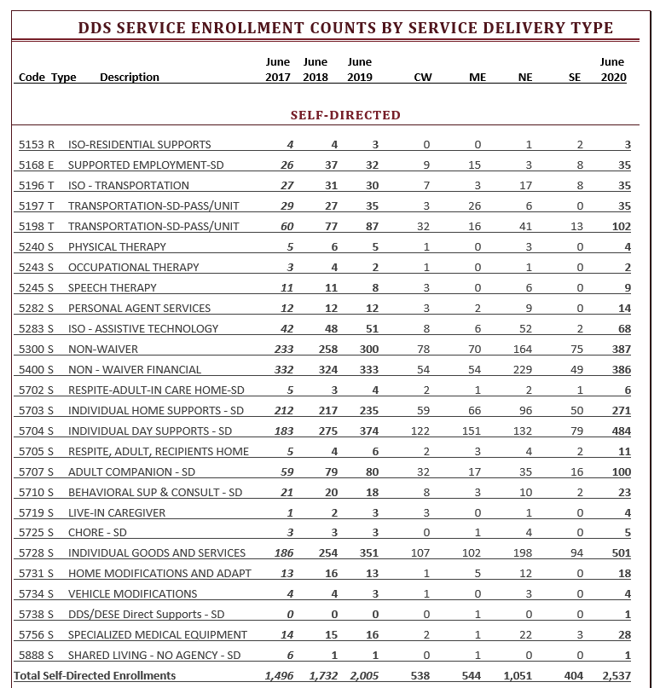

The next chart provides service enrollment information regarding participants who choose the Agency With Choice (AWC) option. This option requires the agency, chosen by the participant, to work closely with the participant on the design and delivery of services. The participant chooses the staff, and the agency and participant jointly supervise and evaluate the staff. In this option, the provider agency is responsible for all personnel/payroll needs, accounting and adherence to expenditure regulations and DDS requirements.

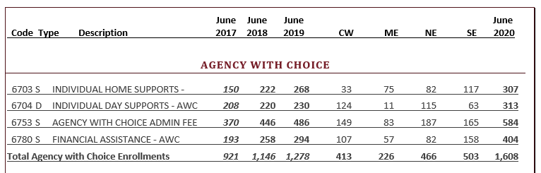

Subsection (vii) provide ranges and averages for expenditures from all individual budgets, inclusive of any adjustments to individual budgets made pursuant to subsection (i);

In the FY2020 Participant Directed Program (PDP) with Public Partnership LLC (PPL), the average statewide allocation was $18,546.02. The smallest allocation spent was $4.50. The smallest allocations are typically for a partial year, new enrollment program or short-term expenditures appropriate for this service model. The largest two allocations were at $233,094 and $149,230; however, these cases represent unique circumstances. Other than these two outliers, the highest allocation spent was $133,686.

In the FY2020 Agency With Choice (AWC) program, the average statewide allocation was $26,375.67. The lowest allocation was $1,103.39, and the highest allocation was $180,384.00.

Subsection (viii) the number of participants who withdrew voluntarily from the option;

During FY2020, ten (10) individuals voluntarily moved out of the Self-Determination Program. This number does not include withdrawals due to deaths, people who were enrolled with the specific purpose to receive short-term services (defined as less than a year), supports or goods and other technical or administrative reasons. Seven of the ten individuals moved to a traditional model due to needs of the individual or family requiring more intensive services (often 24/7 residential services). One preferred a traditional model, one is reassessing AWC agency options, and one has achieved their goals and no longer wanted services.

DDS continues to increase enrollments in self-directed services, streamline service models and systems, expand communication efforts (most recently via user promotion videos), address internal alignment needs and engage varying stakeholders for feedback and evaluation to improve self-directed service. We are committed to increasing participation in self-directed service options within DDS and fully expect the enrollment numbers, system improvements and service enhancements to continue in the coming year.

