
.
Maura T. Healy Kate Walsh
Governor Secretary

Kimberly Driscoll Sarah W. Peterson
Lieutenant Governor Acting Commissioner

REPORT ON DDS
SELF-DETERMINATION SERVICES

September 2024


Massachusetts Department of Developmental Services

The Department of Developmental Services (DDS) is submitting this report pursuant to the Real Lives Law, Chapter 255 of the Acts of 2014, codified as M.G.L. c. 19B, § 19 (e)(18). This section requires DDS to:
provide, in consultation with the advisory board established in subsection (c), an annual report to the chairs of the house and senate committees on ways and means and to the house and senate chairs of the joint committee on children, families and persons with disabilities, not later than September 1; provided that said report shall (i) set forth any modifications or improvements made by the department to the administration of self-determination, (ii) specify any recommended legislation, (iii) provide an assessment of the performance of providers, vendors and persons who have received funds for the provision of services, supports and goods under this section, (iv) specify the number of participants utilizing self-determination during the previous fiscal year, (v) specify the number of participants per region in the commonwealth, (vi) specify types and amounts of services, supports or goods purchased under self-determination, in a manner that facilitates analyses and year to year comparisons, (vii) provide ranges and averages for expenditures from all individual budgets, inclusive of any adjustments to individual budgets made pursuant to subsection (i), and (viii) the number of participants who withdrew voluntarily from the option.

The Self-Determination Advisory Board, as outlined in M.G.L. c. 19B, § 19(c), was established in December 2014. Previous Annual reports are available on the DDS website.

In FY24, the Board met on September 6, 2023, December 6, 2023, March 13, 2024, June 5, 2024. The September and December meetings were held virtually, and the March and June meetings were held in person at the Metro Regional Office in Waltham. Meeting minutes as well as documents presented, reviewed and discussed are also on the DDS website.

The number of participants enrolled in self-directed services increased from 1,270 to 1,456 for FY’24. A review of the various work products, tasks, activities, and ongoing efforts is provided below.

Subsection (i) – modifications and improvements made to the administration of self-determination;

- In 2015, the DDS Real Lives Law Work Plan was developed to establish operational and oversight protocols aimed at monitoring the implementation of the Real Lives Law. Since its development, twenty-eight items requiring DDS action have been completed and eight are categorized as “ongoing.”
- Self-Determination Advisory Board Members are appointed for a three-year term. Many of the board members have continued to be reappointed as their terms expire. No new members were added this year. We currently have 1 vacant seat.
- Agency With Choice (AWC) has been a self-directed service choice since 2010. This is a co-employment model of service delivery in which a Qualified Provider shares employer responsibility with individuals and families. The AWC provider serves as the employer of record and the individual/family serves as the managing employer.
  - AWC Request for Response (RFR) was issued in FY’23 in response to growing interest by the provider community. Changes made in the RFR are designed to simplify the AWC program model and enhance aspects of service delivery. Key elements included:
    - Streamlining the menu of direct support service options to Individualized Home Supports and Individualized Day Supports (which aligned with current utilization and continues to offer flexibility for participants), and
    - Increasing clarity on the roles of individuals/families and providers related to their shared responsibilities in this co-employment arrangement, as well as the role and responsibilities of the Service Navigators.
A collaborative work group of DDS staff and Agency with Choice (AWC) providers initiated the development of a comprehensive AWC Program and Operations Manual that includes many helpful resources and tools to support consistency in understanding and implementation of these services. The manual’s release in FY’23 was accompanied by regional training sessions for AWC providers and DDS Area Office staff.
- DDS Regional Self-Direction Managers continue ongoing outreach, communication and training efforts related to the promotion and understanding of DDS self-directed service options. The target audiences have included DDS Area Office staff, new DDS Service Coordinators, self-advocates, individuals and families, providers, and local advisory boards. Presentations on self-direction are also provided at DDS conferences, Transition and Turning 22 Forums, Family Support Centers, and other appropriate DDS training venues. The Regional Self-Direction managers began offering information sessions in Spanish in FY’23 to individuals and their families who were interested in learning more about the 2 self-direction programs.
- DDS Regional Self-Direction Managers hold monthly Support Broker Meetings in each region that are focused on training, process improvements, best practices in self-determination program development and a variety of other topics.
- DDS drafted regulations specific to Self-Directed Services. A second Public Hearing on those draft regulations was held in December 2023 to review the updated regulations which included the feedback they received from the first Public Hearing in November 2022. DDS anticipates promulgating regulations in FY’25.
- DDS continues to work with Human Services Research Institute (HSRI) to review the self-direction program, identify areas to improve consistency, transparency, equity and accessibility, complete a review of services and make recommendations for a budget determination process based on an assessment of a person’s support needs. These recommendations resulted in:
  - Convening a workgroup consisting of participants, family members, advocates and DDS staff to draft a guide written in plain, accessible language. This was published and is available on the DDS Website.
  - Enhancing program infrastructure by offering continued Support Broker training,
  - Identifying a new person-centered assessment to determine support needs and budget allocations based on the needs captured. DDS has contracted with American Association on Intellectual and Developmental Disabilities (AAIDD) to use their assessment tool, the Supports Intensity Scale Assessment, 2nd Edition, Adult Version.
    - AAIDD provided the assessors from November 2023- June 2024. DDS hired and trained 5 SIS-A assessors to complete the assessments
Subsection (ii) specify any recommended legislation;

DDS recommends adjusting the frequency of the Self Determination Advisory Board meetings. DDS recommended that these meetings be moved to twice yearly, SDAB members would like meetings to continue at the quarterly cadence.

Subsection (iii) assesses the performance of providers, vendors and persons who have received funds for the provision of services, supports and goods under this section;

Participant Directed Program (PDP)

PPL is the current fiscal intermediary under contract to provide fiscal services for the PDP. The PDP is the service option that provides the individual or the family the greatest control over their services. It also requires significant time and responsibility by the person or their family. DDS works closely with PPL to create specific goals and objectives for their work on the PDP and DDS increased their oversight of PPL by holding monthly in-person meetings with PPL leadership and staff.

Agency With Choice (AWC)

The AWC self-direction option allows individuals and families to self-direct services through a contracted DDS agency. In this option, the individual or family maintains control over design and delivery of services but receives assistance or support in management of staff, budgeting, and many other administrative needs. The agency is responsible for all accounting, personnel/payroll management and assuring adherence to regulations and DDS requirements.

Each year, AWC agencies conduct annual satisfaction surveys for the services they provide. The information received is collected and shared with DDS and other stakeholders to improve identified areas of concern. By design, the AWC model requires close collaboration between the provider and the participant. This ongoing, frequent communication ensures that problems, concerns and general satisfaction issues can be discussed and addressed as such matters arise. Additionally, at the end of each fiscal year, staff from the agency and the Service Coordinator reviews the performance of staff and the effectiveness of the service plan to make changes accordingly.

Subsection (iv) specify the number of participants utilizing self-determination during the previous fiscal year.
On June 30, 2024 there were a total of 2,451 participants enrolled in self-direction.

Subsection (v) specify the number of participants per region in the Commonwealth;

As of June 30, 2024, the 2,451 enrolled self-direction participants were from the following regions:
- Central West: 653
- Metro: 459
- Northeast: 636
- Southeast: 703

Subsection (vi) specify types and amounts of services, supports or goods purchased under self-determination, in a manner that facilitates analyses and year to year comparisons;

The Department keeps data on the categories of self-determination services used each month, the year-to-date total and lists the yearly total for the previous three fiscal years. Below are the two charts with this detail for FY24, numbers in these charts represent the total enrollments in each service category. Many participants are enrolled in more than one service category. The total number of people enrolled in self-determination is provided in subsection (iv) above.

The following chart lists all the service enrollments for self-directed participants enrolled through the PDP option. As noted in section (iii) above, this option allows the participant the greatest control over their services, staff and budget and requires the greatest responsibility to manage the services, staff and service choices made. In this option, the fiscal intermediary, PPL, is responsible for all the payroll, accounting and adherence to expenditure qualification/requirements and regulations.
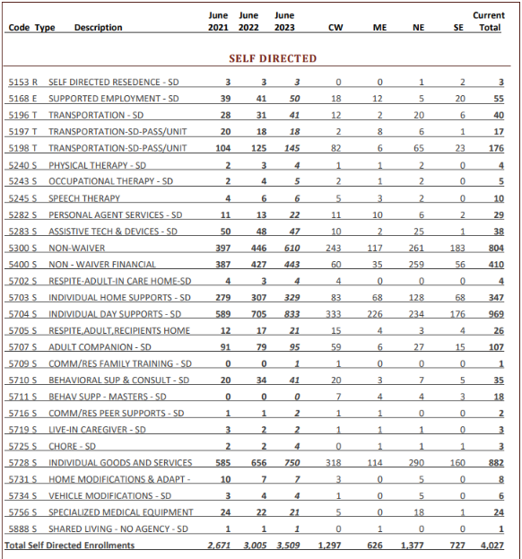

The next chart provides service enrollment information regarding participants who choose the Agency With Choice (AWC) option. This option requires the agency, chosen by the participant, to work closely with the participant on the design and delivery of services. The participant chooses the staff, and the agency and participant jointly supervise and evaluate the staff. In this option, the provider agency is responsible for all personnel/payroll needs, accounting and adherence to expenditure regulations and DDS requirements.

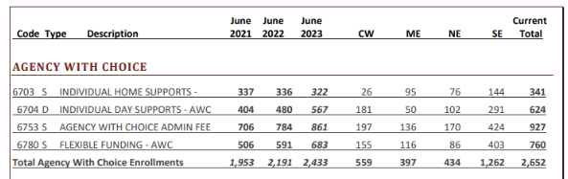

Subsection (vii) provide ranges and averages for expenditures from all individual budgets, inclusive of any adjustments to individual budgets made pursuant to subsection (i);

In the FY’24, for PDP with PPL, the average statewide allocation was $24,825.46. The smallest allocation spent was $425.00. The smallest allocations are typically for a partial year, new enrollment program or short-term expenditures appropriate for this service model. The largest two allocations were at $292,877.13 and $180,381.25; however, these cases represent unique circumstances.

In the FY’24 AWC program, the average statewide allocation was $28,448.97. The lowest allocation was $798.50, and the highest allocation was $147,496.

Subsection (viii) the number of participants who withdrew voluntarily from the option;

During FY’24, 390 individuals voluntarily moved out of the Self-Direction Program. This number does not include withdrawals due to deaths, people who were enrolled with the specific purpose to receive short-term services, services that last less than a year, supports or goods and other technical or administrative reasons.

Conclusion

DDS continues to increase enrollments in self-directed services, streamline service models and systems, expand communication efforts and engage varying stakeholders for feedback and evaluation to improve self-directed service. DDS is committed to increasing participation in self-directed service options and we fully expect the enrollment numbers, system improvements and service enhancements to continue in the coming year.

