Please join us for an interactive discussion about expanding choices and control in your life through Self- Directed Supports. This is an opportunity to hear how participants and their families can design individualized services to meet their needs through the
Participant Directed Program
or
Agency with Choice

1/6/21
1/27/21
2/2/21
2/24/21
3/9/21
3/31/21
WHEN:
1:00pm to 2:30pm 4:00pm to 5:30pm 10:00am to 11:30am 4:00pm to 5:30pm 10:00am to 11:30am 4:00pm to 5:30pm

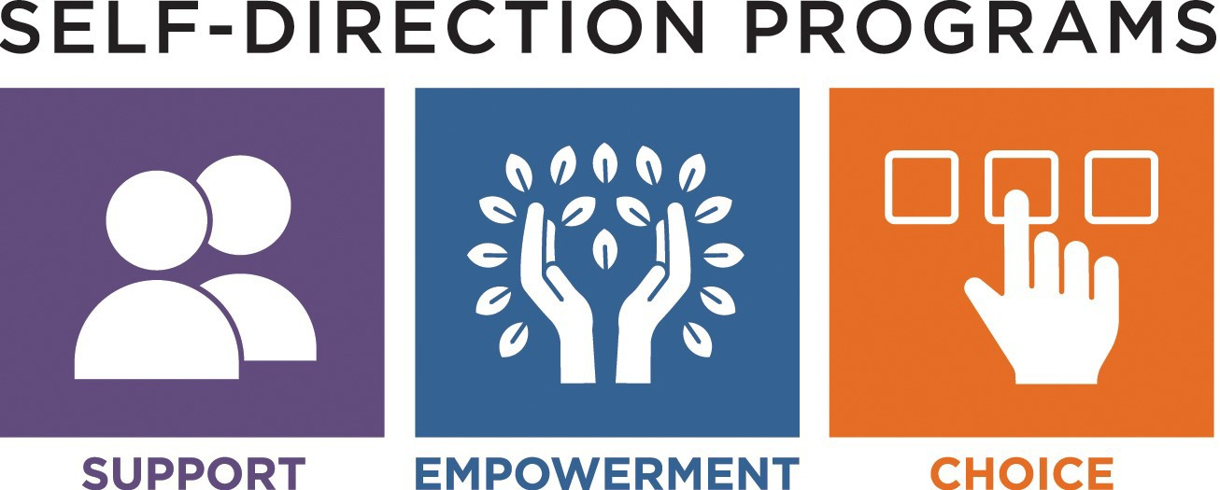
Offered via WEBEX
To register please contact: jennifer.r.benoit@mass.gov

