Department of Developmental Services Regional Self-Direction Manager Contact information

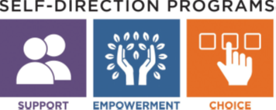

A DDS Self-Directed Support manger is available for each region to help individuals and their families learn about Agency with Choice and the Participant Directed Program.
Not sure which area office serves you? Click here: DDS area office locator

Central/West Region: Pamela Hickey
413-726-4396
pamela.hickey@mass.gov

Metro Region: Jennifer Benoit
617-485-7902
jennifer.r.benoit@mass.gov

Northeast Region: Bev McGovern
978-766-0620
beverly.mcgovern@mass.gov

Southeast Region: Edward Wilson
774-289-7185
edward.b.wilson@mass.gov

For more information visit our website: https://www.mass.gov/dds-self-directed-services

