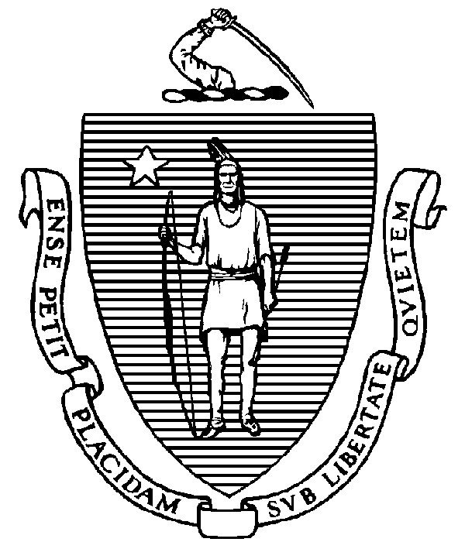
THE COMMONWEALTH OF MASSACHUSETTS

EXECUTIVE OFFICE FOR ADMINISTRATION AND FINANCE STATE HOUSE ▪ ROOM 373 BOSTON, MA 02133

TEL: (617) 727-2040
FAX: (617) 727-2779 www.mass.gov/eoaf

NOTICE OF PUBLIC MEETING

Capital Debt Affordability Committee

Friday, September 10, 2021 1:00 p.m. In accordance with the Governor’s Executive Order Suspending Certain Provisions of the Open Meeting Law, G.L. c. 30A, § 20, signed and dated March 12, 2020, this meeting will be conducted, and open to the public, via Zoom video and teleconference.
Zoom URL: https://mass-gov-anf.zoom.us/j/84631669009?pwd=c0QxUnRZWDcrekJWUGFVRmNxTFNVZz09 Password: DAC091021
Teleconference line: 713-353-7024; Conference code: 319738

AGENDA

1. Administrative Matters
- Adoption of meeting minutes from December 4, 2020 (Vote)
- Announcements

2. Fiscal 2023 Schedule and Work Plan

3. Fiscal 2023 DAC Draft Report Section Review
- Committee Overview
- Commonwealth Debt Overview

4. Adjournment

