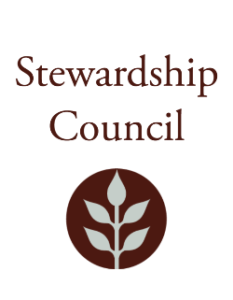

# Stewardship Council Meeting

**Thursday, September 11, 2025|** 1:00PM to 3:00PM

Mount Holyoke Range State Park Notch Visitor Center

1500 West St

Amherst, MA 01002

## Agenda

|  |  |
| --- | --- |
| TOPIC | SEGMENT |
| **Welcome and Chair’s Update** – Dicken Crane, Chair | 1:00 – 1:10 PM |
| **DCR Report** – Nicole LaChapelle, Commissioner | 1:10 – 1:30 PM |
| **Regular Business I**   * Wachusett Complex Resource Management Plans Presentation – Paul Cavanagh, Resource Management Planner * Approve Minutes: July 24, 2025 * Public Comment | 1:30 – 2:15 PM |
| **Regular Business II**   * + - * Committee Discussion * Committee Updates * Councilor Comments | 2:15 – 3:00 PM |
| **Adjourn** | 3:00 PM |

## Zoom Meeting Information

**Meeting of the DCR Stewardship Council**

You are invited to register for a Zoom webinar!

When: Sep 11, 2025 01:00 PM Eastern Time (US and Canada)

Topic: September 11, 2025 Stewardship Council Meeting

Register in advance for this webinar:

<https://zoom.us/webinar/register/WN_qv3rtUA4TviPE8ohjAFBfw>

After registering, you will receive a confirmation email containing information about joining the webinar.

Please contact Matt Perry at [matthew.s.perry1@mass.gov](mailto:matthew.s.perry1@mass.gov%20) for accessibility information.

9/5/2025 10:42 AM