September 11, 2025 Meeting Minutes
Council Members Present: Dicken Crane, Susan Smiley, Jeff Collins, Dennis Smith, Laura Jasinski, Jennifer Wilson, Jack Buckley
Council Members Attending Virtually: Vivian Ortiz, Phil Doherty, Kevin O’Shea
Council Members Absent: Ann Canedy, Melissa Harper, Ted Dooley
DCR Staff Attendees: Nicole LaChapelle, Matthew Perry, Kendra Amaral, Paul Cavanagh, Aimee Graeber, John Daly, Wendy Pearl, Paul Fahey, Mackenzie Greer, Ilyse Wolberg
Public Attendees as Registered: Deb Cary, Bill Boles, Lawrence Tucker, Chip Jones, Chris Egan, Jonathan Parrott, Nicole Freedman, Peter Rayton, Charles Thompson
Virtual Attendees: Chris Redfern, Sarah Freeman

Call to Meeting, 1:00pm – Chair Dicken Crane
Chair Crane welcomed everyone to the meeting and did a roll call of councilors. He invited Interpretive Services Supervisor Joshua Epstein to speak.
Mr. Epstein welcomed everyone to the Notch Visitor Center and went over some of the upcoming events that they will be hosting for the public.

DCR Report – Commissioner Nicole LaChapelle
Commissioner LaChapelle welcomed the Council to the Notch Visitor Center, part of the Mount Holyoke Range State Park. She said that the park is one that she has been going to for decades, and that it is a special place for her and her family.

Gronk Playground
On August 19, Commissioner LaChapelle joined partners from the Esplanade Association and the Gronk Nation Youth Foundation to officially open the new Gronk Playground on the Esplanade. She said that Governor Healey, Secretary Tepper, and her tested out some of the equipment and loved seeing the kids enjoying the new playground. Commissioner LaChapelle thanked the DCR team who worked over the course of four years to bring the vision of the playground to life, including Sandy Libby, Ruth Helfeld, Tom Atkins, and Patrice Kish.

Biodiversity Announcement
Commissioner LaChapelle attended Governor Healey’s biodiversity announcement in Barnstable, where a new public-private Massachusetts Biodiversity Partnership crafted by DCR’s colleagues at Mass Wildlife was introduced. She said that the partnership is a great example of the Healey/Driscoll Administration cross agency work, and that she is proud that the work done by teams at DCR helps increase biodiversity and makes forests and parks more resilient to extreme weather. The initiative lays out clear paths for cross-state agency collaboration - increasing the impact. She thanked Councilor Jeff Collins for also attending.

Hometown Heroes
On August 8 at Breakheart Reservation, the DCR Forest Fire Control team was celebrated as part of the health benefits company Wellpoint and 98.5 the Sports Hub Hometown Heroes recognition. When an unprecedented 662 wildfires broke out across Massachusetts last fall, our firefighters safeguarded our infrastructure and protected natural resources. Commissioner LaChapelle said that DCR firefighters work hand in hand with the Operations and Rangers teams when these dangerous situations arise and that partnership and collaboration is essential to maintaining and preserving treasured open spaces for the next generation.

Salisbury Beach Dedication
Commissioner LaChapelle joined Governor Healey and Secretary Tepper at Salisbury Beach to unveil a new sign and interpretive panel honoring Robert “Boots” Chinourd. Mr. Chinourd is 101 years old and was a lifeguard at Salisbury starting in 1943, and the event was attended by his friends and family, as well as the local community.

Quabbin Reservoir Visit
Commissioner LaChapelle visited the Quabbin Visitor Center in Belchertown and learned about what active Forestry Management plan can look like compared to a plot where a Forestry Management plan is in process. She said that in the area where thinning out has occurred, purple milkweed has bloomed. Staff organized a boat tour of the Quabbin to highlight watershed management as well as reservoir infrastructure.

Golf Courses
Commissioner LaChapelle gave an update on the two golf courses run by DCR, Leo J. Martin in Weston and Ponkapoag in Canton. In June, DCR welcomed Justin Grimes, the new Director of Golf Course Maintenance who is overseeing maintenance and contracts at both golf courses. The agency is currently performing turf maintenance on the greens, which will continue this October once the new maintenance contract is online. While this level of maintenance has been sufficient for many of the greens, DCR is aware that several require more attention. For those greens, full reconstruction is being considered, which would involve excavating and replacing them to bring them up to an acceptable standard. The Commissioner said that DCR remains committed to improving both courses for those who enjoy them.

DCR Launches Visitor Survey Project
DCR’s Research Office and Park Operations teams are collaborating on a pilot project to better understand the public’s perception of property conditions and visitor experiences. This summer, they posted multilingual signs in eight parks. Half received a Property Condition sign, and the other half received a Visitor Experience sign. Each sign includes a QR Code, that leads to a park-specific survey available in multiple languages. The pilot project will extend into October. The teams will meet in November to help prepare to expand these surveys next spring. The hope is that this feedback will help create even better visitor experiences.

Girl Scouts Love State Parks
Commissioner LaChapelle announced that DCR is again partnering with the Girl Scouts for Girl Scouts Love State Parks weekend on Saturday and Sunday, September 13 and 14. Every year, DCR welcomes hundreds of Girl Scouts from around the state for special interpretive programs that give them an opportunity earn their nature-based badges. This is a great opportunity to get out into the parks, take in the turning leaves, and attend a program. In honor of this great partnership, the agency will be waiving parking fees at all DCR parks for all visitors that weekend.

The Summit Show at Skinner State Park
For two weekends, Skinner State Park, in Hadley, hosted The Summit Show, featuring works by 40 artists. It was organized by Mundus Press and included works by 40 artists. The art was showcased along several trails and at the Summit House. The curator of the event lives in Easthampton, but the artists were mostly from the Berkshires and New York City, and the event attracted attention in New York, including the Commissioner’s nephew and his friends from Brooklyn who made the trip up to see it. Commissioner LaChapelle said that it is great to see a DCR property hosting such a unique cultural event, especially in Western Mass.

Big E
DCR will once again be at its booth in the Massachusetts Building for the Big E from September 12 to 28. Staff is volunteering to work at the booth and will inform visitors about the great programs and properties we have at DCR. The Growing Wild program will also be highlighted, encouraging people to grow native plants and help pollinators.

Boston Harbor Islands Cleanup
After the success of the Great Boston Harbor Islands Cleanup last year, DCR is again teaming up with the Center for Coastal Studies on another Harbor Islands cleanup, this time on Peddocks Island. This event will take place from September 14 to 17. Some volunteers will camp on this island, and others will arrive by boat daily to assist in the work. The Commissioner encouraged anyone that is interested in participating to register.

Councilor Questions and Comments
Councilor Wilson asked if there was an update on the 311-system pilot.
Commissioner LaChapelle and Deputy Commissioner Kendra Amaral said that they could get more information about the system pilot for the council.
Councilor Wilson asked if councilors could take part in the pilot once that phase is rolled out.
Councilor Buckley asked about a committee being formed by Governor Healey about the PILOT (Payment In Lieu of Taxes) program.
Ms. Amaral said that the committee was created to review the program and the payments that DCR makes to cities and towns that have DCR properties in them. She said that she is not sure if they had met yet about this topic.
Councilor Buckley asked if current immigration policies and enforcement has negatively impacted park usage in the state.
Commissioner LaChapelle said that they don’t have the data to know whether that is the case, but that they have had the issue being brought up by people visiting the parks and by staff.
Councilor Jasinski asked Commissioner LaChapelle what comes next for her as she settles into her new role.
Commissioner LaChapelle said that she is going to work with the operations and finance teams to learn more about the budget and seasonal staffing. She also mentioned that the Wachusett Complex RMPs have been a big focus and it was the first time for her going through the RMP process. She said the other issue is the Mass Ready Act, the Biodiversity Goals, and Forest as Climate Solutions. She said that she’s trying to balance being in the field to meet with staff and learn about the properties with the financials of the agency.
Councilor Collins said that it was great to see Commissioner LaChapelle at the Biodiversity Goals announcement. He commended the Parkways Planning team for their public meeting about Memorial Drive and said that it is a fantastic plan to change the parkway to a multi-user safe space. He said that there was another bike accident on William Day Blvd. a few weeks ago, and that he encourages the agency to continue the work to make the parkways as safe as possible.
Commissioner LaChapelle said that Memorial Drive is a game changer.
Councilor Smiley asked about the golf courses and if there will be additional opportunities for cross country skiing at Ponkapoag like there is at Leo J. Martin.
Commissioner LaChapelle said that it is under consideration, but at this point the plans that they have include questions about the improvements that can be made and how long they can work on them because of the warmer winters.
Ms. Amaral said that the Nordic Skiing group that operates out of Leo J. Martin participated in a study to upgrade the irrigation system for snowmaking. The cost for the system is between $5 million and $8 million and right now the agency is not moving forward with them. She said for Ponkapoag, skiing has not been raised yet and the focus is to get Leo J. Martin back up to a good condition. She noted that with warmer shoulder seasons, the cross-country skiing that is happening has started to cause some additional damage on the golf courses, so they need to find a way to balance the uses and make sure that one is not impacting the other.
Councilor Smiley asked if there were any updates on the Mass Trails Grants.
Commissioner LaChapelle said that the grants are still on hold as they are being reviewed.
Councilor Smiley asked if DCR is seeing any other federal grant funding that is being paused.
Commissioner LaChapelle said not anything specific or new, but that they are watching closely, especially when it comes to the National Park Service and the areas where they partner with DCR including the Boston Harbor Islands.
Councilor Smiley asked if there is anything that the council can do to help support the funding.
Commissioner LaChapelle said that she would get back to the council about this and that there have been conversations about the Biodiversity Goals and the Mass Ready Act and where the council will be most effective in promoting these issues.
Councilor Collins said that for Leo J. Martin, it is a Nordic skiing training center for many schools in Eastern Massachusetts and to keep it in mind when considering its future.
Councilor Smith said that the council had discussed improving signage on trails for bicycles and if there has been any progress with that.
Commissioner LaChapelle said that she didn’t know anything specific, but that she will look into it.
Councilor O’Shea said that he appreciates the update on the golf courses and that it is an issue that it is important to him. He noted that a public golf course in New York run by their State Parks is hosting the Ryder Cup while the two courses run by DCR were recently ranked the worst in the country. He said that he appreciates hearing about the investment and work that is being put into the course, and asked if Commissioner LaChapelle would join him to walk the courses and see their condition.
Commissioner LaChapelle said that she would like to do that.
Councilor Buckley asked about the rebranding process and if there were any updates.
Commissioner LaChapelle said that she received a briefing on the rebranding and that she is waiting to hear more about where everything is.
Councilor Ortiz thanked the staff in the Neponset District, along with NEPRWA and the Neponset Greenway Council for Neponset Day which was a great success. She said that they love to interact with the DCR staff at events along the trail. She asked if there was a plan for an official ribbon cutting on the new stretch of trail that was open during the summer.
Commissioner LaChapelle said that she will get her more information on the ribbon cutting.
Councilor Ortiz said that there is a king tide later that day and when it happens, the Neponset Greenway Council does a lot to educate about it. She said that the focus is on Morrissey Blvd being flooded, and she asked if there can be emphasis on how it affects other people that don’t use Morrissey Blvd as well because it is something that affects more than just drivers. She also noted that the Pumpkin Parade is happening on October 23 at Pope John Pual and that she hopes that Commissioner LaChapelle can attend.
Chair Crane commended the Commissioner for her efforts to learn about all aspects of DCR and the time she is spending in the parks. He said that she has been doing a phenomenal job and that he is sure it will continue as she gets more time in the field.

Regular Business I

Presentation on Wachusett Complex Resource Management Plans – Paul Cavanagh, DCR Resource Management Planner
Mr. Cavanagh gave a presentation on the Wachusett Complex Resource Management Plans (RMPs).

After the presentation concluded, Councilors were given the opportunity for questions and comments.
Councilor Wilson spoke about the role of the Policy Committee and how far the process for RMPs has come. She said that approving RMPs is one of the few statutory requirements for the council, and that having the opportunity to hear from Mr. Cavanagh and ask him questions helps with this requirement. She said that the Policy Committee works on this issue all year long and asks a lot of questions about the process and the rigor of the public meeting process. She noted that the numbers for the meetings are a little disappointing, but they aren’t typical of what they have been seeing, and that holding the meetings during the summer may have contributed to this. She said that the committee also looks for themes that come up over multiple RMPs that can be brought up as a policy matter by the council. Last, she noted that in the past, if Commissioners changed, things like RMPs would have been brought to a standstill, but this wasn’t the case with Commissioner LaChapelle, and she thanked her for her work to keep things moving.
Chair Crane has said that the rate of progress has gone up, and that this has been a long term goal that has moved slowly for a long time.
Councilor Wilson said that the Policy Committee has been focused that it is not speed for the sake of speed, but that the process is in place for things to move smoothly.
Mr. Cavanagh said that what has helped over the past two years has been the institutionalization of the template for the RMP, and that the standardization has allowed them to move faster and more systematically through the plans.
Councilor Jasinski asked about outreach for the public meetings and whether there can be planning for the meetings based on the mutual availability of the stakeholders for the plans, not to substitute for public forums, but to get into the weeds of the plans and rely on the deep knowledge of properties that friends groups and other partner groups have.
Mr. Cavanagh said that this does happen, and with the Wachusett Complex there aren’t the level of friends groups that exist in other parts of the state. He said that in some cases where there are active friends groups they are very involved throughout the whole process, and they hold an additional meeting with them along with the public meeting. He said that there is sometimes a struggle to find friends groups for properties, and that especially for the Central Highlands, traditional friends groups have been missing.
Councilor Jasinski asked how feedback from public meetings is integrated into RMPs.
Mr. Cavanagh said that when comments are given, they have a spreadsheet where they enter the comment and who gave it. It is then assigned to the person who is writing the RMP, and they will raise the issue with Park Operations staff to get feedback. He said that if it goes against regulations or designations, the comment stops there, but if not, it will proceed to other staff to discuss with. Depending on feedback, they may adopt the recommendation and goes to senior staff redlined to note that the change was made through public comment.
Councilor Smiley asked if the public comment on all of the properties is closed.
Mr. Cavanagh said that the Wachusett Complex is closed, but Otter River and Erving are still open.
Councilor Smiley asked how municipalities are engaged for these plans.
Mr. Cavanagh said that they announce the public meeting and contact each town that has the DCR property in it and talk to the various departments that will have an interest in the plan directly.
Councilor Smiley said that she would like to see how the Stakeholders Committee can assist with outreach.
Councilor Collins spoke about unauthorized trails and the impacts they have on natural and cultural resources. He said that they heard from Ale Echandi and the Trail Master Planning process, and that he’s eager to hear the ideas that come up about how to take care of this issue.
Chair Crane said that he appreciates in the presentation that the landscape designation was referenced. He said that the lack of forest management and stewardship plans stands out to him. He said that it would really help if areas designated as woodlands all have forest management or stewardship plans as a goal.

Approval of Minutes
Councilor Smiley made a motion to approve the minutes from the July 24, 2025 Stewardship Council meeting.
Councilor Collins seconded the motion.
The July 24, 2025 meeting minutes were approved with Councilor Wilson abstaining.

Public Comment
Guidelines for Public Comment are available on the DCR Stewardship Council website.
Chairman Crane invited members of the public for comment.

Comments were given by the following members of the public
- Deb Cary and Henry Wolsley, Mass Parks for All
- Bill Boles, Sandwich
- Lawrence Tucker, Snowmobile Association of Massachusetts
- Chip Jones, Snowmobile Association of Massachusetts (Photos from Mr. Jones are included at the end of the minutes.)
- Chris Egan, Mass Forest Alliance
- Jonathan Parrott, Brotherhood Energy Council
- Peter Rayton, Mass Forest Alliance

Regular Business II

Committee Updates

Policy Committee
The committee met and heard from Paul Cavanagh about RMPs, and also spoke with Deputy Commissioner of Operations Rob King about rodenticide use on DCR properties. They are waiting for the results of an Request for Proposals that was put out by the agency for alternative rodent treatments at urban properties.

Stakeholders Committee
The committee met on September 5 and were joined by Deputy Commissioner Kendra Amaral and Director of Partnerships Paul Fahey. The Committee is working closely with them on some issues. Councilor Smiley said that they encourage friends and partner groups to submit to present to the full agency at a meeting. She added that Councilor Harper is working with DCR on the reappointments of councilors and the appointment of new councilors. The committee also discussed upcoming meetings, and the December 11 meeting will be at the DCR headquarters at the Transportation Building in Boston, 10 Park Plaza.

Conservation Committee
The committee is excited by the release of the Biodiversity Report that was released and is eager to work with DCR on how to help drive these goals forward.

Finance Committee
The committee is intending to schedule a listening session on the Mass Ready Act for the public and would like to schedule a meeting with DCR’s finance team.

Councilor Comments
Councilor Smith said that traditionally the December meeting has been held at the State House, and with it at the DCR headquarters this year, they encourage staff to come down and attend.
Councilor Jasinski suggested that they look at the organization of the council and start to plan priorities that can be shared to create cohesion.
Councilor Wilson said that they should revisit the Strategic Oversight Plan in order to do this.
Councilor Buckley said that they should create space on the agenda for something like this and have it at the beginning of the meeting so it doesn’t get lost.
Councilor Buckley said that he has been reappointed to the council by Governor Healey.
Councilor Collins said that he has also been reappointed to the council by Governor Healey.
Chair Crane thanked Commissioner LaChapelle for continuing the work to have reappointments move quickly.
Councilor Wilsons aid that it feels really good to be with people who are engaged with parks and public land, two issues about people, especially on the anniversary of September 11.

Adjournment
Councilor Collins moved to adjourn the meeting.
Councilor Buckley seconded.
Chair Crane thanked everyone and adjourned the meeting.
Please check the DCR Stewardship Council webpage for notice of upcoming meetings. https://www.mass.gov/service-details/dcr-stewardship-council

Photos that accompanied Mr. Jones’s public comments:
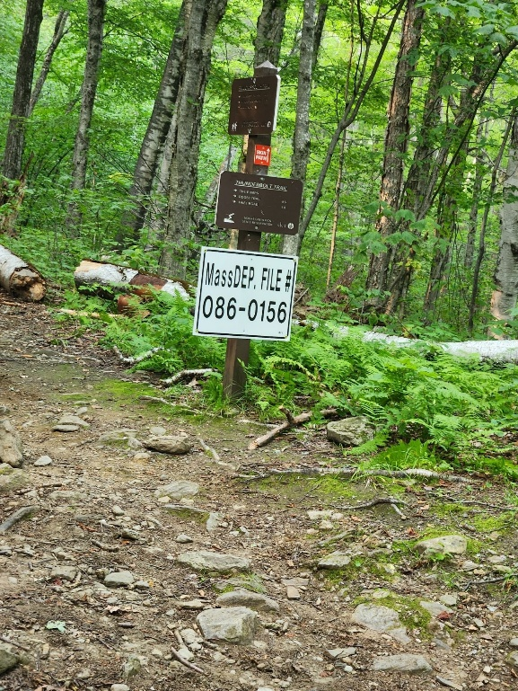 | 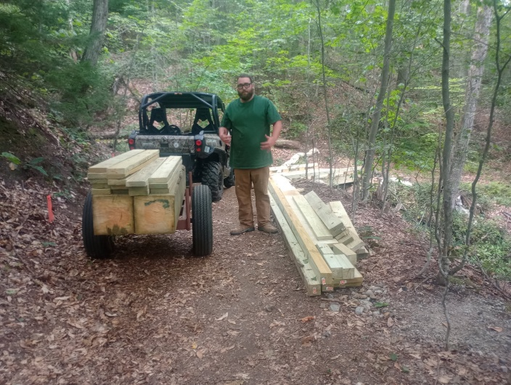
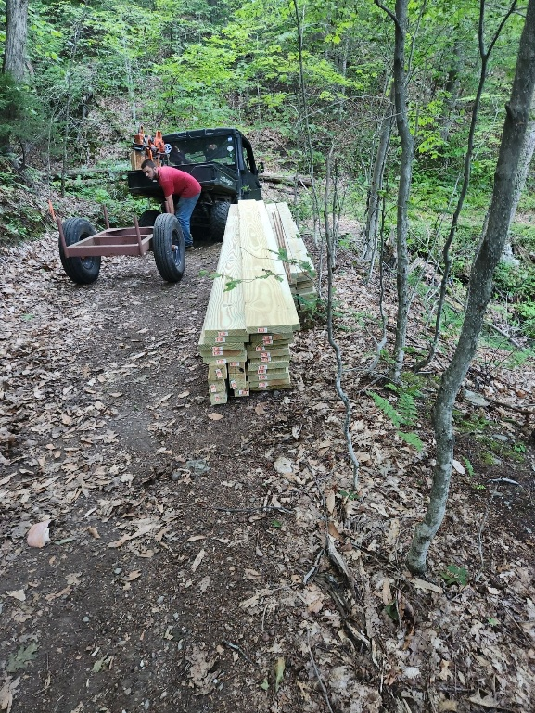 | 