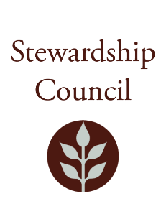
Department of Conservation and Recreation
Stewardship Council Nominating Committee Meeting
Notch Visitor Center, 1500 West St., Amherst, MA 01002
September 11, 2025 | 12:30PM

Nominating Committee Meeting Minutes

Council Members Present: Jack Buckley, Jeff Collins, Dennis Smith

DCR Staff Attendees: Matthew Perry

Call to Order – Chair Jeff Collins

Chair Collins opened the meeting of the Nominating Committee.

Approval of Minutes
Councilor Smith moved to approve the minutes from the September 12, 2024 Nominating Committee meeting.

Councilor Buckley seconded the motion.
The minutes were approved.

Discussion of Nominations

The councilors discussed nominations for the positions of Chair, Vice Chair, and Secretary. They agreed to continue talking to other members of the council to find nominees.

Adjournment

Councilor Buckley moved to adjourn the meeting.
Councilor Smith seconded the motion.

The meeting was adjourned.

Please check the DCR Stewardship Council webpage for notice of upcoming meetings. https://www.mass.gov/service-details/dcr-stewardship-council

