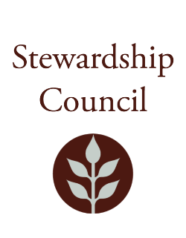

Stewardship Council Meeting
Thursday, September 12, 2024 | 9:00 to 11:00 AM
Hawthorne-By-The-Sea
153 Humphrey St, Swampscott, MA 01907

Agenda

TOPIC | SEGMENT
Welcome and Chair’s Update – Melissa Harper, Vice Chair | 9:00 – 9:10 AM
Remarks from the Swampscott Town Administrator – Sean Fitzgerald, Town Administrator | 9:10 – 9:15 AM
DCR Report – Brian Arrigo, Commissioner | 9:15 – 9:45 AM
Regular Business I  - Save the Harbor/Save the Bay Presentation – Chris Mancini, Executive Director  - Approve Minutes: July 11, 2024  - Public Comment | 9:45 – 10:30 AM
Regular Business II  - Consideration of comment letter regarding the state’s Biodiversity Goals  - Committee Updates  - Councilor Comments | 10:30 – 11:00 AM
Adjourn | 11:00 AM

May Meeting of the DCR Stewardship Council Observation Link (Public comments cannot be taken via Zoom)

Join Zoom Meeting
https://zoom.us/j/99129917687?pwd=ajUzZXZZeEV1M1BxUXd2ejhoWmtldz09

Meeting ID: 991 2991 7687
Passcode: 243454

One tap mobile
+13052241968,,99129917687#,,,,*243454# US
+13092053325,,99129917687#,,,,*243454# US

Please contact Matt Perry at matthew.s.perry1@mass.gov for accessibility information.

