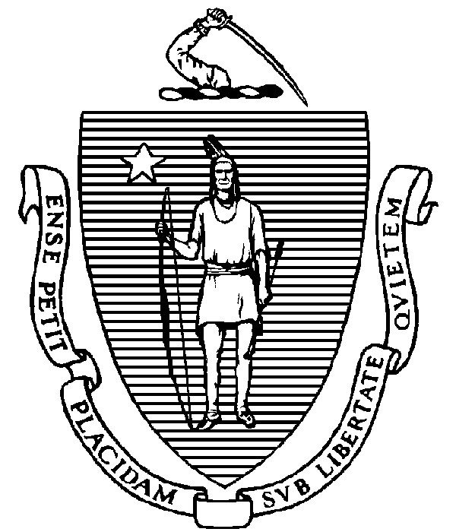
THE COMMONWEALTH OF MASSACHUSETTS

EXECUTIVE OFFICE FOR ADMINISTRATION AND FINANCE STATE HOUSE ▪ ROOM 373 BOSTON, MA 02133 TEL: (617) 727-2040

FAX: (617) 727-2779 www.mass.gov/eoaf

NOTICE OF PUBLIC MEETING

Capital Debt Affordability Committee

Friday, September 17, 2021 1:00 p.m. In accordance with the Governor’s Executive Order Suspending Certain Provisions of the Open Meeting Law, G.L. c. 30A, § 20, signed and dated March 12, 2020, this meeting will be conducted, and open to the public, via Zoom video and teleconference.
Zoom URL: https://mass-gov-anf.zoom.us/j/84919526612?pwd=YVJOeFRoSXVrdEFOVFZxemhOTE9LUT09 Password: DAC091721
Teleconference line: 713-353-7024; Conference code: 319738

AGENDA

1. Administrative Matters
- Adoption of meeting minutes from September 10, 2020 (Vote)
- Announcements

2. Fiscal 2023 DAC Draft Report Section Review
• Credit Ratings & Credit Factors Overview

3. Adjournment

